|  |  |
| --- | --- |
|  | It's an amazing algorithm because it really shows off how this can all be done in space. It's simply taking the array swapping nodes of one with one another without requiring any kind of temporary or other holding data structures or anything like that. It's all done in the space of the array itself.  This is beautiful and this is hard to appreciate only people who are really into computer science and kind of look at the stuff like and appreciate what's going on here. But it's a stunning stunning display of how you can compact something into very very small space and basically have this algorithm do so much with so little space.  So the next time you're talking to that special someone at that cocktail party in San Francisco and they ask you what makes the binary heap so special. You can look them in the eye and say, "Well for one is extremely fast, two, It's beautifully compact and three. It's just amazing how much you can do with so little code." And then pull out your laptop and show them how you built one from scratch just like this. |

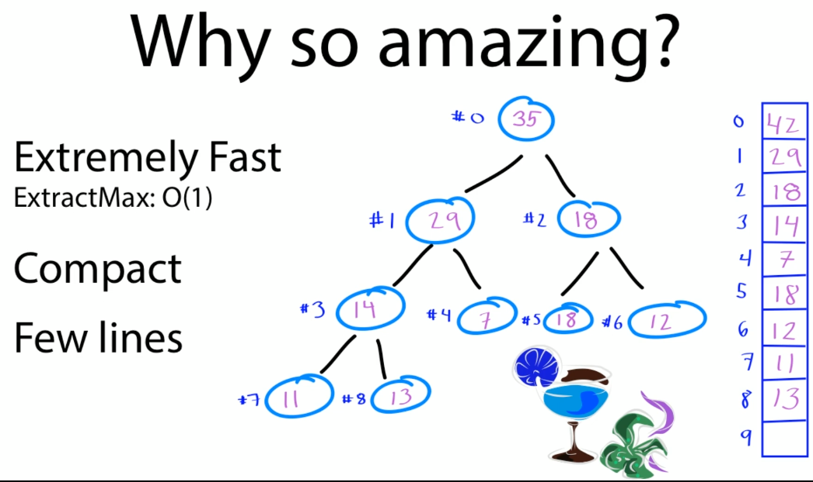

### How to build a Binary Heap from scratch

OK so here we have some unit tests that are going to show us how insert and extract Max work for the binary max heap.

|  |  |
| --- | --- |
| package algorithms;  import java.util.Arrays;  public class MaxIntHeap {  private int capactity = 10;  private int size = 0;  public int[] items = new int[capactity];  private int leftChildIndex(int parentIndex) {  return 2 * parentIndex + 1;  }  private int rightChildIndex(int parentIndex) {  return 2 * parentIndex + 2;  }  private int parentIndex(int childIndex ) {  return (childIndex - 1) / 2;  }  private boolean hasLeftChild(int index) {  return leftChildIndex(index) < size;  }  private boolean hasRightChild(int index) {  return rightChildIndex(index) < size;  }  private boolean hasParent(int index) {  return parentIndex(index) >= 0;  }  private int leftChild(int index) {  return items[leftChildIndex(index)];  }  private int rightChild(int index) {  return items[rightChildIndex(index)];  }  private int parent(int index) {  return items[parentIndex(index)];  }  public void **insert(int item)** {  ensureCapactity();  // put in last spot  items[size] = item;  size++;  heapifyUp();  }  public void print() {  for (int i=0; i < size; i++) {  System.out.println( i + "[" + items[i]  + "]" );  }  }  private void swap(int indexOne, int indexTwo) {  int temp = items[indexOne];  items[indexOne] = items[indexTwo];  items[indexTwo] = temp;  }  public void **heapifyUp() {**  // start at last element  int index = size - 1;  // while my parents are less than me...  while (hasParent(index) &&  parent(index) < items[index]) {  swap(parentIndex(index), index);  // walk upwards to next node  index = parentIndex(index);  }  }  public int **extractMax()** {  if (size == 0)  throw new IllegalStateException();  // grab the max  int item = items[0];  // swap top and bottom  items[0] = items[size - 1];  // effectively deletes last entry (max)  size--;  heapifyDown(); // reorder  return item; // return max  }  private void ensureCapactity() {  if (size == capactity) {  items = Arrays.copyOf( items,  capactity * 2);  capactity *= 2;  }  }    public void **heapifyDown() {**  int index = 0; // start at the top  // as long as I have children  // note: Only need to check left  // because if no left, there is no right  while (hasLeftChild(index)) {  // take the larger of the two indexes  int largerChildIndex =  leftChildIndex(index);  if ( hasRightChild(index) &&  rightChild(index) > leftChild(index)) {  largerChildIndex =  rightChildIndex(index);  }  // now compare  // if I am larger than the  // items of my two children...  // then everything is good. I am sorted.  if(items[index] > items[largerChildIndex]) {  break;  } else {  // we are still not in order - swap  swap(index, largerChildIndex);  }  // then move down to smaller child  index = largerChildIndex;  }  }  } | Now first let's start some general housekeeping on just how this thing was built. At the very top here we're going to just do some things like set an initial capacity on our array. We're going to count the size of array every time we insert something. And then here's how we convert our binary tree into the array.  This is the formula, the formulaic expressions for parent, left child, right child. But here this is this is us putting into math those pointers that mean we don't actually need to store pointers to the left and right children over and over. We can just calculate them and that's how that's done here.    And here's some convenience routines that tell us whether or not we have a left or right child. And then finally some other routines that just return it. So those are just some methods that are going to help us out.  **Let's take a look at what happens on insert**. Let's say that we want to create a new binary heap object over here and now we're just going to insert some nodes into it and then let's just run that and see what that looks like. We're just going to repeatedly run print and see what our array should look like. So here we can see in array position 0 we have a 42 in array index of 129 and index of two,18. So that's our array. That's our binary heap. It's ready to go.    Let's see what happens now when we insert a 35. So we answer to 35. Look how the array has changed. 42 is still the top because it's larger than 35. But as a result of that insert 29 has now been bumped down to an index of three 18 is still at its index position of 2.    But that 35 landed in the right spot at an index of one. So that's how it works.  Now let's look at the code. When we do the insert if we remember back to our dynamic array section first we can check and ensure that we have enough capacity. So that's just a routine that makes sure we have enough space in our array. Then all we do just like we said is we jump to the last spot.    That's where we stick our new item, increment our, count and then heapify up. Heapifying up means we start at the very last element where we just did that insert, and now we just walk up the binary tree asking our parents hey are you bigger than me.  And if you're not let's swap because we we're going to heapify up we always want the largest number on the top. So here we swap the parent with the index and then we just walk up to the next index and continue the process as long as our parent is smaller than we are. That's basically how insert works.  Next let's take a look at extract max. So this is what our array looks like right now. We've got 42, 35, 18, 29. Let's see what happens when we extract the max of that very first item. Forty two. Let's see what our print out looks like.    So if we run this, we now see that after extracting 42 low and behold, good we just got three elements in our array. And now look at the order 35 29 and 18. So that 42 has been popped off we've heapifyed down in this case and then see what happens when we extract Max and how that works. So when it comes to extracting Max, first we are grabbing that Max item. This is the one we want to pop off. We're pushing it down to the bottom. And now we're actually heapifying down.      Let's go see what happens when we heapify down it's looks like a lot of code it's actually not that bad. The big thing with heapify down is we just need to figure out what child to swap with and note that when we heapify down and we're pushing that small number that we've swapped to the top In this case 29 we just need now to heapify down and push it back down into the right place where it should be. So here we just need to check the left side because if we don't have a left there's no need to check the right that we just take the larger of the two indexes. In this case that's going to be 35 for us.    Now we do the comparison. Is 29 greater than 35? In this case it isn't. So we're going to swap. We're going to swap that 29 that 35 walk down again and asked the same question. And in this case there is no more swapping to do. There's nothing smaller or further down than 29. So 29 is now in the right place at 1, 18 can stay in that index of 2. And we've effectively popped the max.    Let's repeat it now and see what that looks like for extracting 35. So here if we just move a print statement down and see what our array looks like for 35. After we extract that 35. Good. |

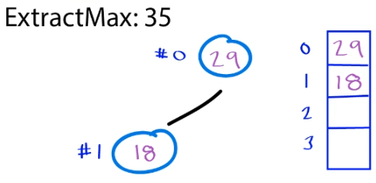 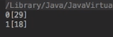

We've now repeated the process 29 is now at the top. 18 is down to the bottom and we can just keep extracting and walking down and this is a really good exercise just to really understand what's going on and seeing what your array is going to look like every time you extract and pop down. In this case after popping off the 29, all we have is 18 and you can see if we just repeat this process we're just going to keep getting smaller smaller smaller until finally pop off 18. And there is nothing left. So that is how we implement the binary heap from scratch.

Now when it comes to the runtime characteristics of the binary heap it's easy to get excited because this is such a cool algorithm. So be careful when you're describing the runtime. When you are describing that killer feature extract Max remember there are two parts to this.

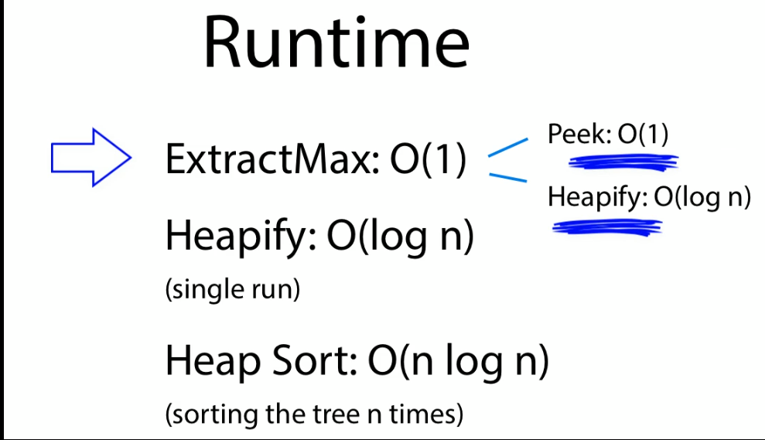

There's the peak which is O(1) that's the killer feature. That's the extremely fast part. That's what makes this thing so special. That's easy to remember. The subtlety is that remember when you extract Max there's also a heapify operation in there which is O(log n).

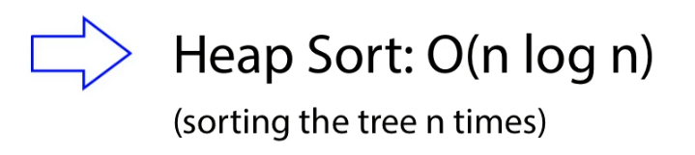

So just remember those two parts. Peak O(1), heapify O(log n) and the rest is pretty easy. if you just remember that heapify every time you go up and down that binary tree in the heap of file operation that's O(log n) for a single run. And then for heapsort that's just going to be n times that so that's O(n log n).

As long as you keep that mental picture in your head you get to be fine. Killer feature O(1) heapifying once, O(n log n) because it is a binary tree. And if you do that n number of times it's O(n log n) And for heapsort. And that's all there is the runtime characteristics of the binary heap.

### For the Interview

In terms of what to know for the interview you've basically seen it all. The main things to remember is really what's the superpower of the binary heap. It's the ability to extract that Max or that min very very quickly O(1) that's what makes this thing so special. After that it's just a matter of remembering that we need to maintain that heap order. When we insert an we want to heapify up in the case of Max and when we extract we're heapifying down.

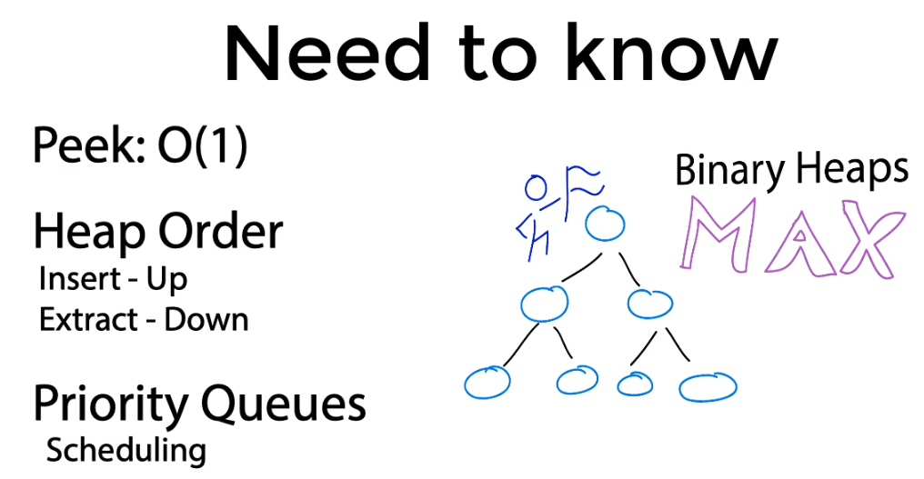

And then just remember what is a binary heap good for, and just associate it anytime you have anything do with priorities, priority queues, scheduling, routing packets, video super important, kernel scheduling, those are all really good implementations of the binary heap. But if you base remember it's really good at extracting Max's it's got super good application for things like priority queues. You're gonna have a good understanding and be able to demonstrate you know how this thing works. Great job everyone. Super super job super great algorithm. Let's keep going.

## AVL and Red Black Trees

### AVL Trees

Here you're going to learn what the AVL tree is how it works and why it's an important concept to understand. If you're working heavily with binary trees. Let's begin. One problem that could occur with binary search trees is they can get skewed.

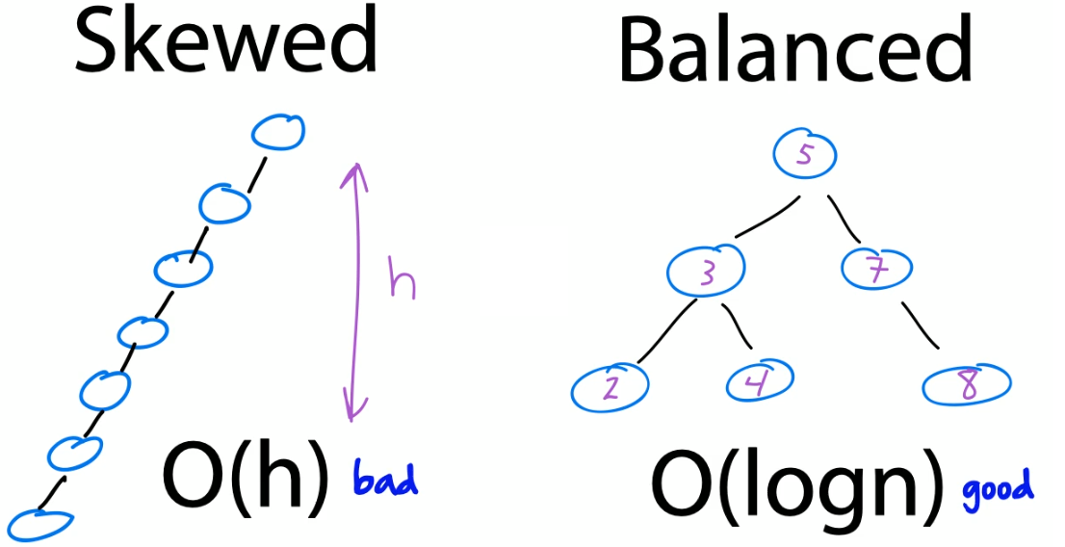

In other words if we get one tree where nodes are heavily attached to either the left or the right hand side, Our searches which should be really fast, can now become really slow, or O(h). In other words, the height of the tree, almost linear. What we really want of course with binary search trees is something more balanced, O(log n). That's good. That's fast. That's why we love binary search trees. Now the AVL tree is a binary search tree with one little tweak. After it does an insert or delete it does one additional step called a rebalance. In other words if it detects that we have a skew or a sub tree greater than one in height it takes it and it rebalances it so that it's flat.

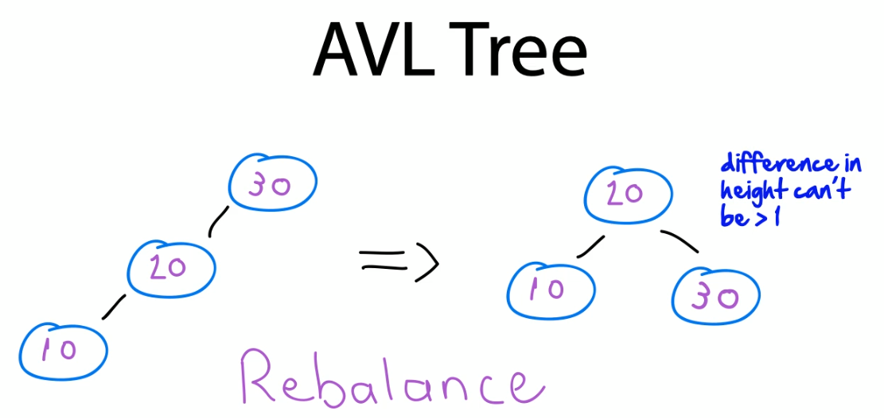

And it just has a nice no difference of height of greater than one. Nice and simple. Now there's four cases we need to be aware of when rebalancing binary trees for AVL we've got something called the left left, right right, the left right, and the right left.

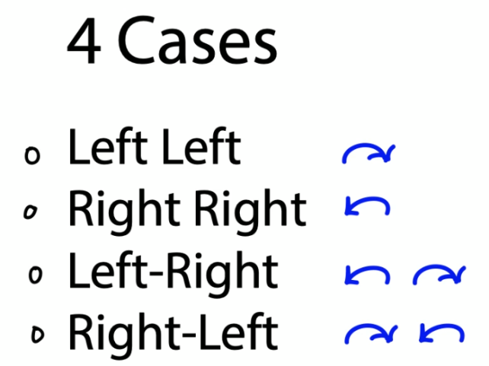

Let's take a look at each of these. So the left left case, here we have a binary tree which is skewed to the left. That's why it's called left left, because there's two nodes to the left and to the left of our parent one. In this case 30. What we do in this case is we rotate to the right and just visualize this as taking that skew and flattening it. We simply take the 20. We bump it up to the top the 10 stays where it is and that 30 which is greater than the 20 rotates down to the right. That's left left.

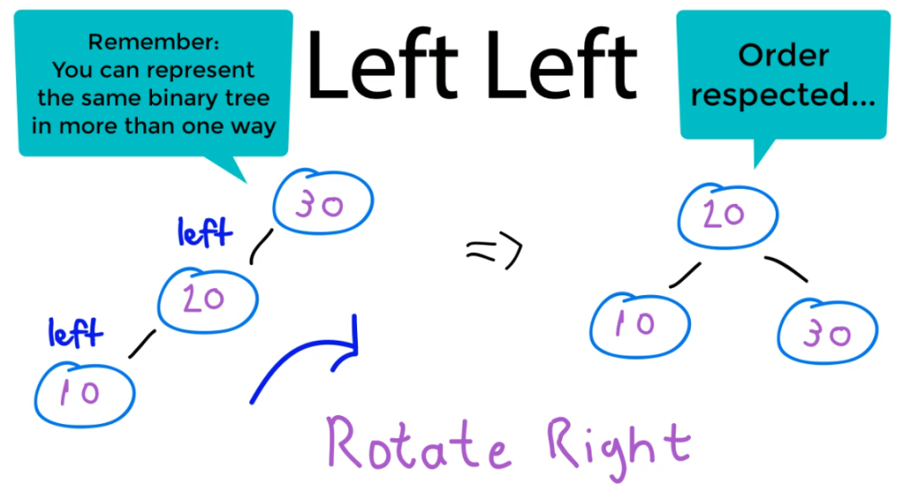

Right, right is exactly the same but opposite here we've got a skew going to the right twice. That's why it's called right. Right. And here we want to take that skew and rotate to the left. In other words just rebalance that tree so that 40 becomes the root. And 30 and 50 hang off that to the left to the right.

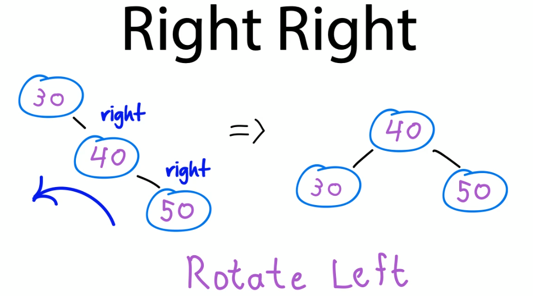

The variations on those left right and right left are exactly the same. Only there a two step process. In the left right case. Here we have a 30, 20, and a 25. To rebalance this first we rotate the left, we stretch it out so that it's skewed left left situation and now we just rotate back to the right and balance it out.

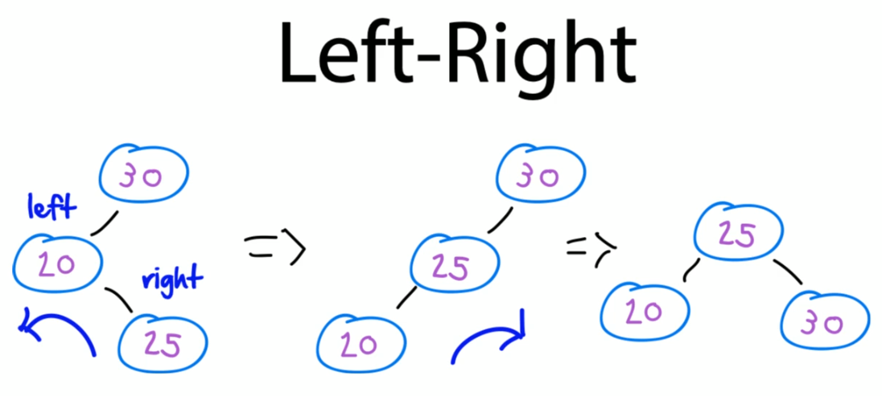

Same thing with the right left. Here we have a right and then left skew. So what we do here is we rotate the right and we flatten it out. Now it's nicely skewed to the right twice and then we just skew it back or rotate to the left and flatten it out.

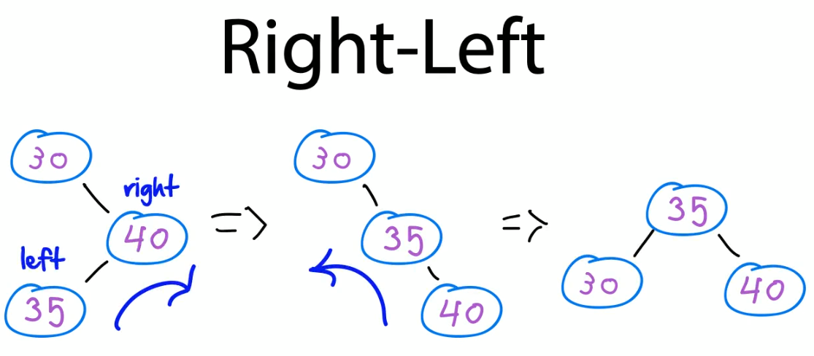

The key to this algorithm is is tracking a couple of additional pieces of information. First we're just gonna do a regular binary tree insert, nothing fancy there, but when we do it we're gonna want to track the height. In other words for each sub tree we want to know what the height is relative to the other sub trees around it. We then we can determine something called the balance factor. And this is the difference in the height between various sub trees. Then we just have to detect each of our four cases and then go in there and do our left and right rotations.

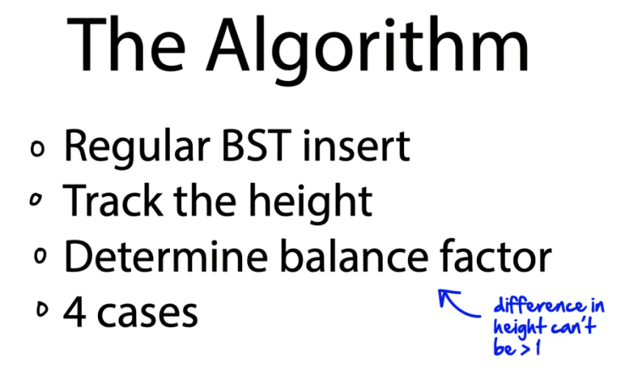

That's it that's all there is to the AVL. Really good thing to understand and know. Let's head into the lab and see how it works.

### AVL Tree in Code

|  |  |
| --- | --- |
| package algorithms;  import org.junit.Assert;  import org.junit.Before;  import org.junit.Test;  public class AVLTreeTest {  private AVLTree avl;  @Before  public void SetUp() {  avl = new AVLTree();  }  @Test  public void **LeftLeft()** {  avl.insert(30);  avl.insert(20);  avl.insert(10);  // avl.printInOrderTraversal();  /*  30  / 20  20 > / \  / 10 30  10  */  }  @Test  public void **RightRight()** {  avl.insert(30);  avl.insert(40);  avl.insert(50);  // avl.printInOrderTraversal();  /*  30  \ 40  40 > / \  \ 30 50  50  */  }  @Test  public void **LeftRight()** {  avl.insert(30);  avl.insert(20);  avl.insert(25);  // avl.printInOrderTraversal();  /*  30 30  / / 25  20 > 25 > / \  \ / 20 30  25 20  */  }  @Test  public void **RightLeft()** {  avl.insert(30);  avl.insert(40);  avl.insert(35);  // avl.printInOrderTraversal();  /*  30 30  \ \ 35  40 > 35 > / \  / \ 30 40  35 40  */  }  }  Now when we actually get into the insertion, this is where all the magic happens. But it's also very similar it's something that we've seen before. When we come in here and do an insert for example when we insert 30 or the very first node into our tree, we start at the route and then here's the actual insertion routine. First we use a regular binary search tree insertion. This is what we've seen before. This is where we take our key, check to see whether we need to go left the right, and then just insert the node. Once we find a null and we're done.  Now after that here's where the AVL kicks in. Next thing we do is we update the height of the ancestor node. So remember we always need to keep track of how high our sub trees are. So here we just take our current height and add the max height which is either gonna be the left or the right that becomes the new height of the current node that we're at. That's how we keep track of height then we get the balance factor. This is where we check and see is our height greater than 1. In other words do we have a skew on either the left or the right hand side and then here's each of our four cases.  Let's take this first one where we go left left. Here we are going to build this binary search tree by going insert 30, 20, and 10. So initially it's going to look like this, but then we're going to do a right rotation and flatten out like this. The key to this algorithm when we go through and we look at the right right case. So here we're going to rotate the right is just keeping this picture in mind.      This is the actual labeling of the algorithm that this particular implementation uses to keep track of what nodes we're at and where we are. In the case of 30, 20, and 10, the Y variable here is gonna be a 30, X is gonna be 20, and the 10 we don't actually care about it can just hang off to the side.  Now watch what happens when we actually do a rotate right. This is all the rotation is it's literally these two lines of code.    It's literally taking the y value and assigning it to the X right hand side. Now this is where we rotate down and if there was a sub tree hanging off that X before now we just hang it to the left of the Y. That's basically it. That's how we do the left left.  We then update our heights and return the node. All right. Let's take a look at. Right right. When we go right right. In this case we have a 30, 40, and 50. We're going to rotate to the left and flatten out like this.    So that's where we come down to this algorithm which is just the exact opposite. And remember now we're just looking at our variables here. They're exactly the same. It's just the Y and the X change now. So now the X is at the top the Y hangs off of it and we have our T2 in our T3.  Here we come in here assign the values and then where the X was. Now we assign that's the Y left. And if we had a T2 hanging off it we assign that the x right and again update the heights and return the new node. | OK so here we are in the AVL tree test and here we've got each of the four cases that we went through in the previous section. We've got our left left, right right, left right, and right left. So here all we're doing is creating our new AVL tree inserting into a binary search search tree just like we did before. But the difference is instead of it looking like this or AVL is going to rebalance it and do that rotation to the right or to the left or to the right and then the left for each of these three cases.  Now let's go take a look at the code in here this is going to look a lot like a binary search tree. We've got our node going to the left and the right. Here's that one additional piece of information we just tracked something called the height and we just start off with the height of one.  package algorithms;  import static java.lang.System.out;  class Node {  int key, height;  Node left, right;  Node(int d) {  key = d;  height = 1;  }  }  class AVLTree {  Node root;  // A utility function to get  // the height of the tree  int **height(Node N)** {  if (N == null)  return 0;  return N.height;  }  // A utility function to get  // maximum of two integers  int **max(int a, int b)** {  return (a > b) ? a : b;  }  // A utility function to right  // rotate subtree rooted with y  // See the diagram given above.  Node **rightRotate(Node y)** {  Node x = y.left;  Node T2 = x.right;  // Perform rotation  x.right = y;  y.left = T2;  // Update heights  y.height = max(height(y.left),  height(y.right)) + 1;  x.height = max(height(x.left),  height(x.right)) + 1;  // Return new root  return x;  }  // A utility function to left rotate  // subtree rooted with x  // See the diagram given above.  Node **leftRotate(Node x)** {  Node y = x.right;  Node T2 = y.left;  // Perform rotation  y.left = x;  x.right = T2;  // Update heights  x.height = max( height(x.left),  height(x.right)) + 1;  y.height = max( height(y.left),  height(y.right)) + 1;  // Return new root  return y;  }  // Get Balance factor of node N  int **getBalance(Node N)** {  if (N == null)  return 0;  return height(N.left) –  height(N.right);  }  void **insert(int key)** {  root = insert(root, key);  }  Node **insert(Node node, int key)** {  /* 1. Perform normal BST insertion */  if (node == null)  return (new Node(key));  if (key < node.key)  node.left = insert(node.left, key);  else if (key > node.key)  node.right =  insert(node.right, key);  else // Duplicate keys not allowed  return node;  /* 2. Update height of this ancestor node */  node.height = 1 +  max( height(node.left),  height(node.right) );  /* 3. Get balance factor of this ancestor  node to check whether this node became  unbalanced */  int balance = getBalance(node);  // If this node becomes unbalanced,  // then there  // are 4 cases Left Left Case  if (balance > 1 && key < node.left.key) {  return rightRotate(node);  }  // Right Right Case  if (balance < -1 && key > node.right.key) {  return leftRotate(node);  }  // Left Right Case  if (balance > 1 && key > node.left.key) {  node.left = leftRotate(node.left);  return rightRotate(node);  }  // Right Left Case  if (balance < -1 && key < node.right.key) {  node.right = rightRotate(node.right);  return leftRotate(node);  }  /* return (unchanged) node pointer */  return node;  }  public void printInOrderTraversal() {  inOrderTraversal(root);  }  private void inOrderTraversal(Node node) {  if (node != null) {  inOrderTraversal(node.left);  out.println(node.key);  inOrderTraversal(node.right);  }  }  }  // Code modified from https://www.geeksforgeeks.org/avl-tree-set-1-insertion/  // See for deletion <https://www.geeksforgeeks.org/avl-tree-set-2-deletion/> |

And that's all there is to this algorithm it's really really beautiful and simple. Look at this case here here's the two complicated cases which really aren't that complicated. For the left right. We simply first of all do a left rotation to flatten it out. In other words get it so it's properly skewed and then we just rotate to the right. And for the right left cases the exact same thing. But here we first rotate the right to get our nice right right skew and then we rotate the left to balance it out. All right let's summarize by looking at what you need to know for the interview.

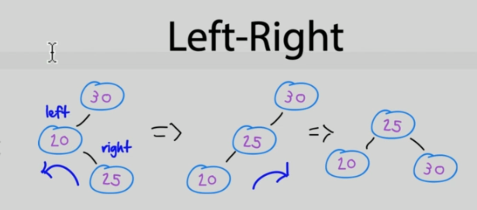 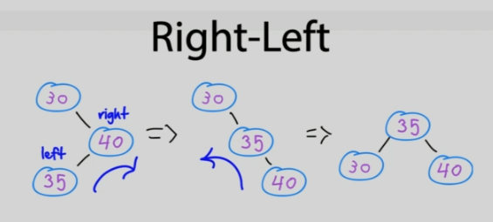

### AVL Delete

AVL Deletion

Deleting a node from an AVL tree is just like deleting from a Binary Search Tree (BST). Only we after deleting we need to rebalance using the same 4 rotations we looked at for the insert.

Also, after we do the rebalance BST at the skewed node, we may repeat the process for any other children until the entire tree is balanced properly.

An example, similar to the one we covered for the insert can be found here:

https://www.geeksforgeeks.org/avl-tree-set-2-deletion/

### For the Interview

OK here's what you need to know for the interview. First of all just know what an AVL tree is. Plain old binary search tree with a few extra bells and whistles.

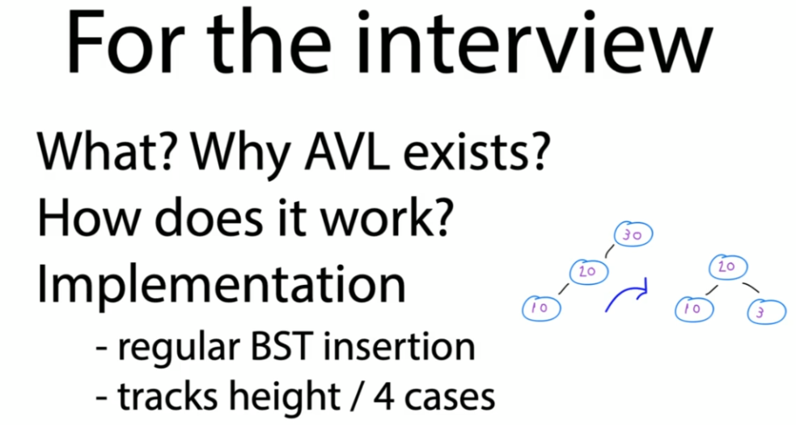

Why does it even exist? To deal with skewing. Binary trees can get out of whack. So just understand it's all about rebalancing and that's what the AVL does. How does it work? You know how it works. It's just a regular binary search tree where after the insert and a lead operation it does some rotations to flatten the skews out.

How does it do this? For the implementation just remember, it tracks the height of each sub tree to figure out if there's a skew either going to the left or right. And then it simply rebalances by checking each of its four cases. I wouldn't worry too much about having to reproduce the ADL entirely in code. But just remember really why it exists, What it's about, that's really going to impress your interviewer. They're gonna know that you've studied these binary search trees. You know what some of the problems with them are. And now you know what one of the techniques is for rebalancing it. The AVL. And if it helps just keep this little image of your mind rotating to the left or the right whenever you have a skew. Oh and just remember everything we did here for the insertion also happens for deletion. It's just the same steps with some slight variations but that's it. That's the AVL tree.

### Red Black Tree

We're going to take a look at another self balancing binary search tree, this was called the Red BlackBerry. In this video, you're going to learn what the red black tree is, how it's different from evil, and an example of how it is used in some of our most modern APIs. All right, let's begin. Red, black. He solves the same problem as the one we were solving in Abbeville, which is how do you deal with binary tree skewing? It's just like the evil which does rotation. Every time a tree gets out of whack, a red black will something slightly different.

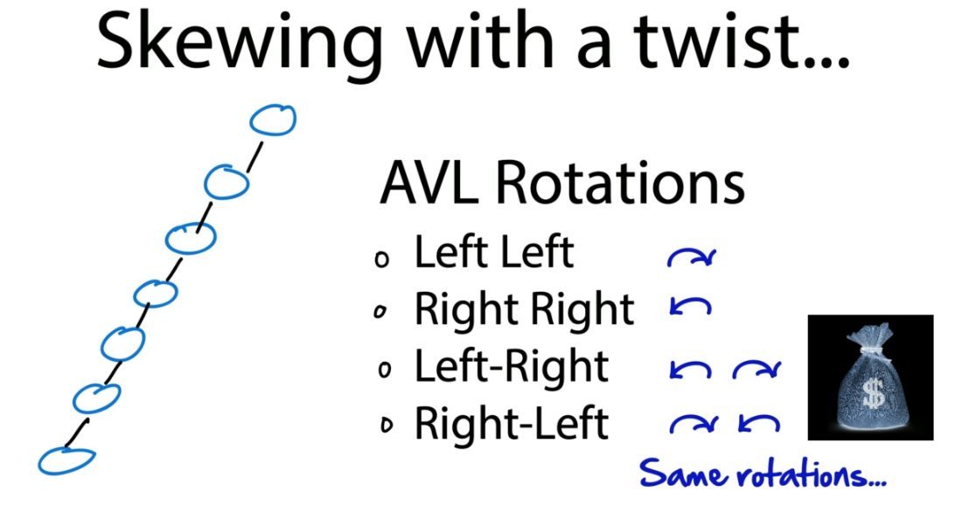

It will put up with a little imbalance in the name of performance is the apple trees are great at keeping beasties balanced, but they do that the cost of rotating every single time that she gets out of whack. For example, whenever you do an insert or delete and if you're bad, he needs to do a lot of inserts and deletes. This can start to affect performance. And this is where the red black tree comes in instead of rotating every time it rotates, occasionally saving a few processing cycles at the expense of a mostly but not completely balanced tree.

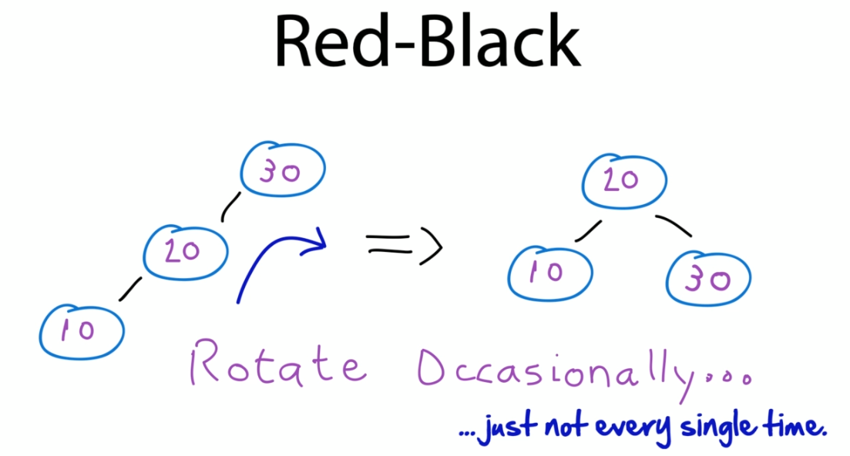

Let's take a look and see how the algorithm works. For all intents and purposes, red, black beast. He really is a variance very similar to the apple tree. It still rotates using our four basic cases when things get out of whack. But the one difference is that in addition to that mechanic of rotating, it has one more one called coloring, and it uses that to choose when and when not to rebalance a tree.

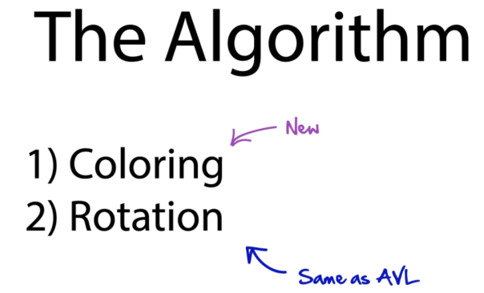

Let's look at example now and see how this works. For example, here's the same binary tree represents in two different ways, one is an evil and one is red black. Watch what happens when we add a five to each of these trees. If we had a five to the spider tree, it should trickle down and be inserted here, which if we do that to the red BlackBerry, it takes that five comes on down and puts it there just as we'd expect it changes its colouring. And note it doesn't do a rotation. This is a skew here, we could rotate this right, but it doesn't, and that's the difference between the red BlackBerry and the Apple Watch. What happens now if we insert a five over here, it's going to come down to AVL, see that it's skewed, do a rotation and bang it changes the tree.

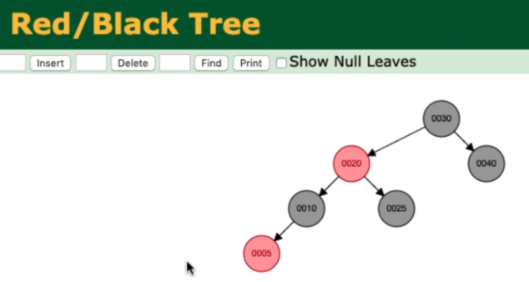

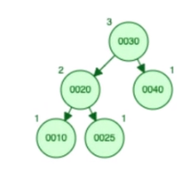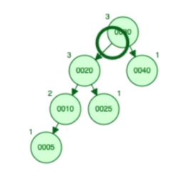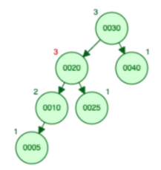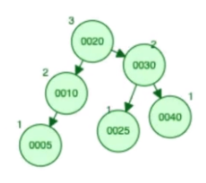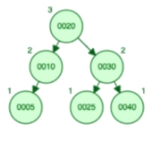

That's the difference between the red black and the Daltry. AVL will always want to balance and deal with any SKU, no matter how small. As soon as it sees a difference of one, it rotates red. Black says, you know what, I'm not going to rotate in that case. I'm going to put up with a little bit of skew in here. But in the name of efficiency, I'm going to save rotation. That's the difference between the red black and the evil.

Other than that, they're pretty much the same. Let's take a look under the hood now and see how this works. When it comes to coloring, there's some basic rules of the red BlackBerry, follow us. First off, every note is either red or black. Root of the tree is always black. No two adjacent nodes can be read, that's between the parent and the child, and every path from top to bottom has to have the same number of black nodes.

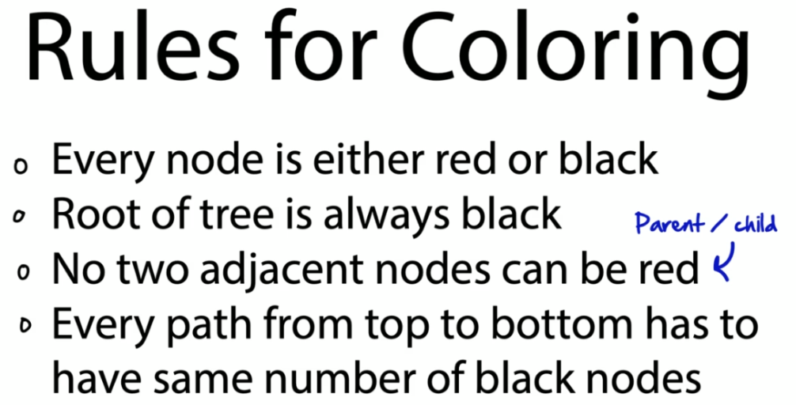

The pseudocode for the algorithm looks like this.

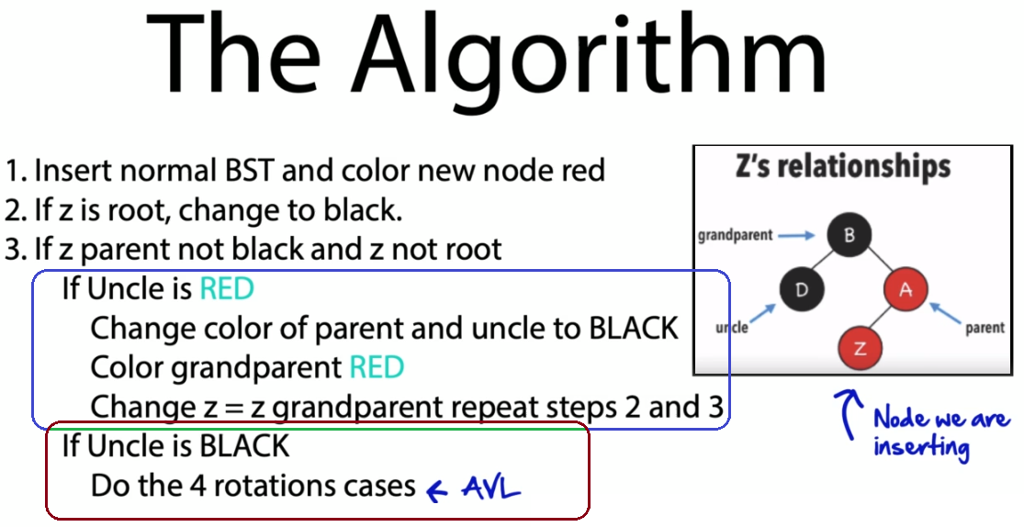

First, just like AVL, you insert a normal BST Node, just like you would any other, only when you do you color that new node red. If Z, the node we are adding is the the root, we change it to black. If Z parent is not black and that is not the root. And if it's uncle is red, it's uncle buying this one up into the left. Then we do a color change here. We change the color appearance of the uncle to black. We change the grandparents red, we change that to equal the grandparent and then repeat steps two and three. That's the only difference between red, black and the evil. If the uncle is red, we do our color and we don't rotate in the event the uncles black. Then we do our standard forecast case rotation with the left, left, right, right, right, left and left, right, standard AVL stuff.

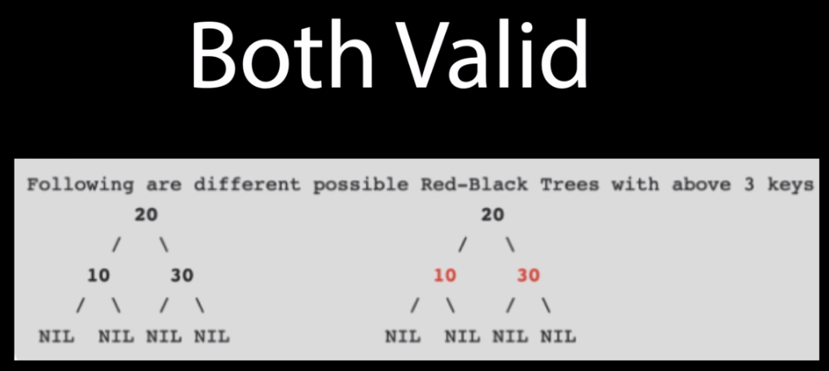

Now it is possible to have a completely black tree or one that is black with two red subgoals like this. So I don't think that just because it is red black, you always need to alternate. These are both completely valid. But in a nutshell, the red black tree is very similar to the AVL.

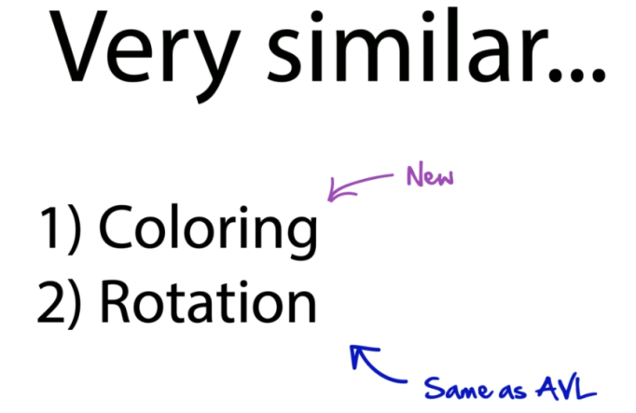

It just has this new Makana for coloring, but it still does all the standard rotations behind the scenes. Certainly you think red. Black, you can definitely think AVL, but not rotating quite as much. And that's the algorithm in a nutshell. Now, with your understanding of that, let's switch gears and try a sample interview question one that may come up in your interview about the differences between evil and red black.

Questions

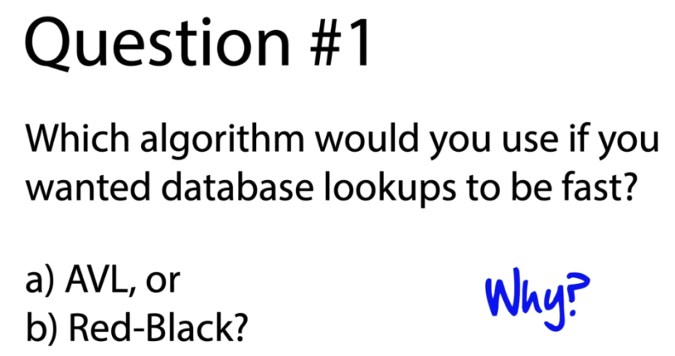

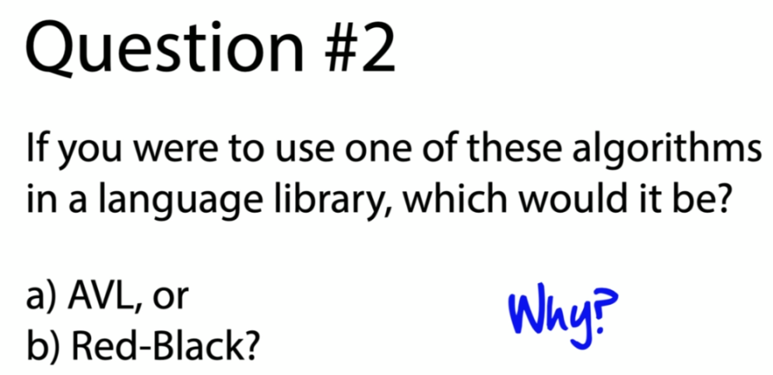

That very first question is a bit of a trick question. The one at the database is because if you naively have been listening then you simply chose red black because you heard it was more performance. You'd be wrong. AVL is actually the better choice for database lookups because it keeps the BST more balanced. Reading from a database is all about optimal balance and because red blacks leave the BST slightly skewed, it would perform worse than a perfectly balanced tree, one more like the AVL. So AVL is the answer here.

Now what about the language library? This one's more straightforward for language libraries where you're doing a lot of inserts and deletes into data. Red black is the way to go. It simply is more performance. And that color instead remember that's the thing that saves the rotating. So when you're explaining why you can say it well Red Black doesn't rotate as much because it uses a coloring scheme to determine when it can and can't skip that rotation. That's where the savings come in. So here Red Black is the way to go. Which is why you generally see AVLs used more in databases and red black in language libraries like the Java tree map.

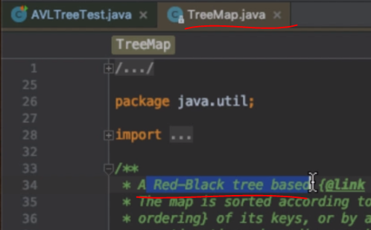 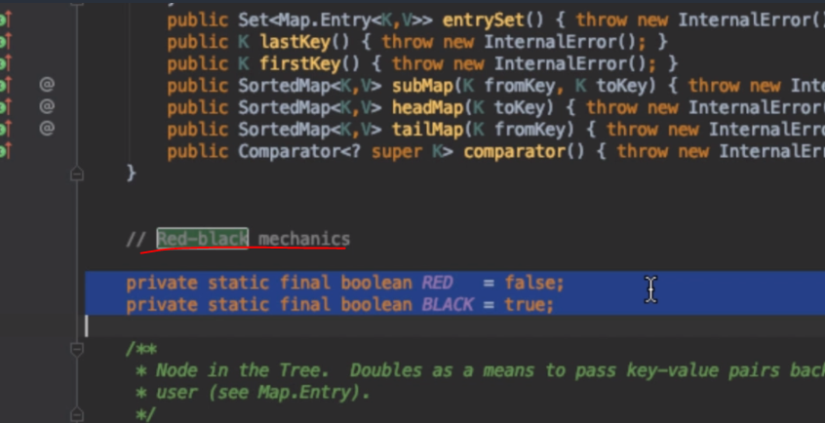

If we create a Java tree map and we go take a look at implementation we'll see that this is really a red black tree based implementation of a language library used within Java. If we go in here and look for the words Red Black, well we can see that this is used and mentioned in several places. You can see the mechanics of where red and black are used in the source code. If we do a search for the word black we'll see that down here in certain implementations.

This is where it does its colouring after it's fixed for deletion. It will look and color certain nodes red and black and this is a concrete implementation of how Java uses the red black tree to rebalance a tree map in this case. But at the expense of not being perfectly balanced. And if you really want to impress your interviewer just remember that red black is used in an algorithm in Java. In this case the tree map and that'll demonstrate that really understand what's going on here and you are aware of some new implementations of how these things are actually used.

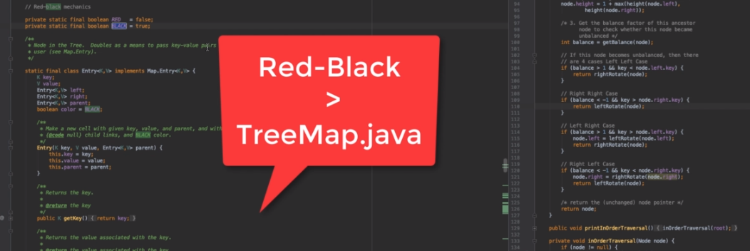

OK so just wrap this section up. What you need to know for the interview. Remember that red black is a self balancing binary search tree. It is more performance than the AVL. You want to use red black when you've got a lot of inserts and deletes going on. Think language libraries here. That's a really good case for when Red Black makes sense. Just like that Java tree map. Otherwise favor AVL. Remember it perfectly balanced things out. It's better for places like databases that need to be able to read really quick but other than that they're very similar algorithms. One just punts on rotations in the favor of a coloring scheme while the other one, the AVL, rotates every time. And that's it. That's all you need to know for AVL and red black binary search trees.

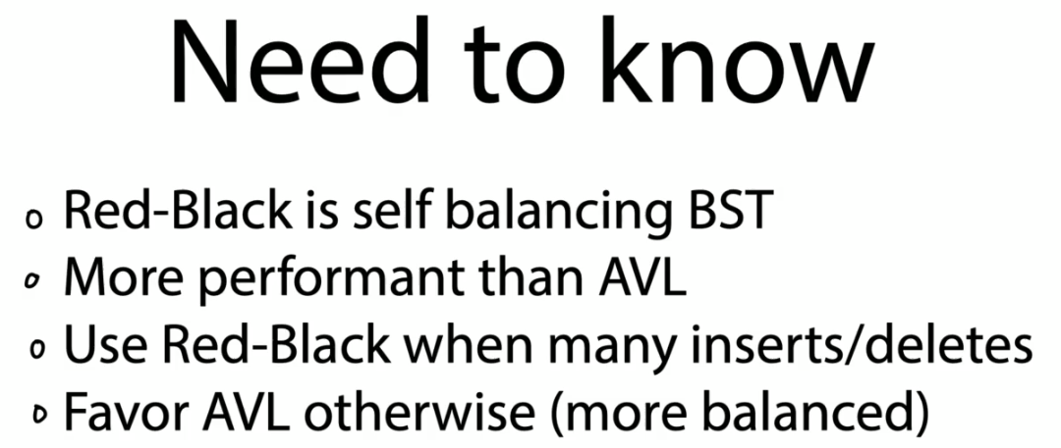

Oh good I'm so glad you're here because Houston we've got a problem. Our stock predictor program doesn't work. I mean it works but it's just too slow. The boss is asking for a thousand fold increase in algorithmic efficiency. We need to really make this thing hum. And the only way to do that is to take this thing called the Fibonacci series and make it really really fast.

Do you think you can help us? In this section.

we're going look at a super powerful technique called memoization and how we can use it to take something like a Fibonacci series and make it super super fast. Buckle your seatbelts. Stay tuned. Let's start by diving in and learning about this thing called the Fibonacci series.

## Fibonacci Series and Memonization





The Fibonacci series comes up a lot in interviews because it combines so many powerful techniques including recursion. It's a great example this thing we're going to look at called memoization. So it's really good to understand what a Fibonacci series is and how it works. Mathematically The Fibonacci series is just a series of numbers governed by this equation. f(n) = f(n-1) + f(n-2)

And believe it or not this sequence shows up in some pretty interesting places. I mean Romans used this when they were tiling their floors to make these things look very pretty and have certain natural artistic designs. And the Fibonacci series actually occurs a lot throughout nature in the forms of shells spirals and galaxies.

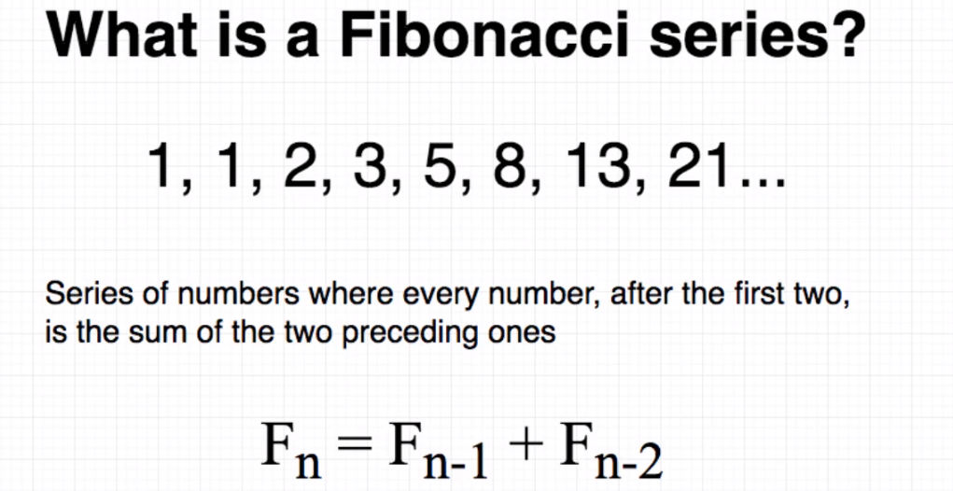

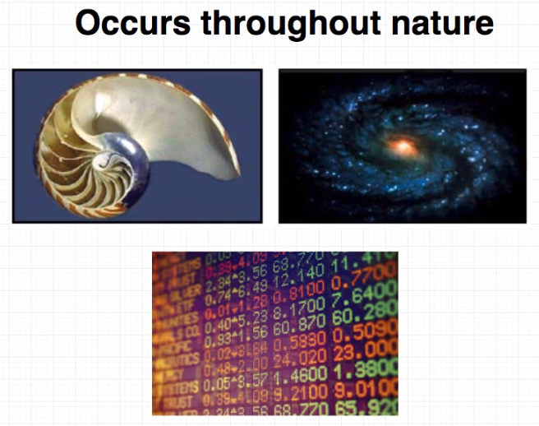

And in this case the startup wants to use it to help make some stock predictions. Now in code the Fibonacci series looks like this and this is actually worth memorizing because it comes up so often. It's basically just taking two numbers with the examples of 0 and 1 they're a bit special. When you have fib 0 and fib 1 you just return them. But after that the heart of the algorithm is really just this line here.

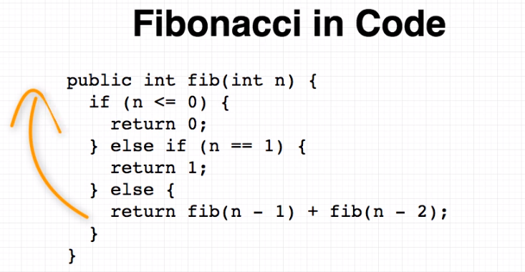

Return fib N minus one plus fib and minus two. Remember that. That is the heart of this algorithm. And as you can see it uses recursion. That's the beauty of this algorithm whenever people ask for simple of example recursion of course you around the binary tree that is simple and beautiful. But the Fibonacci series is another great example. And in here it's this code that produces a sequence of numbers. Now the Fibonacci series is great.

It's just got one problem as you calculate higher and higher order numbers the algorithm itself takes longer and longer to compute for example just run it on a Mac. Calculating fib 30 takes about 19 seconds of my machine. And the reason for that is as the size of the series grows the amount of time it takes to grow exponentially. And we call this O(2^n).

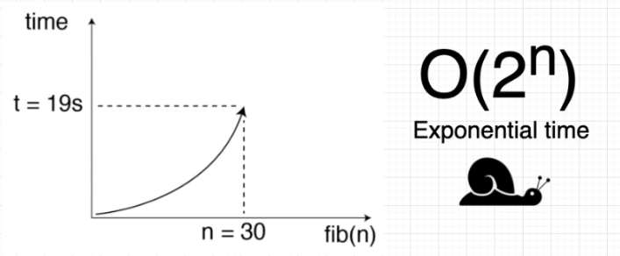

In other words this is a very very expensive calculation in its current form. What the startup's looking for and what we need to do is somehow figure out how can we take this expensive operation called Fibonacci and make it really really fast. And that's where the super powerful technique comes in that you totally want to know and understand which is called memorization.

### What's memoization and how can it help?

To understand memoization it helps to take a look at what the problem with the Fibonacci series is. Let's let's just take a look here. Here we calculate something, a simple number up to Fab Five. This is the number of times each Fibonacci series numbers calculated. Fib one is calculated five times. Fib 2 3. Fib 3 2. And for these very very small numbers that's not a big deal.

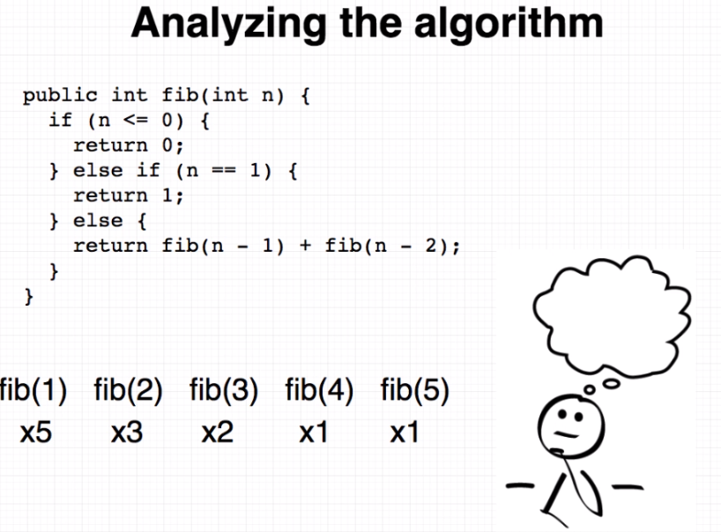

Fib 1 we calculate instantly because we just come in and return. But as we go up higher and as we calculate higher order numbers you could see that these numbers that are recalculated over and over again that starts to be really expensive. This is where the Fibonacci series in this current form breaks down for higher order numbers. It just takes longer and longer and longer.

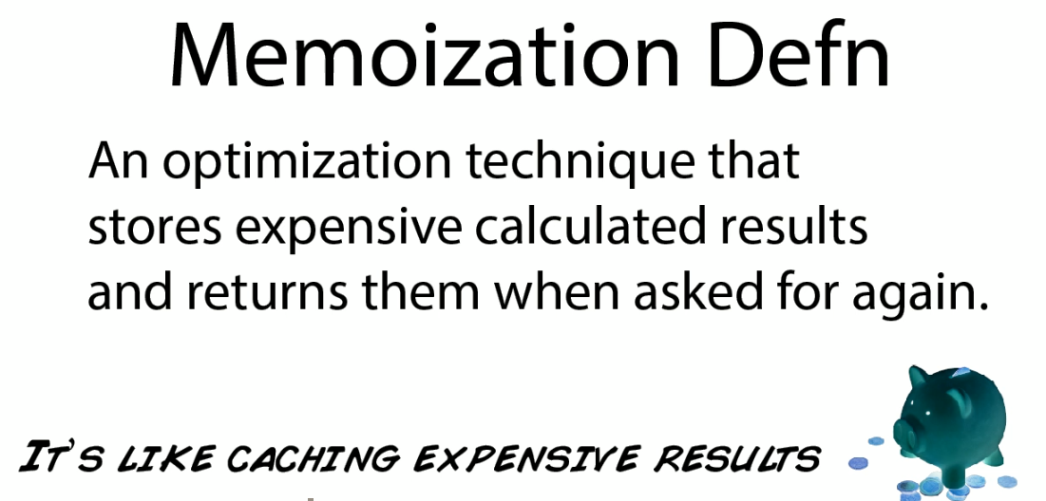

What memoization is, is it's an optimization technique for speeding up computer algorithms by basically caching or storing the calculator results and using them in future calculations. Take our Fibonacci series here. Look what we can do if we want to store or save previously calculated numbers. We can create an array, call it something simple like Memo and in this case as we go through, and as we calculate each Fibonacci series number, we can store the result in this line here.

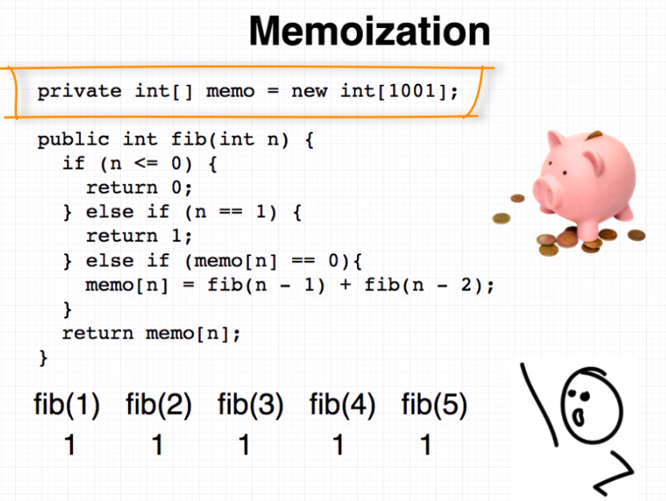

Using the number of the Fibonacci series as an index, we can just take the result of Fib(n-1) + fib (n-2) and store it in that array and then return it. So the next time we come around we can just simply look up the number and return it without having to calculate it over and over again. This leads to a huge increase in efficiency. Now in the space of 19 seconds instead of going up to a Fibonacci series of 30 we can actually go up to a thousand. That's a three thousand three hundred thirty three percent increase. And that's huge.

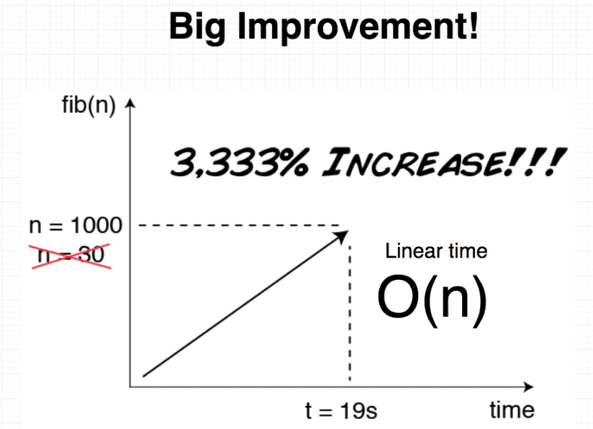

And now we've taken something that was exponential, O(2^n) and made it linear, O(n). That's the power of memoization and that's why this is such a great example and great interview question because it combines so many things. You take something like a Fibonacci series which talks about recursion you show how to take a very expensive algorithm and make it fast with memorization. And that's the beauty of knowing and understanding what a Fibonacci series is and how memoization can make it really really fast.

### Lab: How to build a memoized Fibonacci series from scratch

As far as the code goes, here's a simple test harness that shows two implementations for the Fibonacci series. One is the naive implementation, or the Fibonacci series in its raw form. excuse me. And the other one is the memorized form. That's the one with the optimization in it. And basically you know that the interesting thing here is just to look at and simply compare the two series.

|  |  |
| --- | --- |
| public class FibonacciNaive {  public int fib(int n) {  System.out.println("Start fib("  + n + ")");  if (n <= 0) {  return 0;  } else if (n == 1) {  return 1;  } else {  return fib(n - 1) + fib(n - 2);  }  }  } | package algorithms;  public class FibonacciMemoized {  private int[] memo = new int[1001];  public int fib(int n) {  System.out.println("n = " + n);  if (n <= 0) {  return 0;  } else if (n == 1) {  return 1;  } else if (memo[n] == 0){  memo[n] = fib(n - 1)  + fib(n - 2);  }  return memo[n];  }  } |

So on the left hand side here we can see this is what the Fibonacci series naïve looks like. It just simply is that code that we saw. This is really the line here just returned. fib(n-1) fib(n-2). And if we flip over to the Fibonacci memorized it's very similar only here we have an array that stores our values as we calculate them.

And here you can see here is how we retrieve them. Basically if we don't have anything stored in that line we just come down, calculate it, and then return it basically once that's set. And that's what gives us our super super increase in productivity. So two really good algorithms to know for your interview. Do check these out. Memorize them if you can.

At least the Fibonacci series and be able to explain how you'd memorize it. And that's going to be a really good example to basically demonstrate recursion, Fibonacci series, and memoization. All wrapped up in one.

package algorithms;

import org.junit.Assert;

import org.junit.Before;

import org.junit.Test;

public class FibonacciTest {

private FibonacciNaive naive;

private FibonacciMemoized memo;

@Before

public void SetUp() {

naive = new FibonacciNaive();

memo = new FibonacciMemoized();

}

@Test

public void Naive() {

Assert.assertEquals(0, naive.fib(0));

Assert.assertEquals(1, naive.fib(1));

Assert.assertEquals(1, naive.fib(2));

Assert.assertEquals(2, naive.fib(3));

Assert.assertEquals(3, naive.fib(4));

Assert.assertEquals(5, naive.fib(5));

Assert.assertEquals(8, naive.fib(6));

Assert.assertEquals(13, naive.fib(7));

Assert.assertEquals(21, naive.fib(8));

}

@Test

public void Memoized() {

Assert.assertEquals(0, memo.fib(0));

Assert.assertEquals(1, memo.fib(1));

Assert.assertEquals(1, memo.fib(2));

Assert.assertEquals(2, memo.fib(3));

Assert.assertEquals(3, memo.fib(4));

Assert.assertEquals(5, memo.fib(5));

Assert.assertEquals(8, memo.fib(6));

Assert.assertEquals(13, memo.fib(7));

Assert.assertEquals(21, memo.fib(8));

}

@Test

public void RecordTimeNaive() {

long startTime = System.currentTimeMillis();

naive.fib(30);

long endTime = System.currentTimeMillis();

long elapsedTime = (endTime - startTime) / 1000;

System.out.println("elapsedTime = " + elapsedTime); // 19s

}

@Test

public void RecordTimeMemoized() {

long startTime = System.currentTimeMillis();

memo.fib(1000);

long endTime = System.currentTimeMillis();

long elapsedTime = (endTime - startTime) / 1000;

System.out.println("elapsedTime = " + elapsedTime); // 20s

}

}

### Lab: Real Life Recursion

Before we leave the world of memorization I thought it'd be good to share with you a real life example of where I was actually able to use recursion at work. This is the problem I faced here. I'm building an application for a video company and the backend returns a list of channels. Now unfortunately these channels sometimes come padded with zeros.

So instead of getting just channel 1 I would get Channel 0 0 0 1 and sometimes instead of 11 I'd get 0 0 followed by 1 1 representing Channel Eleven and so on and so on. And sometimes I just needed to treat plain strings as plain strings. Now the first time I solved this problem I just stripped out the zeros using Java's built in string routines but eventually came across a case where I had forgotten a number of zeros.

The pattern was a lot larger than I thought it was. And it occurred to me this is an example of where we could use recursion. So for fun. What I'd like you to try to do is to see if you could write a recursive algorithm to strip off the zeros from these strings one at a time. These are the cases you should be able to handle simply strip off 1 0 and then call yourself recursively using this function over here. I've stubbed that out here.

I've just called it strip zeros but basically we should be able to pass in some text, strip off one 0 and then call ourselves over and over again until we're left with nothing. And then we can simply return the string. Give this a try. See what it feels like to write a recursive method and come back and we'll do the solution together.

import org.junit.Assert;

import org.junit.Before;

import org.junit.Test;

public class RecrusionTest {

private Recursion recursion;

@Before

public void SetUp() {

recursion = new Recursion();

}

/*

Channel formatter

Write a recursive algorithm that strips the leading zeros off Strings of text.

Simply strip off one zero at a time, and then recursively call yourself

until no leading zeros from the original string are left.

*/

@Test

public void StripLeadingZeros() {

Assert.assertEquals("1", recursion.stripZeros("0001"));

Assert.assertEquals("11", recursion.stripZeros("00011"));

Assert.assertEquals("1989", recursion.stripZeros("00001989"));

Assert.assertEquals("VOD", recursion.stripZeros("VOD"));

}

}

OK so how did that go? Don't worry if recursion seems a bit strange at first. It is. You're writing a function and then you're calling yourself with results from a previous calculation. And at first it can look really strange but it's really neat once you see it in action. And this is a perfect example. Let's take a look at the solution I came up with. Let's start with a case of zero zero zero followed by two ones and let's pass that. To make this recursive and strip off one zero at a time. The first thing we can do is check to see does the string start with zero. And if it does strip it off.

|  |  |
| --- | --- |
| public class Recursion {  public String stripZeros(String text) {  if (text.startsWith("0")) {  String substring = text.substring(1);  String newString = stripZeros(substring);  return newString;  }  return text; // nothing left to strip. Return!  }  } |  |

Now we're left with the substring of just two zeros followed by two ones. This is where the recursion takes place. We can now call ourselves again passing in that substring which has one less zero and repeat the process. We come in again. Does the string start with 0. Yes it does.

We can strip it off get a new substring of just 0 1 1 and repeat the process again. And we do this over and over again until we get down to a string that has no 0 in front. And at that point we know we've got a stripped case. There's nothing left to strip.

So here we can return it going back up our stack until we finally return the result that we got. Way down at the bottom are 1 1 and that's how it works. That's all there is to recursion.

It's a really beautiful simple example of where we can subsequently strip off zeros call ourselves over and over again. And it's really nice and elegant. And just to show you how elegant this can be we can refactor this even further, in lining some of these calls, and simply returning the result that comes at the end of all the calculations. So it looks something just like this.

A nice simple algorithm recursively calling itself and stripping off the zeros. OK good stuff everyone we'll see you in the next section.

### What you need to know for Interview?

All right here's what you need to know for the interview. Even though this is a very short little series just understand two important concepts here. First of all the Fibonacci series. Just know this equation adds to Fn-1 + Fn-2 to understand it's recursive. Just just generally know this. And then memoization This is of course a great optimization technique. This is handy not just for Fibonacci series, but for anything that has an expensive calculation that can be stored, and cached and used in a future result. That's the power of memoization. It's used for all sorts of things Fibonacci series is a great example. When it comes to the actual interview, I have heard people actually been asked to reproduce a Fibonacci series.

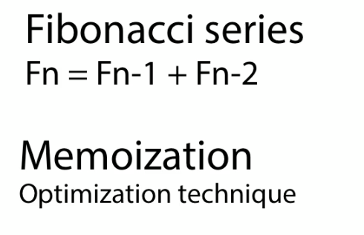 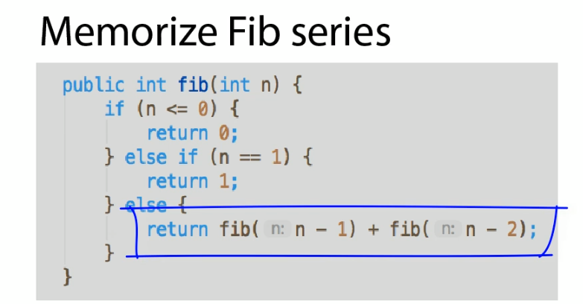

So I think this is a great thing to memorize. It's not a huge algorithm. It really comes down to this one line and these two cases of n=0 and 1 But my advice is just to memorize this series because it demonstrates so many great things like recursion in that. And then once you've got that it's a very simple transition into a memoized example where you can demonstrate not only that you know how to take an expensive algorithm and show a concept how to make it more efficient, but you know the term for this, you know it's called memoization, and you know you throw out in many different places in computer science. So know these for the interview and you're going to do really good on this section.

## Sorting Algorithms

### What is the Bubble Sort?

What is the most efficient way to sort a million 32 bit integers? It may seem hypothetical but yes Google does ask these types of questions as you just saw in interviews. And in this section we're going to go over the top three sorting algorithms you'll need to know for your interview if you ever want to interview with someone like Google. Here we're going to cover the **bubble sort**, the **merge sort**, and the granddaddy of them all, the **quicksort**.



Let's jump in to the simplest one of them all first the bubble sort. Bubbles was kind of a neat sorting algorithm because what it does is really finds the highest number in the array through several passes and it keeps bubbling it up.

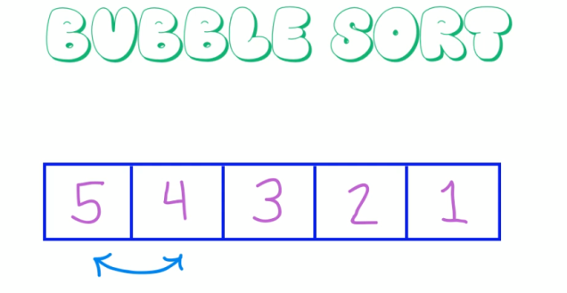

Take a look at this example here if got five four three two one. This is not sort of this is an exact opposite order. We want to actually want that five in the right hand side. And let's just apply the bubble sort algorithm and see how that works here. What we do is we start at the very bottom of our group without five and the four. What do is we're going to start with a five in the four and we're going to comparatively compare the five with each number and kind of bubble it up. So first we'll compare five of four five is greater than four so we'll swap then we'll compare five with three five is greater than three then we'll swap and we'll compare five with two. Five is greater than two then we'll swap. And finally we get to the very end. Five is greater than one.

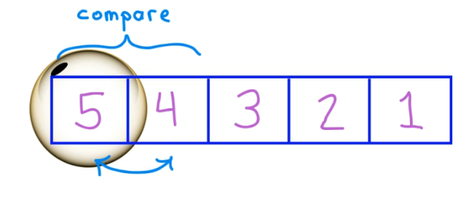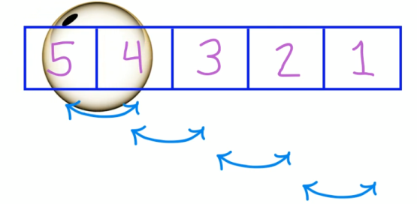

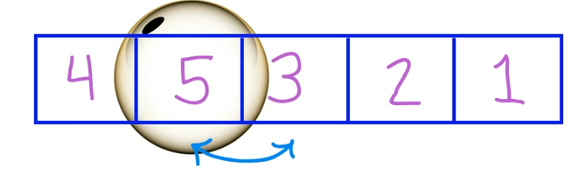 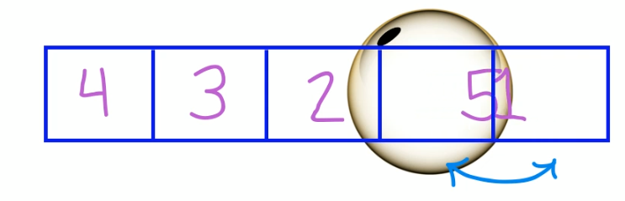

So we will swap and then we lock in that five at the very end. And that is one pass through the bubble sort.

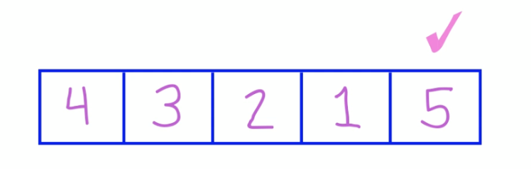

Now we are effectively locked in. We're guaranteed to have the highest number on the right hand side here. Now we just repeat the process with the remaining numbers. So now we've got four three two one and we start again. We go four compared to three. That's bigger. Swap. Four compared to two. It's bigger. Swap. Four compared to one that's bigger swap. And we lock in the four. Now we've got the four in the five and we just repeat this process again. We're left with three to one and we just repeat three to two swap three to one swap. Now we've locked in the three then we're left with two and one two to one swap and then we finally have our sorted array.

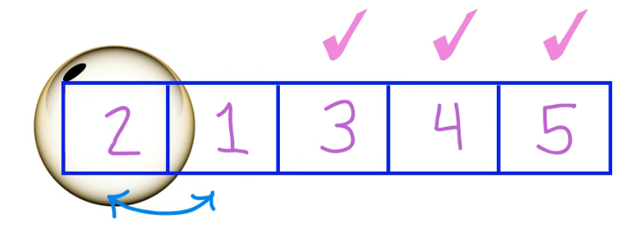

So that's bubble sort. It's just progressively taking the highest number it can find in the array and bubbling up to the top and locking it in. Next let's see what it looks like in code.

### Bubble Sort in code

Bubble sorting code is literally this. It's two for loops. You've got a for loop that starts on the outside to keep track of us and doing our progressive sweeps through and then we've got another pointer for that. J which we just used to keep comparing two consecutive numbers but between each other and if one number is larger than another we swap. And this is the swap here where we just temporarily copy the value of one into a holding variable and then swap and set the two variables there.

|  |  |
| --- | --- |
| public class BubbleSort {  public int[] sort(int arr[])  {  int n = arr.length;  for (int i = 0; i < n-1; i++) {  for (int j = 0; j < n-i-1; j++) {  if (arr[j] > arr[j+1]) {  // swap temp and arr[i]  int temp = arr[j];  arr[j] = arr[j+1];  arr[j+1] = temp;  }  }  }  return arr;  }  } |  |

import org.junit.Assert;

import org.junit.Before;

import org.junit.Test;

public class BubbleSortTest {

private BubbleSort bubbleSort;

@Before

public void SetUp() {

bubbleSort = new BubbleSort();

}

@Test

public void Sort() {

int[] array = {5, 1, 4, 2, 8};

int[] sorted = bubbleSort.sort(array);

Assert.assertEquals(1, sorted[0]);

Assert.assertEquals(2, sorted[1]);

Assert.assertEquals(4, sorted[2]);

Assert.assertEquals(5, sorted[3]);

Assert.assertEquals(8, sorted[4]);

}

}

That's literally all there is to bubble sort. It's that simple and it's really just when you hear bubble sort just think two loops, progressive sweeps, and you don't have to about memorizing this. I mean if there's one thing you do want to memorize Maybe it's just understand that it's basically just a two sweep of an internal for loop one within within one another and that's all there really is to the bubble sort. Next I want to see if you can describe what the runtime of this would be.

### Runtime Characteristics of Bubble Sort

Now if I was to ask you in an interview what the runtime characteristics were of the bubble sort What would you say? Here's the algorithm. You can see that it got two for loops and hopefully you've covered the Big-O notation section before but just take this as an opportunity to do a practice run and pretend this is an interview question what would you say the runtime characteristics are for the bubble sort. Hit the pause button will come back shortly and we'll take a look at the answer. OK how did that go. Do you remember from our cheat sheet how we could look at the runtime characteristics and how we would break this down?

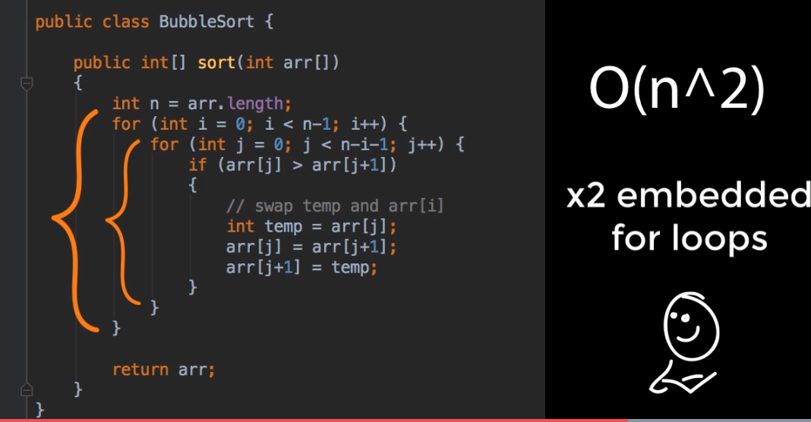

Well if you take a look here, what do we see? We've got one for loop here and another for loop there. Note they are also embedded within another. That's what we call O(n^2). Remember? 2 for loops one in bed with one another? That's the runtime characteristic of the bubble sort. It's O(n^2). Not the fastest thing on the planet but it'll get the job done. It's also the simplest and easiest to understand. But that's the bubble sort. Let's now shift gears and take a look at another sorting algorithm. This one called the merge sort.

### Merge Sort

Merge sort is a divide and conquer algorithm and the way it works is with this crucial step called the merge step where really what we're doing is we're combining the final two arrays that we're going to have at some point in our algorithm and we just need to combine these two arrays into one. And there's this merge step which is really the crux of the algorithm. So let's study this first and then look at the rest of the algorithm after.

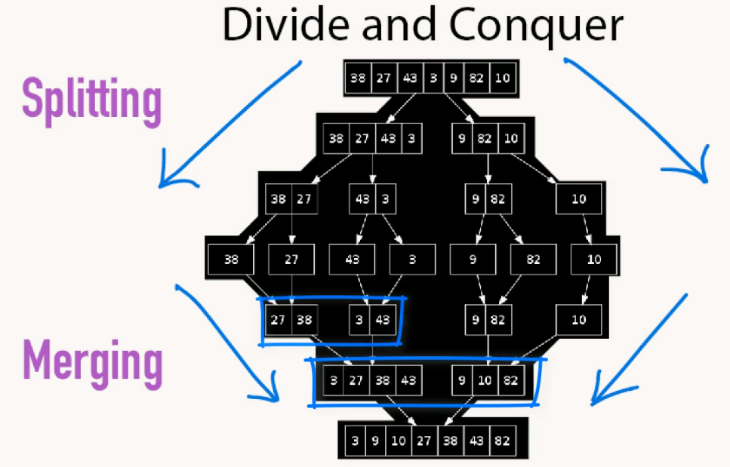

The way the merge step works is it's continuously combining two smaller sorted arrays into one larger one starting on the left. We take the smaller of the two elements there. So here we compare four to one. One being smaller than four. We take the one and then increment its pointer to the right that would repeat this comparison. Now we compare four to three. Three being the smaller. We'll bring a three down, move the pointer to the right and now we'll compare four and nine. In this case four is the larger one that's going to be the four down and increment it's pointer to the right. And now we compare 7 and 9.

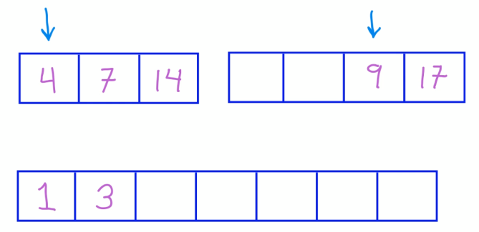 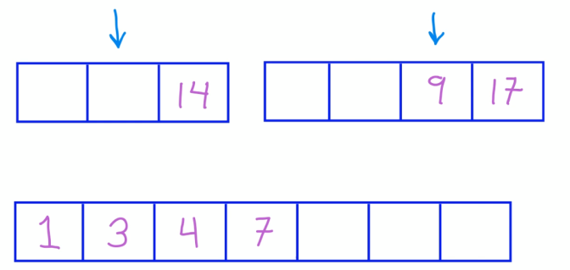

7 is the smaller. So we'll bring it down. Increment it's pointer. Now we'll compare 14 to 9. Nine is the smaller. We'll bring it down. Until finally we are left with 14 compared to 17. 14 is the smaller. We'll bring it down. And finally we're just left with the 17. Now that's really the crux of the algorithm. This merge sort step here. But before the merge sort can do this merging, it first needs to take that array and break it up into a certain kind of format.

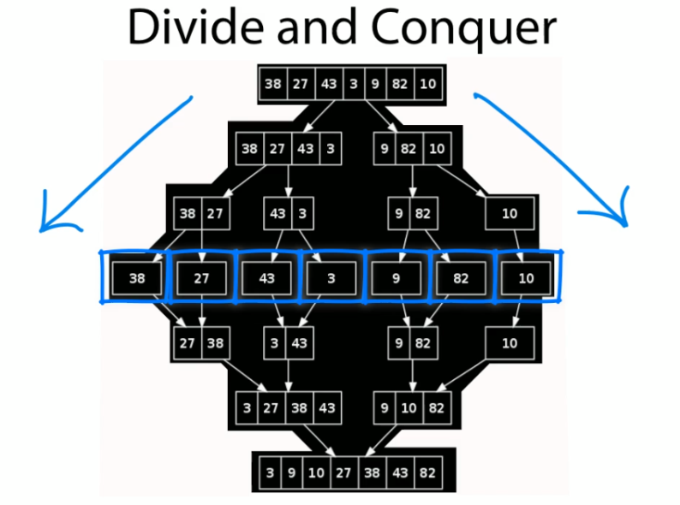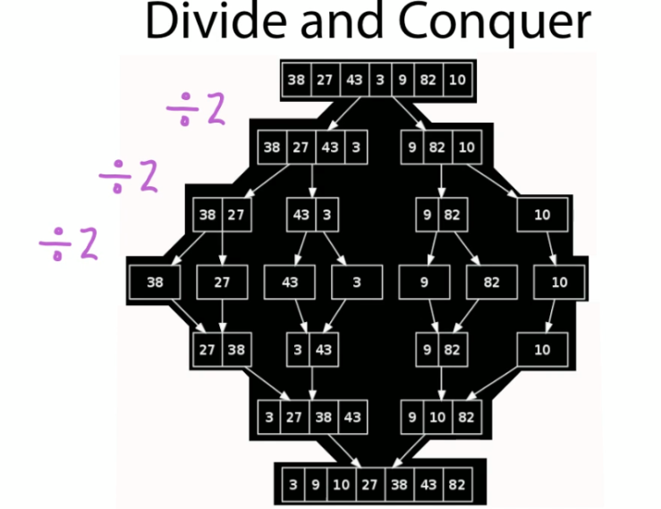

Let's see how the merge sort splits the array up now When a merge sort algorithm is given an array, the first thing it does is it takes that array and it splits it up into its constituent smallest parts. So it takes each element of that array and creates an array of itself basically by continuously dividing over and over again usually dividing by two until it gets that array down to its smallest elements of individual numbers in the array. Step one that's the splitting phase. Then the second phase is the one we just looked at where it takes the smallest elements. or those individual elements of the array and continuously recombines them using that merge sort algorithm. So you can see here starting with 38 and 27 it would compare and merge those to have 27 38.

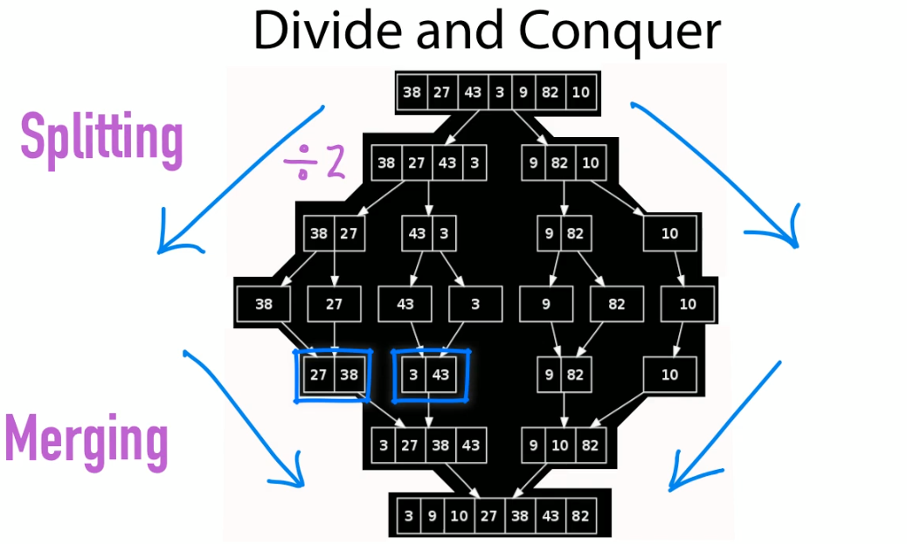

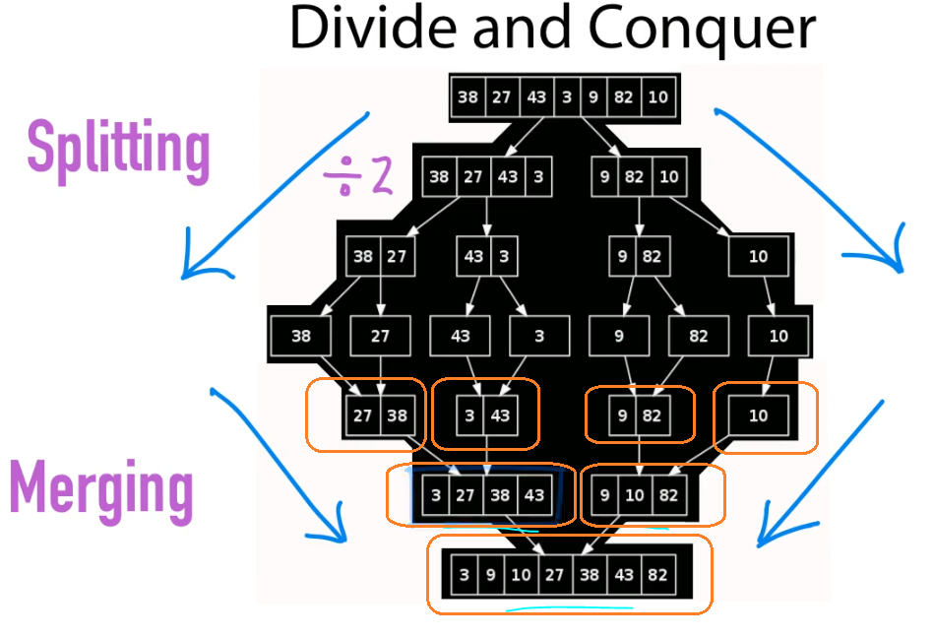

Then it would take the results of that and compare them with the result of a previous merge three and forty three and combine those and it keeps repeating this process over and over again until it gets down to those final two arrays that it needs to combine. And the reason why the merge sort works of course is because these arrays are continuously being sorted as we go. And that's really the whole crux of it right there. It's just splitting them up combining them back together with that merge sort algorithm. And that's really all there is to how this thing works. Let's now look at the code and see what this looks like an action.

### Merge Sort in Code

All right let's take a look at the merge sort code here. Merge sort is basically an exercise in keeping track of pointers. Specifically that left and that right and that middle pointer that's where the bulk of the algorithm is going to be focused on. Here's our test. Here's the array that we're going to sort and the with algorithms written is we're going to pass in the array along with two pointers. A left pointer for the left hand side of the array the far most left and a right pointer on the right. And then just like we said in the description what we're going to do with merge sort is we're going to be splitting this by finding the middle and then continuously splitting that array down into it's smallest elements.

public class MergeSortTest {

private MergeSort mergeSort;

@Before

public void SetUp() {

mergeSort = new MergeSort();

}

@Test

public void Sort() {

// l r

int arr[] = {4, 7, 14, 1, 3, 9, 17};

int l = 0; // left pointer

int r = arr.length - 1; // right pointer

mergeSort.sort(arr, l, r);

Assert.assertEquals(1, arr[0]);

Assert.assertEquals(3, arr[1]);

Assert.assertEquals(4, arr[2]);

Assert.assertEquals(7, arr[3]);

Assert.assertEquals(9, arr[4]);

Assert.assertEquals(14, arr[5]);

Assert.assertEquals(17, arr[6]);

System.out.println("\nSorted array");

mergeSort.printArray(arr);

}

}

So let's jump over to the algorithm now and see what that looks like. So basically here this is the sort that's that's going to basically take that array that we pass in. And so long as we have a left pointer that's left and to the right we're going to continuously split our array in half. Over and over and over again that's what we're going to keep doing. And you can notice we've got some recursion going on here. We're going to continuously split until we get that array down into its smallest individual elements. That's what's going on here. Once it's broken down we then work our way back up by merging the array with whatever our left middle and right pointer are. Building up larger and larger arrays until we get back to our final array. That's what's going on in this merge here.

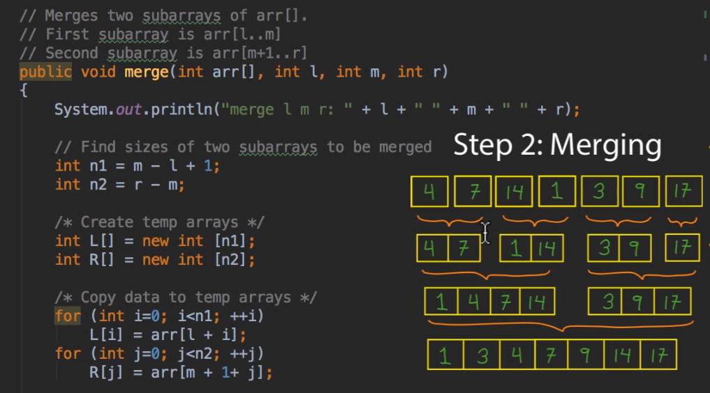

This is really the crux of the algorithm this is the one that's keeping track of left middle right. Creating new arrays. New temporary arrays to hold our merging results and then we just keep continuously merging this up. Now don't worry about memorizing this for the interview. That's not the point. I mean certainly go through this. Walk the algorithm understand what's going on really the best way to understand and see what's going on here is to actually run the test with some strategically placed outputs and we'll just walk through and see how this algorithm works and what's going on. Let's do that now.

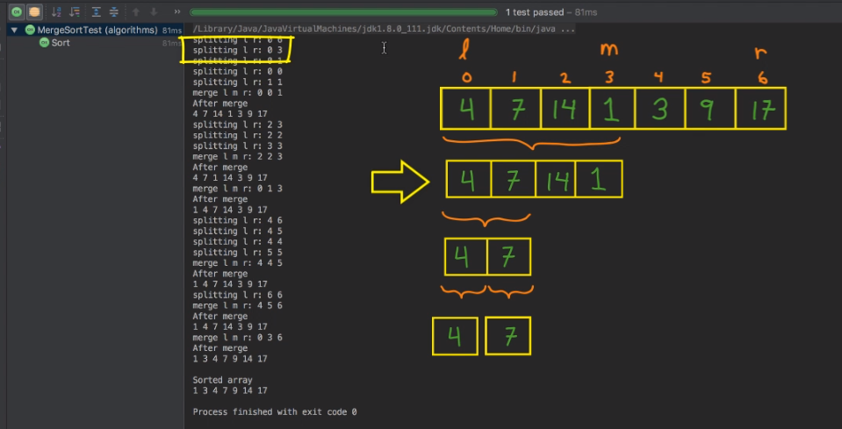

So what we can see here is we're starting off with our array in its entirety with the pointer on the left add an index of 0 and the one in the rate at 6. And basically this is where we're going to start doing our very first splits. We're going to split it here with the middle being the one and then what we're going to do is we're in a walk in the left hand side of this array the 4, 7, 14, and 1 and keep splitting it down into its smallest arguments. So here we're splitting from 0 to 3 we're taking a left hand side of the array. We're further splitting that up with a 0 and 1 and we're breaking it down and when you see it get down to 0 0 1 1. In other words those indexes are at the same place. That's how we know we've broken it down as far as we can.

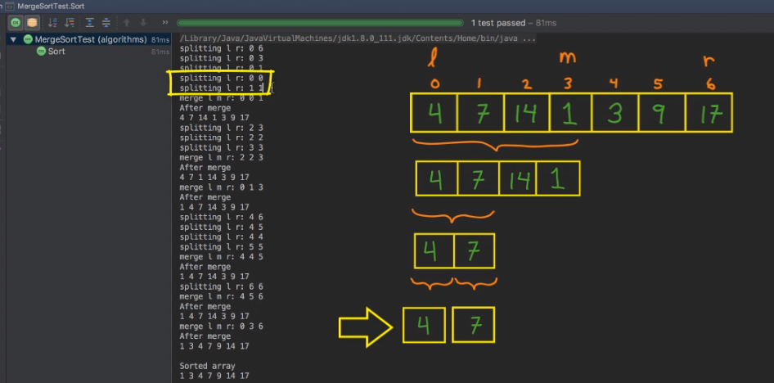

And then here is the very first time we start merging things back up so in this case when we start merging back up 0 0 and 1 for left and middle and right. All we're doing here is we're taking that four and that seven and merging those together. Now in this case there was nothing to swap. Those were already in order. But now we have a four and a seven built up into a slightly larger array. So after the merge this is the result of our array.

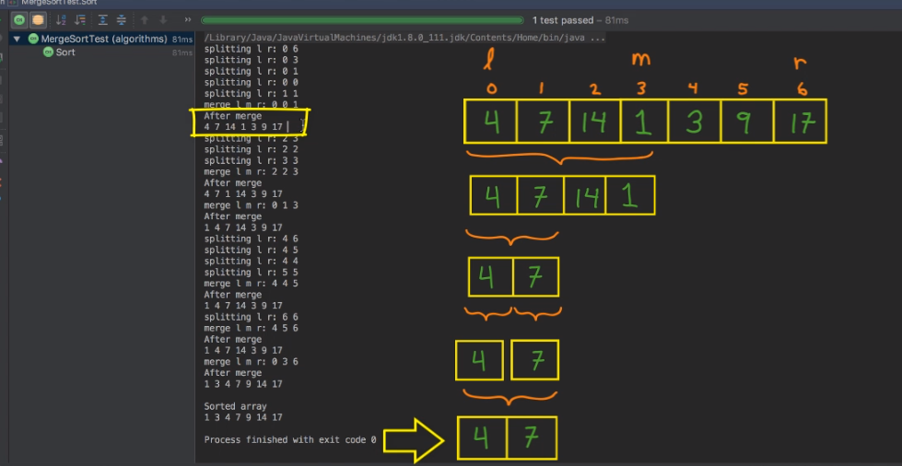

In other words no real change here. Now we walk down the right hand side of that left most array. Here we're splitting the two to the three that would be the 14 and the 1. Splitting it down to its small constituent elements. And then we start merging those. Now in this case we merge left of two, middle two, right of three. Here we do have a swap. Here the 1 of the 14 swapped. So now we've got one array of four and seven. Another array of 1 and 14 where we had our first swap.

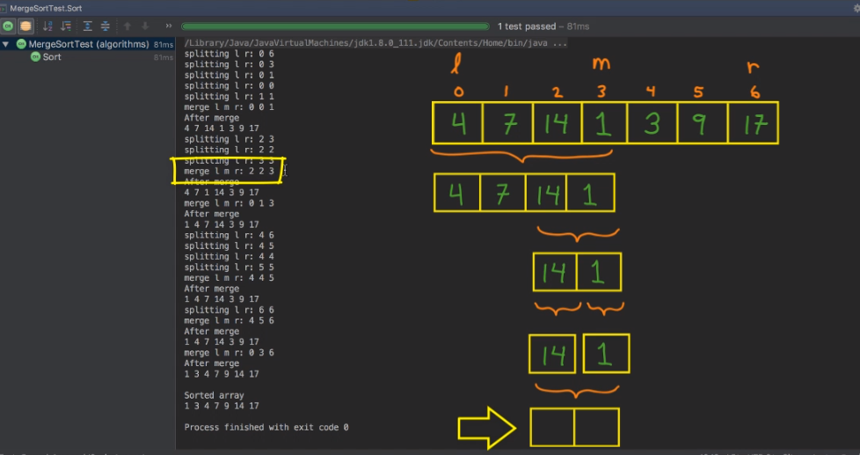

Now we're going to and here's what the result looks like here. Now we're going to merge those two smaller arrays up into this larger one. So now you can see we've got half of a sorted array here. The 1, 4, 7, 14 are merged and sorted. And that basically takes care the left hand side.

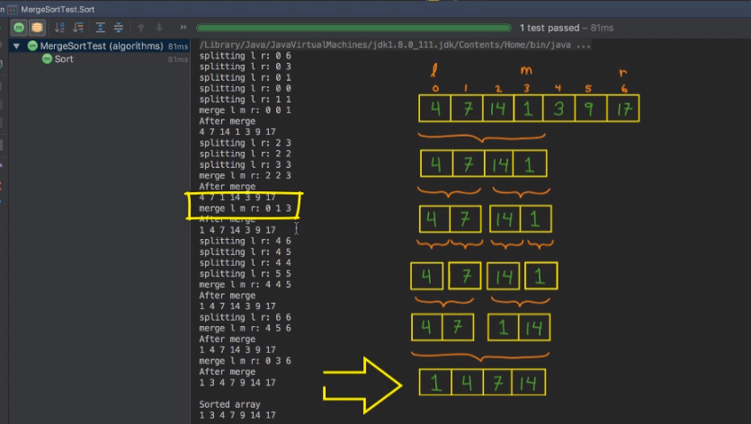

Now we shift back to the split at the top. The right hand side going from four to six and just repeating that process we keep breaking it down into its smallest elements. We break the four and the five, the three in the nine up into one array. The 17 that one stays on its own with the six. Then we just keep breaking up the 4th 4 and the 5 5. That's how we know we've broke them down as far as we can. And then we slowly begin to merge again. Here we bring back the three and the nine. In this case nothing to swap they're already sorted. And finally when we combine the 3 9 and 17 those in fact are already sorted too.

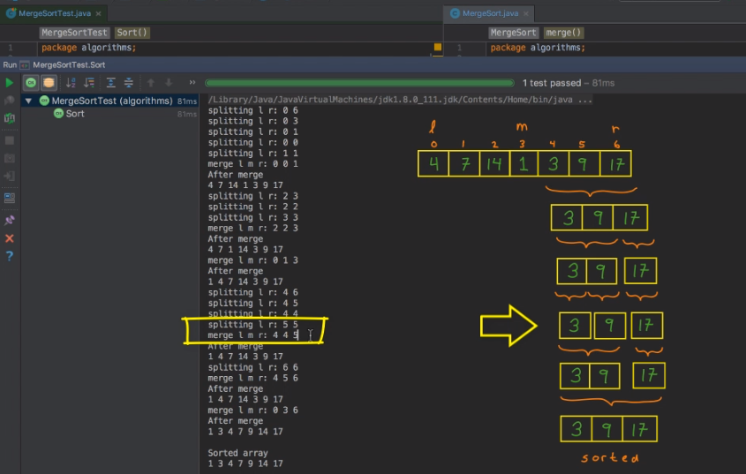

So there we have our sorted array on the right hand side 3 9 and 17. Now at this point we've got two large sorted arrays. Now we just need to bring them together and this is simply applying the merge sort routine we saw at the beginning of the section. Here we just merge these two arrays by continuously sliding the pointers along grabbing the smaller element each time until we get to the very end. And we have our sorted array.

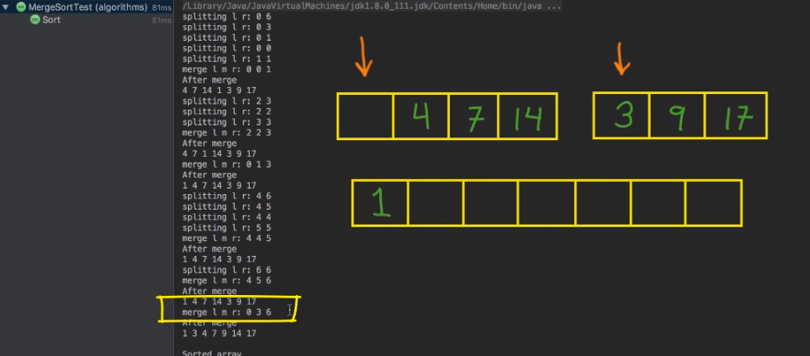

Voila that's all there is to it. Now just a few tips for you if the merge sort comes up in your interview. Number one don't memorize the algorithm. Instead, memorize this picture. Demonstrate that you understand how the merge sort works by drawing the picture of any given array. Splitting it up into its smallest elements and then merging it together memorize the algorithm is really really tough. I don't recommend it. Instead I'd recommend just burning this picture into your mind and be able to walk people through how the merge sort works pictorially.

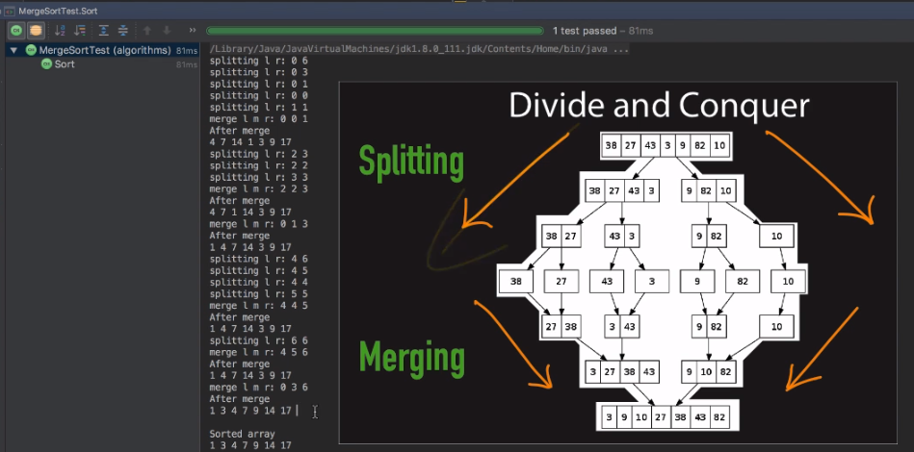

This is all you really need for the interview. This is going to demonstrate the you know how it works and then if they really want to jump in, OK you can start working it out there. But I think this is what's going to help you more just memorizing and understanding how the merge sort works from its fundamentals and then you can walk through and compare and talk about merge versus quick, bubble, or any of the others. But there you have it a walkthrough of the merge sort algorithm in action. And now you've seen it in code.

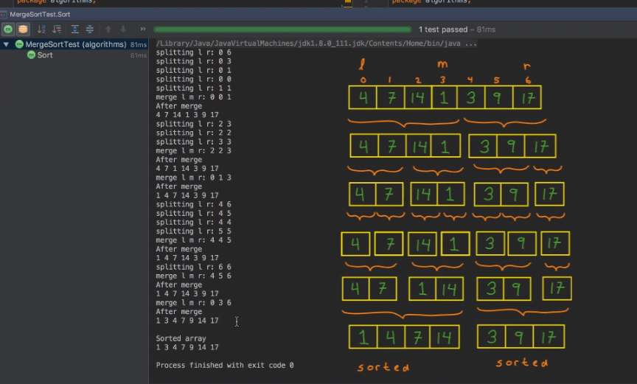

OK. So one easier way to remember the runtime characteristic of the merge sort is to visualize what's actually happening when we run the algorithm.

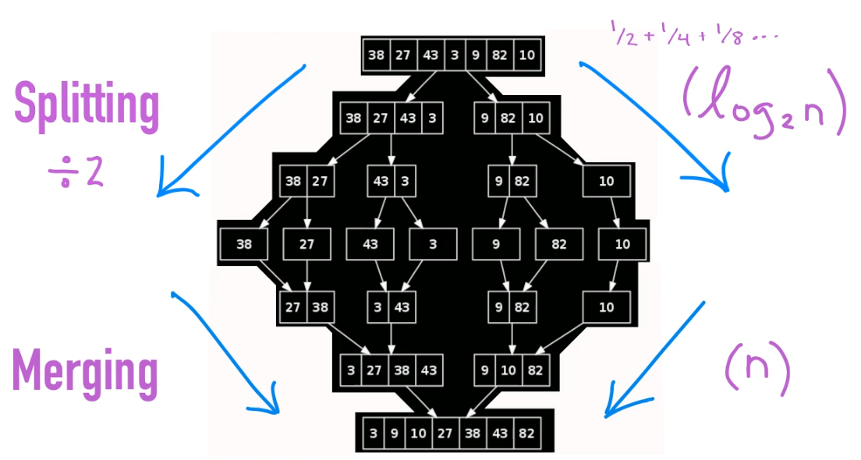

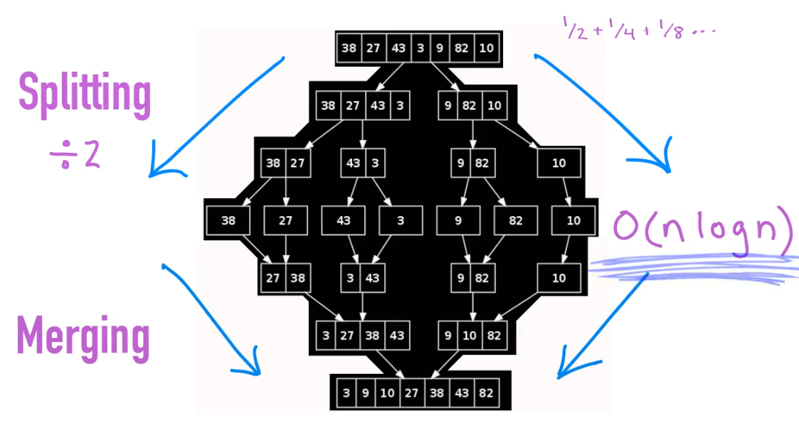

Remember when we start this algorithm we're continuously recursively half the array into numerous parts. And just like we saw in the binary search tree when you got that recursive happy nature think log n. Just instantly think that. That's automatic. Then the second part of the algorithm was well we've got to merge these things n number of times. So when you combine log n with n that gives you O(n log n) And that's basically the runtime of merge sort.

### QuickSort

The quicksort is a really neat algorithm that when you first look at it, it looks kind of alien, like what planet did this thing come from? But once you visualize it and kind of see the mechanics behind how it works, it's actually not that bad. And it's kind of a cool little sorting algorithm. But the way it works is you pick something called a pivot anywhere in your way, hopefully somewhere near the middle.

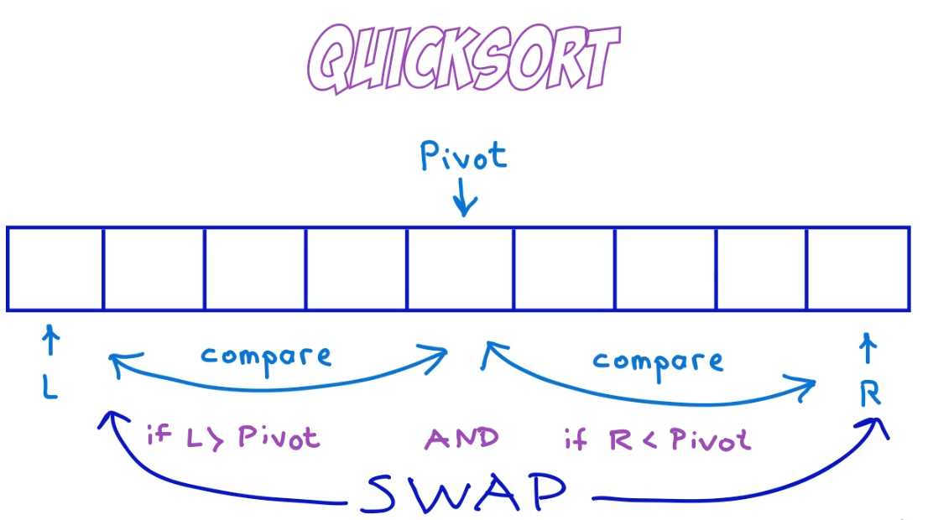

And what we're going to be doing is we're going to pivot in we're going to be pivoting numbers around this pivot point.

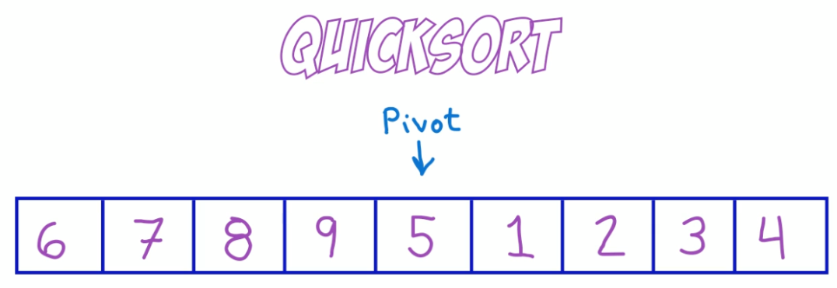

We're going to take all the numbers to the left of the pivot that are bigger than its value and hopefully swap them over to the right. And likewise, all the numbers that are smaller than the pivot on the right. We're going to bring those over to the left.

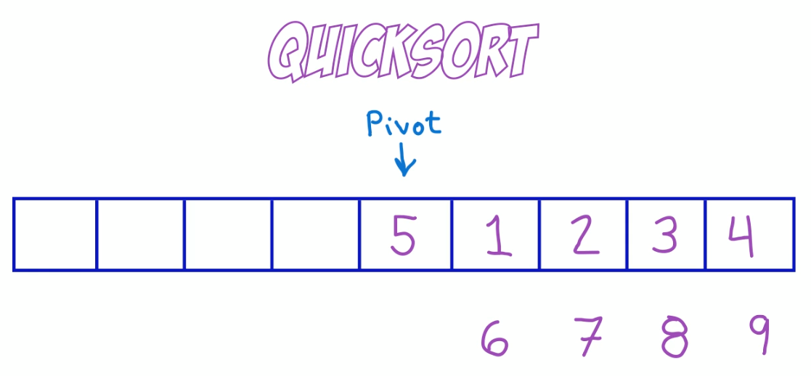

And the way we're going to do that as we pick a left pointer and a three pointer and we continuously compare those to the pivot to see if they're bigger or smaller than the pivot, adjust them accordingly.

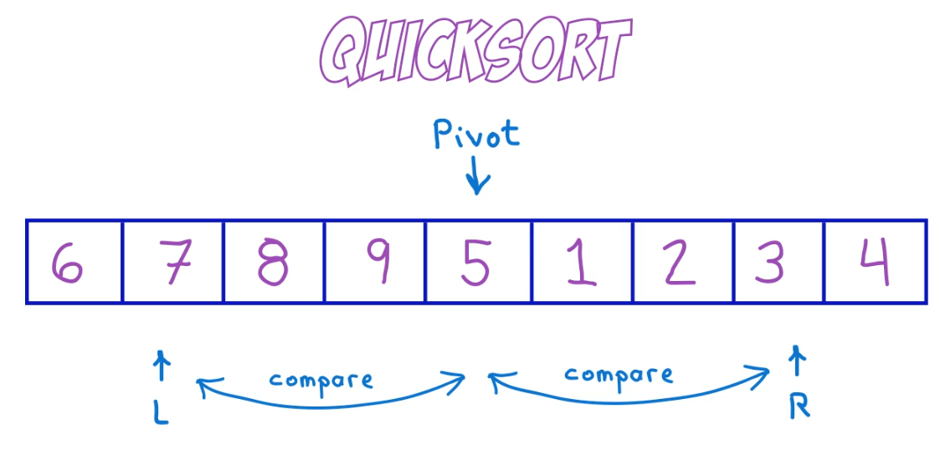

And as soon as we find a case where we have a number that is greater than the pivot on the left and a number that's less than the pivot in the right, we swap them. That's how we get all the numbers that are smaller or bigger to the left or the right of the pivot. After we do this repeatedly, what we're left with is really to sort of raise out of our main one when we're all the numbers in the left are less than those of the pivot and all the numbers in the rate are greater than the pivot. Maybe you can see where this is going, because now we can just apply the same algorithm again, only on these two separate arrays and repeat the process. And we just keep doing this and doing this until all the numbers in the algorithm are sorted. That's really all there is to the quicksort. Let's look at an example. So here we have an uncertain array and let's just pick the pivot somewhere like this, let's say seven, and we'll start our left and right pointers at the fifteen in the six. All right. Here's how it works. Because one is larger than our pivot, seven and six is less than our seven, we can just swap those instantly, swapping the six in the 15 there. Those are done. Now, we take that left pointer and slide it over until we find a number that's greater than seven, in this case nine. And likewise, we take that right pointer and slide it over until we find a number that is less than seven. Nine and one at this point, both satisfy the criteria, so we swap them, the one it comes over to the left, the nine goes over to the right, and we repeat, we now shift our left pointer over to the eight and our eight pointer over to the two. It's OK that a pass of the pivot. And here we have two more numbers that should be swapped. So we swap the two in the eight. And at this point, all the numbers to the left of the pivot, with the exception of the eight, are less than seven. Likewise, all the numbers to the right of the five are greater than seven. So we can now effectively split this array into two and repeat the process again, this time on the left and the right. Let's take the left one here. We have six three, one, two, five. Let's pick a pivot. Let's just say three. Let's slapdown our left and our right numbers and let's do a check. No, this doesn't quite satisfy our criteria, the six does, the six in the right place will leave the left, but this right one needs to be moved over. Let's slide it over until we find a no less than three, which in this case is two. And let's swap those swap. The two in the six of the two comes over here. The six comes over here. Now we've got the two is less than the three. And actually in this case, we're done. This can now be broken apart again into two arrays, two, three and one. And we'll leave the six and the five over there. And now we just repeat it one more time with the two three in the one. Let's just pick a pivot off, say, two. Let's put down our left and our right pointers to three and one. So with our pivot of two, let's slide the left over to the three and three is greater than one. And in this case, let's swap those and again, just break it down right down to where we just have one or two elements in this case, a two and a one and Erminia three. And we could apply the sort again on the one in the two. And you can see progressively if you do this over and over again, eventually you will sort all the numbers and the array that's called the quicksort. It's Pivot's, it's left Senate right. And it's just swapping and bringing numbers that are smaller and greater over to the right hand sides. And that's all there is to it. Let's now look at it in code.

# Functional JAVA ( Pg 460 )

## *Introduction*

Java has been evolving since the release of JDK 1.0 in 1996 to JDK 7.0 in the March 2014.

The newer architectures favor functional style over imperative.

The changes enable you to write programs more easily — instead of writing verbose code. There’s also a hardware influence: commodity CPUs have become multicore — the processor in your laptop or desktop machine probably has four or more CPU cores within it. But the vast majority of existing Java programs use only one of these cores and leave the other three idle (or spend a small fraction of their processing power running part of the operating system or a virus checker).

Prior to Java 8, experts might tell you that you have to use threads to use these cores. The problem is that working with threads is difficult and error prone. Java has followed an evolutionary path of continually trying to make concurrency easier and less error prone.

Java 1.0 had threads and locks and even a memory model — the best practice at the time — but these primitives proved too difficult to use reliably in nonspecialist project teams.

Java 5 added industrial-strength building blocks like Thread Pools & Concurrent Collections. Java 7 added Fork/ Join framework, making parallelism more practical but still difficult. Java 8 has a new, simpler way of thinking about parallelism - Streams.

Streams that supports many parallel operations to process data and resembles the way you might think in database query languages — you express what you want in a higher-level manner, and implementation (here the Streams library) chooses the best low-level execution mechanism. As a result, it avoids the need for you to write code that uses synchronized, which is not only highly error prone but is also more expensive than you may realize on multicore CPUs

Multicore CPUs have separate caches (fast memory) attached to each processor core. Locking requires these to be synchronized, requiring relatively slow cache-coherency-protocol intercore communication. From a slightly revisionist viewpoint, the addition of Streams in Java 8 can be seen as a direct cause of the two other additions to Java 8: Method References, Lambdas ( concise techniques to pass code to methods ) and Default Methods in interfaces.

But thinking of passing code to methods as a mere consequence of Streams downplays its range of uses within Java 8. It gives you a new concise way to express behavior parameterization. Suppose you want to write two methods that differ in only a few lines of code; you can now just pass the code of the parts that differ as an argument (this programming technique is shorter, clearer, and less error prone than the common tendency to use copy and paste). Experts will here note that behavior parameterization could, prior to Java 8, be encoded using anonymous classes—but we’ll let the example on the first page of this chapter, which shows increased code conciseness with Java 8, speak for itself in terms of clarity!

Collections.sort(inventory, new Comparator<Apple>() {

public int compare(Apple a1, Apple a2){

return a1.getWeight().compareTo(a2.getWeight()); // before Java 8

}

}

);

v/s

inventory.sort(comparing(Apple::getWeight)); // Java 8 - concise

it reads like this - sort inventory comparing apple weight

Java 8 provides -

* Functional programming
* Concise Code
* Default Methods in interfaces
* Lambda Expressions - concise representation of anonymous function that can be passed around
* Streams API - parallel processing w/o multithreaded code. Simpler use of multicore processors.
* Behavior Parameterization - passing code to methods
* Optional as a better alternative to null
* New Date and Time API

Indeed, there’s a danger that the Java virtual machine (JVM) and its bytecode will be seen as more important than the Java language itself and that, for certain applications, Java might be replaced by one of its competing languages such as Scala or Groovy, which also run on the JVM. Various recent updates to the JVM ( for example, the new invoke dynamic bytecode in JDK7 ) aim to help such competitor languages run smoothly on the JVM—and to interoperate with Java. Java has also been successful at colonizing various aspects of embedded computing (everything from smartcards, toasters, and settop boxes to car braking systems).

**Stream Processing**

A stream is a sequence of data items that are conceptually produced one at a time—a program might read items from an input stream one by one and similarly write items to an output stream. The output stream of one program could well be the input stream of another.

Unix cat creates a stream by concatenating two files, tr translates the characters in a stream, sort sorts lines in a stream, and tail -3 gives the last three lines in a stream. The Unix command line allows such programs to be linked together with pipes (|)

cat file1 file2 | tr "[A-Z]" "[a-z]" | sort | tail -3

which (supposing file1 and file2 contain a single word per line) prints the three words from the files that appear latest in dictionary order, after first translating them to lowercase. Sort takes a stream of lines[3] as input and produces another stream of lines as output.

Java 8 adds a Streams API (note the uppercase S) in java.util.stream based on this idea; Stream<T> is a sequence of items of type T. You can think of it as a fancy iterator for now. The Streams API has many methods that can be chained to form a complex pipeline just like Unix commands were chained in the previous example.

The key motivation for this is that you can now program in Java 8 at a higher level of abstraction, structuring your thoughts of turning a stream of this into a stream of that (similarly to how you think when writing database queries) rather than one item at a time.

Another advantage is that Java 8 can transparently run your pipeline of Stream operations on several CPU cores on disjoint parts of the input — this is parallelism almost for free instead of hard work using Threads.

**Passing code to methods with behavior parameterization**

Java 8 adds the ability to pass methods (your code) as arguments to other methods. We also refer to this conceptually as behavior parameterization. Why is this important? The Streams API is built on the idea of passing code to parameterize the behavior of its operations, just as you passed compareUsingCustomerId to parameterize the behavior of sort.

**Parallelism and shared mutable data**

The third programming concept - “parallelism almost for free” as discussed in Stream processing –

You must provide behavior that is safe to execute concurrently on different pieces of input. Typically this means writing code that doesn’t access shared mutable data to do its job. Sometimes these are referred to as pure functions or side-effect-free functions or stateless functions. If there’s a shared variable or object, which is written to, then things no longer work.

Java 8 streams exploit parallelism more easily than Java’s existing Threads API, so although it’s possible to use synchronized to break the no-shared-mutable-data rule, it’s fighting the system in that it’s abusing an abstraction optimized around that rule. Using synchronized across multiple processing cores is often far more expensive than you expect, because synchronization forces code to execute sequentially, which works against the goal of parallelism.

Synchronization forces code to execute sequentially, it works against the goal of parallelism.

|  |
| --- |
| Two of these points ( no shared mutable data and ability to pass methods & functions — code — to other methods ) are cornerstones of paradigm of functional programming. |

In contrast, in the imperative programming paradigm you typically describe a program in terms of a sequence of statements that mutate state. The no-shared-mutable-data requirement means that a method is perfectly described solely by the way it transforms arguments to results; in other words, it behaves as a mathematical function and has no (visible) side effects.

You’ve seen evolution in Java before. For example, the introduction of generics (catching more errors at compile time and making code easier to read). Other changes have made common things easier to express, for example, using a for-each loop instead of exposing the boilerplate use of an Iterator. The main changes in Java 8 reflect a move away from classical object orientation, which often focuses on mutating existing values, and toward the functional-style programming spectrum in which what you want to do in broad-brush terms (for example, create a value representing all transport routes from A to B for less than a given price) is considered prime and separated from how you can achieve this (for example, scan a data structure modifying certain components). Note that classical object-oriented programming and functional programming, as extremes, might appear to be in conflict. But the idea is to get the best from both programming paradigms, so you have a better chance of having the right tool for the job! We discuss this in detail in the next two sections: functions in Java and the new Streams API.

Java 8 adds functions as new forms of value. These facilitate the use of Streams, which Java 8 provides to exploit parallel programming on multicore processors. We start by showing that functions as values are useful in themselves. Experiments in other languages such as Scala and Groovy have determined that allowing concepts like methods to be used as first-class values made programming easier by adding to the toolset available to programmers. And once programmers become familiar with a powerful feature, they become reluctant to use languages without it!. So, the designers of Java 8 decided to allow methods to be values — to make it easier for you to program. Moreover, the Java 8 feature of methods as values forms the basis of various other Java 8 features (such as Streams).

The first new Java 8 feature we introduce is that of method references. Suppose you want to filter all the hidden files in a directory. You need to start writing a method that given a File will tell you whether it’s hidden or not. Thankfully there’s such a method inside the File class called isHidden. It can be viewed as a function that takes a File and returns a boolean. But to use it for filtering you need to wrap it into a FileFilter object that you then pass to the File.listFiles method, as follows:

File[] hiddenFiles = new File(".").listFiles(new FileFilter() {

public boolean accept(File file) {

return file.isHidden(); // filtering hidden files

}

}

Filtering files with the isHidden method requires wrapping into a FileFilter object before passing it to File.listFiles method. You already have a method isHidden that you could use. Why do you have to wrap it up in a verbose FileFilter class and then instantiate it? Because that’s what you had to do prior to Java 8! Now, in Java 8 you can rewrite that code as follows:

File[] hiddenFiles = new File(".").listFiles(File::isHidden);

You already have the function isHidden available, so you just pass it to the listFiles method using the Java 8 method reference :: syntax (meaning “use this method as a value”); note that we’ve also slipped into using the word function for methods.

Methods are no longer second-class values. Analogously to using an object reference when you pass an object around (and object references are created by new), in Java 8 when you write File::isHidden you create a method reference, which can similarly be passed around.

**Lambdas — anonymous functions**

As well as allowing (named) methods to be first-class values, Java 8 allows a richer idea of functions as values, including lambdas (or anonymous functions). For example, you can now write (int x) -> x + 1 to mean “the function that, when called with argument x, returns the value x + 1.” You might wonder why this is necessary because you could define a method add1 inside a class MyMathsUtils and then write MyMaths-Utils::add1! Yes, you could, but the new lambda syntax is more concise for cases where you don’t have a convenient method and class available.

An example:

Before Java 8, you thus might write a method filterGreenApples

public static List<Apple> filterGreenApples(List<Apple> Inventory) {

List<Apple> result = new ArrayList();

for (Apple apple: inventory) {

if ("green".equals(apple.getColor()) {

result.add(apple);

}

}

return result;

}

somebody would like the list of heavy apples

public static List<Apple> filterGreenApples(List<Apple> Inventory) {

List<Apple> result = new ArrayList();

for (Apple apple: inventory) {

if (apple.getWeight() > 50) {

result.add(apple);

}

}

return result;

}

These two methods vary in just the condition line

Java 8 makes it possible to pass the code of the condition as an argument, thus avoiding code duplication of the filter method. You can now write it like this

public static boolean isGreenApple(Apple apple) {

return "green".equals(apple.getColor());

}

public static boolean isHeavyApple(Apple apple) {

return apple.getWeight() > 50;

}

// included for clarity, normally just imported from java.util.function

public interface Predicate<T>{

boolean test(T t);

}

// a method is passed as a predicate parameter named p.

static List<Apple> filterApples(List<Apple> inventory,

Predicate<Apple> p) {

List<Apple> result = new ArrayList<>();

for (Apple apple: inventory) {

// Does the apple match condition represented by p?

if (p.test(apple)) {

result.add(apple);

}

}

**return** result;

}

And to use this, you call either

filterApples(inventory, Apple::isGreenApple); or

filterApples(inventory, Apple::isHeavyApple);



We explain how this works in detail in the next two chapters. The key idea to take away for now is that you can pass around a method in Java 8!

What’s a Predicate?

The previous code passed a method Apple::isGreenApple (which takes an Apple for argument and returns a boolean) to filterApples, which expected a Predicate<Apple> parameter. The word predicate is often used in mathematics to mean something function-like that takes a value for an argument and returns true or false. As you’ll see later, Java 8 would also allow you to write Function<Apple,Boolean> — more familiar to readers who learned about functions but not predicates at school — but using Predicate<Apple> is more standard (and slightly more efficient because it avoids boxing a boolean into a Boolean).

From passing methods to lambdas

Passing methods as values is clearly useful, but it’s a bit annoying having to write a definition for short methods such as isHeavyApple and isGreenApple when they’re used perhaps only once or twice. But Java 8 has solved this too. It introduces a new notation (anonymous functions, or lambdas) that enables you to write just

filterApples(inventory, (Apple a) -> "green".equals(a.getColor()) );

or

filterApples(inventory, (Apple a) -> a.getWeight() > 150 );

or even

filterApples(inventory, (Apple a) -> a.getWeight() < 80 ||

"brown".equals(a.getColor()) );

So you don’t even need to write a method definition that’s used only once; the code is crisper and clearer because you don’t need to search to find the code you’re passing. But if such a lambda exceeds a few lines in length, then you should instead use a method reference to a method with a descriptive name instead of using an anonymous lambda. Code clarity should be your guide.

The Java 8 designers could almost have stopped here, and perhaps they would have done so before multicore CPUs! Functional-style programming as presented so far turns out to be powerful, as you’ll see. Java might then have been rounded off by adding filter and a few friends as generic library methods, such as

static <T> Collection<T> filter(Collection<T> c, Predicate<T> p);

So you wouldn’t even have to write methods like filterApples because, for example, the previous call

filterApples(inventory, (Apple a) -> a.getWeight() > 150 );

could simply be written as a call to the library method filter:

filter(inventory, (Apple a) -> a.getWeight() > 150 );

But, for reasons centered on better exploiting parallelism, the designers didn’t do this. Java 8 instead contains a whole new Collections-like API called Streams, containing a comprehensive set of operations similar to filter that functional programmers may be familiar with (for example, map, reduce), along with methods to convert between Collections and Streams, which we now investigate.

Streams

Nearly every Java application *makes* and *processes* collections. But working with collections isn’t always ideal. For example, let’s say you need to filter expensive transactions from a list and then group them by currency. You’d need to write a lot of boilerplate code to implement this data processing query, as shown here:

Map<Currency, List<Transactions>> transactionsByCurrencies =

new HashMap();

for (Transaction transaction: transactions) {

if (transaction.getPrice() > 1000) {

Currency currency = transaction.getCurrency();

List<Transaction> transactionsForCurrency =

transactionsByCurrencies.get(currency);

if (transactionsForCurrency == null) {

transactionsForCurrency = new ArrayList<>();

transactionsByCurrencies.put(currency,

transactionsForCurrency);

}

transactionsForCurrency.add(transaction);

}

}

In addition, it’s difficult to understand at a glance what the code does because of the multiple nested control-flow statements.

Using the Streams API, you can solve this problem as follows:

import static java.util.stream.Collectors.toList;

Map<Currency, List<Transaction>> transactionsByCurrencies =

transactions.stream()

.filter( (Transaction t) -> t.getPrice() > 1000 )

.collect( groupingBy(Transaction::getCurrency) );

The Streams API provides a very different way to process data in comparison to the Collections API. Using a collection, you’re managing the iteration process yourself. You need to iterate through each element one by one using a for-each loop and then process the elements. We call this way of iterating over data *external iteration*. In contrast, using the Streams API, you don’t need to think in terms of loops at all. The data processing happens internally inside the library. We call this idea *internal iteration*.

As a second pain point of working with collections, think for a second about how you would process the list of transactions if you had a vast number of them; how can you process this huge list? A single CPU wouldn’t be able to process this large amount of data, but you probably have a multicore computer on your desk. Ideally, you’d like to share the work among the different CPU cores available on your machine to reduce the processing time. In theory, if you have eight cores, they should be able to process your data eight times as fast as using one core because they work in parallel.

This naming is unfortunate in some ways. Each of the cores in a multicore chip is a full-fledged CPU. But the phrase “multicore CPU” has become common, so *core* is used to refer to the individual CPUs.

All new desktop and laptop computers are multicore computers. Instead of a single CPU, they have four or eight or more CPUs (usually called cores[5]). The problem is that a classic Java program uses just a single one of these cores, and the power of the others is wasted. Similarly, many companies use *computing clusters* (computers connected together with fast networks) to be able to process vast amounts of data efficiently. Java 8 facilitates new programming styles to better exploit such computers.

Google’s search engine is an example of a piece of code that’s too big to run on a single computer. It reads every page on the internet and creates an index, mapping every word appearing on any internet page back to every URL containing that word. Then, when you do a Google search involving several words, software can quickly use this index to give you a set of web pages containing those words. Try to imagine how you might code this algorithm in Java (even for a smaller index than Google’s you’d need to exploit all the cores in your computer).

Multithreading is difficult

The problem is that exploiting parallelism by writing *multithreaded* code (using the Threads API from previous versions of Java) is difficult. You have to think differently: threads can access and update shared variables at the same time. As a result, data could change unexpectedly if not coordinated properly.

Java 8 also addresses both problems (boilerplate and obscurity involving processing collections and difficulty leveraging multicore) with the Streams API (java.util .stream). The first design motivator is that there are many data processing patterns (similar to filterApples in the previous section, or operations familiar from database query languages such as SQL) that occur over and over again and that would benefit from forming part of a library: *filtering* data based on a criterion (for example, heavy apples), *extracting* data (for example, extracting the weight field from each apple in a list), or *grouping* data (for example, grouping a list of numbers into separate lists of even and odd numbers), and so on. The second motivator is that such operations can often be parallelized.

Forking filter onto two CPUs and joining the result

|  |  |
| --- | --- |
|  | Filtering a list on two CPUs could be done by asking one CPU to process the first half of a list and the second CPU to process the other half of the list (this is called the *forking step* (1)). The CPUs then filter their respective half-lists (2). Finally (3), one CPU would join the two results (this is closely related to how Google searches work so quickly, of course using many more than two processors). |

For now, we’ll just say that the new Streams API behaves very similarly to Java’s existing Collections API: both provide access to sequences of data items. But it’s useful for now to keep in mind that Collections is mostly about storing and accessing data, whereas Streams is mostly about describing computations on data. The key point here is that Streams allows and encourages the elements within a Stream to be processed in parallel. Although it may seem odd at first, often the fastest way to filter a Collection (using filterApples on a List in the previous section) is to convert it to a Stream, process it in parallel, and then convert it back to a List, as exemplified here for both the serial and parallel cases. Again we’ll just say “parallelism almost for free” and provide a taste of how you can filter heavy apples from a list sequentially or in parallel using Streams and a lambda expression

Sequential processing:

import static java.util.stream.Collectors.toList;

List<Apple> heavyApples =

inventory.stream()

.filter((Apple a) -> a.getWeight() > 150)

.collect(toList());

Parallel processing:

import static java.util.stream.Collectors.toList;

List<Apple> heavyApples =

inventory.parallelStream()

.filter((Apple a) -> a.getWeight() > 150)

.collect(toList());

One of the practical issues the Java 8 developers found in evolving Java with all these new goodies was that of evolving existing interfaces. For example, the method Collections.sort really belongs to the List interface but was never included. Ideally, you’d like to do list.sort(comparator) instead of Collections.sort(list, comparator). This may seem trivial but, prior to Java 8, you can update an interface only if you update all the classes that implement it — a logistic nightmare! This issue is resolved in Java 8 by *default methods*.

Parallelism in Java and no shared mutable state

People have always said parallelism in Java is difficult, and all this stuff about synchronized is error prone. Where’s the magic bullet in Java 8? There are actually two magic bullets. First, the library handles partitioning — breaking down a big stream into several smaller streams to be processed in parallel for you. Second, this parallelism almost for free from streams works only if the methods passed to library methods like filter don’t interact, for example, by having mutable shared objects. But it turns out that this restriction feels quite natural as a coder (see, by way of example, our Apple::isGreenApple example). Indeed, although the primary meaning of *functional* in *functional programming* means “using functions as first class values,” it often has a secondary nuance of “no interaction during execution between components.”

Default methods

Default methods are added to Java 8 largely to support library designers by enabling them to write *more evolvable* interfaces. They’re important because you’ll increasingly encounter them in interfaces, but because relatively few programmers will need to write default methods themselves and because they facilitate program evolution rather than helping write any particular program, we keep the explanation here short and example-based:

List<Apple> heavyApples1 = inventory.stream()

.filter((Apple a) -> a.getWeight() > 150)

.collect(toList());

List<Apple> heavyApples2 = inventory.parallelStream()

.filter((Apple a) -> a.getWeight() > 150)

.collect(toList());

But there’s a problem here: a List<T> prior to Java 8 doesn’t have stream or parallel-Stream methods—and neither does the Collection<T> interface that it implements—because these methods hadn’t been conceived of! And without these methods this code won’t compile. The simplest solution, which you might employ for your own interfaces, would have been for the Java 8 designers simply to add the stream method to the Collection interface and add the implementation in the ArrayList class.

But doing this would have been a nightmare for users. There are many alternative collection frameworks that implement interfaces from the Collections API. Adding a new method to an interface means all concrete classes must provide an implementation for it. Language designers have no control on all existing implementations of Collections, so you have a bit of a dilemma: how can you evolve published interfaces without disrupting existing implementations?

The Java 8 solution is to break the last link — an interface can now contain method signatures for which an implementing class doesn’t provide an implementation! So who implements them? The missing method bodies are given as part of the interface (hence default implementations) rather than in the implementing class.

This provides a way for an interface designer to enlarge an interface beyond those methods that were originally planned — without breaking existing code. Java 8 uses the new 'default' keyword in the interface specification to achieve this.

For example, in Java 8 you can now call the sort method directly on a List. This is made possible with the following default method in the Java 8 List interface, which calls the static method Collections.sort:

default void sort(Comparator<? super E> c) {

Collections.sort(this, c);

}

This means any concrete classes of List don’t have to explicitly implement sort, whereas in previous Java versions such concrete classes would fail to recompile unless they provided an implementation for sort. But wait a second—a single class can implement multiple interfaces, right? So if you have multiple default implementations in several interfaces, does that mean you have a form of multiple inheritance in Java? Yes, to some extent! There are some restrictions that prevent issues such as the infamous *diamond inheritance problem* in C++.

The previous sections introduced two core ideas from functional programming that are now part of Java:

* using methods and lambdas as first-class values,
* executed in parallel in the absence of mutable shared state.

Both of these ideas are exploited by the new Streams API we described earlier.

Common functional languages (SML, OCaml, Haskell) also provide further constructs to help programmers. One of these is avoiding null by explicit use of more descriptive data types.

In Java 8 there’s an Optional<T> class that, if used consistently, can help you avoid NullPointer exceptions. It’s a container object that may or not contain a value. Optional<T> includes methods to explicitly deal with the case where a value is absent, and as a result you can avoid NullPointer exceptions. In other words, it uses the type system to allow you to indicate when a variable is anticipated to potentially have a missing value.

Following are the key concepts you should take away from this chapter:

* Keep in mind the idea of language ecosystem and the consequent evolve-or-wither pressure on languages. Although Java may be supremely healthy at the moment, you can recall other healthy languages such as COBOL that failed to evolve.
* The core additions to Java 8 provide exciting new concepts and functionality to ease the writing of programs that are both effective and concise.
* Multicore processors aren’t fully served by existing Java programming practice.
* Functions are first-class values; remember how methods can be passed as functional values and how anonymous functions (lambdas) are written.
* The Java 8 concept of Streams generalizes many aspects of Collections but both enables more readable code and allows elements of a stream to be processed in parallel.
* You can use a default method in an interface to provide a method body if an implementing class chooses not to do so.
* Other interesting ideas from functional programming include dealing with null and using pattern matching.

## *Passing code with Behavior Parameterization*

Behavior parameterization is a software development pattern that lets you handle frequent requirement changes. In a nutshell, it means taking a block of code and making it available without executing it. This block of code can be called later by other parts of your programs, which means that you can defer the execution of that block of code. For instance, you could pass the block of code as an argument to another method that will execute it later. As a result, the method’s behavior is parameterized based on that block of code. For example, if you process a collection, you may want to write a method that

* Can do “something” for every element of a list
* Can do “something else” when you finish processing the list
* Can do “yet something else” if you encounter an error

This is what behavior parameterization refers to.

Lets walk through an example of how you can evolve your code to be more flexible for changing requirements. Building on this knowledge, we show how to use behavior parameterization for several real-world examples. For example, you may have already used the behavior parameterization pattern using existing classes and interfaces in the Java API to sort a List, to filter names of files, or to tell a Thread to execute a block of code or even perform GUI event handling. You’ll soon realize that using this pattern is verbose in Java at the moment. Lambda expressions in Java 8 tackle the problem of verbosity.

Writing code that can cope with changing requirements is difficult. Let’s walk through an example that we’ll gradually improve, showing some best practices for making your code more flexible.

First attempt: filtering green apples

public static List<Apple> filterGreenApples(List<Apple> inventory) {

List<Apple> result = new ArrayList();

for (Apple apple: inventory) {

if ("green".equals(apple.getColor()) {

result.add(apple);

}

}

return result;

}

Now the farmer changes his mind and wants to also filter red apples

Second attempt: parameterizing the color

public static List<Apple> filterApplesByColor(List<Apple> inventory,

String color) {

List<Apple> result = new ArrayList<>();

for (Apple apple: inventory){

if ( apple.getColor().equals(color) ) {

result.add(apple);

}

}

return result;

}

You can now make the farmer happy and call your method as follows:

List<Apple> greenApples = filterApplesByColor(inventory, "green");

List<Apple> redApples = filterApplesByColor(inventory, "red");

The farmer comes back with the criteria of Heavy apples weight > 150g

public static List<Apple> filterApplesByWeight(List<Apple> inventory, int weight) {

List<Apple> result = new ArrayList<>();

for (Apple apple: inventory){

if ( apple.getWeight() > weight ){

result.add(apple);

}

}

return result;

}

Notice how you have to duplicate most of the implementation and break the DRY (don’t repeat yourself) principle of software engineering.

Third attempt: filtering with every attribute you can think of

public static List<Apple> filterApplesByColor(List<Apple> inventory,

String color, int weight, boolean flag) {

List<Apple> result = new ArrayList<>();

for (Apple apple: inventory){

// really ugly way of doing this

if ( ( flag && apple.getColor().equals(color) ) ||

!flag && apple.getWeight() > weight ) {

result.add(apple);

}

}

return result;

}

You could use it as follows (but it’s really ugly):

List<Apple> greenApples = filterApples(inventory, "green", 0, true);

List<Apple> heavyApples = filterApples(inventory, "", 150, false);

**Behavior parameterization**

You need a better way than adding lots of parameters to cope with changing requirements. Let’s step back and find a better level of abstraction. One possible solution is to model your selection criteria: you’re working with apples and returning a boolean based on some attributes of Apple (for example, is it green? is it heavier than 150 g?). We call this a predicate

public interface ApplePredicate{

boolean test (Apple apple);

}

You can now declare multiple implementations of ApplePredicate to represent different selection criteria, for example



public class AppleGreenColorPredicate implements ApplePredicate {

public boolean test(Apple apple) {

return "green".equals(apple.getColor());

}

}

public class AppleHeavyWeightPredicate implements ApplePredicate {

public boolean test(Apple apple) {

return apple.getWeight() > 150;

}

}

What you just did is related to the strategy design pattern, which lets you define a family of algorithms, encapsulate each algorithm (called a strategy), and select an algorithm at run-time. In this case the family of algorithms is ApplePredicate and the different strategies are AppleHeavyWeightPredicate and AppleGreenColorPredicate.

You need your filterApples method to accept ApplePredicate objects to test a condition on an Apple. This is what behavior parameterization means: the ability to tell a method to take multiple behaviors

(or strategies) as parameters and use them internally to accomplish different behaviors.

To achieve this in the running example, you add a parameter to the filterApples method to take an ApplePredicate object.

Fourth attempt: filtering by abstract criteria

public static List<Apple> filterApples(List<Apple> inventory,

ApplePredicate p) {

List<Apple> result = new ArrayList();

for (Apple apple: inventory) {

if (p.test(apple)) {

result.add(apple);

}

}

return result;

}

Passing code/behavior

Your code is now flexible enough for any change of requirements involving the attributes of Apple:

public class AppleRedAndHeavyPredicate implements ApplePredicate{

public boolean test(Apple apple){

return "red".equals(apple.getColor()) &&

apple.getWeight() > 150;

}

}

List<Apple> redAndHeavyApples =

filter(inventory, new AppleRedAndHeavyPredicate());

You’ve achieved something really cool: the behavior of the filterApples method depends on the code you pass to it via the ApplePredicate object

You’ll see that by using lambdas, you’ll be able to directly pass the expression "red".equals(apple.getColor()) && apple.getWeight() > 150 to the filterApples method without having to define multiple ApplePredicate classes and thus removing unnecessary verbosity.

Multiple behaviors, one parameter



**Parameterizing the behavior of filterApples and passing different filter strategies**

As we explained earlier, behavior parameterization is great because it enables you to separate the logic of iterating the collection to filter and the behavior to apply on each element of that collection. As a consequence, you can reuse the same method and give it different behaviors to achieve different things

We will pass the above highlighted red lines now as a parameter instead of the interface.



**Second Assignment : Write a flexible prettyPrintApple method**

Write a prettyPrintApple method that takes a List of Apples and that can be parameterized with

multiple ways to generate a String output from an apple (a bit like multiple customized toString

methods).

public interface AppleFormatter{

String accept(Apple a);

}

public class AppleFancyFormatter implements AppleFormatter{

public String accept(Apple apple){

String characteristic = apple.getWeight() > 150 ? "heavy" :

"light";

return "A " + characteristic + " " + apple.getColor() +"

apple";

}

}

public class AppleSimpleFormatter implements AppleFormatter{

public String accept(Apple apple){

return "An apple of " + apple.getWeight() + "g";

}

}

Finally, you need to tell your prettyPrintApple method to take AppleFormatter objects and use them internally. You can do this by adding a parameter to prettyPrintApple:

public static void prettyPrintApple(List<Apple> inventory,

AppleFormatter formatter){

for(Apple apple: inventory){

String output = formatter.accept(apple);

System.out.println(output);

}

}

Calling Now:

prettyPrintApple(inventory, new AppleFancyFormatter());

prettyPrintApple(inventory, new AppleSimpleFormatter());

**Tackling verbosity**

When you want to pass new behavior to your filterApples method, you’re forced to declare several classes that implement the ApplePredicate interface and then instantiate several ApplePredicate objects that you allocate only once. There’s a lot of verbosity involved and it’s a time-consuming process!

Java has a mechanism called anonymous classes, which let you declare and instantiate a class at the same time. They enable you to improve your code one step further by making it a little more concise. But they’re not entirely satisfactory. Lambda expressions can make your code more readable

Anonymous classes

Anonymous classes are like the local classes (a class defined in a block) that you’re already familiar with in Java. But anonymous classes don’t have a name. They allow you to declare and instantiate a class at the same time. In other words, they allow you to create ad hoc implementations

Fifth attempt: using an anonymous class

Anonymous classes are still not good enough. First, they tend to be very bulky because they take a lot of space, as shown below

List<Apple> redApples = filterApples(inventory, new ApplePredicate() {

public boolean test(Apple e) {

return "red".equals(a.getColor());

}

})

Many programmers find anonymous classes very confusing to use.

Another Example:

public class MyClass {

public final int value = 4;

public void doIt() {

int value = 6;

Runnable r = new Runnable() {

public final int value = 5;

public void run() {

int value = 10;

System.out.println(this.value);

}

r.run();

}

}

public static void main(String[] args) {

MyClass m = new MyClass();

m.doIt();

}

}

Whats the result?

The result is that it would print 5

Verbosity in general is bad; it discourages the use of a language feature because it takes a long time to write and maintain verbose code, and it’s not pleasant to read! Good code should be easy to comprehend at a glance. Even though anonymous classes somewhat tackle the verbosity associated with declaring multiple concrete classes for an interface, they’re still unsatisfactory.

In the context of passing a simple piece of code (for example, a boolean expression representing a selection criterion), you still have to create an object and explicitly implement a method to define a new behavior (for example, the method test for Predicate or the method handle for EventHandler).

Ideally we’d like to encourage programmers to use the behavior parameterization pattern, because as you’ve just seen, it makes your code more adaptive to requirement changes. The Java 8 language designers solved this problem by introducing lambda expressions, a more concise way to pass code.

Sixth attempt: using a lambda expression

The previous code can be rewritten as follows in Java 8 using a lambda expression:

List<Apple> result =

filterApples(inventory,

(Apple apple) -> "red".equals(apple.getColor()));

You have to admit this code looks a lot cleaner than our previous attempts!

**Behavior parameterization vs. value parameterization**



Seventh attempt: abstracting over List type

There’s one more step that you can do in your journey toward abstraction. At the moment, the filterApples method works only for Apple. But you can also abstract on the List type to go beyond the problem domain you’re thinking of right now:

public interface Predicate<T> {

boolean test(T t);

}

public static <T> List<T> filter(List<T> list, Predicate<T> p) {

List<T> result = new ArrayList();

for (T e: list ) {

if (p.test(e)) {

result.add(e);

}

}

return result;

}

You can now use the method filter with a List of bananas, oranges, Integers, or Strings! Here’s an example, using lambda expressions:

List<Apple> redApples = filter(inventory, (Apple apple) ->

"red".equals(apple.getColor()));

List<String> evenNumbers =

filter(numbers, (Integer i) -> i % 2 == 0);

You’ve managed to find the sweet spot between flexibility and conciseness, which wasn’t possible prior to Java 8.

**Real-world examples**

Sorting with a Comparator

Sorting a collection is a recurring programming task. For example, say your farmer wants you to sort the inventory of apples based on their weight. Or perhaps he changes his mind and wants you to sort the apples by color. Sound familiar? Yes, you need a way to represent and use different sorting behaviors to easily adapt to changing requirements.

inventory.sort(new Comparator<Apple>() {

public int compare(Apple a1, Apple a2){

return a1.getWeight().compareTo(a2.getWeight());

}

});

If the farmer changes his mind about how to sort apples, you can create an ad hoc Comparator to match the new requirement and pass it to the sort method!

inventory.sort( (Apple a1, Apple a2) ->

a1.getWeight().compareTo(a2.getWeight()));

Threads are like a lightweight process: they execute a block of code on their own. But how can you tell a thread what block of code to run? Several threads may run different code. What you need is a way to represent a piece of code to be executed later. In Java, you can use the Runnable interface to represent a block of code to be executed; note that the code will return no result (that is, void):

// java.lang.Runnable

public interface Runnable{

public void run();

}

You can use this interface to create threads with different behaviors as follows:

Thread t = new Thread(new Runnable() {

public void run(){

System.out.println("Hello world");

}

}

);

With a lambda expression it would look like this:

Thread t = new Thread(() -> System.out.println("Hello world"));

GUI event handling

Button button = new Button("Send");

button.setOnAction(new EventHandler<ActionEvent>() {

public void handle(ActionEvent event) {

label.setText("Sent!!");

}

});

With a lambda expression it would look like this:

button.setOnAction((ActionEvent event) -> label.setText("Sent!!"));

Following are the key concepts you should take away from this chapter:

* Behavior parameterization is the ability for a method to take multiple different behaviors as parameters and use them internally to accomplish different behaviors.
* Behavior parameterization lets you make your code more adaptive to changing requirements and saves on engineering efforts in the future.
* Passing code is a way to give new behaviors as arguments to a method. But it’s verbose prior to Java Anonymous classes helped a bit before Java 8 to get rid of the verbosity associated with declaring multiple concrete classes for an interface that are needed only once.
* The Java API contains many methods that can be parameterized with different behaviors, which include sorting, threads, and GUI handling.

## *Lambda expressions*

Behavior parameterization is useful for coping with frequent requirement changes in your code. It lets you define a block of code that represents a behavior and then pass it around. But you saw that using anonymous classes to represent different behaviors is unsatisfying: it’s verbose, which doesn’t encourage programmers to use behavior parameterization in practice.

Lambda expressions, which let you represent a behavior or pass code in a concise way. For now you can think of lambda expressions as anonymous functions, basically methods without declared names, but which can also be passed as arguments to a method as you can with an anonymous class.

A lambda expression can be understood as a concise representation of an anonymous function that can be passed around: it doesn’t have a name, but it has a list of parameters, a body, a return type, and also possibly a list of exceptions that can be thrown. That’s one big definition; let’s break it down:

* Anonymous— We say anonymous because it doesn’t have an explicit name like a method would normally have: less to write and think about!
* Function— We say function because a lambda isn’t associated with a particular class like a method is. But like a method, a lambda has a list of parameters, a body, a return type, and a possible list of exceptions that can be thrown.
* Passed around— A lambda expression can be passed as argument to a method or stored in a variable.
* Concise— You don’t need to write a lot of boilerplate like you do for anonymous classes.

If you’re wondering where the term lambda comes from, it originates from a system developed in academia called lambda calculus, which is used to describe computations.

Lambdas technically don’t let you do anything that you couldn’t do prior to Java 8. But you no longer have to write clumsy code using anonymous classes to benefit from behavior parameterization! Lambda expressions will encourage you to adopt the style of behavior parameterization that we described in the previous chapter. The net result is that your code will be clearer and more flexible.

Before:

Comparator<Apple> byWeight = new Comparator<Apple>() {

public int compare(Apple a1, Apple a2){

return a1.getWeight().compareTo(a2.getWeight());

}

};

After (with lambda expressions):

Comparator<Apple> byWeight =

( Apple a1, Apple a2 ) ->

a1.getWeight().compareTo( a2.getWeight() );



* A list of parameters— In this case it mirrors the parameters of the compare method of a Comparator—two Apples.
* An arrow— The arrow -> separates the list of parameters from the body of the lambda.
* The body of the lambda— Compare two Apples using their weights. The expression is considered the lambda’s return value.

Valid lambda expressions in Java 8

(String s) -> s.length();

(Apple a) -> "green".equals(a.getColor());

(int x, int y) -> {

System.out.println("x = ")+x;

System.out.println("")+y;

};

() -> 42;

(Apple a1, Apple a2) -> a1.getWeight().compareTo(a2.getWeight());

This syntax was chosen by the Java language designers because it was well received in other languages such as C# and Scala, which have a similar feature.

The basic syntax of a lambda is either

(parameters) -> expression

or (note the curly braces for statements)

(parameters) -> { statements; }

Lambda syntax

1. () -> {}

2. () -> "Raoul"

3. () -> {return "Mario";}

4. (Integer i) -> return "Alan" + i;

5. (String s) -> {"Iron Man";}

Only 4 and 5 are invalid lambdas.

1. This lambda has no parameters and returns void. It’s similar to a method with an empty body:

public void run() { }.

2. This lambda has no parameters and returns a String as an expression.

3. This lambda has no parameters and returns a String (using an explicit return statement).

4. return is a control-flow statement. To make this lambda valid, curly braces are required as

follows: (Integer i) -> {return "Alan" + i;}.

5. “Iron Man” is an expression, not a statement. To make this lambda valid, you can remove the

curly braces and semicolon as follows: (String s) -> "Iron Man". Or if you prefer, you can use an explicit return statement as follows: (String s) -> {return "Iron Man";}.

Examples of lambdas

Use case Examples of lambdas

A boolean expression (List<String> list) -> list.isEmpty()

Creating objects : () -> new Apple(10)

Consuming from an object : (Apple a) -> {

System.out.println(a.getWeight());

}

Select/extract from an object: (String s) -> s.length()

Combine two values: (int a, int b) -> a * b

Compare two objects : (Apple a1, Apple a2) ->

a1.getWeight().compareTo(a2.getWeight())

**Where and how to use lambdas**

You may now be wondering where you’re allowed to use lambda expressions. In the previous example, you assigned a lambda to a variable of type Comparator<Apple>. You could also use another lambda with the filter method you implemented in the previous chapter:

List<Apple> greenApples =

filter(inventory, (Apple a) -> "green".equals(a.getColor()));

So where exactly can you use lambdas? You can use a lambda expression in the context of a functional interface. In the code shown here, you can pass a lambda as second argument to the method filter because it expects a Predicate<T>, which is a functional interface. Don’t worry if this sounds abstract; we now explain in detail what this means and what a functional interface is.

**Functional interface**

Remember the interface Predicate<T> you created in chapter 2 so you could parameterize the behavior of the filter method? It’s a functional interface! Why? Because Predicate specifies only one abstract method:

public interface Predicate<T>{

boolean test (T t);

}

In a nutshell, a functional interface is an interface that specifies exactly one abstract method. You already know several other functional interfaces in the Java API such as Comparator and Runnable

Comparator, Runnable, ActionListener, Callable, PrivilegedAction

public interface Comparator<T>{

int compare(T o1, T o2);

}

public interface Runnable{

void run();

}

public interface ActionListener extends EventListener{

void actionPerformed(ActionEvent e);

}

public interface Callable<V> {

V call();

}

public interface PrivilegedAction<V>{

T run();

}

Interfaces can now also have default methods (that is, a method with a body that provides some default implementation for a method in case it isn’t implemented by a class).

An interface is still a functional interface if it has many default methods as long as it specifies only one abstract method.

From the below only Adder is a functional interface

public interface Adder{

int add(int a, int b);

}

public interface SmartAdder extends Adder{

int add(double a, double b);

}

public interface Nothing{

}

SmartAdder isn’t a functional interface because it specifies two abstract methods called add (one is inherited from Adder).

Nothing isn’t a functional interface because it declares no abstract method at all.

What can you do with functional interfaces? Lambda expressions let you provide the implementation of the abstract method of a functional interface directly inline and treat the whole expression as an instance of a functional interface (more technically speaking, an instance of a concrete implementation of the functional interface). You can achieve the same thing with an anonymous inner class, although it’s clumsier: you provide an implementation and instantiate it directly inline. The following code is valid because Runnable is a functional interface defining only one abstract method, run:

Assigning Lamda

Runnable r1 = () -> { System.out.println("Hello There"); }

Runnable r2 = new Runnable() {

public void run() {

System.out.println("Hello There");

}

}

public static void process(Runnable r) {

r.run();

}

process(r1);

process(r2);

process( () -> System.out.println("Hello There"); );

Function Descriptor

The signature of the abstract method of the functional interface essentially describes the signature of the lambda expression. We call this abstract method a "function descriptor". For example, the Runnable interface can be viewed as the signature of a function that accepts nothing and returns nothing (void) because it has only one abstract method called run, which accepts nothing and returns nothing (void).

Some languages such as Scala provide explicit type annotations in their type system to describe the type of a function (called function types). Java reuses existing nominal types provided by functional interfaces and maps them into a form of function types behind the scenes.

We use a special notation throughout the chapter to describe the signatures of lambdas and functional interfaces. The notation () -> void represents a function with an empty list of parameters returning void. This is exactly what the Runnable interface represents. As another example, (Apple, Apple) -> int denotes a function taking two Apples as parameters and returning an int.

**Common functional interfaces in Java 8**

|  |  |  |
| --- | --- | --- |
| **Functional interface** | **Function Descriptor** | **Primitive specializations** |
|  |  |  |
| Predicate<T> | T -> boolean | IntPredicate, LongPredicate, DoublePredicate |
| Function<T, R> | T -> R | IntFunction<R>, IntToDoubleFunction, |
|  |  | IntToLongFunction, LongToIntFunction, |
|  |  | LongToDoubleFunction, |
|  |  | DoubleFunction<R>, ToIntFunction<T>, |
|  |  | ToDoubleFunction<T>, ToLongFunction<T> |
| Consumer<T> | T -> void | IntConsumer, LongConsumer, DoubleConsumer |
| Supplier<T> | () -> T | BooleanSupplier, IntSupplier, LongSupplier, DoubleSupplier |
| UnaryOperator<T> | T -> T | IntUnaryOperator, LongUnaryOperator, DoubleUnaryOperator |
| BinaryOperator<T> | (T, T) -> T | IntBinaryOperator, LongBinaryOperator, DoubleBinaryOperator |
| BiPredicate<L, R> | (L, R) -> boolean |  |
| BiFunction<T, U, R> | (T, U) -> R | ToIntBiFunction<T, U>, ToLongBiFunction<T, U>, ToDoubleBiFunction<T, U> |
| BiConsumer<T, U> | (T, U) -> void | ObjIntConsumer<T>, ObjLongConsumer<T>, ObjDoubleConsumer<T> |
|  |  |  |

You may already be wondering how lambda expressions are type checked. We detail how the compiler checks whether a lambda is valid in a given context in section 3.5. For now, it suffices to understand that a lambda expression can be assigned to a variable or passed to a method expecting a functional interface as argument, provided the lambda expression has the same signature as the abstract method of the functional interface. For instance, in our earlier example, you could pass a lambda directly to the process method as follows

public void process(Runnable r){

r.run();

}

process( () -> System.out.println("This is awesome!!") );

This is exactly the signature of the run method defined in the Runnable interface.

The language designers chose this way because it fits naturally without increasing the complexity of the language

**Where can you use lambdas?**

1. execute(() -> {});

public void execute(Runnable r){

r.run();

}

2. public Callable<String> fetch() {

return () -> "Tricky example ;-)";

}

3. Predicate<Apple> p = (Apple a) -> a.getWeight();

Only 1 and 2 are valid. The first example is valid because the lambda () -> {} has the signature

() -> void, which matches the signature of the abstract method run defined in Runnable. Note that running this code will do nothing because the body of the lambda is empty!

The second example is also valid. Indeed, the return type of the method fetch is Callable<String>. Callable<String> essentially defines a method with the signature () -> String when T is replaced with String. Because the lambda () -> "Tricky example ;-)" has the signature () -> String, the lambda can be used in this context.

The third example is invalid because the lambda expression (Apple a) -> a.getWeight() has the signature (Apple) -> Integer, which is different than the signature of the method test defined in Predicate<Apple>: (Apple) -> boolean.

What about @FunctionalInterface?

If you explore the new Java API, you’ll notice that functional interfaces are annotated with @FunctionalInterface (we show an extensive list in section 3.4, where we explore functional interfaces in depth). This annotation is used to indicate that the interface is intended to be a functional interface. The compiler will return a meaningful error if you define an interface using the @FunctionalInterface annotation and it isn’t a functional interface. For example, an error message could be “Multiple non-overriding abstract methods found in interface Foo” to indicate that more than one abstract method is available. Note that the @FunctionalInterface annotation isn’t mandatory, but it’s good practice to use it when an interface is designed for that purpose. You can think of it like the @Override notation to indicate that a method is overridden.

Putting lambdas into practice: the execute around pattern

Let’s look at an example of how lambdas, together with behavior parameterization, can be used in practice to make your code more flexible and concise. A recurrent pattern in resource processing (for example, dealing with files or databases) is to open a resource, do some processing on it, and then close the resource. The setup and cleanup phases are always similar and surround the important code doing the processing. This is called the execute around pattern

For example, in the following code, the highlighted lines show the boilerplate code required to read one line from a file (note also that you use Java 7’s try-with-resources statement, which already simplifies the code, because you don’t have to close the resource explicitly):

Tasks A and B are surrounded by the same redundant code responsible for preparation/cleanup.



public static String processFile() throws IOException {

try (BufferedReader br = new BufferedReader(

new FileReader("data.txt"))) {

return br.readLine(); // line that actually does the work

}

}

Step 1: Remember behavior parameterization

This current code is limited. You can read only the first line of the file. What if you’d like to return the first two lines instead or even the word used most frequently? Ideally, you’d like to reuse the code doing setup and cleanup and tell the processFile method to perform different actions on the file. Does this sound familiar? Yes, you need to parameterize the behavior of processFile. You need a way to pass behavior to processFile so it can execute different behaviors using a BufferedReader.

Passing behavior is exactly what lambdas are for. So what should the new processFile method look like if you wanted to read two lines at once? You basically need a lambda that takes a BufferedReader and returns a String. For example, here’s how to print two lines of a BufferedReader:

String result = processFile(

(BufferedReader br) -> br.readLine() + br.readLine());

Step 2. Use a functional interface to pass behaviors

We explained earlier that lambdas can be used only in the context of a functional interface. You need to create one that matches the signature BufferedReader -> String and that may throw an IOException. Let’s call this interface BufferedReaderProcessor:

@FunctionalInterface

public interface BufferedReaderProcessor {

String process(BufferedReader b) throws IOException;

}

You can now use this interface as the argument to your new processFile method:

public static String processFile(BufferedReaderProcessor p) throws IOException {

...

}

Step 3: Execute a behavior!

Any lambdas of the form BufferedReader -> String can be passed as arguments, because they match the signature of the process method defined in the Buffered-ReaderProcessor interface. You now need only a way to execute the code represented by the lambda inside the body of processFile. Remember, lambda expressions let you provide the implementation of the abstract method of a functional interface directly inline, and they treat the whole expression as an instance of a functional interface. You can therefore call the method process on the resulting BufferedReaderProcessor object inside the processFile body to perform the processing:

public static String processFile(BufferedReaderProcessor p)

throws IOException {

try (BufferedReader br =

new BufferedReader( new FileReader("data.txt") ) {

return p.process(br); // process BufferedReader object

}

}

Step 4: Pass lambdas

You can now reuse the processFile method and process files in different ways by passing different lambdas.

Processing one line:

String oneLine =

processFile((BufferedReader br) -> br.readLine());

Processing two lines:

String twoLines =

processFile((BufferedReader br) -> br.readLine() + br.readLine());

**Four-step process to apply the execute around pattern**

So far, we’ve showed how you can make use of functional interfaces to pass lambdas. But you had to define your own interfaces. In the next section we explore new interfaces that were added to Java 8 that you can reuse to pass multiple different lambdas.

Functional interface specifies exactly one abstract method. Functional interfaces are useful because the signature of the abstract method can describe the signature of a lambda expression. The signature of the abstract method of a functional interface is called a function descriptor. So in order to use different lambda expressions, you need a set of functional interfaces that can describe common function descriptors. There are several functional interfaces already available in the Java API such as Comparable, Runnable, and Callable

The Java library designers for Java 8 have helped you by introducing several new functional interfaces inside the java.util.function package. We describe the interfaces Predicate, Consumer, and Function next, and a more complete list is available in table 3.2 at the end of this section.

**Predicate**

The java.util.function.Predicate<T> interface defines an abstract method named test that accepts an object of generic type T and returns a boolean. It’s exactly the same one that you created earlier, but is available out of the box! You might want to use this interface when you need to represent a boolean expression that uses an object of type T. For example, you can define a lambda that accepts String objects, as shown in the following listing.

**Working with a Predicate**

@FunctionalInterface

public interface Predicate<T>{

boolean test(T t);

}

public static <T> List<T> filter(List<T> list, Predicate<T> p) {

List<T> results = new ArrayList<>();

for(T s: list){

if(p.test(s)){

results.add(s);

}

}

return results;

}

Predicate<String> nonEmptyStringPredicate =

(String s) -> !s.isEmpty();

List<String> nonEmpty =

filter(listOfStrings, nonEmptyStringPredicate);

If you look up the Javadoc specification of the Predicate interface, you may notice additional methods such as and and or. Don’t worry about them for now.

**Consumer**

The java.util.function.Consumer<T> interface defines an abstract method named accept that takes an object of generic type T and returns no result (void). You might use this interface when you need to access an object of type T and perform some operations on it. For example, you can use it to create a method forEach, which takes a list of Integers and applies an operation on each element of that list. In the following listing you use this forEach method combined with a lambda to print all the elements of the list.

@FunctionalInterface

public interface Consumer<T> {

void accept(T t);

}

public static <T> void forEach(List<T> list, Consumer<T> c) {

for (T i: list) {

c.accept(i);

}

}

forEach( Arrays.asList(1,2,3,4,5),

(Integer i ) -> System.out.println(i) );

**Function**

The java.util.function.Function<T, R> interface defines an abstract method named apply that takes an object of generic type T as input and returns an object of generic type R. You might use this interface when you need to define a lambda that maps information from an input object to an output (for example, extracting the weight of an apple or mapping a string to its length). In the listing that follows we show how you can use it to create a method map to transform a list of Strings into a list of Integers containing the length of each String.

Working with a Function

@FunctionalInterface

public interface Function<T, R>{

R apply(T t);

}

public static <T, R> List<R> map(List<T> list, Function<T, R> f) {

List<R> result = new ArrayList();

for(T s: list) {

result.add(f.apply(s));

}

return result;

}

List<Integer> l = map( Arrays.asList("lamdas", "in", "action"),

(String s) -> s.length()

);

The lamda passed above is the implementation of the apply method in the Function.

**Primitive Specializations**

We described three functional interfaces that are generic: Predicate<T>, Consumer<T>, and Function<T, R>. There are also functional interfaces that are specialized with certain types. To refresh a little: every Java type is either a reference type (for example, Byte, Integer, Object, List) or a primitive type (for example, int, double, byte, char). But generic parameters (for example, the T in Consumer<T>) can be bound only to reference types. This is due to how generics are internally implemented.[2] As a result, in Java there’s a mechanism to convert a primitive type into a corresponding reference type. This mechanism is called boxing. The opposite approach (that is, converting a reference type into a corresponding primitive type) is called unboxing. Java also has an autoboxing mechanism to facilitate the task for programmers: boxing and unboxing operations are done automatically. For example, this is why the following code is valid (an int gets boxed to an Integer):

List<Integer> list = new ArrayList<>();

for (int i = 300; i < 400; i++){

list.add(i);

}

But this comes with a performance cost. Boxed values are essentially a wrapper around primitive types and are stored on the heap. Therefore, boxed values use more memory and require additional memory lookups to fetch the wrapped primitive value. Java 8 brings a specialized version of the functional interfaces we described earlier in order to avoid autoboxing operations when the inputs or outputs are primitives.

In following code, using an IntPredicate avoids a boxing operation of value 1000, whereas using a Predicate<Integer> would box argument 1000 to an Integer object:

public interface IntPredicate {

boolean test(int i);

}

IntPredicate evenNumbers = (int i) -> i % 2 == 0; // avoids boxing

evenNumbers.test(1000);

Predicate<Integer> oddNumbers = (Integer i) -> i % 2 == 1;

oddNumbers.test(1000); // boxing

In general, the names of functional interfaces that have a specialization for the input type parameter are preceded by the appropriate primitive type, for example, DoublePredicate, IntConsumer, LongBinaryOperator, IntFunction, and so on. The Function interface has also variants for the output type parameter: ToIntFunction<T>, IntToDoubleFunction, and so on.

Table shown above gave us a summary of the most commonly used functional interfaces available in the Java API and their function descriptors. Keep in mind that they’re only a starter kit. You can always make your own if needed! Remember, the notation (T, U) -> R shows how to think about a function descriptor. The left side of the table is a list representing the types of the arguments. In this case it represents a function with two arguments of respectively generic type T and U and that has a return type of R. You’ve now seen a lot of functional interfaces that can be used to describe the signature of various lambda expressions.

What functional interfaces would you use for the following function descriptors (that is, signatures of a lambda expression)?

1. T -> R

2. (int, int) -> int

3. T -> void

4. () -> T

5. (T, U) -> R

1. Function<T, R> is a good candidate. It’s typically used for converting an object of type T into an object of type R (for example, Function<Apple, Integer> to extract the weight of an apple).

2. IntBinaryOperator has a single abstract method called applyAsInt representing a function descriptor (int, int) -> int.

3. Consumer<T> has a single abstract method called accept representing a function descriptor

T -> void.

4. Supplier<T> has a single abstract method called get representing a function descriptor () -> T. Alternatively, Callable<T> also has a single abstract method called call representing a function descriptor () -> T.

5. BiFunction<T, U, R> has a single abstract method called apply representing a function descriptor (T, U) -> R.

**Examples of lambdas with functional interfaces**

Use case Example of lambda Matching functional interface

A boolean (List<String> list) -> list.isEmpty() Predicate<List<String>> expression

Creating objects () -> new Apple(10) Supplier<Apple>

Consuming from (Apple a) -> Consumer<Apple>

an object System.out.println(a.getWeight())

Select/extract (String s) -> s.length() Function<String, Integer> or

from an object ToIntFunction<String>

Combine two (int a, int b) -> a * b IntBinaryOperator

values

Compare two (Apple a1, Apple a2) -> Comparator<Apple> or

objects a1.getWeight().compareTo BiFunction<Apple, Apple, Integer> or

(a2.getWeight()) ToIntBiFunction<Apple, Apple>

What about exceptions, lambdas, and functional interfaces?

Note that none of the functional interfaces allow for a checked exception to be thrown. You have two options if you need a lambda expression to throw an exception: define your own functional interface that declares the checked exception, or wrap the lambda with a try/catch block.

@FunctionalInterface

public interface BufferedReaderProcessor {

String process(BufferedReader b) throws IOException;

}

BufferedReaderProcessor p = (BufferedReader br) -> br.readLine();

But you may be using an API that expects a functional interface such as Function<T, R> and there’s no option to create your own (you’ll see in the next chapter that the Streams API makes heavy use of the functional interfaces from table 3.2). In this case you can explicitly catch the checked exception:

Function<BufferedReader, String> f =

(BufferedReader b) -> {

try {

return b.readLine();

} catch(IOException e) {

throw new RuntimeException(e);

}

};

You’ve now seen how to create lambdas and where and how to use them. Next, we explain some more advanced details: how lambdas are type checked by the compiler and rules you should be aware of, such as lambdas referencing local variables inside their body and void-compatible lambdas.

Type checking, type inference, and restrictions

When we first mentioned lambda expressions, we said that they let you generate an instance of a functional interface. Nonetheless, a lambda expression itself doesn’t contain the information about which functional interface it’s implementing. In order to have a more formal understanding of lambda expressions, you should know what the actual type of a lambda is.

Type checking

The type of a lambda is deduced from the context in which the lambda is used.

The type expected for the lambda expression inside the context (for example, a method parameter that it’s passed to or a local variable that it’s assigned to) is called the target type.

**Deconstructing the type-checking process of a lambda expression**

1) What is the context in which the Lamda is used? Lets first look up the definition of filter

filter(inventory, (Apple a) -> getWeight() > 150 );

2) Cool, so the target type is Predicate<Apple> ( T is bound to Apple )

filter(List<Apple> inventory, Predicate<Apple> p);

3) What is the abstract method in the Predicate<Apple> interface? Target type?

boolean test(Apple apple)

4) Cool, it is test which takes an Apple and returns a boolean

Apple -> boolean

5) The function descriptor Apple -> boolean matches the signature of the lamda! It takes an apple and returns a boolean, so the code type checks.

List<Apple> heavierThan150g =

filter(inventory, (Apple a) -> a.getWeight() > 150);

The type-checking process is deconstructed as follows:

* First, you look up the declaration of the filter method.
* Second, it expects as the second formal parameter an object of type Predicate-<Apple> (the target type).
* Third, Predicate<Apple> is a functional interface defining a single abstract method called test.
* Fourth, the method test describes a function descriptor that accepts an Apple and returns a boolean.
* Finally, any actual argument to the filter method needs to match this requirement.

The code is valid because the lambda expression that we’re passing also takes an Apple as parameter and returns a boolean. Note that if the lambda expression were throwing an exception, then the declared throws clause of the abstract method would also have to match.

**Same lambda, different functional interfaces**

Because of the idea of target typing, the same lambda expression can be associated with different functional interfaces if they have a compatible abstract method signature.

For example, both interfaces Callable and PrivilegedAction described earlier represent functions that accept nothing and return a generic type T. The following two assignments are therefore valid:

Callable<Integer> c = () -> 42;

PrivilegedAction<Integer> p = () -> 42;

In this case the first assignment has target type Callable<Integer> and the second assignment has target type PrivilegedAction<Integer>

The same lambda can be used with multiple different functional interfaces:

Comparator<Apple> c1 =

(Apple a1, Apple a2) -> a1.getWeight().compareTo(a2.getWeight());

ToIntBiFunction<Apple, Apple> c2 =

(Apple a1, Apple a2) -> a1.getWeight().compareTo(a2.getWeight());

BiFunction<Apple, Apple, Integer> c3 =

(Apple a1, Apple a2) -> a1.getWeight().compareTo(a2.getWeight());

Diamond operator

Those of you who are familiar with Java’s evolution will recall that Java 7 had already introduced the idea of types being "inferred" from context with generic inference using the diamond operator (<>) (this idea can be found even earlier with generic methods). A given class instance expression can appear in two or more different contexts, and the appropriate type argument will be inferred as exemplified here:

List<String> listOfStrings = new ArrayList<>();

List<Integer> listOfIntegers = new ArrayList<>();

Special void-compatibility rule

If a lambda has a statement expression as its body, it’s compatible with a function descriptor that returns void (provided the parameter list is compatible too). For example, both of the following lines are legal even though the method add of a List returns a boolean and not void as expected in the Consumer context (T -> void):

// Predicate has a boolean return

Predicate<String> p = s -> list.add(s);

// Consumer has a void return

Consumer<String> b = s -> list.add(s);

By now you should have a good understanding of when and where you’re allowed to use lambda expressions. They can get their target type from an assignment context, method invocation context (parameters and return), and a cast context.

Type checking – why won’t the following code compile?

How could you fix the problem?

Object o = () -> {System.out.println("Tricky example"); };

Answer:

The context of the lambda expression is Object (the target type). But Object isn’t a functional interface. To fix this you can change the target type to Runnable, which represents a function descriptor () -> void:

Runnable r = () -> {System.out.println("Tricky example"); };

You’ve seen how the target type can be used to check whether a lambda can be used in a particular context. It can also be used to do something slightly different: infer the types of the parameters of a lambda.

**Type inference**

You can simplify your code one step further. The Java compiler deduces what functional interface to associate with a lambda expression from its surrounding context (the target type), meaning it can also deduce an appropriate signature for the lambda because the function descriptor is available through the target type. The benefit is that the compiler has access to the types of the parameters of a lambda expression, and they can be omitted in the lambda syntax. In other words, the Java compiler infers the types of the parameters of a lambda as shown here

Note that when a lambda has just one parameter whose type is inferred, the parentheses surrounding the parameter name can also be omitted.

List<Apple> greenApples =

filter(inventory, a -> "green".equals(a.color()));

// No explicit type on parameter a

The benefits of code readability are more noticeable with lambda expressions that have several parameters. For example, here’s how to create a Comparator object:

// without type inference

Comparator<Apple> a =

(Apple a1, Apple a2) -> a1.getWeight().compareTo(a2.getWeight());

// with type inference

Comparator<Apple> a =

(a1, a2) -> a1.getWeight().compareTo(a2.getWeight());

Note that sometimes it’s more readable to include the types explicitly and sometimes more readable to exclude them. There’s no rule for which way is better; developers must make their own choices about what makes their code more readable.

**Using local variables**

All the lambda expressions we’ve shown so far used only their arguments inside their body. But lambda expressions are also allowed to use free variables (variables that aren’t the parameters and defined in an outer scope) just like anonymous classes can. They’re called capturing lambdas. For example, the following lambda captures the variable portNumber:

int portNumber = 1337;

Runnable r = () -> System.out.println(portNumber);

Nonetheless, there’s a small twist: there are some restrictions on what you can do with these variables. Lambdas are allowed to reference in their bodies instance variables and static variables without restrictions. But local variables have to be explicitly declared final or are effectively final. In other words, lambda expressions can capture local variables that are assigned to them only once. (Note: capturing an instance variable can be seen as capturing the final local variable this.) For example, the following code doesn’t compile because the variable portNumber is assigned to twice:

int portNumber = 1330;

Runnable r = () -> System.out.println("Port number is "+portNumber);

portNumber = 1337;

Error: Local variables accessed from a lambda expression must be final or effectively final

**Restrictions on Local Variables**

You may be asking yourself why local variables have these restrictions. First, there’s a key difference in how instance and local variables are implemented behind the scenes. Instance variables are stored on the heap, whereas local variables live on the stack. If a lambda could access the local variable directly and the lambda were used in a thread, then the thread using the lambda could try to access the variable after the thread that allocated the variable had deallocated it. Hence, Java implements access to a free local variable as access to a copy of it rather than access to the original variable.

This makes no difference if the local variable is assigned to only once—hence the restriction. Second, this restriction also discourages typical imperative programming patterns (which, as we explain in later chapters, prevent easy parallelization) that mutate an outer variable.

Closure

You may have heard of the term closure and may be wondering whether lambdas meet the definition of a closure (not to be confused with the Clojure programming language). To put it scientifically, a closure is an instance of a function that can reference non local variables of that function with no restrictions. For example, a closure could be passed as argument to another function. It could also access and modify variables defined outside its scope. Now Java 8 lambdas and anonymous classes do something similar to closures: they can be passed as argument to methods and can access variables outside their scope. But they have a restriction: they can’t modify the content of local variables of a method in which the lambda is defined. Those variables have to be implicitly final. It helps to think that lambdas close over values rather than variables. As explained previously, this restriction exists because local variables live on the stack and are implicitly confined to the thread they’re in. Allowing capture of mutable local variables opens new thread-unsafe possibilities, which are undesirable (instance variables are fine because they live on the heap, which is shared across threads).

We now describe another feature that you’ll see in Java 8 code: method references. Think of them as shorthand versions of certain lambdas

**Method references**

Method references let you reuse existing method definitions and pass them just like lambdas. In some cases they appear more readable and feel more natural than using lambda expressions. Here’s our sorting example written with a method reference and a bit of help from the updated Java 8 API

Before:

inventory.sort((Apple a1, Apple a2) ->

a1.getWeight().compareTo(a2.getWeight()));

After (using a method reference and java.util.Comparator.comparing):

inventory.sort(comparing(Apple::getWeight()); // Method reference

Method references can be seen as shorthand for lambdas calling only a specific method. The basic idea is that if a lambda represents “call this method directly,” it’s best to refer to the method by name rather than by a description of how to call it. Indeed, a method reference lets you create a lambda expression from an existing method implementation. But by referring to a method name explicitly, your code can gain better readability. How does it work? When you need a method reference, the target reference is placed before the delimiter :: and the name of the method is provided after it. For example, Apple::getWeight is a method reference to the method getWeight defined in the Apple class. Remember that no brackets are needed because you’re not actually calling the method. The method reference is shorthand for the lambda expression (Apple a) -> a.getWeight().

Examples of lambdas and method reference equivalents

**Lambda Method reference equivalent**

(Apple a) -> a.getWeight() Apple::getWeight

() -> Thread.currentThread() Thread.currentThread()::dumpStack

.dumpStack()

(str, i) -> str.substring(i) String::substring

(String s) -> System.out::println

System.out.println(s)

You can think of method references as syntactic sugar for lambdas that refer only to a single method because you write less to express the same thing.

There are three main kinds of method references:

1. A method reference to a static method (for example, the method parseInt of Integer, written Integer::parseInt)

2. A method reference to an instance method of an arbitrary type (for example, the method length of a String, written String::length)

3. A method reference to an instance method of an existing object (for example, suppose you have a local variable expensiveTransaction that holds an object of type Transaction, which supports an instance method getValue; you can write expensiveTransaction::getValue)

The second and third kinds of method references may be a bit overwhelming at first. The idea with the second kind of method references such as String::length is that you’re referring to a method to an object that will be supplied as one of the parameters of the lambda. For example, the lambda expression (String s) -> s.toUpperCase() can be rewritten as String::toUpperCase. But the third kind of method references refers to a situation when you’re calling a method in a lambda to an external object that already exists. For example, the lambda expression () -> expensiveTransaction.getValue() can be rewritten as

expensiveTransaction::getValue.

The shorthand rules to refactor a lambda expression to an equivalent method reference follow simple recipes

Recipes for constructing method references for three different types of lambda expressions

Lamda Method Reference

(args) -> ClassName::staticMethod

ClassName.staticMethod(args)

(arg0, rest) -> ClassName::instanceMethod

arg0.instanceMethod(rest);

(args) -> expr.instanceMethod(args) <variable>::instanceMethod

Note that there are also special forms of method references for constructors, array constructors, and super-calls. Let’s apply method references in a concrete example. Say you’d like to sort a List of strings, ignoring case differences. The sort method on a List expects a Comparator as parameter. You saw earlier that Comparator describes a function descriptor with the signature (T, T) -> int. You can define a lambda expression that leverages the method compareToIgnoreCase in the String class as follows (note that compareToIgnoreCase is predefined in the String class):

List<String> str = Arrays.asList("a","b","A","B");

str.sort((s1, s2) -> s1.compareToIgnoreCase(s2));

The lambda expression has a signature compatible with the function descriptor of Comparator. Using the recipes described previously, the example can also be written using a method reference as follows:

List<String> str = Arrays.asList("a","b","A","B");

str.sort(String::compareToIgnoreCase);

Note that the compiler goes through a similar type-checking process as for lambda expressions to figure out whether a method reference is valid with a given functional interface: the signature of the method reference has to match the type of the context.

Method references

What are equivalent method references for the following lambda expressions?

1.

Function<String, Integer> stringToInteger =

(String s) -> Integer.parseInt(s);

2.

BiPredicate<List<String>, String> contains =

(list, element) -> list.contains(element);

Answers:

1. This lambda expression forwards its argument to the static method parseInt of Integer. This method takes a String to parse and returns an Integer. As a result, the lambda can be rewritten using recipe (1) from figure 3.5 (lambda expressions calling a static method) as follows:

Function<String, Integer> stringToInteger = Integer::parseInt;

2. This lambda uses its first argument to call the method contains on it. Because the first argument is of type List, you can use recipe (2) from figure 3.5 as follows:

BiPredicate<List<String>, String> contains = List::contains;

This is because the target type describes a function descriptor

(List<String>, String) -> boolean, and List::contains

can be unpacked to that function descriptor.

**Constructor references**

You can create a reference to an existing constructor using its name and the keyword new as follows: ClassName::new. It works similarly to a reference to a static method. For example, suppose there’s a zero-argument constructor. This fits the signature () -> Apple of Supplier; you can do the following,

Supplier<Apple> c1 = Apple::new; // constructor reference to Apples constructor

Apple a1 = c1.get(); // calling suppliers get method, will produce a new Apple

which is equivalent to

Supplier<Apple> c1 = () -> new Apple(); // Lambda Expression

Apple a1 = c1.get(); // calling suppliers get method, creates instance

If you have a constructor with signature Apple(Integer weight), it fits the signature of the Function interface, so you can do this

Function<Integer, Apple> c2 = Apple::new; // constructor reference

Apple a2 = c2.apply(110); // calling apply with requested weight produces a apple

which is equivalent to

// Lamda Expression

Function<Integer, Apple> c2 = (weight) -> new Apple(weight);

Apple a2 = c2.apply(110); // calling apply with requested weight produces a apple

In the following code, each element of a List of Integers is passed to the constructor of Apple using a similar map method we defined earlier, resulting in a List of apples with different weights:

List<Integer> weights = Arrays.asList(7, 3, 4, 5, 10);

List<Apple> apples = map(weights, Apple::new );

public static List<Apple> map(List<Integer> list, Function<Integer, Apple> f) {

List<Apple> result = new ArrayList();

for (Integer e: list) {

result.add(f.apply(e));

}

return result;

}

If you have a two-argument constructor, Apple(String color, Integer weight), it fits the signature of the BiFunction interface, so you can do this

BiFunction<String, Integer, Apple> c3 = Apple::new; // constr. reference

Apple c3 = c3.apply("green", 110); // calling bifunction apply method with 2 args

which is equivalent to

BiFunction<String, Integer, Apple> c3 = (color, weight) ->

new Apple(color, weight) // constr. reference

Apple c3 = c3.apply("green", 110); // calling bifunction apply method with 2 args

The capability of referring to a constructor without instantiating it enables interesting applications. For example, you can use a Map to associate constructors with a string value. You can then create a method giveMeFruit that, given a String and an Integer, can create different types of fruits with different weights

static map<String, Function<Integer, Fruit>> map = new HashMap();

static {

map.put("apple", Apple::new);

map.put("orange", Orange::new);

map.put("Pineapple", Pineapple::new);

}

public static Fruit giveMeFruit(String fruit, Integer weight) {

// You get a Function<Integer, Fruit> from the map

return map.get(fruit.toLowerCase()).apply(weight);

// Calling the Functions apply() method with Integer weight parameter will provide Fruit

}

Constructor references

You saw how to transform zero-, one-, and two-argument constructors into constructor references. What would you need to do in order to use a constructor reference for a three-argument constructor such as Color(int, int, int)?

Answer: You saw that the syntax for a constructor reference is ClassName::new, so in this case it’s Color::new. But you need a functional interface that will match the signature of that constructor reference. Because there isn’t one in the functional interface starter set, you can create your own:

public interface TriFunction<T, U, V, R>{

R apply(T t, U u, V v);

}

And you can now use the constructor reference as follows:

TriFunction<Integer, Integer, Integer, Color> colorFactory = Color::new;

**Putting lambdas and method references into practice!**

To wrap up this chapter and all we’ve discussed on lambdas, we continue with our initial problem of sorting a list of Apples with different ordering strategies and show how you can progressively evolve a naïve solution into a concise solution, using all the concepts and features explained so far in the book: behavior parameterization, anonymous classes, lambda expressions, and method references. The final solution we work toward is this (note that all source code is available on the book’s web page):

inventory.sort(comparing(Apple::getWeight));

Step 1: Pass code

You’re lucky; the Java 8 API already provides you with a sort method available on List so you don’t have to implement it. So the hard part is done! But how can you pass an ordering strategy to the sort method? Well, the sort method has the following signature:

void sort(Comparator<? super E> c)

It expects a Comparator object as argument to compare two Apples! This is how you can pass different strategies in Java: they have to be wrapped in an object. We say that the behavior of sort is parameterized: its behavior will be different based on different ordering strategies passed to it.

Your first solution looks like this:

public class AppleComparator implements Comparator<Apple> {

public int compare(Apple a1, Apple a2){

return a1.getWeight().compareTo(a2.getWeight());

}

}

inventory.sort(new AppleComparator());

Step 2: Use an anonymous class

Rather than implementing Comparator for the purpose of instantiating it once, you saw that you could use an anonymous class to improve your solution:

inventory.sort(new Comparator<Apple>() {

public int compare(Apple a1, Apple a2){

return a1.getWeight().compareTo(a2.getWeight());

}

});

Step 3: Use lambda expressions

But your current solution is still verbose. Java 8 introduces lambda expressions, which provide a lightweight syntax to achieve the same goal: passing code. You saw that a lambda expression can be used where a functional interface is expected. As a reminder, a functional interface is an interface defining only one abstract method. The signature of the abstract method (called function descriptor) can describe the signature of a lambda expression. In this case, the Comparator represents a function descriptor (T, T) -> int. Because you’re using apples, it represents more specifically (Apple, Apple) -> int. Your new improved solution looks therefore as follows:

inventory.sort((Apple a1, Apple a2) -> a1.getWeight().compareTo(a2.getWeight()));

We explained that the Java compiler could infer the types of the parameters of a lambda expression by using the context in which the lambda appears. So you can rewrite your solution like this:

inventory.sort((a1, a2) -> a1.getWeight().compareTo(a2.getWeight()));

Can you make your code even more readable? Comparator has a static helper method called comparing that takes a Function extracting a Comparable key and produces a Comparator object (we explain why interfaces can have static methods in chapter 9). It can be used as follows (note that you now pass a lambda with only one argument: the lambda specifies how to extract the key to compare with from an apple):

Comparator<Apple> c = Comparator.comparing((Apple a) -> a.getWeight());

You can now rewrite your solution in a slightly more compact form:

import static java.util.Comparator.comparing;

inventory.sort(comparing((a) -> a.getWeight()));

Step 4: Use method references

We explained that method references are syntactic sugar for lambda expressions that forwards their arguments. You can use a method reference to make your code slightly less verbose (assuming a static import of java.util.Comparator.comparing):

inventory.sort(comparing(Apple::getWeight));

Congratulations, this is your final solution! Why is this better than code prior to Java 8? It’s not just because it’s shorter; it’s also obvious what it means, and the code reads like the problem statement “sort inventory comparing the weight of the apples.”

**Useful methods to compose lambda expressions**

Several functional interfaces in the Java 8 API contain convenient methods. Specifically, many functional interfaces such as Comparator, Function, and Predicate that are used to pass lambda expressions provide methods that allow composition. What does this mean? In practice it means you can combine several simple lambda expressions to build more complicated ones. For example, you can combine two predicates into a larger predicate that performs an or operation between the two predicates. Moreover, you can also compose functions such that the result of one becomes the input of another function. You may wonder how it’s possible that there are additional methods in a functional interface. (After all, this goes against the definition of a functional interface!) The trick is that the methods that we’ll introduce are called default methods (that is, they’re not abstract methods).

Composing Comparators

You’ve seen that you can use the static method Comparator.comparing to return a Comparator based on a Function that extracts a key for comparison as follows:

Comparator<Apple> c = Comparator.comparing(Apple::getWeight);

Reversed order

What if you wanted to sort the apples by decreasing weight? There’s no need to create a different instance of a Comparator. The interface includes a default method reverse that imposes the reverse ordering of a given comparator. So you can simply modify the previous example to sort the apples by decreasing weight by reusing the initial Comparator:

inventory.sort(comparing(Apple::getWeight).reversed());

**Chaining Comparators**

This is all nice, but what if you find two apples that have the same weight? Which apple should have priority in the sorted list? You may want to provide a second Comparator to further refine the comparison. For example, after two apples are compared based on their weight, you may want to sort them by country of origin. The thenComparing method allows you to do just that. It takes a function as parameter (just like the method comparing) and provides a second Comparator if two objects are considered equal using the initial Comparator. You can solve the problem elegantly again:

inventory.sort(comparing(Apple::getWeight).reversed()

.thenComparing(Apple::getCountry));

Composing Predicates

The Predicate interface includes three methods that let you reuse an existing Predicate to create more complicated ones: negate, and, and or. For example, you can use the method negate to return the negation of a Predicate, such as an apple that is not red:

Predicate<Apple> notRedApple = redApple.negate(); // negation

You may want to combine two lambdas to say that an apple is both red and heavy with the and method:

Predicate<Apple> redAndHeavyApple = redApple.and(

a -> a.getWeight() > 150 );

You can combine the resulting predicate one step further to express apples that are red and heavy (above 150 g) or just green apples:

Predicate<Apple> redAndHeavyApple = redApple.

and( a -> a.getWeight() > 150 )

.or( a -> "green".equals(a.getColor()));

From simpler lambda expressions you can create more complicated lambda expressions that still read like the problem statement! Note that the precedence of methods and and or is managed from left to right using their positions in the chain. So a.or(b).and(c) can be seen as (a || b) && c.

**Composing Functions**

Finally, you can also compose lambda expressions represented by the Function interface. The Function interface comes with two default methods for this, andThen and compose, which both return an instance of Function.

The method andThen returns a function that first applies a given function to an input and then applies another function to the result of that application. For example, given a function f that increments a number (x -> x + 1) and another function g that multiples a number by 2, you can combine them to create a function h that first increments a number and then multiplies the result by 2:

Function<Integer, Integer> f = x -> x + 1;

Function<Integer, Integer> g = x -> x * 2;

Function<Integer, Integer> h = f.andThen(g);

int result = h.apply(1); // returns 4

You can also use the method compose similarly to first apply the function given as argument to compose and then apply the function to the result. For example, in the previous example using compose, it would mean f(g(x)) instead of g(f(x)) using andThen:

Function<Integer, Integer> f = x -> x + 1;

Function<Integer, Integer> g = x -> x * 2;

Function<Integer, Integer> h = f.compose(g);

int result = h.apply(1); // returns 3

This all sounds a bit too abstract. How can you use these in practice? Let’s say you have various utility methods that do text transformation on a letter represented as a String:

public class Letter{

public static String addHeader(String text){

return "From Raoul, Mario and Alan: " + text;

}

public static String addFooter(String text){

return text + " Kind regards";

}

public static String checkSpelling(String text){

return text.replaceAll("labda", "lambda");

}

}

You can now create various transformation pipelines by composing the utility methods, for example, creating a pipeline that first adds a header, then checks spelling, and finally adds a footer



Function<String, String> addHeader = Letter::addHeader;

Function<String, String> transformationPipeline

= addHeader.andThen(Letter::checkSpelling)

.andThen(Letter::addFooter);

A second pipeline might be only adding a header and footer without checking for spelling:

Function<String, String> addHeader = Letter::addHeader;

Function<String, String> transformationPipeline

= addHeader.andThen(Letter::addFooter);

**Similar ideas from mathematics**

If you feel comfortable with school mathematics, then this section gives another viewpoint of the idea of lambda expressions and passing around functions. Feel free to just skip it; nothing else in the book depends on it, but you may enjoy seeing another perspective.

Integration

Suppose you have a (mathematical, not Java) function f, perhaps defined by

f(x) = x + 10

Then, one question that’s often asked (at school, in engineering degrees) is that of finding the area beneath the function when drawn on paper (counting the x-axis as the zero line). For example, you write





Area under the function f(x) = x + 10 for x from 3 to 7

In this example, the function f is a straight line, and so you can easily work out this area by the trapezium method (essentially drawing triangles) to discover the solution:

1/2 × ((3 + 10) + (7 + 10)) × (7 – 3) = 60

Now, how might you express this in Java? Your first problem is reconciling the strange notation like the integration symbol or dy/dx with familiar programming language notation.

Indeed, thinking from first principles you need a method, perhaps called integrate, that takes three arguments: one is f, and the others are the limits (3.0 and 7.0 here). Thus, you want to write in Java something that looks like this, where the function f is just passed around:

integrate(f, 3, 7)

Note that you can’t write something as simple as

integrate(x+10, 3, 7)

for two reasons. First, the scope of x is unclear, and second, this would pass a value of x+10 to integrate instead of passing the function f.

Indeed, the secret role of dx in mathematics is to say “that function taking argument x whose result is x+10.”

**Connecting to Java 8 lambdas**

Now, as we mentioned earlier, Java 8 uses the notation (double x) -> x+10 (a lambda expression) for exactly this purpose; hence you can write

integrate((double x) -> x + 10, 3, 7) or

integrate((double x) -> f(x), 3, 7)

or, using a method reference as mentioned earlier, simply

integrate(C::f, 3, 7)

if C is a class containing f as a static method. The idea is that you’re passing the code for f to the method integrate. You may now wonder how you’d write the method integrate itself. Continue to suppose that f is a linear function (straight line). You’d probably like to write in a form similar to mathematics:

public double integrate((double -> double)f, double a, double b) {

return (f(a)+f(b)) * (b-a) / 2.0

}

But because lambda expressions can be used only in a context expecting a functional interface (in this case, Function), you have to write it this way:

public double integrate(DoubleFunction<Double> f, double a,

double b) {

return (f.apply(a) + f.apply(b)) * (b-a) / 2.0;

}

As a side remark, it’s a bit of a shame that you have to write f.apply(a) instead of just f(a) as in mathematics, but Java just can’t get away from the view that everything is an object — instead of the idea of a function being truly independent!

**Summary**

Following are the key concepts you should take away from this chapter:

* A lambda expression can be understood as a kind of anonymous function: it doesn’t have a name, but it has a list of parameters, a body, a return type, and also possibly a list of exceptions that can be thrown.
* Lambda expressions let you pass code concisely.
* A functional interface is an interface that declares exactly one abstract method.
* Lambda expressions can be used only where a functional interface is expected.
* Lambda expressions let you provide the implementation of the abstract method of a functional interface directly inline and treat the whole expression as an instance of a functional interface.
* Java 8 comes with a list of common functional interfaces in the java.util .function package, which includes Predicate<T>, Function<T, R>, Supplier<T>, Consumer<T>, and BinaryOperator<T>, described in table 3.2.
* There are primitive specializations of common generic functional interfaces such as Predicate<T> and Function<T, R> that can be used to avoid boxing operations: IntPredicate, IntToLongFunction, and so on.
* The execute around pattern (that is, you need to execute a bit of behavior in the middle of code that’s always required in a method, for example, resource allocation and cleanup) can be used with lambdas to gain additional flexibility and reusability.
* The type expected for a lambda expression is called the target type.
* Method references let you reuse an existing method implementation and pass it around directly.
* Functional interfaces such as Comparator, Predicate, and Function have several default methods that can be used to combine lambda expressions.

## *Functional-style data processing*

The second part of this book is a deep exploration of the new Streams API, which lets you write powerful code that processes a collection of data in a declarative way. By the end of this second part, you’ll have a full understanding of what streams are and how you can use them in your codebase to process a collection of data concisely and efficiently.

**Introducing streams**

Collections is the most heavily used API in Java. What would you do without collections? Nearly every Java application makes and processes collections. Collections are fundamental to many programming tasks: they let you group and process data

Streams are an update to the Java API that lets you manipulate collections of data in a declarative way (you express a query rather than code an ad hoc implementation for it). For now you can think of them as fancy iterators over a collection of data. In addition, streams can be processed in parallel transparently, without you having to write any multithreaded code!

Here’s a taste of the benefits of using streams: compare the following code to return the names of dishes that are low in calories, sorted by number of calories, first in Java 7 and then in Java 8 using streams.

List<Dish> lowCalorieDishes = new ArrayList();

for (Dish d: menu) {

if (d.getCalories() < 400) {

lowCalorieDishes.add(d);

}

}

Collections.sort(lowCalorieDishes, new Comparator<Dish>() {

public int compare(Dish d1, Dish d2) {

return Integer.compare(d1.getCalories(), d2.getCalories());

}

});

List<String> lowCalorieDishesName = new ArrayList<>();

for (Dish d: lowCalorieDishes) {

lowCalorieDishesName.add(d.getName());

}

In this code you use a “garbage variable,” lowCaloricDishes. Its only purpose is to act as an intermediate throwaway container. In Java 8, this implementation detail is pushed into the library where it belongs.

import static java.util.Comparator.comparing;

import static java.util.stream.Collectors.toList;

List<String> lowCalorieDishesName = menu.stream()

.filter( d -> d.getCalories() < 400 )

.sorted( comparing( Dish::getCalories ) )

.map( Dish::getName )

.collect( toList() );

To exploit a multicore architecture and execute this code in parallel, you need only change stream() to parallelStream()

List<String> lowCaloricDishesName = menu.parallelStream()

.filter( d -> d.getCalories() < 400 )

.sorted( comparing( Dishes::getCalories ) )

.map( Dish::getName )

.collect( toList() );

For now, you can see that the new approach offers several immediate benefits from a software engineering point of view:

* The code is written in a declarative way: you specify what you want to achieve ( that is, filter dishes that are low in calories ) as opposed to specifying how to implement an operation ( using control-flow blocks such as loops and if conditions ). As you saw in the previous chapter, this approach, together with behavior parameterization, enables you to cope with changing requirements: you could easily create an additional version of your code to filter high-calorie dishes using a lambda expression, without having to copy and paste code.
* You chain together several building-block operations to express a complicated data processing pipeline ( you chain the filter by linking sorted, map, and collect operations, as illustrated in figure 4.1 ) while keeping your code readable and its intent clear. The result of the filter is passed to the sorted method, which is then passed to the map method and then to the collect method.

**Chaining stream operations forming a stream pipeline**



Because operations such as filter (or sorted, map, and collect) are available as high-level building blocks that don’t depend on a specific threading model, their internal implementation could be single-threaded or potentially maximize your multicore architecture transparently! In practice, this means you no longer have to worry about threads and locks to figure out how to parallelize certain data processing tasks: the Streams API does it for you! The new Streams API is very expressive

Map<Dish.Type, List<Dish>> dishesByType =

menu.stream().collect( groupingBy( Dish::getType ) );

It basically groups dishes by their types inside a Map. For example, the Map may contain the following result:

{FISH=[prawns, salmon],

OTHER=[french fries, rice, season fruit, pizza],

MEAT=[pork, beef, chicken]}

Now try to think how you’d implement this with the typical imperative programming approach using loops. Don’t waste too much of your time. Embrace the power of streams in this and the following chapters!

There have been many attempts at providing Java programmers with better libraries to manipulate collections. For example, Guava is a popular library created by Google. It provides additional container classes such as multimaps and multisets. The Apache Commons Collections library provides similar features. Finally, lambdaj, written by Mario Fusco, coauthor of this book, provides many utilities to manipulate collections in a declarative manner, inspired by functional programming.

Java 8 now comes with its own library for manipulating collections in a more declarative style.

To summarize, the Streams API in Java 8 lets you write code that’s

Declarative— More concise and readable

Composable — Greater flexibility

Parallelizable — Better performance

For the remainder of this chapter and the next, we’ll use the following domain for our examples: a menu that’s nothing more than a list of dishes

List<Dish> menu = Arrays.asList(

new Dish("pork", false, 800, Dish.Type.MEAT),

new Dish("beef", false, 700, Dish.Type.MEAT),

new Dish("chicken", false, 400, Dish.Type.MEAT),

new Dish("french fries", true, 530, Dish.Type.OTHER),

new Dish("rice", true, 350, Dish.Type.OTHER),

new Dish("season fruit", true, 120, Dish.Type.OTHER),

new Dish("pizza", true, 550, Dish.Type.OTHER),

new Dish("prawns", false, 300, Dish.Type.FISH),

new Dish("salmon", false, 450, Dish.Type.FISH)

);

where a Dish is an immutable class defined as

public class Dish {

private final String name;

private final boolean vegetarian;

private final int calories;

private final Type type;

public Dish(String name, boolean vegetarian, int calories,

Type type) {

this.name = name;

this.vegetarian = vegetarian;

this.calories = calories;

this.type = type;

}

public String getName() { return name; }

public boolean isVegetarian() { return vegetarian; }

public int getCalories() { return calories; }

public Type getType() { return type; }

@Override

public String toString() { return name; }

public enum Type { MEAT, FISH, OTHER }

}

## *Getting started with streams*

We start our discussion of streams with collections, because that’s the simplest way to begin working with streams. Collections in Java 8 support a new stream method that returns a stream ( the interface definition is available in java.util.stream.Stream ). You’ll later see that you can also get streams in various other ways (for example, generating stream elements from a numeric range or from I/O resources).

So first, what exactly is a stream? “a sequence of elements from a source that supports data processing operations.” Let’s break down this definition step by step:

Sequence of elements — Like a collection, a stream provides an interface to a sequenced set of values of a specific element type. Because collections are data structures, they’re mostly about storing and accessing elements with specific time/space complexities (for example, an ArrayList vs. a LinkedList). But streams are about expressing computations such as filter, sorted, and map that you saw earlier. Collections are about data; streams are about computations. We explain this idea in greater detail in the coming sections.

Source — Streams consume from a data-providing source such as collections, arrays, or I/O resources. Note that generating a stream from an ordered collection preserves the ordering. The elements of a stream coming from a list will have the same order as the list.

Data processing operations — Streams support database-like operations and common operations from functional programming languages to manipulate data, such as filter, map, reduce, find, match, sort, and so on. Stream operations can be executed either sequentially or in parallel.

In addition, stream operations have two important characteristics:

Pipelining — Many stream operations return a stream themselves, allowing operations to be chained and form a larger pipeline. This enables certain optimizations that we explain in the next chapter, such as laziness and short-circuiting. A pipeline of operations can be viewed as a database-like query on the data source.

Internal iteration — In contrast to collections, which are iterated explicitly using an iterator, stream operations do the iteration behind the scenes for you.

import static java.util.stream.Collectors.toList;

List<String> threeHighCaloricDishNames =

menu.stream()

.filter( d -> d.getCalories() > 300 )

.map( Dish::getName )

.limit( 3 )

.collect( toList() );

System.out.println( threeHighCaloricDishNames );

In this example, you first get a stream from the list of dishes by calling the stream method on menu. The data source is the list of dishes (the menu) and it provides a sequence of elements to the stream. Next, you apply a series of data processing operations on the stream: filter, map, limit, and collect. All these operations except collect return another stream so they can be connected to form a pipeline, which can be viewed as a query on the source. Finally, the collect operation starts processing the pipeline to return a result ( it’s different because it returns something other than a stream — here, a List ). No result is produced, and indeed no element from menu is even selected, until collect is invoked. You can think of it as if the method invocations in the chain are queued up until collect is called

Filtering a menu using a stream to find out three high-calorie dish names

filter — Takes a lambda to exclude certain elements from the stream. In this case, you select dishes that have more than 300 calories by passing the lambda d -> d.getCalories() > 300.

map — Takes a lambda to transform an element into another one or to extract information. In this case, you extract the name for each dish by passing the method reference Dish::getName, which is equivalent to the lambda d -> d.getName().

limit — Truncates a stream to contain no more than a given number of elements.

collect — Converts a stream into another form. In this case you convert the stream into a list. It looks like a bit of magic; we describe how collect works in more detail in chapter 6. At the moment, you can see collect as an operation that takes as an argument various recipes for accumulating the elements of a stream into a summary result. Here, toList() describes a recipe for converting a stream into a list.

First, you use a much more declarative style to process the data in the menu where you say what needs to be done: “Find names of three high-calorie dishes.” You don’t implement the filtering (filter), extracting (map), or truncating (limit) functionalities; they’re available through the Streams library. As a result, the Streams API has more flexibility to decide how to optimize this pipeline. For example, the filtering, extracting, and truncating steps could be merged into a single pass and stop as soon as three dishes are found.

**Streams vs. collections**

Both the existing Java notion of collections and the new notion of streams provide interfaces to data structures representing a sequenced set of values of the element type. By sequenced, we mean that we commonly step through the values in turn rather than randomly accessing them in any order. So what’s the difference?

In coarsest terms, the difference between collections and streams has to do with when things are computed. A collection is an in-memory data structure that holds all the values the data structure currently has — every element in the collection has to be computed before it can be added to the collection. ( You can add things to, and remove them from, the collection, but at each moment in time, every element in the collection is stored in memory; elements have to be computed before becoming part of the collection. )

By contrast, a stream is a conceptually fixed data structure ( you can’t add or remove elements from it ) whose elements are computed on demand. This gives rise to significant programming benefits. In chapter 6 we show how simple it is to construct a stream containing all the prime numbers (2,3,5,7,11,...) even though there are an infinite number of them. The idea is that a user will extract only the values they require from a stream, and these elements are produced — invisibly to the user — only as and when required. This is a form of a producer-consumer relationship. Another view is that a stream is like a lazily constructed collection: values are computed when they’re solicited by a consumer ( in management speak this is demand-driven, or even just-in-time, manufacturing ).

In contrast, a collection is eagerly constructed ( supplier-driven: fill your warehouse before you start selling ). Applying this to primes example, attempting to construct a collection of all prime numbers would result in a program loop that forever computes a new prime, adding it to collection, but of course could never finish making the collection, so the consumer would never get to see it.

**Traversable only once**

Note that, similarly to iterators, a stream can be traversed only once. After that a stream is said to be consumed. You can get a new stream from the initial data source to traverse it again just like for an iterator (assuming it’s a repeatable source like a collection; if it’s an I/O channel, you’re out of luck). For example, the following code would throw an exception indicating the stream has been consumed:

List<String> title = Arrays.asList("Java8", "In", "Action")

Stream<String> s = title.stream();

s.forEach( System.out::println() );

s.forEach( System.out::println() ); // Illegal, stream is already operated upon

So keep in mind that you can consume a stream only once!

Streams and collections philosophically

For readers who like philosophical viewpoints, you can see a stream as a set of values spread out in time. In contrast, a collection is a set of values spread out in space (here, computer memory), which all exist at a single point in time—and which you access using an iterator to access members inside a for-each loop.

**External vs. internal iteration**

Using the Collection interface requires iteration to be done by the user; this is called external iteration. The Streams library by contrast uses internal iteration — it does the iteration for you and takes care of storing the resulting stream value somewhere; you merely provide a function saying what’s to be done. The following code listings illustrate this difference.

**Collections: external iteration with a for-each loop**

List<String> names = new ArrayList<>();

for ( Dish d: menu ) {

names.add( d.getName() );

}

Note that the for-each hides some of the iteration complexity. The for-each construct is syntactic sugar that translates into something much uglier using an Iterator object.

**Collections: external iteration using an iterator behind the scenes**

List<String> names = new ArrayList<>();

Iterator<String> iterator = menu.iterator();

while ( iterator.hasNext() ) { // Iterating Explicitly

Dish d = iterator.next();

menus.add( d.getName() );

}

**Streams Internal Iteration**

List<String> names =

menu.stream().map( Dish::getName ).collect( Collectors.toList() );

Using an internal iteration, the processing of items could be transparently done in parallel or in a different order that may be more optimized. These optimizations are difficult if you iterate the collection externally as you’re used to doing in Java. This may seem like nit-picking, but it’s much of the raison-d’être of Java 8’s introduction of streams—the internal iteration in the Streams library can automatically choose a data representation and implementation of parallelism to match your hardware. By contrast, once you’ve chosen external iteration by writing for-each, then you’ve essentially committed to self-manage any parallelism

We’ve described the conceptual differences between collections and streams. Specifically, streams make use of internal iteration: iteration is taken care of for you. But this is useful only if you have a list of predefined operations to work with (for example, filter or map) that hide the iteration. Most of these operations take lambda expressions as arguments so you can parameterize their behavior as we showed in the previous chapter. The Java language designers shipped the Streams API with an extensive list of operations you can use to express complicated data processing queries.

**Stream operations**

The Stream interface in java.util.stream.Stream defines many operations. They can be classified into two categories. Let’s look at our previous example once again:

Stream Operations

The Stream interface in java.util.stream.Stream defines many operations. They can be classified into two categories. Let’s look at our previous example once again:

List<String> names = menu.stream().filter( d -> d.getCalories() > 300 )

.map( Dish::getName )

.limit( 3 )

.collect( .toList() )

System.out.println(names);

You can see two groups of operations:

* filter, map, and limit can be connected together to form a pipeline.
* collect causes pipeline to be executed and closes it.

Stream operations that can be connected are called *intermediate operations*, and operations that close a stream are called *terminal operations*.

Intermediate vs. terminal operations



Intermediate operations

Intermediate operations such as filter or sorted return another stream as the return type. This allows the operations to be connected to form a query. What’s important is that intermediate operations don’t perform any processing until a terminal operation is invoked on the stream pipeline—they’re lazy. This is because intermediate operations can usually be merged and processed into a single pass by the terminal operation.

To understand what’s happening in the stream pipeline, modify the code so each lambda also prints the current dish it’s processing (like many demonstration and debugging techniques, this is appalling programming style for production code but directly explains the order of evaluation when you’re learning):

List<String> names = menu.stream().filter( {

System.out.println("filtering " + d.getName);

d -> d.getCalories() > 300

})

.map(

System.out.println("mapping " + d.getName);

return d.getName();

)

.limit( 3 )

.collect( toList() );

System.out.println(names);

This code when executed will print the following:

* filtering pork
* mapping pork

You can notice several optimizations due to the lazy nature of streams. First, despite the fact that many dishes have more than 300 calories, only the first three are selected! This is because of the limit operation and a technique called *short-circuiting*, as we’ll explain in the next chapter. Second, despite the fact that filter and map are two separate operations, they were merged into the same pass (we call this technique *loop fusion* ).

Terminal operations

Terminal operations produce a result from a stream pipeline. A result is any nonstream value such as a List, an Integer, or even void. For example, in the following pipeline, forEach is a terminal operation that returns void and applies a lambda to each dish in the source. Passing System.out.println to forEach asks it to print every Dish in the stream created from menu:

menu.stream().forEach( System.out::println );

To check your understanding of intermediate versus terminal operations

Intermediate vs. terminal operations

In the stream pipeline that follows, can you identify the intermediate and terminal operations?

long count = menu.stream()

.filter( d -> d.getCalories() > 300 )

.distinct()

.limit( 3 )

.count(); // terminal operation

Answer: The last operation in the stream pipeline count returns a long, which is a non-Stream value. It’s therefore a *terminal operation*. All previous operations, filter, distinct, limit, are connected and return a Stream. They are therefore *intermediate operations*.

Working with streams

To summarize, working with streams in general involves three items:

* A *data source* (such as a collection) to perform a query on
* A chain of *intermediate operations* that form a stream pipeline
* A *terminal operation* that executes the stream pipeline and produces a result

The idea behind a stream pipeline is similar to the builder pattern.[1] In the builder pattern, there’s a chain of calls to set up a configuration (for streams this is a chain of intermediate operations), followed by a call to a build method (for streams this is a terminal operation).

Intermediate operations

Operation Type Return type Argument of the Function

Operation descriptor

filter Intermediate Stream<T> Predicate<T> T -> boolean

map Intermediate Stream<R> Function<T, R> T -> R

limit Intermediate Stream<T>

sorted Intermediate Stream<T> Comparator<T> (T, T) -> int

distinct Intermediate Stream<T>

Terminal operations

Operation Type Purpose

forEach Terminal Consumes each element from a stream and applies a lambda

to each of them. The operation returns void.

count Terminal Returns the number of elements in a stream. The operation

returns a long.

collect Terminal Reduces the stream to create a collection

such as a List, a Map, or even an Integer. See chapter 6 for

more detail.

## *Working with streams*

Filtering, slicing, and matching

Finding, matching, and reducing

Using numeric streams such as ranges of numbers

Creating streams from multiple sources

Infinite streams

In the previous chapter, you saw that streams let you move from *external iteration* to *internal iteration*. Instead of writing code as follows where you explicitly manage the iteration over a collection of data (external iteration),

List<Dish> vegetarianDishes = new ArrayList<>();

for( Dish d: menu ){

if ( d.isVegetarian() ) {

vegetarianDishes.add( d );

}

}

you can use the Streams API (internal iteration), which supports the filter and collect operations, to manage the iteration over the collection of data for you. All you need to do is pass the filtering behavior as argument to the filter method:

import static java.util.stream.Collectors.toList;

List<Dish> vegetarianDishes = menu.stream()

.filter( Dish::isVegetarian )

.collect( Collectors.toList() );

This different way of working with data is useful because you let the Streams API manage how to process the data. As a consequence, the Streams API can work out several optimizations behind the scenes. In addition, using internal iteration, the Streams API can decide to run your code in parallel. Using external iteration, this isn’t possible because you’re committed to a single-threaded step-by-step sequential iteration.

List x =

menu.stream()

.filter( (Dish d) -> d.getType().equals(Dish.Type.FISH) )

.collect( Collectors.toCollection( ArrayList::new ) );

Collectors.toCollection( ArrayList::new ) or Collectors.toList() can be used to convert to List in the collect method above.

Filtering and slicing

In this section, we look at how to select elements of a stream: filtering with a predicate, filtering only unique elements, ignoring the first few elements of a stream, or truncating a stream to a given size.

Filtering with a predicate

The Streams interface supports a filter method (which you should be familiar with by now). This operation takes as argument a *predicate* (a function returning a boolean) and returns a stream including all elements that match the predicate. For example, you can create a vegetarian menu by filtering all vegetarian dishes as follows and as illustrated in figure 5.1:

List<Dish> vegetarianMenu =

menu.stream().filter( Dish::isVegetarian ).collect( Collectors.toList() );

Filtering a stream with a predicate



Filtering unique elements

Streams also support a method called distinct that returns a stream with unique elements (according to the implementation of the hashCode and equals methods of the objects produced by the stream). For example, the following code filters all even numbers from a list and makes sure that there are no duplicates.

Filtering Unique Elements in a String



List<Integer> numbers = Arrays.asList(1, 2, 1, 3, 3, 2, 4);

numbers.stream()

.filter(i -> i % 2 == 0)

.distinct()

.forEach(System.out::println);

Truncating a stream

Streams support the limit(n) method, which returns another stream that’s no longer than a given size. The requested size is passed as argument to limit. If the stream is ordered, the first elements are returned up to a maximum of n. For example, you can create a List by selecting the first three dishes that have more than 300 calories as follows:

List<Dish> dishes = menu.stream()

.filter(d -> d.getCalories() > 300)

.limit(3)

.collect(toList());

Figure below illustrates a combination of filter and limit. You can see that only the first three elements that match the predicate are selected and the result is immediately returned.



Note that limit also works on unordered streams (for example, if the source is a Set). In this case you shouldn’t assume any order on the result produced by limit.

Skipping elements

Streams support the skip(n) method to return a stream that discards the first n elements. If the stream has fewer elements than n, then an empty stream is returned. Note that limit(n) and skip(n) are complementary! For example, the following code skips the first two dishes that have more than 300 calories and returns the rest. Figure below illustrates this query:

Skipping elements in a stream



List<Dish> dishes = menu.stream()

.filter( d -> d.getCalories() > 300 )

.skip( 2 )

.collect( toList() );

Put what you’ve learned in this section into practice

How would you use streams to filter the first two meat dishes?

Answer: You can solve this problem by composing the methods filter and limit together and using

collect(toList()) to convert the stream into a list as follows:

List<Dish> dishes = menu.stream()

.filter( d -> d.getType() == Dish.Type.MEAT )

.limit( 2 )

.collect( toList() );

Mapping

A very common data processing idiom is to select information from certain objects. For example, in SQL you can select a particular column from a table. The Streams API provides similar facilities through the map and flatMap methods.

Applying a function to each element of a stream

Streams support the method map, which takes a function as argument. The function is applied to each element, mapping it into a new element (the word *mapping* is used because it has a meaning similar to *transforming* but with the nuance of “creating a new version of” rather than “modifying”). For example, in the following code you pass a method reference Dish::getName to the map method to *extract* the names of the dishes in the stream:

List<String> dishNames = menu.stream() // Stream<Dish>

.map( Dish::getName ) // Stream<String>

.collect( Collectors.toList() );

Because the method getName returns a String, the stream outputted by the map method is of type Stream<String>.

Let’s take a slightly different example to solidify your understanding of map. Given a list of words, you’d like to return a list of the number of characters for each word. How would you do it? You’d need to apply a function to each element of the list. This sounds like a job for the map method! The function to apply should take a word and return its length. You can solve this problem as follows by passing a method reference String::length to map:

List<String> words = Arrays.asList("Java8", "Lambdas", "Action");

List<Integer> wordLengths = words.stream() // Stream<String>

.map( String::length ) // Stream<Int>

.collect( Collectors.toList() );

Let’s now return to the example where you extracted the name of each dish. What if you wanted to find out the length of the name of each dish? You could do this by chaining another map as follows:

List<Integer> dishNameLengths = menu.stream()

.map( Dish::getName )

.map( String::length )

.collect( Collectors.toList() );

Flattening streams

You saw how to return the length for each word in a list using the method map. Let’s extend this idea a bit further: how could you return a list of all the *unique characters* for a list of words? For example, given the list of words ["Hello", "World"] you’d like to return the list ["H", "e", "l", "o", "W", "r", "d"].

You might think that this is easy, that you can just map each word into a list of characters and then call distinct to filter duplicate characters. A first go could be like this:

words.stream().map(word -> word.split("")).distinct()

.collect( Collectors.toCollection(ArrayList::new) );

The problem with this approach is that the lambda passed to the map method returns a String[] (an array of String) for each word. So the stream returned by the map method is actually of type Stream<String[]>. What you really want is Stream<String> to represent a stream of characters.

Incorrect use of map to find unique characters from a list of words



Luckily there’s a solution to this problem using the method flatMap! Let’s see step by step how to solve it.

Attempt using map and Arrays.stream

First, you need a stream of characters instead of a stream of arrays. There’s a method called Arrays.stream() that takes an array and produces a stream, for example:

String[] arrayOfWords = {"Goodbye", "World"};

Stream<String> streamOfwords = Arrays.stream(arrayOfWords);

Use it in the previous pipeline to see what happens:

word.stream().map( word -> word.split("") ) // Stream<String[]>

.map( Arrays::asStream ) // Stream<Stream<String>> - makes String[] as Stream

.distinct() // wont work

.collect( Collectors.toList() );

The current solution still doesn’t work! This is because you now end up with a list of streams (more precisely, Stream<Stream<String>>)! Indeed, you first convert each word into an array of its individual letters and then make each array into a separate stream.

Using flatMap

You can fix this problem by using flatMap as follows:

List<String> uniqueCharacters = words.stream()

.map( w -> w.split(""))

.flatMap( Arrays::stream ) // flattens each generated stream to a single stream

.distinct()

.collect( Collectors.toList() );

Using the flatMap method has the effect of mapping each array not with a stream but *with the contents of that stream*. All the separate streams that were generated when using map(Arrays::stream) get amalgamated — flattened into a single stream. Figure 5.6 illustrates the effect of using the flatMap method. Compare it with what map does in figure 5.5.

Using flatMap to find the unique characters from a list of words



In a nutshell, the flatMap method lets you replace each value of a stream with another stream and then concatenates all the generated streams into a single stream.

We come back to flatMap in chapter 10 when we discuss more advanced Java 8 patterns such as using the new library class Optional for null checking.

1. Given a list of numbers, how would you return a list of the square of each number? For example, given [1, 2, 3, 4, 5] you should return [1, 4, 9, 16, 25].

Answer: You can solve this problem by using map with a lambda that takes a number and returns the square of the number:

List<Integer> numbers = Arrays.asList(1, 2, 3, 4, 5);

List<Integer> squares = numbers.stream()

.map( n -> n * n)

.collect( Collectors.toList() );

2. Given two lists of numbers, how would you return all pairs of numbers? For example, given a list [1, 2, 3] and a list [3, 4] you should return [(1, 3), (1, 4), (2, 3), (2, 4), (3, 3), (3, 4)]. For simplicity, you can represent a pair as an array with two elements.

List<Integer> numbers1 = Arrays.asList(1, 2, 3);

List<Integer> numbers2 = Arrays.asList(3, 4);

List<int[]> pairs = numbers1.stream()

.flatMap( i -> numbers2.stream().map(j -> new int[]{i, j} ))

.collect( Collectors.toList() );

flatMap takes i as a parameter and then the 2nd map takes j as a parameter which are respective iteration values from the array.

The flatMap method lets you replace each value of a stream with another stream and then concatenates all the generated streams into a single stream.

Answer: You could use two maps to iterate on the two lists and generate the pairs. But this would return a Stream<Stream<Integer[]>>. What you need to do is flatten the generated streams to result in a Stream<Integer[]>. This is what flatMap is for.

3. How would you extend the previous example to return only pairs whose sum is divisible by 3?

For example, (2, 4) and (3, 3) are valid.

Answer: You saw earlier that filter can be used with a predicate to filter elements from a stream. Because after the flatMap operation you have a stream of int[] that represent a pair, you just need a

predicate to check to see if the sum is divisible by 3:

List<Integer> numbers1 = Arrays.asList(1, 2, 3);

List<Integer> numbers2 = Arrays.asList(3, 4);

List<int[]> pairs = numbers1.stream()

.flatMap( i -> numbers2.stream()

.filter(j -> (i + j) % 3 == 0)

.map(j -> new int[]{i, j} ) )

.collect(toList());

The inner stream method would return a Stream<int[]> - the outer flatMap will merge the int[] returned by inner stream method to its own stream which is numbers1.stream() – so we would get Stream<int[]>. The toCollect method will convert that to List<int[]>

The result is [(2, 4), (3, 3)].

Finding and matching

Another common data processing idiom is finding whether some elements in a set of data match a given property. The Streams API provides such facilities through the allMatch, anyMatch, noneMatch, findFirst, and findAny methods of a stream.

Checking to see if a predicate matches at least one element

The anyMatch method can be used to answer the question “Is there an element in the stream matching the given predicate?” For example, you can use it to find out whether the menu has a vegetarian option:

if( menu.stream().anyMatch( Dish::isVegetarian ) ){

System.out.println("The menu is vegetarian friendly!!");

}

The anyMatch method returns a boolean and is therefore a terminal operation.

Checking to see if a predicate matches all elements

The allMatch method works similarly to anyMatch but will check to see if all the elements of the stream match the given predicate. For example, you can use it to find out whether the menu is healthy (that is, all dishes are below 1000 calories):

boolean isHealthy = menu.stream().allMatch( d -> d.getCalories() < 1000 );

**noneMatch**

The opposite of allMatch is noneMatch. It ensures that no elements in the stream match the given predicate. For example, you could rewrite the previous example as follows using noneMatch:

boolean isHealthy = menu.stream().noneMatch( d -> d.getCalories() >= 1000 );

These three operations, anyMatch, allMatch, and noneMatch, make use of what we call *short-circuiting*, a stream version of the familiar Java short-circuiting && and || operators.

Short-circuiting evaluation

Some operations don’t need to process the whole stream to produce a result. For example, say you need to evaluate a large boolean expression chained with and operators. You need only find out that one expression is false to deduce that the whole expression will return false, no matter how long the expression is; there’s no need to evaluate the entire expression. This is what short*-*circuitingrefers to.

In relation to streams, certain operations such as allMatch, noneMatch, findFirst, and findAny don’t need to process the whole stream to produce a result. As soon as an element is found, a result can be produced. Similarly, limit is also a short-circuiting operation: the operation only needs to create a stream of a given size without processing all the elements in the stream. Such operations are useful, for example, when you need to deal with streams of infinite size, because they can turn an infinite stream into a stream of finite size.

We show examples of infinite streams below

Finding an element

The findAny method returns an arbitrary element of the current stream. It can be used in conjunction with other stream operations. For example, you may wish to find a dish that’s vegetarian. You can combine the filter method and findAny to express this query:

Optional<Dish> dish = menu.stream()

.filter( Dish::isVegetarian )

.findAny();

The stream pipeline will be optimized behind the scenes to perform a single pass and finish as soon as a result is found by using short-circuiting. But wait a minute; what’s this Optional thing in the code?

Optional in a nutshell

The Optional<T> class ( java.util.Optional ) is a container class to represent the existence or absence of a value. In the previous code, it’s possible that findAny doesn’t find any element. Instead of returning null, which is well known for being error prone, the Java 8 library designers introduced Optional<T>. We won’t go into the details of Optional here, because we show in detail in chapter 10 how your code can benefit from using Optional to avoid bugs related to null checking. But for now, it’s good to know that there are a few methods available in Optional that force you to explicitly check for the presence of a value or deal with the absence of a value:

* isPresent() returns true if Optional contains a value, false otherwise.
* ifPresent(Consumer<T> block) executes the given block if a value is present. We introduced the Consumer functional interface in chapter 3; it lets you pass a lambda that takes an argument of type T and returns void.
* T get() returns the value if present; otherwise it throws a NoSuchElement-Exception.
* T orElse(T other) returns the value if present; otherwise it returns a default value.

For example, in the previous code you’d need to explicitly check for the presence of a dish in the Optional object to access its name:

menu.stream().filter(Dish::isVegetarian)

.findAny()

.ifPresent(d -> System.out.println(d.getName()));

Finding the first element

Some streams have an *encounter order* that specifies the order in which items logically appear in the stream (for example, a stream generated from a List or from a sorted sequence of data). For such streams you may wish to find the first element. There’s the findFirst method for this, which works similarly to findAny. For example, the code that follows, given a list of numbers, finds the first square that’s divisible by 3:

List<Integer> someNumbers = Arrays.asList(1, 2, 3, 4, 5);

Optional<Integer> firstSquareDivisibleByThree =

someNumbers.stream()

.map( x -> x * x )

.filter( x -> x % 3 == 0 )

.findFirst(); // 9

When to use findFirst and findAny

You may wonder why we have both findFirst and findAny. The answer is parallelism. Finding first element is more constraining in parallel. If you don’t care about which element is returned, use findAny because it’s less constraining when using parallel streams.

**Reducing**

So far, the terminal operations you’ve seen return a boolean (allMatch and so on), void (forEach), or an Optional object (findAny and so on). You’ve also been using collect to combine all elements in a stream into a List. In this section, you’ll see how you can combine elements of a stream to express more complicated queries such as “Calculate the sum of all calories in the menu,” or “What is the highest calorie dish in the menu?” using the reduce operation. Such queries combine all the elements in the stream repeatedly to produce a single value such as an Integer. These queries can be classified as *reduction operations* (a stream is reduced to a value). In functional programming-language jargon, this is referred to as a *fold* because you can view this operation as repeatedly folding a long piece of paper (your stream) until it forms a small square, which is the result of the fold operation.

Summing the elements

Before we investigate how to use the reduce method, it helps to first see how you’d sum the elements of a list of numbers using a for-each loop:

int sum = 0;

for (int x : numbers) {

sum += x;

}

Each element of numbers is combined iteratively with the addition operator to form a result.

You *reduce* the list of numbers into one number by repeatedly using addition. There are two parameters in this code:

* The initial value of the sum variable, in this case 0
* The operation to combine all the elements of the list, in this case +

Wouldn’t it be great if you could also multiply all the numbers without having to repeatedly copy and paste this code? This is where the reduce operation, which abstracts over this pattern of repeated application, can help. You can sum all the elements of a stream as follows:

int sum = numbers.stream().reduce( 0, (a, b) -> a + b );

reduce takes two arguments:

* An initial value, here 0.
* A BinaryOperator<T> to combine two elements and produce a new value; here you use the lambda (a, b) -> a + b.

You could just as easily multiply all the elements by passing a different lambda, (a, b) -> a * b, to

the reduce operation:

int product = numbers.stream().reduce(1, (a, b) -> a * b);

Figure below illustrates how the reduce operation works on a stream: the lambda combines each

element repeatedly until the stream is reduced to a single value.

Using reduce to sum the numbers in a stream



Let’s take an in-depth look into how the reduce operation happens to sum a stream of numbers. First, 0 is used as the first parameter of the lambda (a), and 4 is consumed from the stream and used as the second parameter (b). 0 + 4 produces 4, and it becomes the new accumulated value. Then the lambda is called again with the accumulated value and the next element of the stream, 5, which produces the new accumulated value, 9. Moving forward, the lambda is called again with the accumulated value and the next element, 3, which produces 12. Finally, the lambda is called with 12 and the last element of the stream, 9, which produces the final value, 21.

You can make this code more concise by using a method reference. In Java 8 the Integer class now comes with a static sum method to add two numbers, which is just what you want instead of repeatedly writing out the same code as lambda:

int sum = numbers.stream().reduce( 0, Integer::sum );

No initial value

There’s also an overloaded variant of reduce that doesn’t take an initial value, but it returns an Optional object:

Optional<Integer> sum = numbers.stream().reduce( (a, b) -> (a + b) );

Why does it return an Optional<Integer>? Consider the case when the stream contains no elements. The reduce operation can’t return a sum because it doesn’t have an initial value. This is why the result is wrapped in an Optional object to indicate that the sum may be absent. Now see what else you can do with reduce.

List<Integer> numbers = Arrays.asList(1, 2, 3, 4);

Optional<Integer> sum = numbers.stream().reduce( (a, b) -> a * b );

System.out.println(sum);

It prints 24

Maximum and minimum

It turns out that reduction is all you need to compute maxima and minima as well! Let’s see how you can apply what you just learned about reduce to calculate the maximum or minimum element in a stream. As you saw, reduce takes two parameters:

* An initial value
* A lambda to combine two stream elements and produce a new value

The lambda is applied step by step to each element of the stream with the addition operator, as shown in figure above. So you need a lambda that, given two elements, returns the maximum of them. The reduce operation will use the new value with the next element of the stream to produce a new maximum until the whole stream is consumed! You can use reduce as follows to calculate the maximum in a stream; this is illustrated in figure below:

A reduce operation—calculating the maximum



Optional<Integer> max = numbers.stream().reduce( Integer::max );

To calculate the minimum, you need to pass Integer.min to the reduce operation instead of Integer.max:

Optional<Integer> min = numbers.stream().reduce( Integer::min );

You could have equally well used the lambda (x,y) -> x<y ? x:y instead of Integer::min, but the latter is easier to read.

Reducing: How would you count the number of dishes in a stream using the map and reduce methods?

Answer: You can solve this problem by mapping each element of a stream into the number 1 and then summing them using reduce! This is equivalent to counting in order the number of elements in

the stream.

int count = menu.stream()

.map( d -> 1 )

.reduce( 0, (a, b) -> a + b );

A chain of map and reduce is commonly known as the map-reduce pattern, made famous by Google’s use of it for web searching because it can be easily parallelized. Note that in chapter 4 you saw the built-in method count to count the number of elements in the stream:

long count = menu.stream().count();

Benefit of the reduce method and parallelism

The benefit of using reduce compared to the step-by-step iteration summation that you wrote earlier is that the iteration is abstracted using internal iteration, which enables the internal implementation to choose to perform the reduce operation in parallel.

The iterative summation example involves shared updates to a sum variable, which doesn’t parallelize gracefully. If you add in the needed synchronization, you’ll likely discover that thread contention robs you of all the performance that parallelism was supposed to give you! Parallelizing this computation requires a different approach: partition the input, sum the partitions, and combine the sums.

const numbers: number[] = [3, 5, 7, 9, 12];

let accumulator: number = 0;

numbers.forEach((number: number) => {

accumulator += number;

});

But now the code is starting to look really different. You’ll see what this looks like in chapter 7 using the fork/join framework. But for now it’s important to realize that the mutable accumulator pattern is a dead end for parallelization. You need a new pattern, and this is what reduce provides you. You’ll also see in chapter 7 that to sum all the elements in parallel using streams, there’s almost no modification to your code: stream() becomes parallelStream():

int sum = numbers.parallelStream().reduce( 0, Integer::sum );

But there’s a price to pay to execute this code in parallel, as we explain later: the lambda passed to reduce can’t change state (for example, instance variables), and the operation needs to be associative so it can be executed in any order.

So far you saw reduction examples that produced an Integer: the sum of a stream, the maximum of a stream, or the number of elements in a stream. The built-in methods such as sum and max are available as well to help you write slightly more concise code for common reduction patterns. We investigate a more complex form of reductions using the collect method in the next chapter. For example, instead of reducing a stream into an Integer, you can also reduce it into a Map if you want to group dishes by types.

Stream operations: stateless vs. stateful

You’ve seen a lot of stream operations. An initial presentation can make them seem a panacea; everything just works, and you get parallelism for free when you use parallelStream instead of stream to get a stream from a collection.

Certainly for many applications this is the case, as you’ve seen in the previous examples. You can turn a list of dishes into a stream, filter to select various dishes of a certain type, then map down the resulting stream to add on the number of calories, and then reduce to produce the total number of calories of the menu. You can even do such stream calculations in parallel. But these operations have different characteristics. There are issues about what internal state they need to operate. Operations like map and filter take *each* element from the input stream and produce *zero or one* result in the output stream. These operations are thus in general *stateless*: they don’t have an internal state (assuming the user-supplied lambda or method reference has no internal mutable state).

But operations like reduce, sum, and max need to have internal state to accumulate the result. In this case the internal state is small. In our example it consisted of an int or double. The internal state is of *bounded size* no matter how many elements are in the stream being processed.

By contrast, some operations such as sorted or distinct seem at first to behave like filter or map—all take a stream and produce another stream (an intermediate operation), but there’s a crucial difference. Both sorting and removing duplicates from a stream require knowing the previous history to do their job. For example, sorting requires *all the elements to be buffered* before a single item can be added to the output stream; the storage requirement of the operation is *unbounded*. This can be problematic if the data stream is large or infinite. (What should reversing the stream of all prime numbers do? It should return the largest prime number, which mathematics tells us doesn’t exist.) We call these operations *stateful operations*.

You’ve now seen a lot of stream operations that you can use to express sophisticated data processing queries! Table below summarizes the operations seen so far. You get to practice them in the next section through an exercise.

**Intermediate and terminal operations**

|  |  |  |  |  |
| --- | --- | --- | --- | --- |
| Operation | Type | Return | Type/functional | Function |
|  |  | type | interface used | descriptor |
| filter | Intermediate | Stream<T> | Predicate<T> | T - > boolean |
| map | Intermediate | Stream<R> | Function<T, R> | T -> R |
| flatMap | Intermediate | Stream<R> | Function<T, Stream<R» | T -> Stream<R> |
| distinct | Intermediate (stateful-unbounded) | Stream<T> |  |  |
| skip | Intermediate (stateful-bounded) | Stream<T> | long |  |
| limit | Intermediate (stateful-bounded) | Stream<T> | long |  |
| sorted | Intermediate (stateful-unbounded) | Stream<T> | Comparator<T> | (T, T) -> int |
| anyMatch | Terminal | boolean | Predicate <1> | T - > boolean |
| noneMatch | Terminal | boolean | Predicate<T> | T - > boolean |
| allMatch | Terminal | boolean | Predicate<T> | T - > boolean |
| findAny | Terminal | Optional<T> |  |  |
| findFirst | Terminal | Optional<T> |  |  |
| forEach | Terminal | void | Consumer<T> | T -> void |
| collect | Terminal | R | Collector<T, A, R> |  |
| reduce | Terminal (stateful-bounded) | Optional<T> | BinaryOperator<T> | (T, T) -> T |
| count | Terminal | long |  |  |

Putting it all into practice

In this section, you get to practice what you’ve learned about streams so far. We give a different domain: traders executing transactions. You’re asked by your manager to find answers to eight queries. Can you do it? We give the solutions in section 5.5.2, but you should try them yourself first to get some practice.

1. Find all transactions in the year 2011 and sort them by value (small to high).

2. What are all the unique cities where the traders work?

3. Find all traders from Cambridge and sort them by name.

4. Return a string of all traders’ names sorted alphabetically.

5. Are any traders based in Milan?

6. Print all transactions’ values from the traders living in Cambridge.

7. What’s the highest value of all the transactions?

8. Find the transaction with the smallest value.

The domain: Traders and Transactions

Here’s the domain you’ll be working with, a list of Traders and Transactions:

Trader raoul = new Trader("Raoul", "Cambridge");

Trader mario = new Trader("Mario","Milan");

Trader alan = new Trader("Alan","Cambridge");

Trader brian = new Trader("Brian","Cambridge");

List<Transaction> transactions = Arrays.asList(

new Transaction(brian, 2011, 300),

new Transaction(raoul, 2012, 1000),

new Transaction(raoul, 2011, 400),

new Transaction(mario, 2012, 710),

new Transaction(mario, 2012, 700),

new Transaction(alan, 2012, 950)

);

Trader and Transaction are classes defined as follows:

public class Trader{

private final String name;

private final String city;

public Trader(String n, String c){

this.name = n; this.city = c;

}

public String getName(){ return this.name; }

public String getCity(){ return this.city; }

public String toString(){

return "Trader:"+this.name + " in " + this.city;

}

}

public class Transaction{

private final Trader trader;

private final int year;

private final int value;

public Transaction(Trader trader, int year, int value){

this.trader = trader;

this.year = year;

this.value = value;

}

public Trader getTrader(){ return this.trader; }

public int getYear(){ return this.year; }

public int getValue(){ return this.value; }

public String toString(){

return "{" + this.trader + ", " +

"year: "+this.year+", " +

"value:" + this.value +"}";

}

}

Solutions

* map - takes a lambda expression to transform to required elements. "Method reference is syntactic sugar".
* filter - takes a lambda expression to filter out elements

We now provide the solutions in the following code listings, so you can verify your understanding of what you’ve learned so far. Well done!

Find all transactions in 2011 and sort by value (small to high)

List<Transaction> tr2011 = transactions.stream()

.filter( transaction -> transaction.getYear() == 2011 )

.sorted( comparing(Trader::getYear) )

What are all the unique cities where the traders work?

List<String> cities = transactions.stream()

.map( transaction -> transaction.getTrader().getCity())

.distinct()

.collect( Collectors.toList() );

You haven’t seen this yet, but you could also drop distinct() and use toSet() instead, which would convert the stream into a set.

Set<String> cities = transactions.stream()

.map( transaction -> transaction.getTrader().getCity())

.collect( Collectors.toSet() );

Find all traders from Cambridge and sort them by name

List<traders> traders = transaction.stream()

.map( Transaction::getTrader )

.filter( transaction -> transaction.getTrader().getCity().equals("Cambridge") )

.distinct()

.sorted( comparing( Trader::getName ) )

.collect( Collectors.toList() );

Return a string of all traders’ names sorted alphabetically

String traderStr = transaction.stream()

.map( transaction -> transaction.getTrader().getName() )

.distinct()

.sorted()

.reduce("", (n1, n2) -> n1 + n2);

Note that this solution isn’t very efficient (all Strings are repeatedly concatenated, which creates a new String object at each iteration). In the next chapter, you’ll see a more efficient solution that uses joining() as follows (which internally makes use of a StringBuilder):

String traderStr = transactions.stream()

.map( transaction -> transaction.getTrader().getName() )

.distinct()

.sorted()

.collect( joining() );

Are any traders based in Milan?

boolean milanBased = transactions.stream()

.anyMatch( transaction -> transaction.getTrader().getCity().equals(“Milan”) );

Print all transactions’ values from the traders living in Cambridge

transactions.stream().filter( t -> "Cambridge".equals( t.getTrader().getCity()))

.map( Transaction::getValue )

.forEach( System.out::println );

What’s the highest value of all the transactions?

Optional<Integer> highestValue =

transactions.stream().map( Transaction::getValue )

.reduce( Integer::max );

Find the transaction with the smallest value

Optional<Transaction> smallestTransaction = transaction.stream()

.reduce( (t1, t2) -> t1.getValue() < t2.getValue() ) ? t1 : t2;

You can do better. A stream supports the methods min and max that take a Comparator as argument to specify which key to compare with when calculating the minimum or maximum:

Optional<Transaction> smallestTransaction =

transactions.stream().min( comparing( Transaction::getValue ));

Numeric streams

You saw earlier that you could use the reduce method to calculate the sum of the elements of a stream. For example, you can calculate the number of calories in the menu as follows:

int calories = menu.stream()

.map( Dish::getCalories ) // Method Refr is syntactic sugar

.reduce(0, Integer::sum);

The problem with this code is that there’s an insidious boxing cost. Behind the scenes each Integer needs to be unboxed to a primitive before performing the summation. In addition, wouldn’t it be nicer if you could call a sum method directly as follows?

int calories = menu.stream()

.map(Dish::getCalories) // Method Refr is syntactic sugar

.sum();

But this isn’t possible. The problem is that the method map generates a Stream<T>. Even though the elements of the stream are of type Integer, the Streams interface doesn’t define a sum method. Why not? Say you had only a Stream<Dish> like the menu; it wouldn’t make any sense to be able to sum dishes. But don’t worry; the Streams API also supplies *primitive stream specializations* that support specialized methods to work with streams of numbers.

**Primitive stream specializations**

Java 8 introduces three primitive specialized stream interfaces to tackle this issue, IntStream, DoubleStream, and LongStream, that respectively specialize the elements of a stream to be int, long, and double—and thereby avoid hidden boxing costs. Each of these interfaces brings new methods to perform common numeric reductions such as sum to calculate the sum of a numeric stream and max to find the maximum element. In addition, they have methods to convert back to a stream of objects when necessary. The thing to remember is that these specializations aren’t more complexity about streams but instead more complexity caused by boxing—the (efficiency-based) difference between int and Integer and so on.

**Mapping to a numeric stream**

The most common methods you’ll use to convert a stream to a specialized version are mapToInt, mapToDouble, and mapToLong. These methods work exactly like the method map that you saw earlier but return a specialized stream instead of a Stream<T>.

For example, you can use mapToInt as follows to calculate the sum of calories in the menu:

int calories = menu.stream().mapToInt(Dish::getCalories).sum();

Here, the method mapToInt extracts all the calories from each dish (represented as an Integer) and returns an IntStream as the result (rather than a Stream<Integer>). You can then call the sum method defined on the IntStream interface to calculate the sum of calories! Note that if the stream were empty, sum would return 0 by default. IntStream also supports other convenience methods such as max, min, and average.

Converting back to a stream of objects

Similarly, once you have a numeric stream, you may be interested in converting it back to a non specialized stream. For example, the operations of an IntStream are restricted to produce primitive integers: the map operation of an IntStream takes a lambda that takes an int and produces an int (an IntUnaryOperator). But you may want to produce a different value such as a Dish. For this you need to access the operations defined in the Streams interface that are more general. To convert from a primitive stream to a general stream (each int will be boxed to an Integer) you can use the method boxed as follows:

Converting a stream to a numeric stream // returns a IntStream rather than a Stream<Int>

IntStream intStream = menu.stream().mapToInt( Dish::getCalories );

Converting the Numeric stream to a stream

Stream<Integer> stream = intStream.boxed();

You’ll learn in the next section that boxed is particularly useful when you deal with numeric ranges that need to be boxed into a general stream.

Default values: OptionalInt

The sum example was convenient because it has a default value: 0. But if you want to calculate the maximum element in an IntStream, you need something different because 0 is a wrong result. How can you differentiate that the stream has no element and that the real maximum is 0? Earlier we introduced the Optional class, which is a container that indicates the presence or absence of a value. Optional can be parameterized with reference types such as Integer, String, and so on. There’s a primitive specialized version of Optional as well for the three primitive stream specializations: OptionalInt, OptionalDouble, and OptionalLong.

For example, you can find the maximal element of an IntStream by calling the max method, which returns an OptionalInt:

OptionalInt maxCalories = menu.stream()

.mapToInt(Dish::getCalories)

.max();

You can now process the OptionalInt explicitly to define a default value if there’s no maximum:

int max = maxCalories.orElse(1);

Numeric ranges

A common use case when dealing with numbers is working with ranges of numeric values. For example, suppose you’d like to generate all numbers between 1 and 100. Java 8 introduces two static methods available on IntStream and LongStream to help generate such ranges: range and rangeClosed. Both methods take the starting value of the range as the first parameter and the end value of the range as the second parameter. But range is exclusive, whereas rangeClosed is inclusive. Let’s look at an example:

IntStream evenNumbers = IntStream.rangeClosed(1, 100)

.filter(n -> n % 2 == 0 );

System.out.println(evenNumbers.count()); // 50 even numbers betw 1 to 100

Here you use the rangeClosed method to generate a range of all numbers from 1 to 100. It produces a stream so you can chain the filter method to select only even numbers. At this stage no computation has been done. Finally, you call count on the resulting stream. Because count is a terminal operation, it will process the stream and return the result 50, which is the number of even numbers from 1 to 100, inclusive. Note that by comparison, if you were using IntStream.range(1, 100) instead, the result would be 49 even numbers because range is exclusive.

Putting numerical streams into practice: Pythagorean triples

We now look at a more difficult example so you can solidify what you’ve learned about numeric streams and all the stream operations you’ve learned so far. Your mission, if you choose to accept it, is to create a stream of Pythagorean triples.

Pythagorean triple

So what’s a Pythagorean triple? We have to go back a few years in the past. In one of your exciting math classes, you learned that the famous Greek mathematician Pythagoras discovered that certain triples of numbers (a, b, c) satisfy the formula a * a + b * b = c * c where a, b, and c are integers. For example, (3, 4, 5) is a valid Pythagorean triple because 3 * 3 + 4 * 4 = 5 * 5 or 9 + 16 = 25. There are an infinite number of such triples. For example, (5, 12, 13), (6, 8, 10), and (7, 24, 25) are all valid Pythagorean triples. Such triples are useful because they describe the three side lengths of a right-angled triangle, as illustrated in figure below



Pythogoream theorem

Representing a triple

So where do you start? The first step is to define a triple. Instead of (more properly) defining a new class to represent a triple, you can use an array of int with three elements, for example, new int[]{3, 4, 5} to represent the tuple (3, 4, 5). You can now access each individual component of the tuple using array indexing.

Filtering good combinations

Let’s assume someone provides you with the first two numbers of the triple: a and b. How do you know whether that will form a good combination? You need to test whether the square root of a * a + b * b is an integer number; that is, it has no fractional part, which in Java can be expressed using expr % 1.0. If it’s not an integer, that means c is not an integer. You can express this requirement as a filter operation (you’ll see how to connect it later to form valid code):

filter(b -> Math.sqrt(a*a + b*b) % 1 == 0)

Assuming that surrounding code has given a value for a and assuming stream provides possible values for b, filter will select only those values for b that can form a Pythagorean triple with a. You may be wondering what the line Math.sqrt(a*a + b*b) % 1 == 0 is about. It’s basically a way to test whether Math.sqrt(a*a + b*b) returns an integer result. The condition will fail if the result of the square root produces a number with a decimal such as 9.1 (9.0 is valid).

Generating tuples

Following the filter, you know that both a and b can form a correct combination. You now need to create a triple. You can use the map operation to transform each element into a Pythagorean triple as follows:

stream.filter(b -> Math.sqrt(a*a + b*b) % 1 == 0)

.map(b -> new int[]{a, b, (int) Math.sqrt(a * a + b * b)});

Generating b values

You’re getting closer! You now need to generate values for b. You saw that Stream .rangeClosed allows you to generate a stream of numbers in a given interval. You can use it to provide numeric values for b, here 1 to 100:

IntStream.rangeClosed(1, 100)

.filter(b -> Math.sqrt(a*a + b*b) % 1 == 0)

.boxed()

.map(b -> new int[]{a, b, (int) Math.sqrt(a * a + b * b)});

|  |
| --- |
| Note that you call boxed after the filter to generate a Stream<Integer> from the IntStream returned by rangeClosed. This is because your map returns an array of int for each element of the stream. |

The map method from an IntStream expects only another int to be returned for each element of the stream, which isn’t what you want! You can rewrite this using the method mapToObj of an IntStream, which returns an object-valued stream:

IntStream.rangeClosed(1, 100)

.filter(b -> Math.sqrt(a*a + b*b) % 1 == 0)

.mapToObj(b -> new int[]{a, b, (int) Math.sqrt(a * a + b * b)});

Generating a values

There’s one crucial piece that we assumed was given: the value for a. You now have a stream that produces Pythagorean triples provided the value a is known. How can you fix this? Just like with b, you need to generate numeric values for a! The final solution is as follows:

Stream<int[]> pythagoreanTriples =

IntStream.rangeClosed(1, 100).boxed()

.flatMap(a -> IntStream.rangeClosed(a, 100)

.filter(b -> Math.sqrt(a*a + b*b) % 1 == 0)

.mapToObj(b -> new int[]{a, b, (int)Math.sqrt(a * a + b * b)})

);

Okay, what’s the flatMap about? First, you create a numeric range from 1 to 100 to generate values for a. For each given value of a you’re creating a stream of triples. Mapping a value of a to a stream of triples would result in a stream of streams! The flatMap method does the mapping and also flattens all the generated streams of triples into a single stream. As a result you produce a stream of triples. Note also that you change the range of b to be a to 100. There’s no need to start the range at the value 1 because this would create duplicate triples (for example, (3, 4, 5) and (4, 3, 5)).

Running the code

You can now run your solution and select explicitly how many triples you’d like to return from the generated stream using the limit operation that you saw earlier:

pythagoreanTriples.limit(5)

.forEach(t -> System.out.println(t[0] + ", " + t[1] + ", " + t[2]));

This will print

3, 4, 5

5, 12, 13

6, 8, 10

7, 24, 25

8, 15, 17

Can you do better?

The current solution isn’t optimal because you calculate the square root twice. One possible way to make your code more compact is to generate all triples of the form (a*a, b*b, a*a+b*b) and then filter the ones that match your criteria:

Stream<double[]> pythagoreanTriples2 = IntStream.rangeClosed(1, 100)

.boxed().flatMap(a -> IntStream.rangeClosed(1, 100)

.mapToObj( b -> new double[]{ a, b, Math.sqrt(a*a + b*b)}

.filter( t -> t[2] % 1 == 0));

**Building streams**

Hopefully by now you’re convinced that streams are very powerful and useful to express data processing queries. So far, you were able to get a stream from a collection using the stream method. In addition, we showed you how to create numerical streams from a range of numbers. But you can create streams in many more ways! This section shows how you can create a stream from a sequence of values, from an array, from a file, and even from a generative function to create infinite streams!

Streams from values

You can create a stream with explicit values by using the static method Stream.of, which can take any number of parameters. For example, in the following code you create a stream of strings directly using Stream.of. You then convert the strings to uppercase before printing them one by one:

Stream<String> stream = Stream.of("Java 8 ", "Lambdas ", "In ", "Action");

stream.map(String::toUpperCase).forEach(System.out::println);

You can get an empty stream using the empty method as follows:

Stream<String> emptyStream = Stream.empty();

**Streams from arrays**

You can create a stream from an array using the static method Arrays.stream, which takes an array as parameter. For example, you can convert an array of primitive ints into an IntStream as follows:

int[] numbers = {2,3,5,7,11,13};

int sum = Arrays.stream(numbers).sum();

Streams from files

Java’s NIO API (non-blocking I/O), which is used for I/O operations such as processing a file, has been updated to take advantage of the Streams API. Many static methods in java.nio.file.Files return a stream. For example, a useful method is Files.lines, which returns a stream of lines as strings from a given file. Using what you’ve learned so far, you could use this method to find out the number of unique words in a file as follows:

long uniqueWords = 0;

try( Stream<String> lines

= Files.lines(Paths.get(“data.txt”), Charset.defaultCharset()))

{

uniqueWords = lines.flatMap(line -> Arrays.asStream( line.split(“ “)))

.distinct().count();

} catch (IOException e) {

}

You use Files.lines to return a stream where each element is a line in the given file. You then split each line into words by calling the split method on line. Notice how you use flatMap to produce one flattened stream of words instead of multiple streams of words for each line. Finally, you count each distinct word in the stream by chaining the methods distinct and count.

Streams from functions: creating infinite streams!

The Streams API provides two static methods to generate a stream from a function: Stream.iterate and Stream.generate. These two operations let you create what we call an *infinite stream*: a stream that doesn’t have a fixed size like when you create a stream from a fixed collection. Streams produced by iterate and generate create values on demand given a function and can therefore calculate values forever! It’s generally sensible to use limit(n) on such streams to avoid printing an infinite number of values.

Iterate

Let’s look at a simple example of how to use iterate before we explain it:

Stream.iterate(0, n -> n + 2)

.limit(10)

.forEach(System.out::println);

The iterate method takes an initial value, here 0, and a lambda (of type Unary-Operator<T>) to apply successively on each new value produced. Here you return the previous element added with 2 using the lambda n -> n + 2. As a result, the iterate method produces a stream of all even numbers: the first element of the stream is the initial value 0. Then it adds 2 to produce the new value 2; it adds 2 again to produce the new value 4 and so on. This iterate operation is fundamentally sequential because the result depends on the previous application. Note that this operation produces an *infinite stream*—the stream doesn’t have an end because values are computed on demand and can be computed forever. We say the stream is *unbounded*. As we discussed earlier, this is a key difference between a stream and a collection. You’re using the limit method to explicitly limit the size of the stream. Here you select only the first 10 even numbers. You then call the forEach terminal operation to consume the stream and print each element individually.

In general, you should use iterate when you need to produce a sequence of successive values, for example, a date followed by its next date: January 31, February 1, and so on. To see a more difficult example of how you can apply iterate, try out

Fibonacci tuples series

The Fibonacci series is famous as a classic programming exercise. The numbers in the following sequence are part of the Fibonacci series: 0, 1, 1, 2, 3, 5, 8, 13, 21, 34, 55.... The first two numbers of the series are 0 and 1, and each subsequent number is the sum of the previous two. The series of Fibonacci tuples is similar; you have a sequence of a number and its successor in the series:

(0, 1), (1, 1), (1, 2), (2, 3), (3, 5), (5, 8), (8, 13), (13, 21)....

Your task is to generate the first 20 elements of the series of Fibonacci tuples using the iterate method!

Let us help you get started. The first problem is that the iterate method takes a UnaryOperator<T> as argument and you need a stream of tuples such as (0, 1). You can, again rather sloppily, use an array of two elements to represent a tuple. For example, new int[]{0, 1} represents the first element of the Fibonacci series (0, 1). This will be the initial value of the iterate method:

Stream.iterate(new int[]{0, 1}, ???)

.limit(20)

.forEach(t -> System.out.println("(" + t[0] + "," + t[1] +")"));

In this quiz, you need to figure out the highlighted code with the ???. Remember that iterate will apply the given lambda successively.

Answer:

Stream.iterate(new int[]{0, 1}, t -> new int[]{t[1], t[0]+t[1]})

.limit(20)

.forEach(t -> System.out.println("(" + t[0] + "," + t[1] +")"));

How does it work? iterate needs a lambda to specify the successor element. In the case of the tuple (3, 5) the successor is (5, 3+5) = (5, 8). The next one is (8, 5+8). Can you see the pattern? Given a tuple, the successor is (t[1], t[0] + t[1]). This is what the following lambda specifies: t -> new int[]{t[1],t[0] + t[1]}. By running this code you’ll get the series (0, 1), (1, 1), (1, 2), (2, 3), (3, 5), (5, 8), (8, 13), (13, 21).... Note that if you just wanted to print the normal Fibonacci series, you could use a map to extract only the first element of each tuple:

Stream.iterate(new int[]{0, 1}, t -> new int[]{t[1], t[0] + t[1]})

.limit(10)

.map(t -> t[0])

.forEach(System.out::println);

This code will produce the Fibonacci series: 0, 1, 1, 2, 3, 5, 8, 13, 21, 34....

Generate

Similarly to the method iterate, the method generate lets you produce an infinite stream of values computed on demand. But generate doesn’t apply successively a function on each new produced value. It takes a lambda of type Supplier<T> to provide new values. Let’s look at an example of how to use it:

Stream.generate(Math::random)

.limit(5)

.forEach(System.out::println);

This code will generate a stream of five random double numbers from 0 to 1. For example, one run gives the following:

0.9410810294106129

0.6586270755634592

0.9592859117266873

0.13743396659487006

0.3942776037651241

The static method Math.random is used as a generator for new values. Again you limit the size of the stream explicitly using the limit method; otherwise the stream would be unbounded! You may be wondering if there’s anything else useful you can do using the method generate. The supplier we used (a method reference to Math.random) was stateless: it wasn’t recording any values somewhere that can be used in later computations. But a supplier doesn’t have to be stateless. You can create a supplier that stores state that it can modify and use when generating the next value of the stream. As an example, we show how you can also create the Fibonacci series from Quiz 5.4 using generate so you can compare it with the approach using the iterate method! But it’s important to note that a supplier that’s stateful isn’t safe to use in parallel code. So what follows is shown just for completeness but should be avoided! We discuss the problem of operations with side effects and parallel streams further in chapter 7.

We’ll use an IntStream in our example to illustrate code that’s designed to avoid boxing operations. The generate method on IntStream takes an IntSupplier instead of a Supplier<T>. For example, here’s how to generate an infinite stream of ones:

IntStream ones = IntStream.generate(() -> 1);

You saw in the chapter 3 that lambdas let you create an instance of a functional interface by providing the implementation of the method directly inline. You can also pass an explicit object as follows by implementing the getAsInt method defined in the IntSupplier interface (although this seems gratuitously long-winded, please bear with us):

IntStream twos = IntStream.generate(new IntSupplier(){

public int getAsInt(){

return 2;

}

});

The generate method will use the given supplier and repeatedly call the getAsInt method, which always returns 2. But the difference between the anonymous class used here and a lambda is that the anonymous class can define state via fields, which the getAsInt method can modify. This is an example of a side effect. All lambdas you’ve seen so far were side-effect free; they didn’t change any state.

To come back to our Fibonacci tasks, what you need to do now is create an IntSupplier that maintains in its state the previous value in the series, so getAsInt can use it to calculate the next element. In addition, it can update the state of the IntSupplier for the next time it’s called. The following code shows how to create an IntSupplier that will return the next Fibonacci element when it’s called:

IntSupplier fib = new IntSupplier(){

private int previous = 0;

private int current = 1;

public int getAsInt(){

int oldPrevious = this.previous;

int nextValue = this.previous + this.current;

this.previous = this.current;

this.current = nextValue;

return oldPrevious;

}

};

IntStream.generate(fib).limit(10).forEach(System.out::println); In the preceding code you create an instance of IntSupplier. This object has *mutable* state: it tracks the previous Fibonacci element and the current Fibonacci element in two instance variables. The getAsInt method changes the state of the object when it’s called so that it produces new values on each call. In comparison, our approach using iterate was purely *immutable*: you didn’t modify existing state but were creating new tuples at each iteration. You’ll learn in chapter 7 that you should always prefer an *immutable approach* in order to process a stream in parallel and expect a correct result.

Note that because you’re dealing with a stream of infinite size, you have to limit its size explicitly using the operation limit; otherwise, the terminal operation (in this case forEach) will compute forever. Similarly, you can’t sort or reduce an infinite stream because all elements need to be processed, but this would take forever because the stream is infinite!

Here are some key concepts to take away from this chapter:

* The Streams API lets you express complex data processing queries. Common stream operations are summarized in table 5.1.
* You can filter and slice a stream using the filter, distinct, skip, and limit methods.
* You can extract or transform elements of a stream using the map and flatMap methods.
* You can find elements in a stream using the findFirst and findAny methods. You can match a given predicate in a stream using the allMatch, noneMatch, and anyMatch methods.
* These methods make use of short-circuiting: a computation stops as soon as a result is found; there’s no need to process the whole stream.
* You can combine all elements of a stream iteratively to produce a result using the reduce method, for example, to calculate the sum or find the maximum of a stream.
* Some operations such as filter and map are stateless; they don’t store any state. Some operations such as reduce store state to calculate a value. Some operations such as sorted and distinct also store state because they need to buffer all the elements of a stream before returning a new stream. Such operations are called stateful operations.
* There are 3 primitive specializations of streams: IntStream, DoubleStream, and LongStream. Their operations are also specialized accordingly.
* Streams can be created not only from a collection but also from values, arrays, files, and specific methods such as iterate and generate.
* An infinite stream is a stream that has no fixed size.

## *Collecting data with streams*

Creating and using a collector with the Collectors class

Reducing streams of data to a single value

Summarization as a special case of reduction

Grouping and partitioning data

Developing your own custom collectors

You learned in the previous chapter that streams help you process collections with database-like operations. You can view Java 8 streams as fancy lazy iterators of sets of data. They support two types of operations: intermediate operations such as filter or map and terminal operations such as count, findFirst, forEach, and reduce. Intermediate operations can be chained to convert a stream into another stream. These operations don’t consume from a stream; their purpose is to set up a pipeline of streams. By contrast, terminal operations *do* consume from a stream—to produce a final result (for example, returning the largest element in a stream). They can often shorten computations by optimizing the pipeline of a stream.

We already used the collect terminal operation on streams, but we employed it there mainly to combine all the elements of a Stream into a List. In this chapter, you’ll discover that collect is a reduction operation, just like reduce, that takes as argument various recipes for accumulating the elements of a stream into a summary result. These recipes are defined by a new Collector interface, so it’s important to distinguish Collection, Collector, and collect!

Here are some example queries of what you’ll be able to do using collect and collectors:

* Group a list of transactions by currency to obtain the sum of the values of all transactions with that currency (returning a Map<Currency, Integer>)
* Partition a list of transactions into two groups: expensive and not expensive (returning a Map<Boolean, List<Transaction>>)
* Create multilevel groupings such as grouping transactions by cities and then further categorizing by whether they’re expensive or not (returning a Map<String, Map<Boolean, List<Transaction>>>)

Grouping transactions by currency in imperative style

Map<Currency, List<Transaction>> transactionsByCurrencies =

transactions.stream().collect(groupingBy(Transaction::getCurrency));

Collectors in a nutshell

The previous example clearly shows one of the main advantages of functional-style programming over an imperative approach: you just have to formulate the result you want to obtain the “what” and not the steps you need to perform to obtain it—the “how.” In the previous example, the argument passed to the collect method is an implementation of the Collector interface, which is a recipe for how to build a summary of the elements in the Stream. In the previous chapter, the toList recipe just said “Make a list of each element in turn”; in this example, the groupingBy recipe says “Make a Map whose keys are (currency) buckets and whose values are a list of elements in those buckets.”

The difference between the imperative and functional versions of this example is even more pronounced if you perform multilevel groupings: in this case the imperative code quickly becomes harder to read, maintain, and modify due to the number of deeply nested loops and conditions required. In comparison, the functional-style version, as you’ll discover in section 6.3, can be easily enhanced with an additional collector.

Collectors as advanced reductions

This last observation brings up another typical benefit of a well-designed functional API: its higher degree of composability and reusability. Collectors are extremely useful because they provide a concise yet flexible way to define the criteria that collect uses to produce the resulting collection. More specifically, invoking the collect method on a stream triggers a reduction operation (parameterized by a Collector) on the elements of the stream itself. This *reduction operation*, illustrated in figure 6.1, internally does for you what you had to code imperatively in listing 6.1. It traverses each element of the stream and lets the Collector process them.

The reduction process grouping the transactions by



Typically, the Collector applies a transforming function to the element (quite often this is the identity transformation, which has no effect, for example, as in toList), and accumulates the result in a data structure that forms the final output of this process. For instance, in our transaction-grouping example shown previously, the transformation function extracts the currency from each transaction, and subsequently the transaction itself is accumulated in the resulting Map, using the currency as key.

The Collectors utility class provides lots of static factory methods to conveniently create an instance of the most common collectors that are ready to use. The most straightforward and frequently used collector is the toList static method, which gathers all the elements of a stream into a List:

List<Transaction> transactions =

transactionStream.collect(Collectors.toList());

Predefined collectors

In the rest of this chapter, we mainly explore the features of the predefined collectors, those that can be created from the factory methods (such as groupingBy) provided by the Collectors class. These offer three main functionalities:

* Reducing and summarizing stream elements to a single value
* Grouping elements
* Partitioning elements

**Reducing and summarizing**

As you just learned, collectors (the parameters to the Stream method collect) are typically used in cases where it’s necessary to reorganize the stream’s items into a collection. But more generally, they can be used every time you want to combine all the items in the stream into a single result. This result can be of any type, as complex as a multilevel map representing a tree or as simple as a single integer—perhaps representing the sum of all the calories in the menu. We’ll look at both of these result types: single integers in section 6.2.2 and multilevel grouping in section 6.3.1.

As a first simple example, let’s count the number of dishes in the menu, using the collector returned by the counting factory method:

long howManyDishes = menu.stream().collect(Collectors.counting());

You can write this far more directly as

long howManyDishes = menu.stream().count();

but the counting collector can be especially useful when used in combination with other collectors, as we demonstrate later.

In the rest of this chapter, we assume that you’ve imported all the static factory methods of the Collectors class with

import static java.util.stream.Collectors.*;

so you can write counting() instead of Collectors.counting() and so on.

Let’s continue exploring simple predefined collectors by looking at how you can find the maximum and minimum values in a stream.

The Collectors Class

Implementations of Collector that implement various useful reduction operations, such as accumulating elements into collections, summarizing elements according to various criteria, etc.

The following are examples of using the predefined collectors to perform common mutable reduction tasks:

// Accumulate names into a List

List<String> list = people.stream().map(Person::getName).collect(

Collectors.toList());

// Accumulate names into a TreeSet

Set<String> set = people.stream().map(Person::getName).collect(

Collectors.toCollection(TreeSet::new));

// Convert elements to strings and concatenate them, separated by commas

String joined = things.stream().map(Object::toString).collect(

Collectors.joining(", "));

// Compute sum of salaries of employee

int total = employees.stream().collect(

Collectors.summingInt(Employee::getSalary)));

// Group employees by department

Map<Department, List<Employee>> byDept

= employees.stream().collect(

Collectors.groupingBy(Employee::getDepartment));

// Compute sum of salaries by department

Map<Department, Integer> totalByDept = employees.stream().collect(

Collectors.groupingBy(Employee::getDepartment,

Collectors.summingInt(Employee::getSalary)));

// Partition students into passing and failing

Map<Boolean, List<Student>> passingFailing =

students.stream().collect(

Collectors.partitioningBy(s -> s.getGrade() >= PASS_THRESHOLD));

Collectors Class Methods

maxBy(Comparator<? super T> comparator)

minBy(Comparator<? super T> comparator)

averagingInt(ToIntFunction<? super T> mapper)

averagingLong(ToLongFunction<? super T> mapper)

averagingDouble(ToDoubleFunction<? super T> mapper)

collectingAndThen(Collector<T,A,R> downstream, Function<R,RR> finisher)

counting()

groupingBy(Function<? super T,? extends K> classifier)

groupingBy(Function<? super T,? extends K> classifier, Collector<? super T,A,D> downstream) : Returns a Collector implementing a cascaded "group by" operation on input elements of type T, grouping elements according to a classification function, and then performing a reduction operation on the values associated with a given key using the specified downstream Collector

groupingBy(Function<? super T,? extends K> classifier, Supplier<M> mapFactory, Collector<? super T,A,D> downstream) : Returns a Collector implementing a cascaded "group by" operation on input elements of type T, grouping elements according to a classification function, and then performing a reduction operation on the values associated with a given key using the specified downstream Collector.

joining()

joining(CharSequence delimiter)

joining(CharSequence delimiter, CharSequence prefix, CharSequence suffix)

partitioningBy(Predicate<? super T> predicate)

partitioningBy(Predicate<? super T> predicate, Collector<? super T,A,D> downstream)

reducing(BinaryOperator<T> op)

reducing(T identity, BinaryOperator<T> op)

summarizingInt(ToIntFunction<? super T> mapper)

summarizingLong(ToLongFunction<? super T> mapper)

summarizingDouble(ToDoubleFunction<? super T> mapper)

summingInt(ToIntFunction<? super T> mapper)

summingLong(ToLongFunction<? super T> mapper)

summingDouble(ToDoubleFunction<? super T> mapper)

toCollection(Supplier<C> collectionFactory)

toConcurrentMap(Function<? super T,? extends K> keyMapper, Function<? super T,? extends U> valueMapper)

toList()

toMap(Function<? super T,? extends K> keyMapper, Function<? super T,? extends U> valueMapper) : Returns a Collector that accumulates elements into a Map whose keys and values are the result of applying the provided mapping functions to the input elements.

toSet() : Returns a Collector that accumulates the input elements into a new Set.

Finding maximum and minimum in a stream of values

Suppose you want to find the highest-calorie dish in the menu. You can use two collectors, Collectors.maxBy and Collectors.minBy, to calculate the maximum or minimum value in a stream. These two collectors take a Comparator as argument to compare the elements in the stream. Here you create a Comparator comparing dishes based on their calorie content and pass it to Collectors.maxBy:

Comparator<Dish> dishCaloriesComparator =

Comparator.comparingInt(Dish::getCalories);

Optional<Dish> mostCalorieDish =

menu.stream().collect(maxBy(dishCaloriesComparator));

You may wonder what the Optional<Dish> is about. To answer this we need to ask the question ”What if menu were empty?” There’s no dish to return! Java 8 introduces Optional, which is a container that may or may not contain a value. Here it perfectly represents the idea that there may or may not be a dish returned. We briefly mentioned it in chapter 5 when you encountered the method findAny. Don’t worry about it for now; we devote chapter 10 to the study of Optional<T> and its operations.

Another common reduction operation that returns a single value is to sum the values of a numeric field of the objects in a stream. Alternatively, you may want to average the values. Such operations are called *summarization* operations. Let’s see how you can express them using collectors.

The Collectors class provides a specific factory method for summing: Collectors.summingInt. It accepts a function that maps an object into the int that has to be summed and returns a collector that, when passed to the usual collect method, performs the requested summarization. So, for instance, you can find the total number of calories in your menu list with

int totalCalories = menu.stream().collect(summingInt(Dish::getCalories));

Here the collection process proceeds as illustrated in figure 6.2. While traversing the stream each dish is mapped into its number of calories, and this number is added to an accumulator starting from an initial value (in this case the value is 0).

The aggregation process of the summingInt collector



The Collectors.summingLong and Collectors.summingDouble methods behave exactly the same way and can be used where the field to be summed is respectively a long or a double. But there’s more to summarization than mere summing; also available is a Collectors.averagingInt, together with its averagingLong and averagingDouble counterparts, to calculate the average of the same set of numeric values:

double avgCalories =

menu.stream().collect(averagingInt(Dish::getCalories));

So far, you’ve seen how to use collectors to count the elements in a stream, find the maximum and minimum values of a numeric property of those elements, and calculate their sum and average. Quite often, though, you may want to retrieve two or more of these results, and possibly you’d like to do it in a single operation. In this case, you can use the collector returned by the summarizingInt factory method. For example, you can count the elements in the menu and obtain the sum, average, maximum, and minimum of the calories contained in each dish with a single summarizing operation:

IntSummaryStatistics menuStatistics =

menu.stream().collect(summarizingInt(Dish::getCalories));

This collector gathers all that information in a class called IntSummaryStatistics that provides convenient getter methods to access the results. Printing the menu-Statistic object produces the following output:

IntSummaryStatistics{count=9, sum=4300, min=120,

average=477.777778, max=800}

As usual, there are corresponding summarizingLong and summarizingDouble factory methods with associated types LongSummaryStatistics and DoubleSummaryStatistics; these are used when the property to be collected is a primitive-type long or a double.

Joining Strings

The collector returned by the joining factory method concatenates into a single string all strings resulting from invoking the toString method on each object in the stream. This means you can concatenate the names of all the dishes in the menu as follows:

String shortMenu =

menu.stream().map(Dish::getName).collect(joining());

Note that joining internally makes use of a StringBuilder to append the generated strings into one. Also note that if the Dish class had a toString method returning the dish’s name, you’d obtain the same result without needing to map over the original stream with a function extracting the name from each dish:

String shortMenu = menu.stream().collect(joining());

Both produce the following string, porkbeefchickenfrench friesriceseason fruitpizzaprawnssalmon which isn’t very readable. Fortunately, the joining factory method has an overloaded version that accepts a delimiter string between two consecutive elements, so you can obtain a comma-separated list of the dishes’ names with

String shortMenu =

menu.stream().map(Dish::getName).collect(joining(", "));

which, as expected, will generate pork, beef, chicken, french fries, rice, season fruit, pizza, prawns, salmon Until now, we’ve explored various collectors that reduce a stream to a single value. In the next section, we demonstrate how all the reduction processes of this form are special cases of the more general reduction collector provided by the Collectors.reducing factory method.

Generalized summarization with reduction

All the collectors we’ve discussed so far are, in reality, only convenient specializations of a reduction process that can be defined using the reducing factory method. The Collectors.reducing factory method is a generalization of all of them. The special cases discussed earlier are arguably provided only for programmer convenience. (But remember that programmer convenience and readability are of prime importance!) For instance, it’s *possible* to calculate the total calories in your menu with a collector created from the reducing method as follows:

int totalCalories = menu.stream().collect(reducing(

0, Dish::getCalories, (i, j) -> i + j));

It takes three arguments:

* The first argument is the starting value of the reduction operation and will also be the value returned in the case of a stream with no elements, so clearly 0 is the appropriate value in the case of a numeric sum.
* The second argument is the same function you used in section 6.2.2 to transform a dish into an int representing its calorie content.
* The third argument is a BinaryOperator that aggregates two items into a single value of the same type. Here, it just sums two ints.

Similarly, you could find the highest-calorie dish using the one-argument version of reducing as follows:

Optional<Dish> mostCalorieDish =

menu.stream().collect(reducing(

(d1, d2) -> d1.getCalories() > d2.getCalories() ? d1 : d2));

You can think of the collector created with the one-argument reducing factory method as a particular case of the three-argument method, which uses the first item in the stream as a starting point and an *identity function* (that is, a function doing nothing more than returning its input argument as is) as a transformation function. This also implies that the one-argument reducing collector won’t have any starting point when passed to the collect method of an empty stream and, as we explained in section 6.2.1, for this reason it returns an Optional<Dish> object.

Collect vs. reduce

We’ve discussed reductions a lot in the previous chapter and this one. You may naturally wonder what the differences between the collect and reduce methods of the Stream interface are, because often you can obtain the same results using either method. For instance, you can achieve what is done by the toList Collector using the reduce method as follows:

Stream<Integer> stream = Arrays.asList(1, 2, 3, 4, 5, 6).stream();

List<Integer> numbers = stream.reduce(

new ArrayList<Integer>(),

(List<Integer> l, Integer e) -> {

l.add(e);

return l;

},

(List<Integer> l1, List<Integer> l2) -> {

l1.addAll(l2);

return l1;

});

This solution has two problems: a semantic one and a practical one. The semantic problem lies in the fact that the reduce method is meant to combine two values and produce a new one; it’s an immutable reduction. In contrast, the collect method is designed to mutate a container to accumulate the result it’s supposed to produce. This means that the previous snippet of code is misusing the reduce method because it’s mutating in place the List used as accumulator. As you’ll see in more detail in the next chapter, using the reduce method with the wrong semantic is also the cause of a practical problem: this reduction process can’t work in parallel because the concurrent modification of the same data structure operated by multiple threads can corrupt the List itself. In this case, if you want thread safety, you’ll need to allocate a new List every time, which would impair performance by object allocation. This is the main reason why the collect method is useful for expressing reduction working on a mutable container but crucially in a parallel-friendly way, as you’ll learn later in the chapter.

Collection framework flexibility: doing the same operation in different ways

You can further simplify the previous sum example using the reducing collector by using a reference to the sum method of the Integer class instead of the lambda expression you used to encode the same operation. This results in the following:

int totalCalories = menu.stream().collect(

reducing(0, Dish::getCalories, Integer::sum) );

Logically, this reduction operation proceeds as shown in figure 6.3, where an accumulator, initialized with a starting value, is iteratively combined, using an aggregating function, with the result of the application of the transforming function on each element of the stream.

The reduction process calculating the total number of calories in the menu



The counting collector we mentioned at the beginning of section 6.2 is, in reality, similarly implemented using the three-argument reducing factory method. It transforms each element in the stream to an object of type Long with value 1 and then sums all these ones:

public static <T> Collector<T, ?, Long> counting() {

return reducing(0L, e -> 1L, Long::sum);

}

Use of the generic ? wildcard

There’s another way to perform the same operation without using a collector—by mapping the stream of dishes into the number of calories of each dish and then reducing this resulting stream with the same method reference used in the previous version:

int totalCalories =

menu.stream().map(Dish::getCalories).reduce(Integer::sum).get();

Note that, like any one-argument reduce operation on a stream, the invocation reduce(Integer::sum) doesn’t return an int but an Optional<Integer> to manage in a null-safe way the case of a reduction operation over an empty stream. Here you just extract the value inside the Optional object using its get method. Note that in this case using the get method is safe only because you’re sure that the stream of dishes isn’t empty. In general, it’s safer to unwrap the value eventually contained in an Optional using a method that also allows you to provide a default, such as orElse or orElseGet. Finally, and even more concisely, you can achieve the same result by mapping the stream to an IntStream and then invoking the sum method on it:

int totalCalories = menu.stream().mapToInt(Dish::getCalories).sum();

Choosing the best solution for your situation

Our suggestion is to explore the largest number of solutions possible for the problem at hand, but always choose the most specialized one that’s general enough to solve it. This is often the best decision for both readability and performance reasons. For instance, to calculate the total calories in our menu, we’d prefer the last solution (using IntStream) because it’s the most concise and likely also the most readable one. At the same time, it’s also the one that performs best, because IntStream lets us avoid all the *auto-unboxing* operations, or implicit conversions from Integer to int, that are useless in this case.

Next, take the time to test your understanding of how reducing can be used as a generalization of other collectors by working through the exercise

Joining strings with reducing

Which of the following statements using the reducing collector are valid replacements for this

joining collector (as used in section 6.2.3)?

String shortMenu =

menu.stream().map(Dish::getName).collect(joining());

1. String shortMenu = menu.stream().map(Dish::getName)

.collect( reducing( (s1, s2) -> s1 + s2 ) ).get();

2. String shortMenu = menu.stream()

.collect( reducing( (d1, d2) ->

d1.getName() + d2.getName() ) ).get();

3. String shortMenu = menu.stream()

.collect( reducing( "", Dish::getName, (s1, s2) -> s1 + s2 ) );

Answer:

Statements 1 and 3 are valid, whereas 2 doesn’t compile.

2. doesn’t compile because the one argument that reducing accepts is a BinaryOperator<T> that’s a BiFunction<T,T,T>. This means that it wants a function taking two arguments and returns a value of the same type, but the lambda expression used there has two dishes as arguments but returns a string.

Grouping

A common database operation is to group items in a set, based on one or more properties. As you saw in the earlier transactions-currency-grouping example, this operation can be cumbersome, verbose, and error prone when implemented with an imperative style. But it can be easily translated in a single, very readable statement by rewriting it in a more functional style as encouraged by Java 8. As a second example of how this feature works, suppose you want to classify the dishes in the menu according to their type, putting the ones containing meat in a group, the ones with fish in another group, and all others in a third group. You can easily perform this task using a collector returned by the Collectors.groupingBy factory method as follows:

Map<Dish.Type, List<Dish>> dishesByType =

menu.stream().collect(groupingBy(Dish::getType));

This will result in the following Map:

{FISH=[prawns, salmon], OTHER=[french fries, rice, season fruit, pizza], MEAT=[pork, beef, chicken]}

Here, you pass to the groupingBy method a Function (expressed in the form of a method reference) extracting the corresponding Dish.Type for each Dish in the stream. We call this Function a *classification* function because it’s used to classify elements of stream into different groups. The result of this grouping operation, shown in figure 6.4, is a Map having as map key the value returned by the classification function and as corresponding map value a list of all the items in the stream having that classified value. In the menu-classification example a key is the type of dish, and its value is a list containing all the dishes of that type.

Classification of an item in the stream during the grouping process



But it isn’t always possible to use a method reference as a classification function, because you may wish to classify using something more complex than a simple property accessor. For instance, you could decide to classify as “diet” all dishes with 400 calories or fewer, set to “normal” the dishes having between 400 and 700 calories, and set to “fat” the ones with more than 700 calories. Because the author of the Dish class unhelpfully didn’t provide such an operation as a method, you can’t use a method reference in this case, but you can express this logic in a lambda expression:

public enum CaloricLevel { DIET, NORMAL, FAT }

Map<CaloricLevel, List<Dish>> dishesByCaloricLevel = menu.stream().collect(

groupingBy(dish -> {

if (dish.getCalories() <= 400)

return CaloricLevel.DIET;

else if (dish.getCalories() <= 700)

return CaloricLevel.NORMAL;

else

return CaloricLevel.FAT;

}

));

Now you’ve seen how to group the dishes in the menu, both by their type and by calories, but what if you want to use both criteria at the same time? Grouping is powerful because it composes effectively. Let’s see how to do this.

**Multilevel grouping**

You can achieve multilevel grouping by using a collector created with a two-argument version of the Collectors.groupingBy factory method, which accepts a second argument of type collector besides the usual classification function. So to perform a two-level grouping, you can pass an inner groupingBy to the outer groupingBy, defining a second-level criterion to classify the stream’s items, as shown in the next listing.

Map<Dish.Type, Map<CaloricLevel, List<Dish>>> dishesByTypeCaloricLevel =

menu.stream().collect( groupingBy( Dish::getType, // 1st level grouping

groupingBy( dish -> { // 2nd level grouping

if (dish.getCalories() <= 400)

return CaloricLevel.DIET;

else if (dish.getCalories() <= 700 )

return CaloricLevel.NORMAL;

else

return CaloricLevel.FAT;

}

}

}

{MEAT={DIET=[chicken], NORMAL=[beef], FAT=[pork]},

FISH={DIET=[prawns], NORMAL=[salmon]},

OTHER={DIET=[rice, seasonal fruit], NORMAL=[french fries, pizza]}}

This multilevel grouping operation can be extended to any number of levels, and an *n*-level grouping has as a result an *n*-level Map modeling an *n*-level tree structure.

Equivalence between n-level nested map and n-dimensional classification table



In general, it helps to think that groupingBy works in terms of “buckets.” The first groupingBy creates a bucket for each key. You then collect the elements in each bucket with the downstream collector and so on to achieve *n*-level groupings!

Collecting data in subgroups

In the previous section, you saw that it’s possible to pass a second groupingBy collector to the outer one to achieve a multilevel grouping. But more generally, the second collector passed to the first groupingBy can be any type of collector, not just another groupingBy. For instance, it’s possible to count the number of Dishes in the menu for each type, by passing the counting collector as a second argument to the groupingBy collector:

Map<Dish.Type, Long> typesCount = menu.stream()

.collect( groupingBy( Dish::getType, counting() ) );

The result is the following Map:

{MEAT=3, FISH=2, OTHER=4}

Also note that the regular one-argument groupingBy(f), where f is the classification function, is in reality just shorthand for groupingBy(f, toList()).

To give another example, you could rework the collector you already used to find the highest-calorie dish in the menu to achieve a similar result, but now classified by the *type* of dish:

Map<Dish.Type, Optional<Dish>> mostCaloricByType =

menu.stream()

.collect(

groupingBy( Dish::getType, maxBy( comparingInt( Dish::getCalories) ) ) );

The result of this grouping is then clearly a Map, having as keys the available types of Dishes and as values the Optional<Dish>, wrapping the corresponding highest-calorie Dish for a given type:

{FISH=Optional[salmon], OTHER=Optional[pizza], MEAT=Optional[pork]}

Note

The values in this Map are Optionals because this is the resulting type of the collector generated by the maxBy factory method, but in reality if there’s no Dish in the menu for a given type, that type won’t have an Optional.empty() as value; it won’t be present at all as a key in the Map. The groupingBy collector lazily adds a new key in the grouping Map only the first time it finds an element in the stream, producing that key when applying on it the grouping criteria being used. This means that in this case, the Optional wrapper isn’t very useful, because it’s not modeling a value that could be eventually absent but is there incidentally, only because this is the type returned by the reducing collector.

Adapting the collector result to a different type

Because the Optionals wrapping all the values in the Map resulting from the last grouping operation aren’t very useful in this case, you may want to get rid of them. To achieve this, or more generally, to adapt the result returned by a collector to a different type, you could use the collector returned by the Collectors.collectingAndThen factory method, as shown in the following listing.

Finding the highest-calorie Dish in each subgroup

Map<Dish.Type, Dish> mostCalorieByType = menu.stream()

.collect(

groupingBy( Dish::getType,

collectingAndThen(

maxBy( comparingInt( Dish::getCalories ) ),

Optional::get

)

)

);

This factory method takes two arguments, the collector to be adapted and a transformation function, and returns another collector. This additional collector acts as a wrapper for the old one and maps the value it returns using the transformation function as the last step of the collect operation. In this case, the wrapped collector is the one created with maxBy, and the transformation function, Optional::get, extracts the value contained in the Optional returned. As we’ve said, here this is safe because the reducing collector will never return an Optional.empty().

The result is the following Map:

{FISH=salmon, OTHER=pizza, MEAT=pork}

It’s quite common to use multiple nested collectors, and at first the way they interact may not always be obvious. Figure 6.6 helps you visualize how they work together. From the outermost layer and moving inward, note the following:

**Combining the effect of multiple collectors by nesting one inside the other**



* The collectors are represented by the dashed lines, so groupingBy is the outermost one and groups the menu stream into three substreams according to the different dishes’ types.
* The groupingBy collector wraps the collectingAndThen collector, so each substream resulting from the grouping operation is further reduced by this second collector.
* The collectingAndThen collector wraps in turn a third collector, the maxBy one.
* The reduction operation on substreams is performed by reducing collector, but the collectingAndThen collector containing it applies the Optional::get transformation function to its result.
* The three transformed values, being the highest-calorie Dishes for a given type (resulting from the execution of this process on each of the three substreams), will be the values associated with the respective classification keys, the types of Dishes, in the Map returned by the groupingBy collector.

Other examples of collectors used in conjunction with groupingBy

More generally, the collector passed as second argument to the groupingBy factory method will be used to perform a further reduction operation on all the elements in the stream classified into the same group. For example, you could also reuse the collector created to sum the calories of all the dishes in the menu to obtain a similar result, but this time for each group of Dishes:

Map<Dish.Type, Integer> totalCaloriesByType =

menu.stream()

.collect(

groupingBy( Dish::getType,

summingInt( Dish::getCalories )

));

Yet another collector, commonly used in conjunction with groupingBy, is one generated by the mapping method. This method takes two arguments: a function transforming the elements in a stream and a further collector accumulating the objects resulting from this transformation. Its purpose is to adapt a collector accepting elements of a given type to one working on objects of a different type, by applying a mapping function to each input element before accumulating them. To see a practical example of using this collector, suppose you want to know which CaloricLevels are available in the menu for each type of Dish. You could achieve this result combining a groupingBy and a mapping collector as follows:

Map<Dish.Type, Set<CaloricLevel>> caloricLevelsByType =

menu.stream().collect( groupingBy( Dish::getType,

mapping( dish -> {

if ( dish.getCalories() <= 400 )

return CaloricLevel.DIET;

else if ( dish.getCalories() <= 700 )

return CaloricLevel.NORMAL;

else

return CaloricLevel.FAT;

},

toSet()

)

));

{OTHER=[DIET, NORMAL], MEAT=[DIET, NORMAL, FAT],

FISH=[DIET, NORMAL]}

Note that in the previous example, there are no guarantees about what type of Set is returned. But by using toCollection, you can have more control. For example, you can ask for a HashSet by passing a constructor reference to it:

Map<Dish.Type, Set<CaloricLevel>> caloricLevelsByType =

menu.stream().collect( groupingBy( Dish::getType,

mapping( dish -> {

if (dish.getCalories() <= 400)

return CaloricLevel.DIET;

else if (dish.getCalories() <= 700)

return CaloricLevel.NORMAL;

else

return CaloricLevel.FAT;

},

toCollection( HashSet::new )

)));

Note that in the previous example, there are no guarantees about what type of Set is returned. But by using toCollection, you can have more control. For example, you can ask for a HashSet by passing a constructor reference to it:

Map<Dish.Type, Set<CaloricLevel>> caloricLevelsByType =

menu.stream().collect( groupingBy( Dish::getType,

mapping( dish -> {

if (dish.getCalories() <= 400)

return CaloricLevel.DIET;

else if (dish.getCalories() <= 700)

return CaloricLevel.NORMAL;

else return CaloricLevel.FAT;

},

toCollection(HashSet::new)

)));

Partitioning is a special case of grouping: having a predicate (a function returning a boolean), called a *partitioning function*, as a classification function. The fact that the partitioning function returns a boolean means the resulting grouping Map will have a Boolean as a key type and therefore there can be at most two different groups—one for true and one for false. For instance, if you’re vegetarian or have invited a vegetarian friend to have dinner with you, you may be interested in partitioning the menu into vegetarian and nonvegetarian dishes:

Map<Boolean, List<Dish>> partitionedMenu = menu.stream()

.collect( partitioningBy( Dish::isVegetarian ) );

This will return the following Map:

{false=[pork, beef, chicken, prawns, salmon],

true=[french fries, rice, season fruit, pizza]}

So you could retrieve all the vegetarian dishes by getting from this Map the value indexed with the key true:

List<Dish> vegetarianDishes = partitionedMenu.get( true );

Note that you could achieve the same result by just filtering the stream created from the menu List with the same predicate used for partitioning and then collecting the result in an additional List:

List<Dish> vegetarianDishes =

menu.stream().filter( Dish::isVegetarian ).collect( toList() );

Advantages of partitioning

Partitioning has the advantage of keeping both lists of the stream elements, for which the application of the partitioning function returns true or false. So in the previous example, you can obtain the List of the nonvegetarian Dishes by accessing the value of the key false in the partitionedMenu Map, using two separate filtering operations: one with the predicate and one with its negation. Also, as you already saw for grouping, the partitioningBy factory method has an overloaded version to which you can pass a second collector, as shown here:

Map<Boolean, Map<Dish.Type, List<Dish>>> vegetarianDishesByType =

menu.stream()

.collect( partitioningBy( Dish::isVegetarian,

groupingBy( Dish::getType )));

This will produce a two-level Map:

{false={FISH=[prawns, salmon], MEAT=[pork, beef, chicken]},

true={OTHER=[french fries, rice, season fruit, pizza]}}

Here the grouping of the dishes by their type is applied individually to both of the substreams of vegetarian and nonvegetarian dishes resulting from the partitioning, producing a two-level Map that’s similar to the one you obtained when you performed the two-level grouping in section 6.3.1. As another example, you can reuse your earlier code to find the most caloric dish among both vegetarian and nonvegetarian dishes:

Map<Boolean, Dish> mostCaloricPartitionedByVegetarian =

menu.stream().collect(

partitioningBy( Dish::isVegetarian,

collectingAndThen(

maxBy( comparingInt( Dish::getCalories ) ), Optional::get )

));

That will produce the following result:

{false=pork, true=pizza}

We started this section by saying that you can think of partitioning as a special case of grouping. The analogies between the groupingBy and partitioningBy collectors don’t end here; as you’ll see in the next quiz, you can also perform multilevel partitioning in a way similar to what you did for grouping in section 6.3.1.

Using partitioningBy

As you’ve seen, like the groupingBy collector, the partitioningBy collector can be used in combination with other collectors. In particular it could be used with a second partitioningBy collector to achieve a multilevel partitioning. What will be the result of the following multilevel partitionings?

1. menu.stream().collect( partitioningBy( Dish::isVegetarian,

partitioningBy( d -> d.getCalories() > 500 )));

2. menu.stream().collect( partitioningBy( Dish::isVegetarian,

partitioningBy( Dish::getType ) ));

3. menu.stream().collect( partitioningBy( Dish::isVegetarian, counting() ));

Answer:

1. This is a valid multilevel partitioning, producing the following two-level Map:

{ false={false=[chicken, prawns, salmon], true=[pork, beef]},

true={false=[rice, season fruit], true=[french fries, pizza]}}

2. This won’t compile because partitioningBy requires a predicate, a function returning a boolean. And the method reference Dish::getType can’t be used as a predicate.

3. This counts the number of items in each partition, resulting in the following Map:

{false=5, true=4}

To give one last example of how you can use the partitioningBy collector, we’ll put aside the menu data model and look at something a bit more complex but also more interesting: partitioning numbers into prime and nonprime.

Partitioning numbers into prime and nonprime

Suppose you want to write a method accepting as argument an int *n* and partitioning the first *n* natural numbers into prime and nonprime. But first, it will be useful to develop a predicate that tests to see if a given candidate number is prime or not:

public boolean isPrime(int candidate) {

// generate a range of numbers starting from 2 to candidate

return IntStream.range( 2, candidate ).noneMatch( i -> candidate % i == 0 );

// return true if candidate isn't divisible by any numbers in this stream

}

A simple optimization is to test only for factors less than or equal to the square root of the candidate:

public boolean isPrime(int candidate) {

int candidateRoot = (int) Math.sqrt( (double) candidate );

return IntStream.rangeClosed( 2, candidateRoot )

.noneMatch( i -> candidate % i == 0 );

}

Now the biggest part of the job is done. To partition the first n numbers into prime and nonprime, it’s enough to create a stream containing those n numbers and reduce it with a partitioningBy collector using as predicate the isPrime method you just developed:

public Map<Boolean, List<Integer>> partitionPrimes(int n) {

return IntStream.rangeClosed(2, n).boxed()

.collect( partitioningBy(candidate -> isPrime(candidate)));

}

We’ve now covered all the collectors that can be created using the static factory methods of the Collectors class, showing practical examples of how they work. Table 6.1 brings them all together, with the type they return when applied to a Stream<T> and a practical example of their use on a Stream<Dish> named menuStream.

The static factory methods of the Collectors class

toList : Gather all the stream’s items in a List. returns List<T>

Example use: List<Dish> dishes = menuStream.collect(toList());

toSet : Gather all the stream’s items in a Set, eliminating duplicates. returns Set<T>

Example use: Set<Dish> dishes = menuStream.collect(toSet());

toCollection : Gather all the stream’s items in the collection created by the provided supplier.

returns Collection<T>

Example use: Collection<Dish> dishes =

menuStream.collect(toCollection(), ArrayList::new);

counting : Count the number of items in the stream, returns a long.

Example use: long howManyDishes = menuStream.collect(counting());

summingInt : Sum values of an Integer property of the items in the stream.

Example use: int totalCalories =

menuStream.collect(summingInt(Dish::getCalories));

averagingInt : Calculate the average value of an Integer property of the items in the stream.

Example use: double avgCalories =

menuStream.collect(averagingInt(Dish::getCalories));

summarizingInt : Collect statistics regarding an Integer property of the items in the stream, such asthe maximum, minimum, returns IntSummaryStatistics

Example use: IntSummaryStatistics menuStatistics =

menuStream.collect(summarizingInt(Dish::getCalories));

joining : Concatenate the strings resulting from the invocation of the toString method on each item of the stream.

Example use: String shortMenu =

menuStream.map(Dish::getName).collect(joining(", "));

maxBy : returns Optional<T>. An Optional wrapping the maximal element in this stream according to the given

comparator or Optional.empty() if the stream is empty.

Example use: Optional<Dish> fattest =

menuStream.collect(maxBy(comparingInt(Dish::getCalories)));

minBy : returns Optional<T>. An Optional wrapping the minimal element in this stream according to the given

comparator or Optional.empty() if the stream is empty.

Example use: Optional<Dish> lightest =

menuStream.collect(minBy(comparingInt(Dish::getCalories)));

reducing : Reduce the stream to a single value starting from an initial value used as accumulator and iteratively combining it with each item of the stream using a BinaryOperator.

Example use: int totalCalories = menuStream.collect(

reducing(0, Dish::getCalories, Integer::sum));

collectingAndThen : Wrap another collector and apply a transformation function to its result.

Example use: int howManyDishes = menuStream.collect(

collectingAndThen(toList(), List::size));

groupingBy : returns Map<K, List<T>>: Group the items in the stream based on the value of one of their properties and use those values as keys in the resulting Map.

Example use: Map<Dish.Type, List<Dish>> dishesByType =

menuStream.collect(groupingBy(Dish::getType));

partitioningBy : Map<Boolean, List<T>> : Partition the items in the stream based on the result of the application of a predicate to each of them.

Example use: Map<Boolean, List<Dish>> vegetarianDishes =

menuStream.collect(partitioningBy(Dish::isVegetarian));

As we mentioned at the beginning of the chapter, all these collectors implement the Collector interface, so in the remaining part of the chapter we investigate this interface in more detail. We investigate the methods in that interface and then explore how you can implement your own collectors.

The Collector interface

The Collector interface consists of a set of methods that provide a blueprint for how to implement specific reduction operations (that is, collectors). You’ve seen many collectors that implement the Collector interface, such as toList or groupingBy. This also implies that you’re free to create customized reduction operations by providing your own implementation of the Collector interface. In section 6.6 we show how you can implement the Collector interface to create a collector to partition a stream of numbers into prime and nonprime more efficiently than what you’ve seen so far.

To get started with the Collector interface, we focus on one of the first collectors you encountered at the beginning of this chapter: the toList factory method, which gathers all the elements of a stream in a List. We said that you’ll frequently use this collector in your day-to-day job, but it’s also one that, at least conceptually, is straightforward to develop. Investigating in more detail how this collector is implemented is a good way to understand how the Collector interface is defined and how the functions returned by its methods are internally used by the collect method.

Let’s start by taking a look at the definition of the Collector interface in the next listing, which shows the interface signature together with the five methods it declares.

**The Collector interface**

public interface Collector<T, A, R> {

Supplier<A> supplier();

BiConsumer<A, T> accumulator();

Function<A, R> finisher();

BinaryOperator<A> combiner();

Set<Characteristics> characteristics();

}

In this listing, the following definitions apply:

* T is the generic type of the items in the stream to be collected.
* A is the type of the accumulator, the object on which the partial result will be accumulated during the collection process.
* R is the type of the object (typically, but not always, the collection) resulting from the collect operation.

For instance, you could implement a ToListCollector<T> class that gathers all the elements of a Stream<T> into a List<T> having the following signature

public class ToListCollector<T> implements Collector<T, List<T>, List<T>>

where, as we’ll clarify shortly, the object used for the accumulation process will also be the final result of the collection process.

**Making sense of the methods declared by Collector interface**

We can now analyze one by one the five methods declared by the Collector interface. When we do so, you’ll notice that each of the first four methods returns a function that will be invoked by the collect method, whereas the fifth one, characteristics, provides a set of characteristics that’s a list of hints used by the collect method itself to know which optimizations (for example, parallelization) it’s allowed to employ while performing the reduction operation.

Making a new result container: the supplier method

The supplier method has to return a Supplier of an empty result—a parameterless function that when invoked creates an instance of an empty accumulator used during the collection process. Clearly, for a collector returning the accumulator itself as result, like our ToListCollector, this empty accumulator will also represent the result of the collection process when performed on an empty stream. In our ToListCollector the supplier will then return an empty List as follows:

public Supplier<List<T>> supplier() {

return () -> new ArrayList<T>();

}

Note that you could also just pass a constructor reference:

public Supplier<List<T>> supplier() {

return ArrayList::new;

}

Adding an element to a result container: the accumulator method The accumulator method returns the function that performs the reduction operation. When traversing the nth element in the stream, this function is applied with two arguments, the accumulator being the result of the reduction (after having collected the first n–1 items of the stream) and the nth element itself. The function returns void because the accumulator is modified in place, meaning that its internal state is changed by the function application to reflect the effect of the traversed element. For ToListCollector, this function merely has to add the current item to the list containing the already traversed ones:

public BiConsumer<List<T>, T> accumulator() {

return (list, item) -> list.add(item);

You could instead use a method reference, which is more concise:

public BiConsumer<List<T>, T> accumulator() {

return List::add;

}

Applying the final transformation to the result container: the finisher method

The finisher method has to return a function that’s invoked at the end of the accumulation process, after having completely traversed the stream, in order to transform the accumulator object into the final result of the whole collection operation. Often, as in the case of the ToListCollector, the accumulator object already coincides with the final expected result. As a consequence, there’s no need to perform a transformation, so the finisher method just has to return the identity function:

public Function<List<T>, List<T>> finisher() {

return Function.identity();

}

These first three methods are enough to execute a sequential reduction of the stream that, at least from a logical point of view, could proceed as in figure 6.7. The implementation details are a bit more difficult in practice due to both the lazy nature of the stream, which could require a pipeline of other intermediate operations to execute before the collect operation, and the possibility, in theory, of performing the reduction in parallel.

Logical steps of the sequential reduction process



Merging two result containers: the combiner method

The combiner method, the last of the four methods that return a function used by the reduction operation, defines how the accumulators resulting from the reduction of different subparts of the stream are combined when the subparts are processed in parallel. In the toList case, the implementation of this method is simple; just add the list containing the items gathered from the second subpart of the stream to the end of the list obtained when traversing the first subpart:

public BinaryOperator<List<T>> combiner() {

return (list1, list2) -> {

list1.addAll(list2);

return list1; }

}

The addition of this fourth method allows a parallel reduction of the stream. This uses the fork/join framework introduced in Java 7 and the Spliterator abstraction that you’ll learn about in the next chapter. It follows a process similar to the one shown in figure 6.8 and described in detail here:

Parallelizing the reduction process using the combiner method



* The original stream is recursively split in substreams until a condition defining whether a stream needs to be further divided becomes false (parallel computing is often slower than sequential computing when the units of work being distributed are too small, and it’s pointless to generate many more parallel tasks than you have processing cores).
* At this point all substreams can be processed in parallel, each of them using the sequential reduction algorithm shown in figure above
* Finally, all the partial results are combined pairwise using the function returned by the combiner method of the collector. This is done by combining results corresponding to substreams associated with each split of the original stream.

**Characteristics method**

The last method, characteristics, returns an immutable set of Characteristics, defining the behavior of the collector—in particular providing hints about whether the stream can be reduced in parallel and which optimizations are valid when doing so. Characteristics is an enumeration containing three items:

UNORDERED—The result of the reduction isn’t affected by the order in which the items in the stream are traversed and accumulated.

CONCURRENT—The accumulator function can be called concurrently from multiple threads, and then this collector can perform a parallel reduction of the stream. If the collector isn’t also flagged as

UNORDERED, it can perform a parallel reduction only when it’s applied to an unordered data source.

IDENTITY_FINISH—This indicates the function returned by the finisher method is the identity one, and its application can be omitted. In this case, the accumulator object is directly used as the final result of the reduction process. This also implies that it’s safe to do an unchecked cast from the accumulator A to the result R.

The ToListCollector developed so far is IDENTITY_FINISH, because the List used to accumulate the elements in the stream is already the expected final result and doesn’t need any further transformation, but it isn’t UNORDERED because if you apply it to an ordered stream you want this ordering to be preserved in the resulting List. Finally, it’s CONCURRENT, but following what we just said, the stream will be processed in parallel only if its underlying data source is unordered.

**Putting them all together**

The five methods analyzed in the preceding subsection are everything you need to develop your own ToListCollector, so you can implement it by putting all of them together, as the next listing shows.

The ToListCollector

import java.util.*;

import java.util.function.*;

import java.util.stream.Collector;

import static java.util.stream.Collector.Characteristics.*;

public class ToListCollector<T> implements Collector<T, List<T>, List<T>>> {

// Creates the Collection operation stand point

@Override

public Supplier<List<T>> supplier() {

return ArrayList::new;

}

// Accumulates traversed item, modifying accumulator in place

@Override

public BiConsumer<List<T>, T> accumulator() {

return List::add;

}

// Identity Function

@Override

public Function<List<T>, List<T>> finisher() {

return Function.identity();

}

// Modify first accumulator combining it with 2nd ones content

@Override

public BinaryOperator<List<T>> combiner() {

return (list1, list2) -> {

list1.addAll(list2); return list1;

}

}

// Flags the Collector as IDENTITY_FINISH and CONCURRENT

@Override

public Set<Characteristics> characteristics() {

return Collections.unmodifiableSet(EnumSet.of(

IDENTITY_FINISH, CONCURRENT));

}

}

}

Note that this implementation isn’t identical to the one returned by the Collectors .toList method, but it differs only in some minor optimizations. These optimizations are mostly related to the fact that the collector provided by the Java API uses the Collections.emptyList() singleton when it has to return an empty list. This means that it could be safely used in place of the original Java as an example to gather a list of all the Dishes of a menu stream:

List<Dish> dishes = menuStream.collect(new ToListCollector<Dish>());

The remaining difference from this and the standard

List<Dish> dishes = menuStream.collect(toList());

formulation is that toList is a factory, whereas you have to use new to instantiate your ToListCollector.

**Performing a custom collect without creating a Collector implementation**

In the case of an IDENTITY_FINISH collection operation, there’s a further possibility of obtaining the same result without developing a completely new implementation of the Collector interface. Stream has an overloaded collect method accepting the three other functions—supplier, accumulator, and combiner—having exactly the same semantics as the ones returned by the corresponding methods of the Collector interface. So, for instance, it’s possible to collect in a List all the items in a stream of dishes as follows:

//arguments - Supplier, Accumulator, Combiner

List<Dish> dishes = menuStream.collect(

ArrayList::new, List::add, List::addAll);

We believe that this second form, even if more compact and concise than the former one, is rather less readable. Also, developing an implementation of your custom collector in a proper class promotes its reuse and helps avoid code duplication. It’s also worth noting that you’re not allowed to pass any Characteristics to this second collect method, so it always behaves as an IDENTITY_FINISH and CONCURRENT but not UNORDERED collector.

In the next section, you’ll take your new knowledge of implementing collectors to the next level. You’ll develop your own custom collector for a more complex but hopefully more specific and compelling use case.

**Developing your own collector for better performance**

In section 6.4, where we discussed partitioning, you created a collector, using one of the many convenient factory methods provided by the Collectors class, which divides the first n natural numbers into primes and nonprimes, as shown in the following listing.

Partitioning the first n natural numbers into primes and nonprimes

public Map<Boolean, List<Integer>> partitionPrimes(int n) {

return IntStream.rangeClosed(2, n).boxed()

.collect(partitioningBy(candidate -> isPrime(candidate));

}

There you achieved an improvement over the original isPrime method by limiting the number of divisors to be tested against the candidate prime to those not bigger than the candidate’s square root:

public boolean isPrime(int candidate) {

int candidateRoot = (int) Math.sqrt((double) candidate);

return IntStream.rangeClosed(2, candidateRoot)

.noneMatch(i -> candidate % i == 0);

}

Is there a way to obtain even better performances? The answer is yes, but for this you’ll have to develop a custom collector.

**Divide only by prime numbers**

One possible optimization is to test only if the candidate number is divisible by prime numbers. It’s pointless to test it against a divisor that’s not itself prime! So you can limit the test to only the prime numbers found before the current candidate. The problem with the predefined collectors you’ve used so far, and the reason you have to develop a custom one, is that during the collecting process you don’t have access to the partial result. This means that when testing whether a given candidate number is prime or not, you don’t have access to the list of the other prime numbers found so far.

Suppose you had this list; you could pass it to the isPrime method and rewrite it as follows:

public static boolean isPrime(List<Integer> primes, int candidate) {

return primes.stream().noneMatch(i -> candidate % i == 0);

}

Also, you should implement the same optimization you used before and test only with primes smaller than the square root of the candidate number. So you need a way to stop testing whether the candidate is divisible by a prime as soon as the next prime is greater than the candidate’s root. Unfortunately, there isn’t such a method available in the Streams API. You could use filter(p -> p <= candidateRoot) to filter the prime numbers smaller than the candidate root. But filter would process the whole stream before returning the adequate stream. If both the list of primes and the candidate number were very large, this would be problematic. You don’t need to do this; all you want is to stop once you find a prime that’s greater than the candidate root! Therefore, you’ll create a method called takeWhile, which, given a sorted list and a predicate, returns the longest prefix of this list whose elements satisfy the predicate:

public static<A> List<A> takeWhile( List<A> list, Predicate<A> p) {

int i = 0;

for (A item: list) {

// check if current item satisfies predicate

if (!p.test(item)) {

// if not return subList prefix until item before tested one

return list.subList(0, i);

}

i++;

}

return list; // all items satisfying predicate

}

Using this method, you can optimize the isPrime method by testing only the candidate prime against only the primes that are not greater than its square root:

public static boolean isPrime(List<Integer> primes, int candidate){

int candidateRoot = (int) Math.sqrt((double) candidate);

return takeWhile(primes, i -> i <= candidateRoot)

.stream()

.noneMatch(p -> candidate % p == 0);

}

Note that this is an eager implementation of takeWhile. Ideally you’d like a lazy version of takeWhile so it can be merged with the noneMatch operation. Unfortunately, implementing it would be beyond the scope of this chapter because you’d need to get a grip on the Streams API implementation.

With this new isPrime method in hand, you’re now ready to implement your own custom collector. First, you need to declare a new class that implements the Collector interface. Then, you need to develop the five methods required by the Collector interface.

**Defining the Collector class signature**

Let’s start with the class signature, remembering that the Collector interface is defined as public interface Collector<T, A, R> where T, A, and R are respectively the type of the elements in the stream, the type of the object used to accumulate partial results, and the type of the final result of the collect operation. In this case, you want to collect streams of Integers while both the accumulator and the result types are Map<Boolean, List<Integer>> (the same Map you obtained as a result of the former partitioning operation in listing 6.6), having as keys true and false and as values respectively the Lists of prime and nonprime numbers:

public class PrimeNumbersCollector implements Collector<Integer,

Map<Boolean, List<Integer>>, Map<Boolean, List<Integer>>

**Implementing the reduction process**

Next, you need to implement the five methods declared in the Collector interface. The supplier method has to return a function that when invoked creates the accumulator:

public Supplier<Map<Boolean, List<Integer>>> supplier() {

return () -> new HashMap<Boolean, List<Integer>>() {{

put(true, new ArrayList<Integer>());

put(false, new ArrayList<Integer>());

}};

}

Here you’re not only creating the Map that you’ll use as the accumulator, but you’re also initializing it with two empty lists under the true and false keys. This is where you’ll add respectively the prime and nonprime numbers during the collection process. The most important method of your collector is the accumulator method, because it contains the logic defining how the elements of the stream have to be collected. In this case, it’s also the key to implementing the optimization we described previously. At any given iteration you can now access the partial result of the collection process, which is the accumulator containing the prime numbers found so far:

public BiConsumer<Map<Boolean, List<Integer>>, Integer>

accumulator() {

return (Map<Boolean, List<Integer>> acc, Integer candidate) -> {

// get thelist of prime and non prime numbers depending on the result of isPrime

acc.get( isPrime( acc.get(true), candidate)).add(candidate);

}

}

In this method, you invoke the isPrime method, passing to it (together with the number for which you want to test whether it’s prime or not) the list of the prime numbers found so far (these are the values indexed by the true key in the accumulating Map). The result of this invocation is then used as key to get the list of either the prime or nonprime numbers so you can add the new candidate to the right list

**Making the collector work in parallel (if possible)**

The next method has to combine two partial accumulators in the case of a parallel collection process, so in this case it just has to merge the two Maps by adding all the numbers in the prime and nonprime lists of the second Map to the corresponding lists in the first Map:

public BinaryOperator<Map<Boolean, List<Integer>>> combiner() {

return (Map<Boolean, List<Integer>> map1,

Map<Boolean, List<Integer>> map2) -> {

map1.get(true).addAll(map2.get(true));

map1.get(false).addAll(map2.get(false));

return map1;

};

}

Note that in reality this collector can’t be used in parallel, because the algorithm is inherently sequential. This means the combiner method won’t ever be invoked, and you could leave its implementation empty (or better, throw an UnsupportedOperation-Exception). We decided to implement it anyway only for completeness.

Step 4: The finisher method and the collector’s characteristic method The implementation of the last two methods is quite straightforward: as we said, the accumulator coincides with the collector’s result so it won’t need any further transformation, and the finisher method returns the identity function:

public Function<Map<Boolean, List<Integer>>,

Map<Boolean, List<Integer>>> finisher() {

return Function.identity();

}

}

As for the characteristic method, we already said that it’s neither CONCURRENT nor UNORDERED but is IDENTITY_FINISH:

public Set<Characteristics> characteristics() {

return Collections.unmodifiableSet(EnumSet.of(IDENTITY_FINISH));

}

The following listing shows the final implementation of PrimeNumbersCollector.

The PrimeNumbersCollector

public class PrimeNumbersCollector

implements Collector<Integer, Map<Boolean, List<Integer>>,

Map<Boolean, List<Integer>>> {

// start the collection process with a map containing two empty Lists

@Override

public Supplier<Map<Boolean, List<Integer>>> supplier() {

return () -> new HashMap<Boolean, List<Integer>>() {

put(true, new ArrayList<Integer>());

put(false, new ArrayList<Integer>());

}

}

// Pass the isPrime method the list of already found Primes.

// Get from Map list of Prime or non Prime numbers, according to what the isPrime method

// returned, and add to current candidate

@Override

public BiConsumer<Map<Boolean, List<Integer>>, Integer>

accumulator() {

return (Map<Boolean, List<Integer>> acc, Integer candidate) ->

{ acc.get( isPrime( acc.get(true), candidate ))

.add(candidate);

}

@Override

public BinaryOperator<Map<Boolean, List<Integer>>> combiner() {

return (Map<Boolean, List<Integer>> map1,

Map<Boolean, List<Integer>> map2) -> {

map1.get(true).addAll(map2.get(true));

map1.get(false).addAll(map2.get(false));

return map1;

}

}

// No transformation necessary at end of Collection process so

// termiate it with the identity function

@Override

public Function<Map<Boolean, List<Integer>>> finisher() {

return Function.identity();

}

// This collector is IDENTITY_FINISH but neither UNORDERED nor CONCURRENT because it

// relies on the fact that prime numbers are discovered in sequence.

@Override

public Set<Characteristics> characteristics() {

return Collections.unmodifiableSet(

EnumSet.of(IDENTITY_FINISH));

}

}

You can now use this new custom collector in place of the former one created with the partitioningBy factory method in section 6.4 and obtain exactly the same result:

public Map<Boolean, List<Integer>>

partitionPrimesWithCustomCollector(int n) {

return IntStream.rangeClosed(2, n).boxed()

.collect(new PrimeNumbersCollector());

}

Comparing collectors’ performances

The collector created with the partitioningBy factory method and the custom one you just developed are functionally identical, but did you achieve your goal of improving the performance of the partitioningBy collector with your custom one? Let’s write a quick harness to check this:

public class CollectorHarness {

public static void main(String[] args) {

long fastest = Long.MAX_VALUE;

for (int i=0; i<10; i++) {

long start = System.nanoTime();

partitionByPrimes(1_00_000);

long duration = (System.nanoTime() - start) / 1_00_000;

if (duration < fastest) fastest = duration;

}

System.out.println("Fastest execution in "+fastest+" msecs");

}

}

Note that a more scientific benchmarking approach would be to use a framework such as JMH, but we didn’t want to add the complexity of using such a framework here and, for this use case, the results provided by this small benchmarking class are accurate enough. This class partitions the first million natural numbers into primes and nonprimes, invoking the method using the collector created with the partitioningBy factory method 10 times and registering the fastest execution. Running it on an Intel i5 2.4 GHz, it prints the following result:

Fastest execution done in 4716 msecs

Now replace partitionPrimes with partitionPrimesWithCustomCollector in the harness, in order to test the performances of the custom collector you developed. Now the program prints Fastest execution done in 3201 msecs

Not bad! This means you didn’t waste your time developing this custom collector for two reasons: first, you learned how to implement your own collector when you need it, and second, you achieved a performance improvement of around 32%.

Finally, it’s important to note that, as you did for the ToListCollector in listing 6.5, it’s possible to obtain the same result by passing the three functions implementing the core logic of PrimeNumbersCollector to the overloaded version of the collect method, taking them as arguments:

public Map<Boolean, List<Integer>>

partitionPrimesWithCustomCollector( int n ) {

IntStream.rangeClosed(2, n).boxed().collect(

() -> new HashMap<Boolean, List<Integer>>() {{ // Supplier

put(true, new ArrayList<Integer>());

put(false, new ArrayList<Integer>());

}},

(acc, candidate) -> { // Accumulator

acc.get(isPrime(acc.get(true), candidate)).add(candidate);

},

(map1, map2) -> { // Combiner

map1.get(true).addAll(map2.get(true));

map1.get(true).addAll(map2.get(false));

}

}

As you can see, in this way you can avoid creating a completely new class that implements the Collector interface; the resulting code is more compact, even if it’s also probably less readable and certainly less reusable.

Following are the key concepts you should take away from this chapter:

* collect is a terminal operation that takes as argument various recipes (called collectors) for
* accumulating the elements of a stream into a summary result.
* Predefined collectors include reducing and summarizing stream elements into a single value, such as calculating the minimum, maximum, or average. Those collectors are summarized in table 6.1.
* Predefined collectors let you group elements of a stream with groupingBy and partition elements of a stream with partitioningBy.
* Collectors compose effectively to create multilevel groupings, partitions, and reductions.
* You can develop your own collectors by implementing the methods defined in the Collector interface.

## *Parallel data processing and performance*

* Processing data in parallel with parallel streams
* Performance analysis of parallel streams
* The fork/join framework
* Splitting a stream of data using a Spliterator

In the last three chapters, you’ve seen how the new Stream interface lets you manipulate collections of data in a declarative way. We also explained that the shift from external to internal iteration enables the native Java library to gain control over processing the elements of a stream. This approach relieves Java developers from explicitly implementing optimizations necessary to speed up the processing of collections of data. By far the most important benefit is the possibility of executing a pipeline of operations on these collections that automatically makes use of the multiple cores on your computer.

For instance, before Java 7, processing a collection of data in parallel was extremely cumbersome. First, you needed to explicitly split the data structure containing your data into subparts. Second, you needed to assign each of these subparts to a different thread. Third, you needed to synchronize them opportunely to avoid unwanted race conditions, wait for the completion of all threads, and finally combine the partial results. Java 7 introduced a framework called fork/join to perform these operations more consistently and in a less error-prone way. We explore this framework in section 7.2.

The Stream interface gives you the opportunity to execute operations in parallel on a collection of data without much effort. It lets you declaratively turn a sequential stream into a parallel one. Moreover, you’ll see how Java can make this magic happen or, more practically, how parallel streams work under the hood by employing the fork/join framework introduced in Java 7. You’ll also discover that it’s important to know how parallel streams work internally, because if you ignore this aspect, you could obtain unexpected (and very likely wrong) results by misusing them.

In particular we’ll demonstrate that the way a parallel stream gets divided into chunks, before processing the different chunks in parallel, can in some cases be the origin of these incorrect and apparently unexplainable results. For this reason, you’ll learn how to take control of this splitting process by implementing and using your own Spliterator.

**Parallel streams**

In chapter 4, we briefly mentioned that the Stream interface allows you to process its elements in parallel in a very convenient way: it’s possible to turn a collection into a parallel stream by invoking the method parallelStream on the collection source. A parallel stream is a stream that splits its elements into multiple chunks, processing each chunk with a different thread. Thus, you can automatically partition the workload of a given operation on all the cores of your multicore processor and keep all of them equally busy. Let’s experiment with this idea by using a simple example.

Let’s suppose you need to write a method accepting a number n as argument and returning the sum of all the numbers from 1 to the given argument. A straightforward (perhaps naïve) approach is to generate an infinite stream of numbers, limiting it to the passed number, and then reduce the resulting stream with a BinaryOperator that just sums two numbers, as follows:

public static long sequentialSum(long n) {

return Stream.iterate( 1L, i -> i + 1) // generate infinite stream of natural no.s

.limit(n) // Limit it to the first n numbers

.reduce(0L, Long::sum); // Reduce the stream by summing all the numbers

}

This operation seems to be a good candidate to leverage parallelization, especially for large values of n. But where do you start? Do you synchronize on the result variable? How many threads do you use? Who does the generation of numbers? Who adds them up? Don’t worry about all of this. It’s a much simpler problem to solve if you adopt parallel streams!

**Turning a sequential stream into a parallel one**

You can make the former functional reduction process (that is, summing) run in parallel by turning the stream into a parallel one; call the method parallel on the sequential stream:

public static long parallelSum(long n) {

return Stream.iterate( 1L, i->i+1)

.limit(n)

.parallel() // turns the stream to a parallel one

.reduce(0L, Long::sum);

}

In the previous code, the reduction process used to sum all the numbers in the stream works in a way that’s similar to what’s described in section 5.4.1. The difference is that the Stream is internally divided into multiple chunks. As a result, the reduction operation can work on the various chunks independently and in parallel, as shown in figure 7.1. Finally, the same reduction operation combines the values resulting from the partial reductions of each substream, producing the result of the reduction process on the whole initial stream.

A Parallel reduce operation



Note that, in reality, calling the method parallel on a sequential stream doesn’t imply any concrete transformation on the stream itself. Internally, a boolean flag is set to signal that you want to run in parallel all the operations that follow the invocation to parallel. Similarly, you can turn a parallel stream into a sequential one by just invoking the method sequential() on it. Note that you might think that you could achieve finer-grained control over which operations you want to perform in parallel and which one sequentially while traversing the stream by combining these two methods. For example, you could do something like the following:

stream.parallel()

.filter(...)

.sequential()

.map(...)

.parallel()

.reduce();

|  |
| --- |
| But the last call to parallel or sequential wins and affects the pipeline globally. In this example, the pipeline will be executed in parallel because that’s the last call in the pipeline. |

Configuring the thread pool used by parallel streams

Looking at the stream’s parallel method, you may wonder where the threads used by the parallel stream come from, how many there are, and how you can customize the process. Parallel streams internally use the default ForkJoinPool (you’ll learn more about the fork/join framework in section 7.2), which by default has as many threads as you have processors, as returned by

Runtime.getRuntime().availableProcessors().

But you can change the size of this pool using the system property java.util.concurrent.ForkJoinPool.common.parallelism, as in following example:

System.setProperty("java.util.concurrent.ForkJoinPool.common.parallelism", "12");

This is a global setting, so it will affect all the parallel streams in your code. Conversely, it currently isn’t possible to specify this value for a single parallel stream. In general, having the size of the ForkJoinPool equal to the number of processors on your machine is a meaningful default, and we strongly suggest that you not modify it unless you have a very good reason for doing so.

Returning to the numbers-summing exercise, we said that you can expect a significant performance improvement in its parallel version when running it on a multicore processor. You now have three methods executing exactly the same operation in three different ways (iterative style, sequential reduction, and parallel reduction), so let’s see which is the fastest one!

Measuring stream performance

You can develop a method very similar to the basic harness you used in section 6.6.2 to compare the performances of the two collectors partitioning numbers into prime and nonprime, as shown in the following listing.

Measuring performance of a function summing the first n numbers

public long measureSumPerf(Function<Long, Long> adder, long n) {

long fastest = Long.MAX_VALUE;

for (int i = 0; i < 10; i++) {

long start = System.nanoTime();

long sum = adder.apply(n);

long duration = (System.nanoTime() - start) / 1_000_000;

System.out.println("Result: " + sum);

if (duration < fastest) fastest = duration;

}

return fastest;

}

Here this method takes as arguments a function and a long. It applies the function 10 times on the long passed to the method, registers the time taken by each execution in milliseconds, and returns the duration of the fastest one. Supposing that you group all the methods you developed previously into a class named ParallelStreams, you can use this harness to check how long the sequential adder function takes to sum the first 10 million natural numbers:

System.out.println("Sequential sum done in: " +

measureSumPerf(ParallelStreams::sequentialSum, 10_000_000)

+ " msecs");

Note that the results should be taken with a grain of salt. Many factors will influence the execution time, such as how many cores your machine supports! You can try this on your own machine by running the code available on the book’s repository. Executing it on a MacBook pro Intel i7 2.3 GHz quad-core, it prints the following:

Sequential sum done in: 97 msecs

You’ll obtain Iterative sum done in: 2 msecs

Parallel sum is done in: 164 msecs

This is quite disappointing: the parallel version of the summing method is much slower than the sequential one. How can you explain this unexpected result? There are actually two issues mixed together:

* iterate generates boxed objects, which need to be unboxed to no.s before adding them.
* iterate is difficult to divide into independent chunks to execute in parallel.

The second issue is particularly interesting because you need to keep a mental model that some stream operations are more parallelizable than others. Specifically, iterate operation is hard to split into chunks that can be executed independently because the input of one function application always depends on the result of the previous application, as illustrated in figure 7.2.

**iterate is inherently sequential**



This means that in this specific case the reduction process isn’t proceeding as depicted in figure 7.1: the whole list of numbers isn’t available at the beginning of the reduction process, making it impossible to efficiently partition the stream in chunks to be processed in parallel. By flagging stream as parallel, you’re just adding to sequential processing overhead of allocating each sum operation on a different thread.

This demonstrates how parallel programming can be tricky and sometimes counter intuitive. When misused (for example, using an operation that’s not parallel-friendly, like iterate) it can actually worsen the overall performance of your programs, so it’s mandatory to understand what happens behind the scenes when you invoke that apparently magic parallel method.

**Using more specialized methods**

So how can you leverage your multicore processors and use the stream to perform a parallel sum in an effective way? We discussed a method called LongStream.rangeClosed in chapter 5. This method has two benefits compared to iterate:

* LongStream.rangeClosed works on primitive long numbers directly so there’s no boxing and unboxing overhead.
* LongStream.rangeClosed produces ranges of numbers, which can be easily split into independent chunks. For example, the range 1–20 can be split into 1–5, 6–10, 11–15, and 16–20.

Let’s first see how it performs on a sequential stream to see if the overhead associated with

unboxing is relevant:

public static long rangedSum(long n) {

return LongStream.rangeClosed(1, n).reduce(0L, Long::sum);

}

This time the output is

Ranged sum done in: 17 msecs

The numeric stream is much faster than the earlier sequential version, generated with the iterate factory method, because the numeric stream avoids all the overhead caused by all the unnecessary autoboxing and unboxing operations performed by the nonspecialized stream. This is evidence that choosing the right data structures is often more important than parallelizing the algorithm that uses them. But what happens if you try to use a parallel stream in this new version that follows?

public static long parallelRangedSum(long n) {

return LongStream.rangeClosed(1, n).parallel().reduce(0L, Long::sum);

}

Now, passing this function to your test method

System.out.println("Parallel range sum done in: " +

measureSumPerf(ParallelStreams::parallelRangedSum, 10_000_000) +

" msecs");

you obtain Parallel range sum done in: 1 msecs

Finally, you obtain a parallel reduction that’s faster than its sequential counterpart, because this time the reduction operation can actually be executed as shown in figure 7.1. This also demonstrates that using the right data structure and then making it work in parallel guarantees best performance.

Nevertheless, keep in mind that parallelization doesn’t come for free. The parallelization process itself requires you to recursively partition the stream, assign the reduction operation of each substream to a different thread, and then combine the results of these operations in a single value. But moving data between multiple cores is also more expensive than you might expect, so it’s important that work to be done in parallel on another core takes longer than time required to transfer the data from one core to another. In general, there are many cases where it isn’t possible or convenient to use parallelization. But before you use a parallel Stream to make your code faster, you have to be sure that you’re using it correctly; it’s not helpful to produce a result in less time if the result will be wrong. Let’s look at a common pitfall.

Using parallel streams correctly

The main cause of errors generated by misuse of parallel streams is the use of algorithms that mutate some shared state. Here’s another way to implement the sum of the first n natural numbers but by mutating a shared accumulator:

public static long sideEffectSum(long n) {

Accumulator accumulator = new Accumulator();

LongStream.rangeClosed(1, n).forEach(accumulator::add);

return accumulator.total;

}

public class Accumulator {

public long total = 0;

public void add(long value) { total += value; }

}

It’s quite common to write this sort of code, especially for developers who are familiar with imperative programming paradigms. This code closely resembles what you’re used to doing when iterating imperatively a list of numbers: you initialize an accumulator and traverse the elements in the list one by one, adding them on the accumulator.

What’s wrong with this code?

Unfortunately, it’s irretrievably broken because it’s fundamentally sequential. You have a data race on every access of total. And if you try to fix that with synchronization, you’ll lose all your parallelism.

To understand this, let’s try to turn the Stream into a parallel one:

public static long sideEffectParallelSum(long n) {

Accumulator accumulator = new Accumulator();

LongStream.rangeClosed(1, n).parallel().forEach(accumulator::add);

return accumulator.total;

}

Try to run this last method with the harness of listing 7.1, also printing the result of each execution:

System.out.println("SideEffect parallel sum done in: " +

measurePerf(ParallelStreams::sideEffectParallelSum, 10_000_000L)

+ " msecs" );

You could obtain something like the following:

Result: 5959989000692

Result: 7425264100768

Result: 6827235020033

Result: 7192970417739

Result: 6714157975331

Result: 7497810541907

Result: 6435348440385

Result: 6999349840672

Result: 7435914379978

Result: 7715125932481

SideEffect parallel sum done in: 49 msecs

This time the performance of your method isn’t important: the only relevant thing is that each execution returns a different result, all very distant from the correct value of 50000005000000. This is caused by the fact that multiple threads are concurrently accessing the accumulator and in particular executing total += value, which, despite its appearance, isn’t an atomic operation.

The origin of the problem is that the method invoked inside the forEach block has the side effect of changing the mutable state of an object shared among multiple threads. It’s mandatory to avoid these kinds of situations if you want to use parallel Streams without incurring similar bad surprises.

Now you know that shared mutable state doesn’t play well with parallel streams and with parallel computations in general. We’ll come back to this idea of avoiding mutation in chapters 13 and 14 when discussing functional programming in more detail. For now, keep in mind that avoiding shared mutable state ensures that your parallel Stream will produce the right result. Next, we’ll look at some practical advice you can use to figure out when it’s appropriate to use parallel streams to gain performance.

Using parallel streams effectively

In general it’s impossible (and pointless) to try to give any quantitative hint on when to use a parallel stream because any suggestion like “use a parallel stream only if you have at least one thousand (or one million or whatever number you want) elements” could be correct for a specific operation running on a specific machine, but it could be completely wrong in an even marginally different context. Nonetheless, it’s at least possible to provide some qualitative advice that could be useful when deciding whether it makes sense to use a parallel stream in a certain situation:

* Turning a sequential stream into a parallel one is trivial but not always the right thing to do. If in doubt, measure. As we already demonstrated in this section, a parallel stream isn’t always faster than the corresponding sequential version. Moreover, parallel streams can sometimes work in a counter intuitive way, so the first and most important suggestion when choosing between sequential and parallel streams is to always check their performance with an appropriate benchmark.
* Watch out for boxing. Automatic boxing and unboxing operations can dramatically hurt performance. Java 8 includes primitive streams (IntStream, LongStream, and DoubleStream) to avoid such operations, so use them when possible.
* Some operations naturally perform worse on a parallel stream than on a sequential stream. In particular, operations such as limit and findFirst "that rely on the order of the elements" are expensive in a parallel stream. For example, findAny will perform better than findFirst because it isn’t constrained to operate in the encounter order. You can always turn an ordered stream into an unordered stream by invoking the method unordered on it. So, for instance, if you need N elements of your stream and you’re not necessarily interested in the first N ones, calling limit on an unordered parallel stream may execute more efficiently than on a stream with an encounter order (for example, when the source is a List).
* Consider total computational cost of pipeline of operations performed by the stream. With N being the number of elements to be processed and Q the approximate cost of processing one of these elements through the stream pipeline, the product of N*Q gives a rough qualitative estimation of this cost. A higher value for Q implies a better chance of good performance when using a parallel stream.
* For a small amount of data, choosing a parallel stream is almost never a winning decision. The advantages of processing in parallel only a few elements aren’t enough to compensate for the additional cost introduced by the parallelization process.
* Take into account how well the data structure underlying the stream decomposes. For instance, an ArrayList can be split much more efficiently than a LinkedList, because the first can be evenly divided without traversing it, as it’s necessary to do with the second. Also, the primitive streams created with the range factory method can be decomposed quickly. Finally, as you’ll learn in section 7.3, you can get full control of this decomposition process by implementing your own Spliterator.
* The characteristics of a stream, and how the intermediate operations through the pipeline modify them, can change the performance of the decomposition process. For example, a SIZED stream can be divided into two equal parts, and then each part can be processed in parallel more effectively, but a filter operation can throw away an unpredictable number of elements, making the size of the stream itself unknown.
* Consider whether a terminal operation has a cheap or expensive merge step (for example, the combiner method in a Collector). If this is expensive, then the cost caused by the combination of the partial results generated by each substream can outweigh the performance benefits of a parallel stream.

Table 7.1 gives a summary of the parallel-friendliness of certain stream sources in terms of their decomposability.

Stream sources and decomposability

Source Decomposability

ArrayList Excellent

IntStream.range Excellent

HashSet Good

TreeSet Good

LinkedList Poor

Stream.iterate Poor

Finally, we need to emphasize that the infrastructure used behind the scenes by parallel streams to execute operations in parallel is the fork/join framework introduced in Java 7. The parallel summing example proved that it’s vital to have a good understanding of the parallel stream internals in order to use them correctly, so we’ll investigate in detail the fork/join framework in the next section.

**The fork/join framework**

The fork/join framework was designed to recursively split a parallelizable task into smaller tasks and then combine the results of each subtask to produce the overall result. It’s an implementation of the ExecutorService interface, which distributes those subtasks to worker threads in a thread pool, called ForkJoinPool. Let’s start by exploring how to define a task and subtasks.

**Working with RecursiveTask**

To submit tasks to this pool, you have to create a subclass of RecursiveTask<R>, where R is the type of the result produced by the parallelized task (and each of its subtasks) or of RecursiveAction if the task returns no result (it could be updating other nonlocal structures, though). To define RecursiveTasks you need only implement its single abstract method, compute:

protected abstract R compute();

This method defines both the logic of splitting the task at hand into subtasks and the algorithm to produce the result of a single subtask when it’s no longer possible or convenient to further divide it. For this reason an implementation of this method often resembles the following pseudocode:

if (task is small enough or no longer divisible) {

compute task sequentially

} else {

split task in two subtasks

call method recursively possibly further splitting each subtask

wait for the completion of all subtasks

combine the results of each subtask

}

In general there are no precise criteria for deciding whether a given task should be further divided or not, but there are various heuristics that you can follow to help you with this decision. We clarify them in more detail in section 7.2.1. The recursive task-splitting process is visually synthesized by figure 7.3.

Figure 7.3. The fork/join process



As you might have noticed, this is nothing more than the parallel version of the well-known divide-and-conquer algorithm. To demonstrate a practical example of how to use the fork/join framework and to build on our previous examples, let’s try to calculate the sum of a range of numbers (here represented by an array of numbers long[]) using this framework. As explained, you need to first provide an implementation for the RecursiveTask class, as shown by the ForkJoinSumCalculator in the following listing.

Listing 7.2. Executing a parallel sum using the fork/join framework

public class ForkAndJoinSumCalculator

extends java.util.concurrent.RecursiveTask<Long> {

private final long[] numbers; // numbers to be summed

private final int start; // initial position of array to be summed

private final int end; // final position of array to be summed

// size of the array under which this task is no longer split into subtasks

public static final long THRESHOLD = 10_000;

// public constructor used to create main task

public ForkAndJoinSumCalculator(long[] numbers) {

this.numbers(numbers, 0, numbers.length);

}

// private constructor used to recursively create subtasks of main task

private ForkAndJoinSumCalculator(long[] numbers,

int start, int end) {

this.numbers = numbers;

this.start = start; this.end = end;

}

@Override

protected Long compute() { // override abstract method of RecursiveTask

int length = end = start; // size of the portion of array to subtask

if (length <= THRESHOLD) {

return computeSequentially();

}

// create subtask to sum the first half of the array

ForkAndJoinSumCalculator leftTask =

new ForkAndJoinSumCalculator(numbers, start, start + length/ 2);

// asynchronously execute task using another Thread of ForkJoinPool

leftTask.fork();

// create subtask to sum the second half of the array

ForkAndJoinSumCalculator rightTask =

new ForkAndJoinSumCalculator(numbers, start + length/ 2, end);

// execute this 2nd subtask synchronously,

// potentially allowing further recursive splits

Long rightResult = rightTask.compute();

// Read the result of the first subTask or wait if it isn't ready

Long leftResult = leftTask.join();

// combinationof the two tasks gives the result

return leftResult + rightResult;

}

// Simple algorithm calculating result of a subtask when its

// no longer divisible

private long computeSequentially() {

long sum = 0;

for (int i=start; i<end; i++)

sum+ = numbers;

return sum;

}

}

Writing a method performing a parallel sum of the first n natural numbers is now pretty straightforward. You just need to pass the desired array of numbers to the constructor of ForkJoinSumCalculator:

public static long forkJoinSum(long n) {

long[] numbers = LongStream.rangeClosed(1, n).toArray();

ForkJoinTask<Long> task = new ForkJoinSumCalculator(numbers);

return new ForkJoinPool().invoke(task);

}

Here, you generate an array containing the first n natural numbers using a LongStream. Then you create a ForkJoinTask (the superclass of RecursiveTask), passing this array to the public constructor of the ForkJoinSumCalculator shown in listing 7.2. Finally, you create a new ForkJoinPool and pass that task to its invoke method. The value returned by this last method is the result of the task defined by the Fork-JoinSumCalculator class when executed inside the ForkJoinPool.

Note that in a real-world application, it doesn’t make sense to use more than one ForkJoinPool. For this reason, what you typically should do is instantiate it only once and keep this instance in a static field, making it a singleton, so it could be conveniently reused by any part of your software. Here, to create it you’re using its default no-argument constructor, meaning that you want to allow the pool to use all the processors available to the JVM. More precisely, this constructor will use the value returned by Runtime.availableProcessors to determine the number of threads used by the pool. Note that the availableProcessors method, despite its name, in reality returns the number of available cores, including any virtual ones due to hyperthreading.

**Running the ForkJoinSumCalculator**

When you pass the ForkJoinSumCalculator task to the ForkJoinPool, this task is executed by a thread of the pool that in turn calls the compute method of the task. This method checks to see if the task is small enough to be performed sequentially; otherwise, it splits the array of numbers to be summed into two halves and assigns them to two new ForkJoinSumCalculators that are scheduled to be executed by the ForkJoinPool. As a result, this process can be recursively repeated, allowing the original task to be divided into smaller tasks, until the condition used to check if it’s no longer convenient or no longer possible to further split it is met (in this case, if the number of items to be summed is less than or equal to 10,000). At this point, the result of each subtask is computed sequentially, and the (implicit) binary tree of tasks created by the forking process is traversed back toward its root. The result of the task is then computed, combining the partial results of each subtask. This process is shown in figure 7.4.

**The fork/join algorithm**



Once again you can check the performance of the summing method explicitly using the fork/join framework with the harness developed at the beginning of this chapter:

System.out.println("ForkJoin sum done in: " + measureSumPerf(

ForkJoinSumCalculator::forkJoinSum, 10_000_000) + " msecs" );

In this case it produces the following output:

ForkJoin sum done in: 41 msecs

Here, the performance is worse than the version using the parallel stream, but only because you’re obliged to put the whole stream of numbers into a long[] before being allowed to use it in the ForkJoinSumCalculator task.

**Best practices for using the fork/join framework**

Even though the fork/join framework is relatively easy to use, unfortunately it’s also easy to misuse. Here are a few best practices to leverage it effectively:

* Invoking the join method on a task blocks the caller until the result produced by that task is ready. For this reason, it’s necessary to call it after the computation of both subtasks has been started. Otherwise, you’ll end up with a slower and more complex version of your original sequential algorithm because every subtask will have to wait for the other one to complete before starting.
* The invoke method of a ForkJoinPool shouldn’t be used from within a RecursiveTask. Instead, you should always call the methods compute or fork directly; only sequential code should use invoke to begin parallel computation.
* Calling the fork method on a subtask is the way to schedule it on the ForkJoinPool. It might seem natural to invoke it on both the left and right subtasks, but this is less efficient than just directly calling compute on one of them. Doing this allows you to reuse the same thread for one of the two subtasks and avoid the overhead caused by the unnecessary allocation of a further task on the pool.
* Debugging a parallel computation using the fork/join framework can be tricky. In particular, it’s ordinarily quite common to browse a stack trace in your favorite IDE to discover the cause of a problem, but this can’t work with a fork-join computation because the call to compute occurs in a different thread than the conceptual caller, which is the code that called fork.
* As you’ve discovered with parallel streams, you should never take for granted that a computation using the fork/join framework on a multicore processor is faster than the sequential counterpart. We already said that a task should be decomposable into several independent subtasks in order to be parallelizable with a relevant performance gain. All of these subtasks should take longer to execute than forking a new task; one idiom is to put I/O into one subtask and computation into another, thereby overlapping computation with I/O. Moreover, you should consider other things when comparing the performance of the sequential and parallel versions of the same algorithm. Like any other Java code, the fork/join framework needs to be “warmed up,” or executed, a few times before being optimized by the JIT compiler. This is why it’s always important to run the program multiple times before to measure its performance, as we did in our harness. Also be aware that optimizations built into the compiler could unfairly give an advantage to the sequential version (for example, by performing dead code analysis—removing a computation that’s never used).

The fork/join splitting strategy deserves one last note: you must choose the criteria used to decide if a given subtask should be further split or is small enough to be evaluated sequentially. We give some hints about this in the next section.

**Work stealing**

In our ForkJoinSumCalculator example we decided to stop creating more subtasks when the array of numbers to be summed contained at most 10,000 items. This is an arbitrary choice, but in most cases it’s difficult to find a good heuristic, other than trying to optimize it by making several attempts with different inputs. In our test case, we started with an array of 10 million items, meaning that the ForkJoinSumCalculator will fork at least 1,000 subtasks. This might seem like a waste of resources because we ran it on a machine that has only four cores. In this specific case, that’s probably true because all tasks are CPU bound and are expected to take a similar amount of time.

But forking a quite large number of fine-grained tasks is in general a winning choice. This is because ideally you want to partition the workload of a parallelized task in such a way that each subtask takes exactly the same amount of time, keeping all the cores of your CPU equally busy. Unfortunately, especially in cases closer to real-world scenarios than the straightforward example we presented here, the time taken by each subtask can dramatically vary either due to the use of an inefficient partition strategy or because of unpredictable causes like slow access to the disk or the need to coordinate the execution with external services.

The fork/join framework works around this problem with a technique called work stealing. In practice, this means that the tasks are more or less evenly divided on all the threads in the ForkJoinPool. Each of these threads holds a doubly linked queue of the tasks assigned to it, and as soon as it completes a task it pulls another one from the head of the queue and starts executing it. For the reasons we listed previously, one thread might complete all the tasks assigned to it much faster than the others, which means its queue will become empty while the other threads are still pretty busy. In this case, instead of becoming idle, the thread randomly chooses a queue of a different thread and “steals” a task, taking it from the tail of the queue. This process continues until all the tasks are executed, and then all the queues become empty. That’s why having many smaller tasks, instead of only a few bigger ones, can help in better balancing the workload among the worker threads.

More generally, this work-stealing algorithm is used to redistribute and balance the tasks among the worker threads in the pool. Figure 7.5 shows how this process occurs. When a task in the queue of a worker is divided into two subtasks, one of the two subtasks is stolen by another idle worker. As described previously, this process can continue recursively until the condition used to define that a given subtask should be executed sequentially becomes true.

**The work-stealing algorithm used by the fork/join framework**



It should now be clear how a stream can use the fork/join framework to process its items in parallel, but there’s still one missing ingredient. In this section, we analyzed an example where you explicitly developed the logic to split an array of numbers into multiple tasks. Nevertheless, you didn’t have to do anything similar when you used the parallel streams at the beginning of this chapter, and this means that there must be an automatic mechanism splitting the stream for you. This new automatic mechanism is called the Spliterator, and we explore it in the next section.

**Spliterator**

The Spliterator is another new interface added to Java 8; its name stands for “splitable iterator.” Like Iterators, Spliterators are used to traverse the elements of a source, but they’re also designed to do this in parallel. Although you may not have to develop your own Spliterator in practice, understanding how to do so will give you a wider understanding about how parallel streams work. Java 8 already provides a default Spliterator implementation for all the data structures included in its Collections Framework. Collections now implements the interface Spliterator, which provides a method spliterator. This interface defines several methods, as shown in the following listing.

The Spliterator interface

public interface Spliterator<T> {

boolean tryAdvance(Consumer<? super T> action);

Spliterator<T> trySplit();

long estimateSize();

int characteristics();

}

As usual, T is the type of the elements traversed by the Spliterator. The tryAdvance method behaves in a way similar to a normal Iterator in the sense that it’s used to sequentially consume the elements of the Spliterator one by one, returning true if there are still other elements to be traversed. But the trySplit method is more specific to the Spliterator interface because it’s used to partition off some of its elements to a second Spliterator (the one returned by the method), allowing the two to be processed in parallel. A Spliterator may also provide an estimation of the number of the elements remaining to be traversed via its estimateSize method, because even an inaccurate but quick-to-compute value can be useful to split the structure more or less evenly. It’s important to understand how this splitting process is performed internally in order to take control of it when required. Therefore, we analyze it in more detail in the next section.

The splitting process

The algorithm that splits a Stream into multiple parts is a recursive process and proceeds as shown in figure 7.6. In the first step trySplit is invoked on the first Spliterator and generates a second one. Then in step 2 it’s called again on these two Spliterators, which results in a total of four. The framework keeps invoking the method trySplit on a Spliterator until it returns null to signal that the data structure that it’s processing is no longer divisible, as shown in step 3. Finally, this recursive splitting process terminates in step 4 when all Spliterators have returned null to a trySplit invocation.

**The recursive splitting process**



This splitting process can also be influenced by the characteristics of the Spliterator itself, which are declared via the characteristics method.

**The Spliterator characteristics**

The last abstract method declared by the Spliterator interface is characteristics, which returns an int encoding the set of characteristics of the Spliterator itself. The Spliterator clients can use these characteristics to better control and optimize its usage. Table 7.2 summarizes them.

(Unfortunately, although these conceptually overlap with characteristics of a collector, they’re coded differently.)

**Spliterator’s characteristics**

Characteristic Meaning

ORDERED Elements have a defined order (for example, a List), so the Spliterator enforces this order when traversing and partitioning them.

DISTINCT For each pair of traversed elements x and y, x.equals(y) returns false.

SORTED The traversed elements follow a predefined sort order.

SIZED This Spliterator has been created from a source with a known size (for example,

a Set), so the value returned by estimatedSize() is precise.

NONNULL It’s guaranteed that the traversed elements won’t be null.

IMMUTABLE The source of this Spliterator can’t be modified. This implies that no elements

can be added, removed, or modified during their traversal.

CONCURRENT The source of this Spliterator may be safely concurrently modified by other

threads without any synchronization.

SUBSIZED Both this Spliterator and all further Spliterators resulting from its split are

SIZED.

Now that you’ve seen what the Spliterator interface is and which methods it defines, you can try to develop your own implementation of a Spliterator.

Implementing your own Spliterator

Let’s look at a practical example of where you might need to implement your own Spliterator. We’ll develop a simple method that counts the number of words in a String. An iterative version of this method could be written as shown in the following listing.

**An iterative word counter method**

public int countWordsIteratively(String s) {

int counter = 0;

boolean lastSpace = true;

for (char c: s.toCharArray()) { // traverse all characters 1 by 1

lastSpace = true;

} else {

if (lastSpace) counter++;

lastSpace = false;

}

}

Let’s put this method to work on the first sentence of Dante’s Inferno

final String SENTENCE =

" Nel mezzo del cammin di nostra vita " +

"mi ritrovai in una selva oscura" +

" ché la dritta via era smarrita ";

System.out.println("Found " + countWordsIteratively(SENTENCE)

+ " words");

Note that we added some additional random spaces in the sentence to demonstrate that the iterative implementation is working correctly even in the presence of multiple spaces between two words. As expected, this code prints out the following:

Found 19 words

Ideally you’d like to achieve the same result in a more functional style because this way you’ll be able, as shown previously, to parallelize this process using a parallel Stream without having to explicitly deal with threads and their synchronization.

Rewriting the WordCounter in functional style

First, you need to convert the String into a stream. Unfortunately, there are primitive streams only for int, long, and double, so you’ll have to use a Stream<Character>:

Stream<Character> stream = IntStream.range(0, SENTENCE.length())

.mapToObj(SENTENCE::charAt);

You can calculate the number of words by performing a reduction on this stream. While reducing the stream, you’ll have to carry a state consisting of two variables: an int counting the number of words found so far and a boolean to remember if the last-encountered Character was a space or not. Because Java doesn’t have tuples (a construct to represent an ordered list of heterogeneous elements without the need of a wrapper object), you’ll have to create a new class, WordCounter, which will encapsulate this state as shown in the following listing.

A class to count words while traversing a stream of Characters

class WordCounter {

private final int counter;

private final boolean lastSpace;

public WordCounter( in counter, boolean lastSpace) {

this.counter = counter;

this.lastSpace = lastSpace;

}

public WordCounter accumulate(Character c) {

if (Character.isWhiteSpace(c)) {

return lastSpace? this: new WordCounter(counter, true);

} else {

return lastSpace? new WordCounter(counter+1, false) : this;

}

}

public WordCounter combine(WordCounter wordCounter) {

return new WordCounter(counter + wordCounter.counter,

wordCounter.lastSpace);

}

public int getCounter() {

return counter;

}

}

In this listing, the accumulate method defines how to change the state of the WordCounter, or more precisely with which state to create a new WordCounter because it’s an immutable class. The method accumulate is called whenever a new Character of the Stream is traversed. In particular, as you did in the countWordsIteratively method in listing 7.4, the counter is incremented when a new nonspace is met and the last character encountered is a space. Figure 7.7 shows the state transitions of the WordCounter when a new Character is traversed by the accumulate method.

The state transitions of the WordCounter when a new Character c is traversed



The second method, combine, is invoked to aggregate the partial results of two WordCounters operating on two different subparts of the stream of Characters, so it combines two WordCounters by summing their internal counters.

Now that you’ve encoded the logic of how to accumulate characters on a WordCounter and how to combine them in the WordCounter itself, writing a method that will reduce the stream of Characters is straightforward:

private int countWords(Stream<Character> stream) {

WordCounter wordCounter = stream.reduce(new WordCounter(0, true),

WordCounter::accumulate, WordCounter::combine);

return wordCounter.getCounter();

}

Now you can try this method with the stream created from the String containing the first sentence of Dante’s Inferno:

Stream<Character> stream = IntStream.range(0, SENTENCE.length())

.mapToObj(SENTENCE::charAt);

System.out.println("Found " + countWords(stream) + " words");

You can check that its output corresponds with the one generated by the iterative version:

Found 19 words

So far, so good, but we said that one of the main reasons for implementing the WordCounter in functional terms was to be able to easily parallelize this operation, so let’s see how this works.

**Making the WordCounter work in parallel**

You could try to speed up the word-counting operation using a parallel stream, as follows:

System.out.println("Found " + countWords(stream.parallel())

+ " words");

Unfortunately, this time the output is

Found 25 words

Evidently something has gone wrong, but what? The problem isn’t hard to discover. Because the original String is split at arbitrary positions, sometimes a word is divided in two and then counted twice. In general, this demonstrates that going from a sequential stream to a parallel one can lead to a wrong result if this result may be affected by the position where the stream is split.

How can you fix this issue? The solution consists of ensuring that the String isn’t split at a random position but only at the end of a word. To do this, you’ll have to implement a Spliterator of Character that splits a String only between two words, as shown in the following listing, and then creates the parallel stream from it.

The WordCounter Splitter

class WordCounter implements Spliterator<Character>{

private final String string;

private int currentChar = 0;

public WordCounterSpliterator(String string) {

this.string = string;

}

@Override

public boolean tryAdvance(Consumer<? super Character> action) {

action.accept(string.charAt(currentChar++));

return currentChar < string.length();

}

@Override

public Spliterator<Character> trySplit() {

int currentSize = string.length() - currentChar;

if (currentSize < 10) { return null; }

for (int splitPos = currentSize / 2 + currentChar; splitPos <

string.length(); splitPos++) {

if (Character.isWhiteSpace(string.charAt(splitPos))) {

Spliterator<Character> spliterator = new

WordCountSpliterator(string.substring(currentChar, splitPos));

currentChar = splitPos;

return spliterator;

}

}

return null;

}

@Override

public long estimateSize() {

return string.length() - currentChar;

}

@Override

public int characteristics() {

return ORDERED + SIZED + SUBSIZED + NONNULL + IMMUTABLE;

}

}

This Spliterator is created from the String to be parsed and iterates over its Characters by holding the index of the one currently being traversed. Let’s quickly revisit the methods of the WordCounterSpliterator implementing the Spliterator interface:

* The tryAdvance method feeds the Consumer with the Character in the String at the current index position and increments this position. The Consumer passed as argument is an internal Java class forwarding the consumed Character to the set of functions that have to be applied to it while traversing the stream, which in this case is only a reducing function, namely, the accumulate method of the WordCounter class. The tryAdvance method returns true if the new cursor position is less than the total String length and there are further Characters to be iterated.
* The trySplit method is the most important one in a Spliterator because it’s the one defining the logic used to split the data structure to be iterated. As you did in the compute method of the RecursiveTask implemented in listing 7.1 (on how to use the fork/join framework), the first thing you have to do here is set a limit under which you don’t want to perform further splits. Here, you use a very low limit of 10 Characters only to make sure that your program will perform some splits with the relatively short String you’re parsing, but in real-world applications you’ll have to use a higher limit, as you did in the fork/join example, to avoid creating too many tasks. If the number of remaining Characters to be traversed is under this limit, you return null to signal that no further split is necessary. Conversely, if you need to perform a split, you set the candidate split position to the half of the String chunk remaining to be parsed. But you don’t use this split position directly because you want to avoid splitting in the middle of a word, so you move forward until you find a blank Character. Once you find an opportune split position, you create a new Spliterator that will traverse the substring chunk going from the current position to the split one; you set the current position of this to the split one, because the part before it will be managed by the new Spliterator, and then you return it.
* The estimatedSize of elements still to be traversed is the difference between the total length of the String parsed by this Spliterator and the position currently iterated.
* Finally, the characteristic method signals to the framework that this Spliterator is ORDERED (the order is just the sequence of Characters in the String), SIZED (the value returned by the estimatedSize method is exact), SUBSIZED (the other Spliterators created by the trySplit method also have an exact size), NONNULL (there can be no null Characters in the String), and IMMUTABLE (no further Characters can be added while parsing the String because the String itself is an immutable class).

**Putting the WordCounterSpliterator to work**

You can now use a parallel stream with this new WordCounterSpliterator as follows:

Spliterator<Character> spliterator = new WordCounterSpliterator(SENTENCE);

Stream<Character> stream = StreamSupport.stream(spliterator, true);

The second boolean argument passed to the StreamSupport.stream factory method means that you want to create a parallel stream. Passing this parallel stream to the countWords method

System.out.println("Found " + countWords(stream) + " words");

produces the correct output, as expected:

Found 19 words

You’ve seen how a Spliterator can let you to gain control over the policy used to split a data structure. One last notable feature of Spliterators is the possibility of binding the source of the elements to be traversed at the point of first traversal, first split, or first query for estimated size, rather than at the time of its creation. When this happens, it’s called a late-binding Spliterator. We’ve dedicated appendix C to showing how you can develop a utility class capable of performing multiple operations on the same stream in parallel using this feature.

In this chapter, you’ve learned the following:

* Internal iteration allows you to process a stream in parallel without the need to explicitly use and coordinate different threads in your code.
* Even if processing a stream in parallel is so easy, there’s no guarantee that doing so will make your programs run faster under all circumstances. Behavior and performance of parallel software can sometimes be counterintuitive, and for this reason it’s always necessary to measure them and be sure that you’re not actually slowing your programs down.
* Parallel execution of an operation on a set of data, as done by a parallel stream, can provide a performance boost, especially when the number of elements to be processed is huge or the processing of each single element is particularly time consuming.
* From a performance point of view, using the right data structure, for instance, employing primitive streams instead of nonspecialized ones whenever possible, is almost always more important than trying to parallelize some operations.
* The fork/join framework lets you recursively split a parallelizable task into smaller tasks, execute them on different threads, and then combine the results of each subtask in order to produce the overall result.
* Spliterators define how a parallel stream can split the data it traverses.

## *Default methods*

Traditionally, a Java interface groups related methods together into a contract. Any class that implements an interface must provide an implementation for each method defined by the interface or inherit the implementation from a superclass. But this causes a problem when library designers need to update an interface to add a new method. Indeed, existing concrete classes (which may not be under their control) need to be modified to reflect the new interface contract. This is particularly problematic because the Java 8 API introduces many new methods on existing interfaces, such as the sort method on the List interface that you used in previous chapters. Imagine all the angry maintainers of alternative collection frameworks such as Guava and Apache Commons who now need to modify all the classes implementing the List interface to provide an implementation for the sort method too!

Java 8 introduces a new mechanism to tackle this problem. It might sound surprising, but interfaces in Java 8 can now declare methods with implementation code; this can happen in two ways. First, Java 8 allows static methods inside interfaces. Second, Java 8 introduces a new feature called default methods that allows you to provide a default implementation for methods in an interface. In other words, interfaces can provide concrete implementation for methods. As a result, existing classes implementing an interface will automatically inherit the default implementations if they don’t provide one explicitly. This allows you to evolve interfaces nonintrusively. You’ve been using several default methods all along. Two examples you’ve seen are sort in the List interface and stream in the Collection interface.

The sort method in the List interface you saw in chapter 1 is new to Java 8 and is defined as follows:

default void sort(Comparator<? super E> c){

Collections.sort(this, c);

}

Note the new default modifier before the return type. This is how you can tell that a method is a default method. Here the sort method calls the Collections.sort method to perform the sorting. Thanks to this new method, you can sort a list by calling the method directly:

List<Integer> numbers = Arrays.asList( 3, 4, 5, 1, 2, 3);

numbers.sort( Comparator.naturalOrder() ) ;

There’s something else that’s new in this code. Notice that you call the Comparator.naturalOrder method. It’s a new static method in the Comparator interface that returns a Comparator object to sort the elements in natural order (the standard alphanumerical sort).

The stream method in Collection you saw in chapter 4 looks like this:

default Stream<E> stream() {

return StreamSupport.stream(spliterator(), false);

}

Here the stream method, which you used extensively in previous chapters to process collections, calls the StreamSupport.stream method to return a stream. Notice how the body of the stream method is calling the method spliterator, which is also a default method of the Collection interface.

Wow! Are interfaces like abstract classes now? Yes and no; there are fundamental differences, which we explain in this chapter. But more important, why should you care about default methods? The main users of default methods are library designers. As we explain later, default methods were introduced to evolve libraries such as the Java API in a compatible way, as illustrated in figure 9.1.



In a nutshell, adding a method to an interface is the source of many problems; existing classes implementing the interface need to be changed to provide an implementation for the method. If you’re in control of the interface and all the implementations, then it’s not too bad. But this is often not the case. This is the motivation for default methods: they let classes automatically inherit a default implementation from an interface.

Default methods provide a means to evolve interfaces without causing modifications to existing implementations. Default methods can also help structure your programs by providing a flexible mechanism for multiple inheritance of behavior: a class can inherit default methods from several interfaces. Therefore, you may still be interested in finding out about default methods even if you’re not a library designer.

Static methods and interfaces: A common pattern in Java is to define both an interface and a utility companion class defining many static methods for working with instances of the interface. For example, Collections is a companion class to deal with Collection objects. Now that static methods can exist inside interfaces, such utility classes in your code can go away and their static methods can be moved inside an interface. These companion classes will remain in the Java API in order to preserve backward compatibility.

**Default methods in a nutshell**

You’ve seen how adding methods to a published API disrupts existing implementations. Default methods are a new feature added in Java 8 to help evolve APIs in a compatible way. An interface can now contain method signatures for which an implementing class doesn’t provide an implementation. So who implements them? The missing method bodies are given as part of the interface (hence default implementations) rather than in the implementing class. So how do you recognize a default method? It’s very simple. It starts with a default modifier and contains a body just like a method declared in a class. For example, in the context of a collection library, you could define an interface Sized with one abstract method size and a default method isEmpty as follows:

public interface Sized {

int size();

default boolean isEmpty() { // a default method

return size() == 0;

}

}

Now any class that implements the Sized interface will automatically inherit the implementation of isEmpty. Consequently, adding a method to an interface with a default implementation isn’t a source incompatibility.

Let’s go back to our initial example of the Java drawing library and your game. Concretely, to evolve your library in a compatible way (which means the users of your library don’t have to modify all their classes that implement Resizable), use a default method and provide a default implementation for setRelativeSize:

default void setRelativeSize(int wFactor, int hFactor){

setAbsoluteSize(getWidth() / wFactor, getHeight() / hFactor);

}

Because interfaces can now have methods with implementation, does that mean multiple inheritance has arrived in Java? What happens if an implementing class also defines the same method signature or if default methods can be overridden? Don’t worry about these issues for now; there are a few rules to follow and mechanisms available for you to deal with these issues. We explore them in detail in section 9.5.

You may have guessed that default methods are used extensively in the Java 8 API. You saw in the introduction of this chapter that the stream method in the Collection interface we used extensively in previous chapters is a default method. The sort method in the List interface is also a default method. Many of the functional interfaces we presented in chapter 3 such as Predicate, Function, and Comparator also introduced new default methods such as Predicate.and or Function.andThen (remember, a functional interface contains only one abstract method; default methods are non-abstract methods).

**Abstract classes vs. interfaces in Java 8**

So what’s the difference between an abstract class and an interface? They both can contain abstract methods and methods with a body. First, a class can extend only from one abstract class, but a class can implement multiple interfaces. Second, an abstract class can enforce a common state through instance variables (fields). An interface can’t have instance variables.

**Multiple Interface Inheritance Rules**

Default interface methods are a pretty nice feature indeed, but with some caveats worth mentioning. Since Java allows classes to implement multiple interfaces, it's important to know what happens when a class implements several interfaces that define the same *default* methods.

To better understand this scenario, let's define a new *Alarm* interface and refactor the *Car* class:

public interface Alarm {

default String turnAlarmOn() { return "Turning the alarm on."; }

default String turnAlarmOff() { return "Turning the alarm off."; }

}

With this new interface defining its own set of *default* methods, the *Car* class would implement both *Vehicle* and *Alarm*:

public class Car implements Vehicle, Alarm { // ... }

In this case, the code simply won't compile, as there's a conflict caused by multiple interface inheritance (a.k.a the [Diamond Problem](https://en.wikipedia.org/wiki/Multiple_inheritance)). The Car class would inherit both sets of default methods. Which ones should be called then?

To solve this ambiguity, we must explicitly provide an implementation for the methods:

@Override **public** String **turnAlarmOn**() { // custom implementation }

@Override **public** String **turnAlarmOff**() { // custom implementation }

We can also have our class use the default methods of one of the interfaces. Let's see an example that uses the default methods from the Vehicle interface:

@Override

public String turnAlarmOn() {

return Vehicle.super.turnAlarmOn();

}

@Override

public String turnAlarmOff() {

return Vehicle.super.turnAlarmOff();

}

Similarly, we can have the class use the default methods defined within the Alarm interface:

@Override

public String turnAlarmOn() {

return Alarm.super.turnAlarmOn();

}

@Override

public String turnAlarmOff() {

return Alarm.super.turnAlarmOff();

}

Furthermore, it's even possible to make the Car class use both sets of default methods:

@Override

public String turnAlarmOn() {

return Vehicle.super.turnAlarmOn() + " " + Alarm.super.turnAlarmOn();

}

@Override

public String turnAlarmOff() {

return Vehicle.super.turnAlarmOff() + " " + Alarm.super.turnAlarmOff();

}

**Usage patterns for default methods**

You’ve seen how default methods can be useful to evolve a library in a compatible way. Is there anything else you can do with them? You can create your own interfaces that have default methods too. You may want to do this for two use cases that we explore in this section: optional methods and multiple inheritance of behavior.

**Optional methods**

It’s likely you’ve come across classes that implement an interface but leave empty some method implementations. Take, for example, the Iterator interface. It defines hasNext and next but also the remove method. Prior to Java 8, remove was often ignored because the user decided not to use that capability. As a result, many classes implementing Iterator have an empty implementation for remove, which results in unnecessary boilerplate code.

With default methods, you can provide a default implementation for such methods, so concrete classes don’t need to explicitly provide an empty implementation. For example, the Iterator interface in Java 8 provides a default implementation for remove as follows:

interface Iterator<T> {

boolean hasNext();

T next();

default void remove() {

throw new UnsupportedOperationException();

}

}

Consequently, you can reduce boilerplate code. Any class implementing the Iterator interface doesn’t need to declare an empty remove method anymore to ignore it, because it now has a default implementation.

**Multiple inheritance of behavior**

Default methods enable something that wasn’t possible in an elegant way before: multiple inheritance of behavior. This is the ability of a class to reuse code from multiple places, as illustrated in figure 9.3.

Single inheritance vs. multiple inheritance



Remember that classes in Java can inherit from only one other class, but classes have always been allowed to implement multiple interfaces. To confirm, here’s how the class ArrayList is defined in the Java API:

// inherits from 1 class and implements 6 interfaces

public class ArrayList<E> extends AbstractList<E>

implements List<E>, RandomAccess, Cloneable, Serializable,

Iterable<E>, Collection<E> {

}

**Multiple inheritance of types**

Here, ArrayList is extending one class and implementing six interfaces. As a result, an ArrayList is a direct subtype of seven types: AbstractList, List, RandomAccess, Cloneable, Serializable, Iterable, and Collection. So in a sense we already have multiple inheritance of types. Because interface methods can have implementations in Java 8, classes can inherit behavior (implementation code) from multiple interfaces. Let’s explore an example to see how you can use this capability to your benefit. Keeping interfaces minimal and orthogonal lets you achieve great reuse and composition of behavior inside your codebase.

**Minimal interfaces with orthogonal functionalities**

Let’s say you need to define several shapes with different characteristics for the game you’re creating. Some shapes should be resizable but not rotatable; some should be rotatable and moveable but not resizable. How can you achieve great code reuse? You can start by defining a standalone Rotatable interface with two abstract methods, setRotationAngle and getRotationAngle. The interface also declares a default rotateBy method that can be implemented using the setRotationAngle and get-RotationAngle methods as follows:

public interface Rotatable {

void setRotationAngle(int angleInDegrees);

int getRotationAngle();

default void rotateBy(int angleInDegrees) {

setRotationAngle( (getRotationAngle() + angle) % 360);

}

}

This technique is somewhat related to the template design pattern where a skeleton algorithm is defined in terms of other methods that need to be implemented. Now, any class that implements Rotatable will need to provide an implementation for setRotationAngle and getRotationAngle but will inherit the default implementation of rotateBy for free.

Similarly, you can define two interfaces, Moveable and Resizable, that you saw earlier. They both contain default implementations. Here’s the code for Moveable:

public interface Moveable {

int getX();

int getY();

void setX(int x);

void setY(int y);

default void moveHorizontally(int distance){

setX(getX() + distance);

}

default void moveVertically(int distance){

setY(getY() + distance);

}

}

And here’s the code for Resizable:

public interface Resizable {

int getWidth();

int getHeight();

void setWidth(int width);

void setHeight(int height);

void setAbsoluteSize(int width, int height);

default void setRelativeSize(int wFactor, int hFactor){

setAbsoluteSize(getWidth() / wFactor, getHeight() / hFactor);

}

}

Composing interfaces

You can now create different concrete classes for your game by composing these interfaces. For example, monsters can be moveable, rotatable, and resizable:

public class Monster implements Rotatable, Moveable, Resizable {

. . .

}

The Monster class will automatically inherit the default methods from the Rotatable, Moveable, and Resizable interfaces. In this case, Monster inherits the implementations of rotateBy, moveHorizontally, moveVertically, and setRelativeSize.

You can now call the different methods directly:

Monster m = new Monster();

m.rotateBy(100); // from Rotatable

m.moveVertically(10); // from Moveable

Say you now need to declare another class that’s moveable and rotatable but not resizable, such as the sun. There’s no need to copy and paste code; you can reuse the default implementations from the Moveable and Rotatable interfaces as shown here. Figure 9.4 illustrates the UML diagram of this scenario:



**Inheritance considered harmful**

Inheritance shouldn’t be your answer to everything when it comes down to reusing code. For example, inheriting from a class that has 100 methods and fields just to reuse one method is a bad idea, because it adds unnecessary complexity. You’d be better off using delegation: create a method that calls directly the method of the class you need via a member variable. This is why you’ll sometime find classes that are declared “final” intentionally: they can’t be inherited from to prevent this kind of antipattern or have their core behavior messed with. Note that sometimes final classes have a place; for example, String is final because we don’t want anybody to be able to interfere with such core functionality.

The same idea is applicable to interfaces with default methods. By keeping your interface minimal, you can achieve greater composition because you can select only the implementations you need.

You’ve seen that default methods are useful for many usage patterns. But here’s some food for thought: what if a class implements two interfaces that have the same default method signature? Which method is the class allowed to use? We explore this problem in the next section.

**Three resolution rules to know**

There are three rules to follow when a class inherits a method with the same signature from multiple places (such as another class or interface):

1. Classes always win. A method declaration in the class or a superclass takes priority over any default method declaration.

2. Otherwise, sub-interfaces win: the method with the same signature in the most specific default-providing interface is selected. (If B extends A, B is more specific than A).

3. Finally, if choice is still ambiguous, class inheriting from multiple interfaces has to explicitly select which default method implementation to use by overriding it and calling the desired method explicitly.

We promise, these are the only rules you need to know! Let’s now look at some examples.

The most specific default-providing interface wins.



Because B is more specific than A, the hello from B is selected.



public class D implements A { }

public class C extends D implements B, A {

public static void main(String... args) {

System.out.println( (new C()).hello() ); // prints "Hello from B"

}

}

Rule 1 says that a method declaration in the class takes priority. But D doesn’t override hello; it implements interface A. Consequently, it has a default method from interface A. Rule 2 says that if there are no methods in the class or superclass, then the method with the most specific default-providing interface is selected. The compiler therefore has the choice between the hello method from interface A and the hello method from interface B. Because B is more specific, the program will print “Hello from B” again.

For this quiz, let’s reuse the previous example except that D explicitly overrides the hello method from A. What do you think will get printed?

public class D implements A{

void hello(){

System.out.println("Hello from D");

}

}

public class C extends D implements B, A {

public static void main(String... args) {

new C().hello();

}

}

Answer: The program will print “Hello from D” because a method declaration from a superclass has priority, as stated by rule 1.

Note that if D was declared as follows,

public abstract class D implements A {

public abstract void hello();

}

then C would be forced to implement the method hello itself, even though default implementations exist elsewhere in the hierarchy.

**Conflicts and explicit disambiguation**

The examples you’ve seen so far could be resolved using the first two resolution rules. Let’s say now that B doesn’t extend A anymore

Implementing two interfaces



public interface A {

void hello() {

System.out.println("Hello from A");

}

}

public interface B {

void hello() {

System.out.println("Hello from B");

}

}

public class C implements B, A { }

Rule 2 doesn’t help you now because there’s no more-specific interface to select. Both hello methods from A and B could be valid options. Thus, the Java compiler will produce a compile error because it doesn’t know which method is more suitable:

“Error: class C inherits unrelated defaults for hello() from types B and A.”

**Resolving the conflict**

There aren’t many solutions to resolve the conflict between the two possible valid methods; you have to explicitly decide which method declaration you want C to use. To do this, you can override the hello method in class C and then in its body explicitly call the method you wish to use. Java 8 introduces the new syntax X.super.m(...) where X is the superinterface whose method m you want to call. For example, if you want C to use the default method from B, it looks like this:

public class C implements B, A {

void hello() {

B.super.hello(); // explicitly choosing

}

}

Almost the same signature

For this quiz, assume interfaces A and B are declared as follows:

public interface A{

default Number getNumber(){

return 10;

}

}

public interface B{

default Integer getNumber(){

return 42;

}

}

And class C is declared as follows:

public class C implements B, A {

public static void main(String... args) {

System.out.println(new C().getNumber());

}

}

What will the program print?

Answer: C can’t distinguish which method of A or B is more specific. This is why class C won’t compile.

Diamond problem: Let’s consider a final scenario that sends shivers through the C++ community: Figure

public interface A {

default void hello() {

System.out.println("Hello from A");

}

}

public interface B extends A {

}

public interface C extends A {

}

public class D implements B, C {

public static void main(String[] args) {

(new D()).hello();

}

}

It’s called a diamond problem because the shape of the diagram resembles a diamond. So what default method declaration does D inherit — the one from B or the one from C? There’s actually only one method declaration to choose from. Only A declares a default method. Because the interface is a superinterface of D, the code will print “Hello from A.”

Now what happens if B also has a default hello method with the same signature? Rule 2 says that you select the most specific default-providing interface. Because B is more specific than A, the default method declaration from B will be selected. If both B and C declare a hello method with the same signature, you have a conflict and need to solve it explicitly, as we showed earlier.

Just as a side note, you may be wondering what happens if you add an abstract hello method (one that’s not default) in interface C as follows (still no methods in A and B):

public interface C extends A {

void hello();

}

The new abstract hello method in C takes priority over the default hello method from interface A because C is more specific. Therefore, class D now needs to provide an explicit implementation for hello; otherwise the program won’t compile.

C++ diamond problem

The diamond problem is more complicated in C++. First, C++ allows multiple inheritance of classes. By default, if a class D inherits from classes B and C, and classes B and C both inherit from A, then class D will actually have access to a copy of a B object and a copy of a C object. As a result, uses of methods from A have to be explicitly qualified: are they coming from B or are they coming from C? In addition, classes have state, so modifying member variables from B isn’t reflected on the copy of the C object.

You’ve seen that the default method’s resolution mechanism is pretty simple if a class inherits from several methods with the same signature. You just need to follow three rules systematically to solve all possible conflicts:

* First, an explicit method declaration in the class or a superclass takes priority over any default method declaration.
* Otherwise, the method with the same signature in the most specific default-providing interface is selected.
* Finally, if there’s still a conflict, you have to explicitly override the default methods and choose which one your class should use.

Following are the key concepts you should take away from this chapter:

* Interfaces in Java 8 can have implementation code through default methods and static methods.
* Default methods start with a default keyword and contain a body like class methods do.
* Adding an abstract method to a published interface is a source incompatibility.
* Default methods help library designers evolve APIs in a backward-compatible way.
* Default methods can be used for creating optional methods and multiple inheritance of behavior.
* There are resolution rules to resolve conflicts when a class inherits from several default methods with the same signature.
* A method declaration in the class or a superclass takes priority over any default method declaration.
* Otherwise, the method with the same signature in the most specific default-providing interface is selected.
* When 2 methods are equally specific, a class can explicitly override a method & select which one to call.

## *Using Optional as better alternative to null*

What can you do to avoid running into an unexpected NullPointerException? Typically, you can add null checks where necessary.

Nevertheless, this solution is also far from ideal; now the method has four distinct exit points, making it hardly maintainable.

Problems with Null

* It’s a source of error. NullPointerException is by far the most common exception in Java.
* It bloats your code. It worsens readability by making it necessary to fill your code with often deeply nested null checks.
* It’s meaningless. It doesn’t have any semantic meaning, and in particular it represents the wrong way to model the absence of a value in a statically typed language.
* It breaks Java philosophy. Java always hides pointers from developers except in one case: the null pointer.
* It creates a hole in the type system. null carries no type or other information, meaning it can be assigned to any reference type. This is a problem because, when it’s propagated to another part of the system, you have no idea what that null was initially supposed to be.

**Introducing the Optional class**

Java 8 introduces a new class called java.util.Optional<T> that’s inspired by the ideas of Haskell and Scala. It’s a class that encapsulates an optional value. This means, for example, that if you know a person might or might not have a car, the car variable inside the Person class shouldn’t be declared type Car and assigned to a null reference when the person doesn’t own a car, but instead should be type Optional<Car>

When a value is present, the Optional class just wraps it. Conversely, the absence of a value is modeled with an “empty” optional returned by the method Optional.empty. It’s a static factory method that returns a special singleton instance of the Optional class. You might wonder what the difference is between a null reference and Optional.empty(). Semantically, they could be seen as the same thing, but in practice the difference is huge: trying to dereference a null will invariably cause a NullPointerException, whereas Optional.empty() is a valid, workable object of type Optional that can be invoked in useful ways.

**Redefining the Person/Car/Insurance data model using Optional**

public class Person {

private Optional<Car> car;

public Optional<Car> getCar() { return car; }

}

public class Car {

private Optional<Insurance> insurance;

public Optional<Insurance> getInsurance() { return insurance; }

}

public class Insurance {

private String name;

public String getName() { return name; }

}

Note how the use of the Optional class enriches the semantics of your model. The fact that a person references an Optional<Car>, and a car an Optional<Insurance>, makes it explicit in the domain that a person might or might not own a car, and that car might or might not be insured.

At the same time, the fact that the name of the insurance company is declared of type String instead of Optional<String> makes it evident that it’s mandatory for an insurance company to have a name. This way you know for certain whether you’ll get a NullPointerException when dereferencing the name of an insurance company; you don’t have to add a null check because doing so will just hide the problem instead of fixing it. An insurance company must have a name, so if you find one without, you’ll have to work out what’s wrong in your data instead of adding a piece of code covering up this circumstance. Using optionals consistently disambiguates beyond any doubt the case of a value that can be structurally missing from the case of a value that’s absent only because of a bug in your algorithm or a problem in your data. It’s important to note that the intention of the Optional class is not to replace every single null reference. Instead, its purpose is to help you design more-comprehensible APIs so that by just reading the signature of a method, you can tell whether to expect an optional value. This forces you to actively unwrap an optional to deal with the absence of a value.

**Patterns for adopting Optional**

So far, so good; you’ve learned how to employ optionals in types to clarify your domain model and the advantages this offers over representing missing values with null references. But how can you use them now? What can you do with them, or more specifically how can you actually use a value wrapped in an optional?

Creating Optional objects

The first step before working with Optional is to learn how to create optional objects! There are several ways.

Empty optional

As mentioned earlier, you can get hold of an empty optional object using the static factory method Optional.empty:

Optional<Car> optCar = Optional.empty();

Optional from a non-null value

You can also create an optional from a non-null value with the static factory method Optional.of:

Optional<Car> optCar = Optional.of(car);

If car were null, a NullPointerException would be immediately thrown (rather than getting a latent error once you try to access properties of the car).

Optional from null

Finally, by using the static factory method Optional.ofNullable, you can create an Optional object that may hold a null value:

Optional<Car> optCar = Optional.ofNullable(car);

If car were null, the resulting Optional object would be empty.

You might imagine we’ll continue by investigating “how to get a value out of an optional.” In particular, there’s a get() method that does precisely this, and we’ll talk more about it later. But get raises an exception when the optional is empty, and so using it in an ill-disciplined manner effectively re-creates all the maintenance problems caused by using null. So instead we start by looking at ways of using optional values that avoid explicit tests; these are inspired by similar operations on streams.

Extracting and transforming values from optionals with map

A common pattern is to extract information from an object. For example, you may want to extract the name from an insurance company. You’d need to check whether insurance is null before extracting the name as follows:

String name = null;

if(insurance != null){

name = insurance.getName();

}

Optional supports a map method for this pattern. It works as follows (from here on we use the model presented in listing 10.4):

Optional<Insurance> optInsurance = Optional.ofNullable(insurance);

Optional<String> name = optInsurance.map(Insurance::getName);

It’s conceptually similar to the stream’s map method you saw in chapters 4 and 5. The map operation applies the provided function to each element of a stream. You could also think of an Optional object as a particular collection of data, containing at most a single element. If the Optional contains a value, then the function passed as argument to map transforms that value. If the Optional is empty, then nothing happens. Figure 10.2 illustrates this similarity, showing what happens when passing a function that transforms a square into a triangle to the map methods of both a stream of square and an optional of square.

Comparing the map methods of Streams and Optionals



This looks useful, but how could you use this to write the previous code, which was chaining several method calls in a safe way?

public String getCarInsuranceName(Person person) {

return person.getCar().getInsurance().getName();

}

We have to look at another method supported by Optional called flatMap!

Chaining Optional objects with flatMap

Because you’ve just learned how to use map, your first reaction may be that you can rewrite the previous code using map as follows:

Optional<Person> optPerson = Optional.of(person);

Optional<String> name = optPerson.map(Person::getCar).map(Car::getInsurance)

.map(Insurance::getName);

Unfortunately, this code doesn’t compile. Why? The variable optPeople is of type Optional<People>, so it’s perfectly fine to call the map method. But getCar returns an object of type Optional<Car> (as presented in listing 10.4). This means the result of the map operation is an object of type Optional<Optional<Car>>. As a result, the call to getInsurance is invalid because the outermost optional contains as its value another optional, which of course doesn’t support the getInsurance method. Figure 10.3 illustrates the nested optional structure you’d get.

**A two-level optional**



So how can we solve this problem? Again, we can look at a pattern you’ve used previously with streams: the flatMap method. With streams, the flatMap method takes a function as an argument, which returns another stream. This function is applied to each element of a stream, which would result in a stream of streams. But flatMap has the effect of replacing each generated stream by the contents of that stream. In other words, all the separate streams that are generated by the function get amalgamated or flattened into a single stream. What you want here is something similar, but you want to flatten a two-level optional into one.

**Comparing the flatMap methods of Stream and Optional**



Here the function passed to the stream’s flatMap method transforms each square into another stream containing two triangles. The result of a simple map would then be a stream containing three other streams, each of them having two triangles, but the flatMap method flattens this two-level stream into a single stream containing six triangles in total. In the same way, the function passed to the optional’s flatMap method transforms the square contained in the original optional into an optional containing a triangle. If this function was passed to the map method, the result would be an optional containing another optional that, in turn, contains a triangle, but the flatMap method flattens this two-level optional into a single optional containing a triangle.

**Finding a car’s insurance company name with optionals**

Now that you know the theory of the map and flatMap methods of Optional, let’s put them into practice. The ugly attempts we made in listings 10.2 and 10.3 can be rewritten using the optional-based data model of listing 10.4 as follows.

**Finding a car’s insurance company name with Optionals**

public String getCarInsuranceName( Optional<Person> person ) {

return person.flatMap( Person::getCar ).flatMap( Car::getInsurance )

.map( Insurance.getName ).orElse( "Unknown");

// default value if resulting Optional is empty

}

Comparing listing 10.5 with the two former attempts shows the advantages of using optionals when dealing with potentially missing values. This time, you can obtain what you want with an easily comprehensible statement—instead of increasing the code complexity with conditional branches.

In implementation terms, first note that you modify the signature of the getCarInsuranceName method from listings 10.2 and 10.3, because we explicitly said there could also be a case where a nonexistent Person is passed to this method, such as when that Person is retrieved from a database using an identifier, and you want to model the possibility that no Person exists in your data for the given identifier. You model this additional requirement, changing the type of the method’s argument from Person to Optional<Person>.

Once again this approach allows you to make explicit through the type system something that otherwise would remain implicit in your knowledge of the domain model, namely, you should never forget that the first purpose of a language, even a programming language, is communication. Declaring a method to take an optional as an argument or to return an optional as a result documents to your colleagues—and all future users of your method—that it can take an empty value or that it might give an empty value as result.

**Person/Car/Insurance dereferencing chain using optionals**

Starting with this Optional<Person>, the Car from the Person, the Insurance from the Car, and the String containing the insurance company name from the Insurance are dereferenced with a combination of the map and flatMap methods introduced earlier. Figure 10.5 illustrates this pipeline of operations.

The Person/Car/Insurance dereferencing chain using optionals



Here you begin with the optional wrapping the Person and invoking flatMap(Person::getCar)on it. As we said, you can logically think of this invocation as something that happens in two steps. In step 1, a Function is applied to the Person inside the optional to transform it. In this case, the Function is expressed with a method reference invoking the method getCar on that Person. Because that method returns an Optional<Car>, the Person inside the optional is transformed into an instance of that type, resulting in a two-level optional that’s flattened as part of the flatMap operation. From a theoretical point of view, you can think of this flattening operation as the operation that combines two optionals, resulting in an empty optional, if at least one of them is empty. What happens in reality is that if you invoke flatMap on an empty optional, nothing is changed, and it’s returned as is. Conversely, if the optional wraps a Person, the Function passed to the flatMap method is applied to that Person. Because the value produced by that Function application is already an optional, the flatMap method can return it as is

The second step is similar to the first one, transforming the Optional<Car> into an Optional<Insurance>. Step 3 turns the Optional<Insurance> into an Optional<String>: because the Insurance.getName() method returns a String, in this case a flatMap isn’t necessary.

At this point the resulting optional will be empty if any of the methods in this invocation chain returns an empty optional or will contain the desired insurance company name otherwise. So how do you read that value? After all, you’ll end up getting an Optional<String> that may or may not contain the name of the insurance company. In listing 10.5, we used another method called orElse, which provides a default value in case the optional is empty. There are many methods to provide default actions or unwrap an optional. Let’s look at them in more detail.

Using optionals in a domain model and why they’re not Serializable

In listing 10.4, we showed how to use Optionals in your domain model in order to mark with a specific type the values that are allowed to be missing or remain undefined. However, the designers of the Optional class developed it from different assumptions and with a different use case in mind. In particular, Java Language Architect Brian Goetz clearly stated the purpose of Optional is to support the optional-return idiom only.

Because the Optional class wasn’t intended for use as a field type, it also doesn’t implement the Serializable interface. For this reason, using Optionals in your domain model could break applications using tools or frameworks that require a serializable model to work. Nevertheless, we believe that we showed why using Optionals as a proper type in your domain is a good idea, especially when you have to traverse a graph of objects that could be, all or in part, potentially not present. Alternatively, if you need to have a serializable domain model, we suggest you at least provide a method allowing access also to any possibly missing value as an optional, as in the following example:

public class Person {

private Car car;

public Optional<Car> getCarAsOptional() {

return Optional.ofNullable(car);

}

}

Default actions and unwrapping an optional

We decided to read this value using the orElse method that allows you to also provide a default value that will be returned in the case of an empty optional. The Optional class provides several instance methods to read the value contained by an Optional instance.

* get() is the simplest but also the least safe of these methods. It returns the wrapped value if present but throws a NoSuchElementException otherwise. For this reason, using this method is almost always a bad idea unless you’re really sure the optional contains a value. In addition, it’s not much of an improvement over nested null checks.
* orElse(T other) is the method used in listing 10.5, and as we noted there, it allows you to provide a default value for when the optional doesn’t contain a value.
* orElseGet(Supplier<? extends T> other) is the lazy counterpart of the orElse method, because the supplier is invoked only if the optional contains no value. You should use this method either when the default value is time-consuming to create (to gain a little efficiency) or you want to be sure this is done only if the optional is empty (in which case it’s strictly necessary).
* orElseThrow(Supplier<? extends X> exceptionSupplier) is similar to the get method in that it throws an exception when the optional is empty, but in this case it allows you to choose the type of exception that you want to throw.
* ifPresent(Consumer<? super T> consumer) lets you execute the action given as argument if a value is present; otherwise no action is taken.

The analogies between the Optional class and the Stream interface aren’t limited to the map and flatMap methods. There’s a third method, filter, that behaves in a similar fashion, and we explore it in section 10.3.6.

**Combining two optionals**

Let’s now suppose that you have a method that given a Person and a Car queries some external services and implements some quite complex business logic to find the insurance company offering the cheapest policy for that combination:

public Insurance findCheapestInsurance(Person person, Car car) {

// queries services provided by the different insurance companies

// compare all those data

return cheapestCompany;

}

Let’s also suppose that you want to develop a null-safe version of this method taking two optionals as arguments and then returning an Optional<Insurance> that will be empty if at least one of the values passed in to it is also empty. The Optional class also provides an isPresent method returning true if the optional contains a value, so your first attempt could be to implement this method as follows:

public Optional<Insurance> nullSafeFindCheapestInsurance(

Optional<Person> person, Optional<Car> car) {

if (person.isPresent() && car.isPresent()) {

return Optional.of(

findCheapestInsurance(person.get(), car.get()));

} else {

return Optional.empty();

}

}

This method has the advantage of making clear in its signature that both the person and the car values passed to it could be missing and that for this reason it couldn’t return any value. Unfortunately, its implementation resembles too closely the null checks that you’d write if the method took as arguments a Person and a Car and both those arguments could be potentially null. Is there a better and more idiomatic way to implement this method using the features of the Optional class? Take a few minutes to go through Quiz 10.1 and try to find an elegant solution.

Combining two optionals without unwrapping them

Using a combination of the map and flatMap methods you learned in this section, rewrite the implementation of the former nullSafeFindCheapestInsurance() method in a single statement.

Answer:

You can implement that method in a single statement and without using any conditional constructs like the ternary operator as follows:

public Optional<Insurance> nullSafeFindCheapestInsurance(

Optional<Person> person, Optional<Car> car) {

return person.flatMap( p -> car.map(c -> findCheapestInsurance(p, c)) );

}

Here you invoke a flatMap on the first optional, so if this is empty, the lambda expression passed to it won’t be executed at all and this invocation will just return an empty optional. Conversely, if the person is present, it uses it as the input of a Function returning an Optional<Insurance> as required by the flatMap method. The body of this function invokes a map on the second optional, so if it doesn’t contain any car, the Function will return an empty optional and so will the whole nullSafeFindCheapestInsurance method. Finally, if both the person and the car are present, the lambda expression passed as argument to the map method can safely invoke the original findCheapestInsurance method with them.

The analogies between the Optional class and the Stream interface aren’t limited to the map and flatMap methods. There’s a third method, filter, that behaves in a similar fashion on both classes, and we explore it next.

Rejecting certain values with filter

Often you need to call a method on an object and check some property. For example, you might need to check whether the insurance’s name is equal to “Cambridge-Insurance.” To do this in a safe way, you first need to check whether the reference pointing to an Insurance object is null and then call the getName method, as follows:

Insurance insurance = ...;

if(insurance != null &&

"CambridgeInsurance".equals(insurance.getName())){

System.out.println("ok");

}

This pattern can be rewritten using the filter method on an Optional object, as follows:

Optional<Insurance> optInsurance = ...;

optInsurance.filter(insurance -> "CambridgeInsurance".equals(insurance.getName()))

.ifPresent(x -> System.out.println("ok"));

The filter method takes a predicate as an argument. If a value is present in the Optional object and it matches the predicate, the filter method returns that value; otherwise, it returns an empty Optional object. If you remember that you can think of an optional as a stream containing at most a single element, the behavior of this method should be pretty clear. If the optional is already empty, it doesn’t have any effect; otherwise, it applies the predicate to the value contained in the optional. If this application returns true, the optional returns unchanged; otherwise, the value is filtered away, leaving the optional empty.

**Filtering an optional**

Supposing the Person class of our Person/Car/Insurance model also has a method getAge to access the age of the person, modify the getCarInsuranceName method in listing 10.5 using the following signature

public String getCarInsuranceName(Optional<Person> person,

int minAge)

so that the insurance company name is returned only if the person has an age greater than or equal to the minAge argument.

Answer:

You can filter from the Optional the person it eventually contains if the age of the person is greater than the minAge argument by encoding this condition in a predicate and passing this predicate to the filter method as follows:

public String getCarInsuranceName(Optional<Person> person,

int minAge) {

return person.filter(p -> p.getAge() >= minAge)

.flatMap(Person::getCar).flatMap(Car::getInsurance)

.map(Insurance::getName).orElse("Unknown");

}

In the next section, we investigate the remaining features of the Optional class and give more practical examples showing various techniques you could use to reimplement the code you write to manage missing values.

The methods of the Optional class

Method Description

get Returns the value wrapped by this Optional if present; otherwise throws a

NoSuchElementException

empty Returns an empty Optional instance

ifPresent If a value is present, invokes specified consumer with value; otherwise

does nothing

isPresent Returns true if there is a value present; otherwise false

map If a value is present, applies the provided mapping function to it

flatMap If a value is present, returns the Optional resulting from the application of the

provided mapping function to it; otherwise returns the empty Optional

of Returns an Optional wrapping given value or throws a NullPointerException

if this value is null

ofNullable Returns an Optional wrapping the given value or the empty Optional if this

value is null

orElse Returns the value if present or the given default value otherwise

orElseGet Returns value if present or one provided by the given Supplier otherwise

orElseThrow Returns the value if present or throws the exception created by the given

Supplier otherwise

filter If the value is present and matches the given predicate, returns this Optional;

otherwise returns the empty one

Practical examples of using Optional

As you’ve learned, effective use of the new Optional class implies a complete rethink of how you deal with potentially missing values. This rethink involves not only the code you write but, possibly even more important, how you interact with native Java APIs. Indeed, we believe that many of those APIs would have been written differently if the Optional class had been available at the time they were developed. For backward-compatibility reasons, old Java APIs can’t be changed to make proper use of optionals, but all is not lost. You can fix, or at least work around, this issue by adding into your code small utility methods that allow you to benefit from the power of optionals. You’ll see how to do this with a couple of practical examples.

Wrapping a potentially null value in an optional

An existing Java API almost always returns a null to signal the absence of the required value or that the computation to obtain it failed for some reason. For instance, the get method of a Map returns null as its value if it contains no mapping for the requested key. But for the reasons we listed earlier, in most cases like this, you’d prefer that these methods could return an optional. You can’t modify the signature of these existing methods, but you can easily wrap the value they return with an optional. Continuing with the Map example, and supposing you have a Map<String, Object>, then accessing the value indexed by key with

Object value = map.get("key");

will return null if there’s no value in the map associated with the String “key.” You can improve this by wrapping in an optional the value returned by the map. You can do this in two ways: either with an ugly if-then-else adding to code complexity or by using the method Optional.ofNullable that we discussed earlier:

Optional<Object> value = Optional.ofNullable(map.get("key"));

You can use this method every time you want to safely transform a value that could be potentially null into an optional.

**Exceptions vs. Optional**

Throwing an exception is another common alternative in the Java API to returning a null when, for any reason, a value can’t be provided. A typical example of this is the conversion of String into an int, provided by the Integer.parseInt(String) static method. In this case, if the String doesn’t contain a parseable integer, this method throws a NumberFormatException. The net effect is once again that the code signals an invalid argument in the case of a String not representing an integer, the only difference being that this time you have to check it with a try/catch block instead of using an if condition controlling whether a value is not null.

You could also model the invalid value caused by nonconvertible Strings with an empty optional, so you’d prefer that parseInt could return an optional. You can’t change the original Java method, but nothing prevents you from implementing a tiny utility method, wrapping it, and returning an optional as desired, as shown in this next listing.

**Converting a String into an Integer returning an optional**

public static Optional<Integer> stringToInt(String s) {

try {

return Optional.of( Integer.parseInt(s) );

} catch( NumberFormatException nfException) {

return Optional.empty();

}

}

Our suggestion is to collect several methods similar to this in a utility class; let’s call it OptionalUtility. In this way, from now on you’ll always be allowed to convert a String into an Optional<Integer>, using this OptionalUtility.stringToInt method. You can forget that you encapsulated the ugly try/catch logic in it.

**Primitive optionals and why you shouldn’t use them**

Note that, like streams, optionals also have primitive counterparts — OptionalInt, OptionalLong, and OptionalDouble — so the method in listing 10.6 could have returned an OptionalInt instead of Optional<Integer>. In chapter 5, we encouraged the use of primitive streams, especially when they could contain a huge number of elements, for performance reasons, but because an Optional can have at most a single value, that justification doesn’t apply here.

We discourage using primitive optionals because they lack the map, flatMap, and filter methods, which, as you saw in section 10.2, are the most useful methods of the Optional class. Moreover, as happens for streams, an optional can’t be composed with its primitive counterpart, so, for example, if the method of listing 10.6 returned OptionalInt, you couldn’t pass it as a method reference to the flatMap method of another optional.

**Putting it all together**

To demonstrate how the methods of the Optional class presented so far can be used together in a more compelling use case, suppose you have some Properties that are passed as configuration arguments to your program. For the purpose of this example and to test the code you’ll develop, create some sample Properties as follows:

Properties props = new Properties();

props.setProperty("a", "5");

props.setProperty("b", "true");

props.setProperty("c", "-3");

Now let’s also suppose your program needs to read a value from these Properties that it will interpret as a duration in seconds. Because a duration has to be a positive number, you’ll want a method with the following signature

public int readDuration(Properties props, String name)

that, when the value of a given property is a String representing a positive integer, returns that integer, but returns zero in all other cases. To clarify this requirement you can formalize it with a few JUnit assertions:

assertEquals(5, readDuration(param, "a"));

assertEquals(0, readDuration(param, "b"));

assertEquals(0, readDuration(param, "c"));

assertEquals(0, readDuration(param, "d"));

These assertions reflect the original requirement: the readDuration method returns 5 for the property "a" because the value of this property is a String that’s convertible in a positive number; it returns 0 for "b" because it isn’t a number, returns 0 for "c" because it’s a number but it’s negative, and returns 0 for "d" because a property with that name doesn’t exist. Let’s try to implement the method satisfying this requirement in imperative style, as shown in the following listing.

public int readDuration( Properties props, String name ) {

String value = props.getProperty( name );

if (value != null ) {

try {

int i = Integer.parseInt( value );

if ( i > 0 )

return i;

}

}

}

**Reading duration from a property imperatively**

As you might expect, the resulting implementation is quite convoluted and not very readable, presenting multiple nested conditions coded both as if statements and as a try/catch block.

Reading duration from a property using an optional

Using the features of the Optional class and the utility method of listing 10.6, try to reimplement the imperative method of listing 10.7 with a single fluent statement.

Answer: Because the value returned by the Properties.getProperty(String) method is a null when the required property doesn’t exist, it’s convenient to turn this value into an optional with the ofNullable factory method. You can then convert the Optional<String> into an Optional<Integer>, passing to its flatMap method a reference to the OptionalUtility.stringToInt method developed in listing 10.6. Finally, you can easily filter away the negative number. In this way, if any of these operations will return an empty optional, the method will return the 0 that’s passed as the default value to the orElse method; otherwise, it will return the positive integer contained in the optional. This is then simply implemented as follows:

public int readDuration(Properties props, String name) {

return Optional.ofNullable(props.getProperty(name))

.flatMap(OptionalUtility::stringToInt)

.filter(i -> i > 0)

.orElse(0);

}

Note the common style in using optionals and streams; both are reminiscent of a database query where several operations are chained together.

In this chapter, you’ve learned the following:

* null references have been historically introduced in programming languages to generally signal the absence of a value.
* Java 8 introduces the class java.util.Optional<T> to model the presence or absence of a value.
* You can create Optional objects with the static factory methods Optional.empty, Optional.of, & Optional.ofNullable.
* The Optional class supports many methods such as map, flatMap, and filter, which are conceptually similar to the methods of a stream.
* Using Optional forces you to actively unwrap an optional to deal with the absence of a value; as a result, you protect your code against unintended null pointer exceptions.
* Using Optional can help you design better APIs in which, just by reading the signature of a method, users can tell whether to expect an optional value.

## *CompletableFuture: composable asynchronous programming*

The chapter covers

* Creating an asynchronous computation and retrieving its result
* Increasing throughput using non-blocking operations
* Designing and implementing an asynchronous API
* Consuming asynchronously a synchronous API
* Pipelining and merging two or more asynchronous operations
* Reacting to the completion of an asynchronous operation

We noted that since the advent of multicore processors, the most effective way to speed up your applications is to write software that’s able to fully exploit the multicore processors. You saw that this is possible by splitting large tasks and making each subtask run in parallel with the others; you also learned how the fork/join framework (available since Java 7) and parallel streams (new in Java 8) allow you to accomplish this in a simpler and more effective way than by directly working with threads.

The second trend reflects the increasing availability and use by applications of internet services accessible through public APIs, made available by known providers such as Google (for example, localization information), Facebook (for example, social information), and Twitter (for example, news). Nowadays it’s relatively rare to develop a website or a network application that works in total isolation. It’s far more likely that your next web application will be a mash-up: it will use content from multiple sources and aggregate it to ease the life of your end users.

For instance, you might like to provide the collective sentiment about a given topic to your French users; to do this you could ask the Facebook or Twitter API for the most trending comments about that topic in any language and maybe rank the most relevant ones with your internal algorithms. Then you might use Google Translate to translate them into French, or even Google Maps to geolocate where their authors live, and finally aggregate all this information and display it on your website.

Oh, and of course, if any of these external network services are slow to respond, then you’ll wish to provide partial results to your users, for example, showing your text results alongside a generic map with a question mark in it, instead of showing a totally blank screen until the map server responds or times out.

To implement a similar application, you’ll have to contact multiple web services across the internet. But what you don’t want to do is block your computations and waste billions of precious clock cycles of your CPU waiting for an answer from these services. For example, you shouldn’t have to wait for data from Facebook to start processing the data coming from Twitter. This situation represents the other side of the multitask-programming coin. The fork/join framework and parallel streams discussed in chapter 7 are valuable tools for parallelism; they split an operation into multiple suboperations and perform those suboperations in parallel on different cores, CPUs, or even machines.

Conversely, when dealing with concurrency instead of parallelism, or when your main goal is to perform several loosely related tasks on the same CPUs, keeping their cores as busy as possible to maximize the throughput of your application, what you really want to achieve is to avoid blocking a thread and wasting its computational resources while waiting, potentially for quite a while, for a result from a remote service or from interrogating a database. As you’ll see in this chapter, the Future interface and particularly its new CompletableFuture implementation are your best tools in such circumstances.



**Futures**

The Future interface was introduced in Java 5 to model a result made available at some point in the future. It models an asynchronous computation and provides a reference to its result that will be available when the computation itself is completed. Triggering a potentially time-consuming action inside a Future allows the caller Thread to continue doing useful work instead of just waiting for the operation’s result. You can think of it as taking a bag of clothes to your favorite dry cleaner. They will give you a receipt to tell you when your clothes are cleaned (a Future). In the meantime, you can do some other activities. Another advantage of Future is that it’s friendlier to work with than lower-level Threads. To work with a Future, you typically have to wrap the time-consuming operation inside a Callable object and submit it to an Executor-Service. The following listing shows an example written before Java 8.

**Executing a long-lasting operation asynchronously in a Future**

ExecutorService executor = Executors.newCachedThreadPool();

Future<Double> future = executor.submit( new Callable<Double>() {

public Double call() {

return doSomeLongComputation();

}

};

doSomethingElse();

try {

Double.result = future.get(1, TimeUnit.SECONDS );

} catch (ExecutionException eE ) {

. . .

} catch (InterruptedException iE ) {

. . .

} catch (TimeoutException tE ) {

. . .

}

As depicted in figure 11.3, this style of programming allows your thread to perform some other tasks while the long-lasting operation is executed concurrently in a separate thread provided by the ExecutorService. Then, when you can’t do any other meaningful work without having the result of that asynchronous operation, you can retrieve it from the Future by invoking its get method. This method immediately returns the result of the operation if it’s already completed or blocks your thread, waiting for its result to be available.

Using a Future to execute a long operation asynchronously



Can you think of a problem with this scenario? What if the long operation never returns? To handle this possibility, even though there also exists a get method that doesn’t take a parameter, it’s almost always a good idea to use its overloaded version, accepting a timeout defining the maximum time your thread has to wait for the Future’s result, as you did in listing 11.1, instead of waiting indefinitely.

**Futures limitations**

This first small example shows that the Future interface provides methods to check if the asynchronous computation is complete (using the isDone method), to wait for its completion, and to retrieve its result. But these features aren’t enough to let you write concise concurrent code. For example, it’s difficult to express dependencies between results of a Future; declaratively it’s easy to say, “When the result of the long computation is available, please send its result to another long computation, and when that’s done, combine its result with the result from another query.” But implementing this with the operations available in a Future is a different story. This is why more declarative features would be useful, such as these:

* Combining two asynchronous computations in one—both when they’re independent and when the second depends on the result of the first
* Waiting for the completion of all tasks performed by a set of Futures
* Waiting for the completion of only the quickest task in a set of Futures (possibly because they’re trying to calculate the same value in different ways) and retrieving its result
* Programmatically completing a Future (that is, by manually providing the result of the asynchronous operation)
* Reacting to a Future completion (that is, being notified when the completion happens and then having the ability to perform a further action using the result of the Future, instead of being blocked waiting for its result)

In this chapter, you’ll learn how the new CompletableFuture class (which implements the Future interface) makes all of this possible in a declarative way using Java 8’s new features. The designs of Stream and CompletableFuture follow similar patterns: both use lambda expressions and the idea of pipelining. For this reason you could say that CompletableFuture is to a plain Future what Stream is to a Collection.

**Using CompletableFutures to build an asynchronous application**

To demonstrate the CompletableFuture features, we incrementally develop a best-price-finder application that contacts multiple online shops to find the lowest price for a given product or service. Along the way, you’ll learn several important skills:

* First, you’ll learn how to provide an asynchronous API for your customers (useful if you’re the owner of one of the online shops).
* Second, you’ll learn how to make your code non-blocking when you’re a consumer of a synchronous API. You’ll discover how to pipeline two subsequent asynchronous operations, merging them into a single asynchronous computation. This situation would arise, for example, when the online shop returns a discount code along with the original price of the item you wanted to buy — so you have to contact a second remote discount service to find out the percentage discount associated with this discount code before finally calculating the actual price of that item.
* You’ll also learn how to reactively process events representing the completion of an asynchronous operation and how that allows the best-price-finder application to constantly update the best-buy quote for the item you want to buy as each shop returns its price, instead of having to wait for all the shops to return their respective quotes (which also risks giving the user a blank screen forever if one of the shops’ servers is down).

**Synchronous vs. asynchronous API**

The phrase synchronous API is just another way of talking about a traditional call to a method: you call it, the caller then waits while the method computes, the method then returns, and the caller continues with the returned value. Even if the caller and callee were executed on different threads, the caller would still wait for the callee to complete; this gives rise to the phrase blocking call.

In contrast, in an asynchronous API the method returns immediately, or at least before its computation is complete, delegating its remaining computation to a thread, which runs asynchronously to the caller—hence the phrase non-blocking call. The remaining computation gives its value to the caller, either by calling a callback method or by the caller invoking a further “wait until the computation is complete” method. This style of computation is common for I/O systems programming: you initiate a disc access, which happens asynchronously while you do more computation, and when you have nothing more useful to do, you simply wait until the disc blocks are loaded into memory.

**Implementing an asynchronous API**

To start implementing the best-price-finder application, let’s begin by defining the API that each single shop should provide. First, a shop declares a method that returns the price of a product given its name:

public class Shop {

public double getPrice(String product) {

// to be implemented

}

}

The internal implementation of this method would query the shop’s database but probably also perform other time-consuming tasks, such as contacting various other external services (for example, the shop’s suppliers or manufacturer-related promotional discounts). To fake such a long-running method execution, in the rest of this chapter we simply use a delay method, which introduces an artificial delay of 1 second, defined in the following listing.

**A method to simulate a 1-second delay**

public static void delay() {

try {

Thread.sleep(1000L);

} catch (InterruptedException e) {

throw new RuntimeException(e);

}

}

For the purpose of this chapter, the getPrice method can be modeled by calling delay and then returning a randomly calculated value for the price, as shown in the next listing. The code for returning a randomly calculated price may look like a bit of a hack. It randomizes the price based on the product name by using the result of charAt as a number.

**Introducing a simulated delay in the getPrice method**

public double getPrice(String product) {

return calculatePrice(product);

}

private double calculatePrice(String product) {

delay();

return random.nextDouble() * product.charAt(0) + product.charAt(1);

}

This implies that when the consumer of this API (in this case, the best-price-finder application) invokes this method, it will remain blocked and then idle for 1 second while waiting for its synchronous completion. This is unacceptable, especially considering that the best-price-finder application will have to repeat this operation for all the shops in its network. In the subsequent sections of this chapter, you’ll discover how you can resolve this problem by consuming this synchronous API in an asynchronous way. But for the purpose of learning how to design an asynchronous API, we continue this section by pretending to be on the other side of the barricade: you’re a wise shop owner who realizes how painful this synchronous API is for its users and you want to rewrite it as an asynchronous API to make your customers’ lives easier.

**Converting a synchronous method into an asynchronous one**

To achieve this you first have to turn the getPrice method into a getPriceAsync method and change its return value:

public Future<Double> getPriceAsync(String product) { ... }

As we mentioned in the introduction of this chapter, the java.util.concurrent.Future interface was introduced in Java 5 to represent the result of an asynchronous computation (that is, the caller thread is allowed to proceed without blocking). This means a Future is just a handle for a value that isn’t yet available but can be retrieved by invoking its get method after its computation has finally terminated. As a result, the getPriceAsync method can return immediately, giving the caller thread a chance to perform other useful computations in the meantime. The new CompletableFuture class gives you various possibilities to implement this method in an easy way, for example, as shown in the next listing.

**Implementing the getPriceAsync method**

public Future<Double> getPriceAsync(String product) {

CompletableFuture<Double> futurePrice = new CompletableFuture();

new Thread( () -> {

double price = calculatePrice(product);

futurePrice.complete(price);

}).start();

return futurePrice;

}

Here you create an instance of CompletableFuture, representing an asynchronous computation and containing a result when it becomes available. Then you fork a different Thread that will perform the actual price calculation and return the Future instance without waiting for that long-lasting calculation to terminate. When the price of the requested product is finally available, you can complete the CompletableFuture using its complete method to set the value. Obviously this feature also explains the name of this new Future implementation. A client of this API can invoke it, as shown in the next listing.

**Using an asynchronous API**

Shop shop = new Shop("BestShop");

long start = System.nanoTime();

Future<Double> futurePrice = shop.getPriceAsync("My favorite product");

long invocationTime = ( (System.nanoTime - start) / 1_000_000);

System.out.println("Invocation returned after " + invocationTime

+ " msecs");

// Do some more tasks, like querying other shop

doSomethingElse();

// While the price of the product is being calculated

try {

double price = futurePrice.get();

System.out.println("Price is %.2fn", price);

} catch (Exception e) {

throw new RuntimeException(e);

}

long retrievalTime = ((System.nanoTime() - start)/ 1_000_000);

System.out.println("Price returned after "+retrievalTime+" msecs");

As you can see, the client asks the shop to get the price of a certain product. Because the shop provides an asynchronous API, this invocation almost immediately returns the Future, through which the client can retrieve the product’s price at a later time. This allows the client to do other tasks, like querying other shops, instead of remaining blocked waiting for the first shop to produce the requested result. Later, when there are no other meaningful jobs that the client could do without having the product price, it can invoke get on the Future. By doing so the client either unwraps the value contained in the Future (if the asynchronous task is already finished) or remains blocked until that value is available. The output produced by the code in listing 11.5 could be something like this:

Invocation returned after 43 msecs

Price is 123.26

Price returned after 1045 msecs

You can see that the invocation of the getPriceAsync method returns far sooner than when the price calculation eventually finishes. In section 11.4 you’ll learn that it’s also possible for the client to avoid any risk of being blocked. Instead it can just be notified when the Future is completed, and execute a callback code, defined through a lambda expression or a method reference, only when the result of the computation is available. For now we’ll address another problem: how to correctly manage the possibility of an error occurring during the execution of the asynchronous task.

**Dealing with errors**

The code we developed so far works correctly if everything goes smoothly. But what happens if the price calculation generates an error? Unfortunately, in this case you’ll get a particularly negative outcome: the exception raised to signal the error will remain confined in the thread, which is trying to calculate the product price, and will ultimately kill it. As a consequence, the client will remain blocked forever, waiting for the result of the get method to arrive.

The client can prevent this problem by using an overloaded version of the get method that also accepts a timeout. It’s a good practice to always use a timeout to avoid similar situations elsewhere in your code. This way the client will at least avoid waiting indefinitely, but when the timeout expires, it will just be notified with a TimeoutException. As a consequence, it won’t have a chance to discover what really caused that failure inside the thread that was trying to calculate the product price. To make the client aware of the reason the shop wasn’t able to provide the price of the requested product, you have to propagate the Exception that caused the problem inside the CompletableFuture through its completeExceptionally method. This refines listing 11.4 to give the code shown in the listing that follows

**Propagating an error inside the CompletableFuture**

public Future<Double> getPriceAsync(String product) {

CompletableFuture<Double> completableFuture = new CompletableFuture();

new Thread( () -> {

try (

double price = calculatePrice(price);

completableFuture.complete( price );

) catch(Exception ex) {

completableFuture.completeExceptionally( ex );

}

} ).start();

return completableFuture;

}

The client will now be notified with an ExecutionException (which takes an Exception parameter containing the cause—the original Exception thrown by the price calculation method). So, for example, if that method throws a RuntimeException saying “product not available,” the client will get an ExecutionException like the following:

java.util.concurrent.ExecutionException: java.lang.RuntimeException: product not available

at java.util.concurrent.CompletableFuture.get(CompletableFuture.java:2237)

at lambdasinaction.chap11.AsyncShopClient.main(AsyncShopClient.java:14)

... 5 more

Caused by: java.lang.RuntimeException: product not available

at lambdasinaction.chap11.AsyncShop.calculatePrice(AsyncShop.java:36)

at lambdasinaction.chap11.AsyncShop.lambda$getPrice$0(AsyncShop.java:23)

at lambdasinaction.chap11.AsyncShop$$Lambda$1/24071475.run(Unknown Source)

at java.lang.Thread.run(Thread.java:744)

**Creating a CompletableFuture with the supplyAsync factory method**

Until now you’ve created CompletableFutures and completed them programmatically, when it seemed convenient to do so, but the CompletableFuture class itself comes with lots of handy factory methods that can make this process far easier and less verbose. For example, the supplyAsync method can let you rewrite the getPriceAsync method in listing 11.4 with a single statement, as shown in the following listing.

Creating a CompletableFuture with the supplyAsync factory method

public Future<Double> getPriceAsync(String product) {

return CompletableFuture.supplyAsync( () -> calculatePrice(product) );

}

The supplyAsync method accepts a Supplier as argument and returns a CompletableFuture that will be asynchronously completed with the value obtained by invoking that Supplier. This Supplier will be run by one of the Executors in the ForkJoinPool, but you can specify a different Executor by passing it as a second argument to the overloaded version of this method. More generally, it’s possible to optionally pass an Executor to all other CompletableFuture factory methods, and you’ll use this capability in section 11.3.4, where we demonstrate that using an Executor that fits the characteristics of your application can have a positive effect on its performance.

Also note that the CompletableFuture returned by the getPriceAsync method is totally equivalent to the one you created and completed manually earlier, meaning it provides the same error management you carefully added. For the rest of this chapter, we’ll suppose you sadly have no control over the API implemented by the Shop class and that it provides only synchronous blocking methods. This is also what typically happens when you want to consume an HTTP API provided by some service. You’ll learn how it’s still possible to query multiple shops asynchronously, thus avoiding becoming blocked on a single request and thereby increasing the performance and the throughput of your best-price-finder application.

**11.3. Make your code non-blocking**

So you’ve been asked to develop a best-price-finder application, and all the shops you have to query provide only the same synchronous API implemented as shown at the beginning of section 11.2. In other words, you have a list of shops, like this one:

List<Shop> shops = Arrays.asList( new Shop("BestPrice"),

new Shop("LetsSaveBig"),

new Shop("MyFavoriteShop"),

new Shop("BuyItAll") );

You have to implement a method with the following signature, that given the name of a product returns a List of strings, where each string contains the name of a shop and the price of the requested product in that shop:

public List<String> findPrices(String product);

Your first idea will probably be to use the Stream features you learned in chapters 4, 5, and 6. You may be tempted to write something like what’s shown in the next listing (yes, it’s good if you’re already thinking this first solution is bad!).

**Listing 11.8. A findPrices implementation sequentially querying all the shops**

public List<String> findPrices(String product) {

return shops.stream()

.map( shop -> String.format("%s price is %.2f", shop.getName(),

shop.getPrice(product) ) )

.collect(toList());

}

Okay, this was straightforward. Now try to put the method findPrices to work with the only product you want madly these days (yes, you guessed it; it’s the myPhone27S). In addition, record how long the method takes to run, as shown in the following listing; this will let you compare its performance with the improved method we develop later.

**Checking findPrices correctness and performance**

long start = System.nanoTime();

System.out.println(findPrices("myPhone27S"));

long duration = (System.nanoTime() - start) / 1_000_000;

System.out.println("Done in " + duration + " msecs");

The code in listing 11.9 produces output like this:

[BestPrice price is 123.26, LetsSaveBig price is 169.47, MyFavoriteShop price is 214.13, BuyItAll price is 184.74]

Done in 4032 msecs

As you may have expected, the time taken by the findPrices method to run is just a few milliseconds longer than 4 seconds, because the four shops are queried sequentially and blocking one after the other, and each of them takes 1 second to calculate the price of the requested product. How can you improve on this result?

**Parallelizing requests using a parallel Stream**

After reading chapter 7, the first and quickest improvement that should occur to you would be to avoid this sequential computation using a parallel Stream instead of a sequential, as shown in the next listing.

**Parallelizing the findPrices method**

public List<String> findPrices(String product) {

return shops.parallelStream().map(shop -> String.format("%s price is %.2f",

shop.getName(), shop.getPrice(product)))

.collect( toList() );

}

Find out if this new version of findPrices is any better by again running the code in listing 11.9: [BestPrice price is 123.26, LetsSaveBig price is 169.47, MyFavoriteShop price is 214.13, BuyItAll price is 184.74] Done in 1180 msecs

Looks like this was a simple but very effective idea: now the four different shops are queried in parallel, so it takes in total just a bit more than a second to complete. Can you do even better? Let’s try to turn all the synchronous invocations to the different shops in the findPrices method into asynchronous invocations, using what you learned so far about CompletableFutures.

**Making asynchronous requests with CompletableFutures**

You saw that you can use the factory method supplyAsync to create Completable-Future objects. Let’s use it:

List< CompletableFuture<String> > priceFutures =

shops.stream()

.map( shop -> CompletableFuture.supplyAsync( () -> String.format("%s price is %.2f",

shop.getName(), shop.getPrice(product))))

.collect( toList() );

Using this approach, you obtain a List<CompletableFuture<String>>, where each CompletableFuture in the List will contain the String name of a shop when its computation is completed. But because the findPrices method you’re trying to reimplement using CompletableFutures has to return just a List<String>, you’ll have to wait for the completion of all these futures and extract the value they contain before returning the List.

To achieve this result, you can apply a second map operation to the original List<CompletableFuture<String>>, invoking a join on all the futures in the List and then waiting for their completion one by one. Note that the join method of the CompletableFuture class has the same meaning as the get method also declared in the Future interface, with the only difference being that join doesn’t throw any checked exception. By using it you don’t have to bloat the lambda expression passed to this second map with a try/catch block. Putting everything together, you can rewrite the findPrices method as follows.

**Implementing the findPrices method with**

**CompletableFutures**

public List<String> findPrices(String product) {

List<CompletableFuture<String>> priceFutures =

shops.stream().map( shop -> CompletableFuture.supplyAsync(

() -> show.getName() + "price is " + shop.getPrice(product))

.collect( toList() );

return priceFutures.stream().map( CompletableFuture::join ).collect( toList() );

}

Note that you use two separate stream pipelines, instead of putting the two map operations one after the other in the same stream-processing pipeline — and for a very good reason. Given the lazy nature of intermediate stream operations, if you had processed the stream in a single pipeline, you would have succeeded only in executing all the requests to different shops synchronously and sequentially. This is because the creation of each CompletableFuture to interrogate a given shop would start only when the computation of the previous one had completed, letting the join method return the result of that computation.

Figure 11.4 clarifies this important detail.

Why Stream's laziness causes a sequential computation and how to avoid it



The top half of figure 11.4 shows that processing the stream with a single pipeline implies the evaluation order (identified by the dotted line) is sequential. In fact, a new CompletableFuture is created only after the former one has been completely evaluated. Conversely, the bottom half of the figure demonstrates how gathering the CompletableFutures in a list first, represented by the oval, allows all of them to start before waiting for their completion.

Running the code in listing 11.11 to check the performance of this third version of the findPrices method, you could obtain output along the lines of this:

[BestPrice price is 123.26, LetsSaveBig price is 169.47, MyFavoriteShop price is 214.13, BuyItAll price is 184.74]

Done in 2005 msecs

This is quite disappointing, isn’t it? More than 2 seconds means this implementation using CompletableFutures is faster than the original naïve sequential and blocking implementation from listing 11.8. But it’s also almost twice as slow as the previous implementation using a parallel stream. Moreover, it’s even more disappointing considering you obtained the parallel stream version with a trivial change to the sequential version. In comparison, our newer version using CompletableFutures required quite a bit of work! But is this the whole truth? Is using CompletableFutures in this scenario really a waste of time? Or are we perhaps overlooking something important? Take a few minutes before going forward, particularly recalling that you’re testing the code samples on a machine capable of running four threads in parallel.[1]

1 If you’re using a machine capable of running more threads in parallel (for example, eight), then it will require more shops and processes in parallel to reproduce the behavior shown in these pages.

**Looking for the solution that scales better**

The parallel stream version performs so well only because it can run four tasks in parallel, so it’s able to allocate exactly one thread for each shop. But what happens if you decide to add a fifth shop to the list of shops crawled by your best-price-finder application? Not surprisingly, now the sequential version requires just a bit more than 5 seconds to run, as shown in the following output



Unfortunately, the parallel stream version will also now require a whole second more than before, because all four threads it can run in parallel (available in the common thread pool) are now busy with the first four shops. The fifth query will have to wait for the completion of one of the former operations to free up a thread, as shown here:



What about the CompletableFuture version? Let’s also give it a try with the additional fifth shop:



The CompletableFuture version seems just a bit faster than the one using parallel stream. But this last version isn’t satisfying either. For instance, if you try to run your code with nine shops, the parallel stream version takes 3143 milliseconds, whereas the CompletableFuture one requires 3009 milliseconds. They look equivalent and for a very good reason: they both internally use the same common pool that by default has a fixed number of threads equal to the one returned by Runtime.getRuntime().availableProcessors(). Nevertheless, CompletableFutures have an advantage because, in contrast to what’s offered by the parallel Streams API, they allow you to specify a different Executor to submit their tasks to. This allows you to configure this Executor, and in particular to size its thread pool, in a way that better fits the requirements of your application. Let’s see if you can translate this better level of configurability into practical performance gain for your application.

**Using a custom Executor**

In this case, a sensible choice seems to be to create an Executor with a number of threads in its pool that takes into account the actual workload you could expect in your application, but how do you correctly size it?

Sizing thread pools

In the great book Java Concurrency in Practice (http://mng.bz/979c), Brian Goetz and coauthors give some advice to find the optimal size for a thread pool. This is important because if the number of threads in the pool is too big, they’ll end up competing for scarce CPU and memory resources, wasting their time performing context switching. Conversely, if this number is too small (as it very likely is in your application), some of the cores of the CPU will remain underutilized. In particular, Goetz suggests that the right pool size to approximate a desired CPU utilization rate can be calculated with the following formula:

Nthreads = NCPU * UCPU * (1 + W/C)

where

* NCPU is the number of cores, available through Runtime.getRuntime().availableProcessors()
* UCPU is the target CPU utilization (between 0 and 1), and
* W/C is the ratio of wait time to compute time

The application is spending about the 99% of the time waiting for the shops’ responses, so you could estimate a W/C ratio of 100. This means that if your target is 100% CPU utilization, you should have a pool with 400 threads. In practice it will be wasteful to have more threads than shops, because in doing so you’ll have threads in your pool that are never used. For this reason, you need to set up an Executor with a fixed number of threads equal to the number of shops you have to query, so there will be exactly one thread for each shop. But you must also set an upper limit of 100 threads in order to avoid a server crash for a larger number of shops, as shown in the following listing. Math.min returns the minimum of the two numbers passed.

**A custom Executor fitting our best-price-finder application**

private final Executor executor =

Excecutors.newFixedThreadPool( Math.min( shops.size(), 100 ),

new ThreadFactory() {

public Thread newThread(Runnable r) {

Thread t = new Thread(r);

t.setDaemon(true);

return t;

}

}

Note that you’re creating a pool made of daemon threads. A Java program can’t terminate or exit while a normal thread is executing, so a leftover thread waiting for a never-satisfiable event causes problems. By contrast, marking a thread as a daemon means it can be killed on program termination. There’s no performance difference. You can now pass the new Executor as the second argument of the supplyAsync factory method. For example, you should now create the CompletableFuture retrieving the price of the requested product from a given shop as follows:

CompletableFuture.supplyAsync(() -> shop.getName() + " price is " +

shop.getPrice(product), executor);

After this improvement, the solution using the CompletableFutures takes only 1021 ms to process five shops and 1022 ms to process nine. In general this trend carries on until the number of shops reaches that threshold of 400 we calculated earlier. This demonstrates that it was a good idea to create an Executor that better fits the characteristics of your application and to make use of CompletableFutures to submit their tasks to it. This is almost always an effective strategy and something to consider when making intensive use of asynchronous operations.

**Parallelism—via Streams or CompletableFutures?**

You’ve now seen two different ways to do parallel computing on a collection: either convert it to a parallel stream and use operations like map on it, or iterate over the collection and spawn operations within a CompletableFuture. The latter provides more control using resizing of thread pools, which helps ensure that your overall computation doesn’t block just because all of your fixed number of threads are waiting for I/O.

Our advice for using these APIs is as follows:

If you’re doing computation-heavy operations with no I/O, then the Stream interface gives the simplest implementation and one likely to be the most efficient (if all threads are compute-bound, then there’s no point in having more threads than processor cores).

On the other hand, if your parallel units of work involve waiting for I/O (including network connections), then CompletableFutures give more flexibility and the ability to match the number of threads to the wait/computer, or W/C, ratio as discussed previously. Another reason to avoid using parallel streams when I/O waits are involved in the stream-processing pipeline is that the laziness of streams can make it harder to reason about when the waits actually happen.

You’ve learned how to take advantage of CompletableFutures both to provide an asynchronous API to your clients and as the client of a synchronous but slow server. But we performed only a single time-consuming operation in each Future. In the next section, you’ll see how you can use CompletableFutures to pipeline multiple asynchronous operations, in a declarative style similar to what you’ve already learned using the Streams API.

**Pipelining asynchronous tasks**

Let’s now suppose that all the shops have agreed to use a centralized discount service. This service uses five different discount codes, and each code has a different discount percentage. You represent this idea by defining a Discount.Code enumeration, as shown in the following listing.

An enumeration defining the discount codes

public class Discount {

public enum Code {

NONE(0), SILVER(5), GOLD(10), PLATINUM(15), DIAMOND(20);

private final int percentage;

Code(int percentage) {

this.percentage = percentage;

}

}

// Discount class implementation omitted, see Listing 11.14

}

Also suppose the shops have agreed to change the format of the result of the getPrice method. It now returns a String in the format ShopName:price:DiscountCode. Our sample implementation will return a random Discount.Code together with the random price already calculated:

public String getPrice(String product) {

double price = calculatePrice(product);

Discount.Code code = Discount.Code.values()[

random.nextInt(Discount.Code.values().length)];

return String.format("%s:%.2f:%s", name, price, code);

}

private double calculatePrice(String product) {

delay();

return random.nextDouble() * product.charAt(0) + product.charAt(1);

}

Invoking getPrice might then return a String such as BestPrice:123.26:GOLD

**Implementing a discount service**

Your best-price-finder application should now obtain the prices from the different shops, parse the resulting Strings, and for each String, query the discount server’s needs. This process determines the final discounted price of the requested product (the actual discount percentage associated with each discount code could change, so this is why you query the server each time). We’ve encapsulated the parsing of the Strings produced by the shop in the following Quote class:

public class Quote {

private final String shopName;

private final double price;

private final Discount.Code discountCode;

public Quote(String shopName, double price, Discount.Code code) {

this.shopName = shopName;

this.price = price;

this.discountCode = code;

}

public static Quote parse(String s) {

String[] split = s.split(":");

String shopName = split[0];

double price = Double.parseDouble(split[1]);

Discount.Code discountCode = Discount.Code.valueOf(split[2]);

return new Quote(shopName, price, discountCode);

}

public String getShopName() { return shopName; }

public double getPrice() { return price; }

public Discount.Code getDiscountCode() { return discountCode; }

}

You can obtain an instance of the Quote class, which contains the name of the shop, the nondiscounted price, and the discount code, by simply passing the String produced by a shop to the static parse factory method.

The Discount service will also have an applyDiscount method accepting a Quote object and returning a String stating the discounted price for the shop that produced that quote, as shown in the next listing.

**The Discount service**

public class Discount {

public enum Code {

// source omitted

}

public static String applyDiscount( Quote quote ) {

return quote.getShopName() + "price is " +

Discount.apply( quote.getPrice() ), quote.getDiscountCode();

}

public static double apply( double price, Code code) {

delay();

return format( price * ( 100 - code.percentage ) / 100 );

}

}

**Using the Discount service**

Because the Discount service is a remote service, you again add a simulated delay of 1 second to it, as shown in the following listing. As you did in section 11.3, first try to reimplement the findPrices method to fit these new requirements in the most obvious (but sadly sequential and synchronous) way.

**Simplest findPrices implementation that uses the Discount service**

public List<String> findPrices(String product) {

return shops.stream()

.map( shop -> shop.getPrice(product))

.map( Quote::parse )

.map( Discount::applyDiscount )

.collect( toList() );

}

The desired result is obtained by pipelining three map operations on the stream of shops:

* The first operation transforms each shop into a String that encodes the price and discount code of the requested product for that shop.
* The second operation parses those Strings, converting each of them in a Quote object.
* Finally, the third one contacts the remote Discount service that will calculate the final discounted price and return another String containing the name of the shop with that price.

As you may imagine, the performance of this implementation will be far from optimal, but try to

measure it, as usual, by running your benchmark:

[BestPrice price is 110.93, LetsSaveBig price is 135.58, MyFavoriteShop price is 192.72, BuyItAll

price is 184.74, ShopEasy price is 167.28]

Done in 10028 msecs

As expected, it takes 10 seconds, because the 5 seconds used in sequentially querying the five shops is now added to the 5 seconds consumed by the discount service to apply the discount code to the prices returned by the five shops. You already know you can easily improve this result by converting the stream into a parallel one. However, you also learned in section 11.3 that this solution doesn’t scale very well when you increase the number of shops to be queried, due to the fixed common thread pool that streams rely on. Conversely, you learned that you could better utilize your CPU by defining a custom Executor that will schedule the tasks performed by the CompletableFutures

**Composing synchronous and asynchronous operations**

Let’s try to reimplement the findPrices method asynchronously, again using the features provided by CompletableFuture. Here’s the code for it. Don’t worry if there’s something that looks unfamiliar; we explain it shortly.

**CompletableFutures**

public List<String> findPrices(String product) {

List<CompletableFuture<String>> priceFutures = shops.stream();

.map( shop -> CompletableFuture.supplyAsync( () -> shop.getPrice(product), executor ))

.map( future -> future.thenApply( Quote::parse ) )

.map( future -> future.thenCompose(

quote -> CompletableFuture.supplyAsync(

() -> Discount.applyDiscount(quote), executor)) )

.collect( toList() );

return priceFutures.stream().map( CompletableFuture::join ).collect( toList() );

}

Things look a bit more complex this time, so try to understand what’s going on here, step by step. The sequence of these three transformations is depicted in figure below

**Composing synchronous operations and asynchronous tasks**



You’re performing the same three map operations as you did in the synchronous solution of listing 11.15, but you make those operations asynchronous when necessary, using the feature provided by the CompletableFuture class.

**Getting the prices**

You’ve already seen the first of these three operations in various examples in this chapter; you just query the shop asynchronously by passing a lambda expression to the supplyAsync factory method. The result of this first transformation is a Stream<Completable-Future<String>>, where each CompletableFuture will contain, once completed, the String returned by the corresponding shop. Note that you configure the CompletableFutures with the custom Executor developed in listing 11.12.

**Parsing the quotes**

Now you have to convert those Strings into Quotes with a second transformation. But because this parsing operation isn’t invoking any remote service or doing any I/O in general, it can be performed almost instantaneously and can be done synchronously without introducing any delay. For this reason, you implement this second transformation by invoking the thenApply method on the CompletableFutures produced by the first step and passing to it a Function converting a String into an instance of Quote.

Note that using the thenApply method doesn’t block your code until the CompletableFuture on which you’re invoking it is completed. This means that when the CompletableFuture finally completes, you want to transform the value it contains using the lambda expression passed to the thenApply method, thus transforming each CompletableFuture<String> in the stream into a corresponding CompletableFuture<Quote>. You can see this as building a recipe of what to do with the result of the CompletableFuture, just like when you were working with a stream pipeline.

**Composing the futures for calculating the discounted price**

The third map operation involves contacting the remote Discount service to apply the appropriate discount percentage to the nondiscounted prices received from the shops. This transformation is different from the previous one because it will have to be executed remotely (or, in this case, it will have to simulate the remote invocation with a delay), and for this reason you also want to perform it asynchronously. To achieve this, as you did with the first invocation of supplyAsync with getPrice, you pass this operation as a lambda expression to the supplyAsync factory method, which will return another CompletableFuture. At this point you have two asynchronous operations, modeled with two distinct CompletableFutures, that you want to perform in a cascade:

• Retrieve the price from a shop and then transform it into a Quote

• Take this Quote and pass it to the Discount service to obtain the final discounted price

The Java 8 CompletableFutures API provides the thenCompose method specifically for this purpose, allowing you to pipeline two asynchronous operations, passing the result of the first operation to the second operation when it becomes available. In other words, you can compose two CompletableFutures by invoking the thenCompose method on the first CompletableFuture and passing to it a Function. This Function has as argument the value returned by that first CompletableFuture when it completes, and it returns a second CompletableFuture that uses the result of the first as input for its computation. Note that with this approach, while the Futures are retrieving the quotes from the different shops, the main thread can perform other useful operations such as responding to UI events.

Collecting the elements of the Stream resulting from these three map operations into a List, you obtain a List<CompletableFuture<String>>, and finally you can wait for the completion of those CompletableFutures and extract their values using join, exactly as you did in listing 11.11. This new version of the findPrices method implemented in listing 11.8 might produce output like this:

[BestPrice price is 110.93, LetsSaveBig price is 135.58, MyFavoriteShop price is 192.72, BuyItAll

price is 184.74, ShopEasy price is 167.28] Done in 2035 msecs

The thenCompose method you used in listing 11.16, like other methods of the CompletableFuture class, also has a variant with an Async suffix, thenComposeAsync. In general, a method without the Async suffix in its name executes its task in the same thread as the previous task, whereas a method terminating with Async always submits the succeeding task to the thread pool, so each of the tasks can be handled by a different thread. In this case, the result of the second CompletableFuture depends on the first, so it makes no difference to the final result or to its broad-brush timing whether you compose the two CompletableFutures with one or the other variant of this method. We chose to use the one with thenCompose only because it’s slightly more efficient due to less thread-switching overhead.

**Combining two CompletableFutures—dependent and independent**

In listing 11.16, you invoked the thenCompose method on one CompletableFuture and passed to it a second CompletableFuture, which needed as input the value resulting from the execution of the first. But another frequently occurring case is where you need to combine the results of the operations performed by two completely independent CompletableFutures, and you don’t want to wait for the first to complete before starting on the second.

In situations like this, use the thenCombine method; this takes as second argument a BiFunction, which defines how the results of the two CompletableFutures are to be combined when they both become available. Just like thenCompose, the thenCombine method also comes with an Async variant. In this case, using the thenCombineAsync method will cause the combination operation defined by the BiFunction to be submitted to the thread pool and then executed asynchronously in a separate task.

Turning to our running example, you may know that one of the shops provides prices in €(EUR), but you always want to communicate them in $ (USD) to your customers. You can asynchronously ask the shop the price of a given product and retrieve, from a remote exchange-rate service, the current exchange rate between € and $. After both have completed, you can combine the results by multiplying the price by the exchange rate. With this approach, you’ll obtain a third CompletableFuture that will complete when the results of the two CompletableFutures are both available and have been combined using the BiFunction, as done in the following listing.

**Combining two independent CompletableFutures**

Future<Double> futurePriceInUSD =

CompletableFuture.supplyAsync(() -> shop.getPrice(product) )

.thenCombine( CompletableFuture.supplyAsync(

() -> exchangeService.getRate( Money.EUR, Money.USD ),

(price, rate) -> price * rate

));

Here, because the combination operation is a simple multiplication, performing it in a separate task would have been a waste of resources, so you need to use the thenCombine method instead of its asynchronous thenCombineAsync counterpart. Figure 11.6 shows how the different tasks created in listing 11.17 are executed on the different threads of the pool and how their results are combined.

**Combining two independent asynchronous tasks**



**Reflecting on Future vs. CompletableFuture**

The last two examples in listings 11.16 and 11.17 clearly show one of the biggest advantages of CompletableFutures over the other pre-Java 8 Future implementations. CompletableFutures use lambda expressions to provide a declarative API that offers the possibility of easily defining a recipe that combines and composes different synchronous and asynchronous tasks to perform a complex operation in the most effective way. To get a more tangible idea of the code readability benefits of CompletableFuture, try to obtain the same result of listing 11.17 purely in Java 7. Listing 11.18 shows you how to do it.

**Combining two Futures in Java 7**

ExecutorService executor = Executors.newCachedThreadPool();

final Future<Double> futureRate = executor.submit(

new Callable<Double>() {

public Double call() {

return exchangeService.getRate( Money.EUR, Money.USD);

}

Future<Double> futurePriceInUSD = executor.submit(

new Callable<Double>() {

public Double call() {

double priceInEUR = shop.getPrice(product);

return priceInEUR * futureRate.get();

}

}

}

In listing 11.18, you create a first Future, submitting a Callable to an Executor querying an external service to find the exchange rate between EUR and USD. Then you create a second Future, retrieving the price in EUR of the requested product for a given shop. Finally, as you did in listing 11.17, you multiply the exchange rate by the price in the same future that also queried the shop to retrieve the price in EUR. Note that using thenCombineAsync instead of thenCombine in listing 11.17 would have been equivalent to performing the price by rate multiplication in a third Future in listing 11.18. The difference between these two implementations might seem small, but this is because you’re just combining two Futures.

Listings 11.19 and 11.20 show how easy it is to create a pipeline that mixes synchronous and asynchronous operations, and the advantages of this declarative style are more evident when the number of tasks to be performed and results to be combined increases. You’re almost finished with your best-price-finder application, but there’s still one ingredient missing. You’d like to show your users the prices provided by the different shops as soon as they become available (car insurance or flight-comparison websites typically do this), instead of waiting for all the price requests to complete, as you did until now. In the next section, you’ll discover how to achieve this by reacting to the completion of a CompletableFuture instead of invoking get or join on it and thereby remaining blocked until the CompletableFuture itself completes.

**Reacting to a CompletableFuture completion**

In all the code examples you’ve seen in this chapter, you simulated methods doing remote invocations with a 1-second delay in their response. Nevertheless, in a real-world scenario, the various remote services you need to contact from your application are likely to have unpredictable delays, caused by everything from server load to network delays, and perhaps even how valuable the server regards your application’s business compared to other applications that perhaps pay more per query.

For these reasons it’s likely the prices of the products you want to buy will be available for some shops far earlier than for others. For the purpose of this section, we simulate this scenario in the following listing by introducing a random delay between 0.5 and 2.5 seconds, using the randomDelay method instead of the previous delay method that always waited 1 second.

**A method to simulate a random delay between 0.5 and 2.5 seconds**

private static final Random random = new Random();

public static void randomDelay() {

int delay = 500 + random.nextInt(2000);

try {

Thread.sleep(delay);

} catch (InterruptedException e) {

throw new RuntimeException(e);

}

}

Until now, you’ve implemented the findPrices method so it shows the prices provided by the different shops only when all of them are available. What you want to do now is have the best-price-finder application display the price for a given shop as soon as it becomes available, without waiting for the slowest one (which perhaps even times out). How can you achieve this further improvement?

**11.5.1. Refactoring the best-price-finder application**

The first thing to avoid is waiting for the creation of a List already containing all the prices. You’ll need to work directly with the stream of CompletableFutures, where each CompletableFuture is executing the sequence of operations necessary for a given shop. To do this, in the next listing you’ll refactor the first part of the implementation from listing 11.12 into a findPricesStream method to produce this stream of CompletableFutures.

**Refactoring the findPrices method to return a stream of Futures**

public Stream<CompletableFuture<String>> findPricesStream(String product) {

return shops.stream()

.map(shop -> CompletableFuture.supplyAsync(

() -> shop.getPrice(product), executor))

.map( future -> future.thenApply(Quote::parse) )

.map( future ->

future.thenCompose(quote -> CompletableFuture.supplyAsync(

() -> Discount.applyDiscount(quote), executor)));

}

At this point, you add a fourth map operation on the Stream returned by the findPricesStream method to the three already performed inside that method. This new operation simply registers an action on each CompletableFuture; this action consumes the value of the CompletableFuture as soon as it completes. The Java 8 CompletableFuture API provides this feature via the thenAccept method, which take as argument a Consumer of the value with which it completes. In this case, this value is the String returned by the discount services and containing the name of a shop together with the discounted price of the requested product for that shop, and the only action you want to perform to consume this value is to print it:

findPricesStream("myPhone").map(f ->

f.thenAccept(System.out::println));

Note that, as you’ve already seen for the thenCompose and thenCombine methods, the thenAccept method also has an Async variant named thenAcceptAsync. The Async variant schedules the execution of the Consumer passed to it on a new thread from the thread pool instead of directly performing it using the same thread that completed the CompletableFuture. Because you want to avoid an unnecessary context switch, and more importantly you want to react to the completion of the CompletableFuture as soon as possible (instead of risking having to wait for a new thread to be available), you don’t use this variant here.

Because the thenAccept method already specifies how to consume the result produced by the CompletableFuture when it becomes available, it returns a CompletableFuture<Void>. As a result, the map operation will return a Stream<Completable-Future<Void>>. There’s not much you can do on a CompletableFuture<Void> except wait for its completion, but this is exactly what you need. You also want to give the slowest shop a chance to provide its response and print its returned price. To do this, you can put all the CompletableFuture<Void>s of the stream into an array and then wait for the completion of all of them, as in the following listing.

**Listing 11.21. Reacting to CompletableFuture completion**

CompletableFuture[] futures = findPricesStream("myPhone")

.map(f -> f.thenAccept(System.out::println))

.toArray(size -> new CompletableFuture[size]);

CompletableFuture.allOf(futures).join();

The allOf factory method takes as input an array of CompletableFutures and returns a CompletableFuture<Void> that’s completed only when all the CompletableFutures passed have completed. This means that invoking join on the CompletableFuture returned by the allOf method provides an easy way to wait for the completion of all the CompletableFutures in the original stream. This is useful for the best-price-finder application because it can then display a message saying “All shops returned results or timed out,” so a user doesn’t keep wondering whether more prices might become available.

Conversely, in other applications you may wish to wait for the completion of only one of the CompletableFutures in an array, perhaps if you’re consulting two currency-exchange servers and are happy to take the result of the first to respond. In this case, you can similarly use the anyOf factory method. As a matter of detail, this method takes as input an array of CompletableFutures and returns a Completable-Future<Object> that completes with the same value as the first-to-complete CompletableFuture.

**11.5.2. Putting it to work**

As we discussed at beginning of this section, you’ll now suppose that all the methods simulating a remote invocation will use the randomDelay method of listing 11.19, introducing a random delay distributed between 0.5 and 2.5 seconds instead of a delay of 1 second. Running the code in listing 11.21 with this change, you’ll see that the prices provided by the different shops don’t appear all at the same time as happened before but are printed incrementally as soon as the discounted price for a given shop is available. To make the result of this change more obvious, we slightly modified the code to report a timestamp showing the time taken for each price to be calculated:

long start = System.nanoTime();

CompletableFuture[] futures = findPricesStream("myPhone27S")

.map(f -> f.thenAccept(

s -> System.out.println(s + " (done in " +

((System.nanoTime() - start) / 1_000_000) + " msecs)")))

.toArray(size -> new CompletableFuture[size]);

CompletableFuture.allOf(futures).join();

System.out.println("All shops have now responded in "

+ ((System.nanoTime() - start) / 1_000_000) + " msecs");

Running this code produces output similar to the following:

BuyItAll price is 184.74 (done in 2005 msecs)

MyFavoriteShop price is 192.72 (done in 2157 msecs)

LetsSaveBig price is 135.58 (done in 3301 msecs)

ShopEasy price is 167.28 (done in 3869 msecs)

BestPrice price is 110.93 (done in 4188 msecs)

All shops have now responded in 4188 msecs

You can see that, due to the effect of the random delays, the first price is now printed more than twice as fast as the last!

In this chapter, you learned the following:

* Executing relatively long-lasting operations using asynchronous tasks can increase the performance and responsiveness of your application, especially if it relies on one or more remote external services.
* You should consider providing an asynchronous API to your clients. You can easily implement it using CompletableFutures features.
* A CompletableFuture also allows you to propagate and manage errors generated within an asynchronous task.
* You can asynchronously consume from a synchronous API by simply wrapping its invocation in a CompletableFuture.
* You can compose or combine multiple asynchronous tasks both when they’re independent and when the result of one of them is used as the input to another.
* You can register a callback on a CompletableFuture to reactively execute some code when the
* Future completes and its result becomes available.
* You can determine when all values in a list of CompletableFutures have completed, or alternatively you can wait for just the first to complete.

## *Data Structures – Functional Way*

Functional data structures - We are studying data structures for so many years, we know everything about list, how to reverse a linked list, how data gets in and out from stack etc. Almost every literature claims to be language independent they say you can implement any data structure in any language but unfortunately the term language independent is valid in the scope of imperative languages only. In the sense of henry ford, programmers can use any language they want as long as it's imperative. So yes, they are language independent but their base platform or the way of implementations is very imperative.

|  |  |
| --- | --- |
|  |  |

Like the classic implementations of data structures allow us to update or modify data at their place only, like they share mutable state and many more things which makes them not much suitable for functional programming. So this makes this section interesting. As we will see how we can implement the data structures in a functional way and why it's not that easy we will see what properties functional data structures have, how they are different and sometimes better from the regular implementations of data structures and we will implement few basic data structures in functional way. So at the end of this section, you will be able to think about data structures in a functional way.

So let's get started and let's see what functional data structures exactly are

So what are functional data structures.

"A functional data structure is something which is not imperative and yes implemented in a functional way" what do i mean by that is functional data structures do not use any imperative features like there will be no updates and modifications and no such operations on data structure that have side effects as in functional programming. We hardly deal with assignments and any state modifications on objects.

Now what properties these data structures have. A functional data structure is always immutable and persistent in java. We have mutable data structures that are present in collection api like if we look at their methods many of them have void return type which indeed means that it's mutating the state of passed object rather creating a new one so these mutable collections are thread safe they get updated by changing the value of a particular field and leave the rest intact.

|  |  |
| --- | --- |
|  | Functional programs do not allow that partial assignment they are meant to be immutable, though we may also get immutable collections from classic collection itself like we can get a set from unmodifiable set method. So collections has unmodifiable set list and many more functions which return an unmodifiable view of collection, but that's not enough as if the older collection gets exposed to anyone, one still can update or modify that collection in place and even if you are left only with unmodifiable collection, still you need to update it as collections are meant to store elements |

So if you want to get a new collection, having all these values in the previous set, you will have to add all the values from taking it from the set and adding along with the new values so that will be very time consuming as your copying and pasting the values from the previous one. So to avoid this complexity, we should have functional structures and the very first property that functional data structure has is **immutability**.

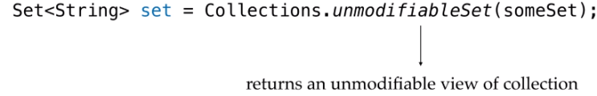

Next property is **persistency** by the term persistent data structure we mean whenever any modification occurs in data structure we have to preserve the previous state.

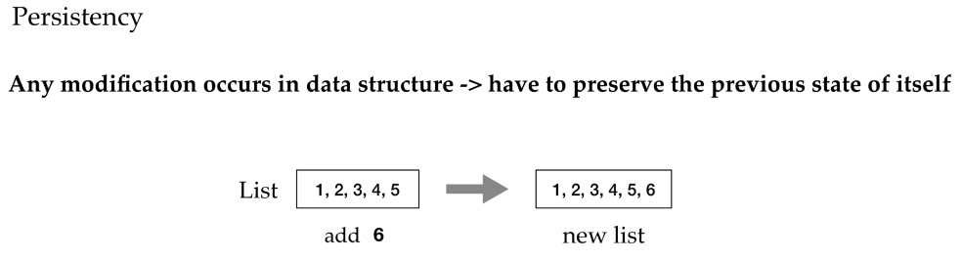

The idea is we don't update the data structure in place or we can say any modification on the functional data structure does not change the existing version it actually produces a new version for that. For example a linked list having few nodes if we need to add a new node at front we will just add it at front and will preserve the previous date too, so this will be a new version of the list. Note that it doesn't copy the large chunk of data it just reuses the old structure and implements the required changes and this makes persistent data structures fast and efficient.

|  |  |
| --- | --- |
|  |  |

Next is the methods of functional data structures are **referentially transparent** that is we call a function once catch the value and later can use it anywhere, it won't be changed throughout the program. Simply saying, for some given input the output will always be the same and it's the reason why it is more efficient to use functional data structure, as with them we don't need to put any extra logs synchronization stuff to secure the things like when we work in concurrent environment with mutable data. We need to be bit careful, but in functional programming we know nothing gonna happen to our data, nothing can modify it.



Now the point comes, why is it more difficult to design and implement functional data structures than imperative ones.

|  |  |
| --- | --- |
|  |  |

There are couple of reasons for that first the functional programming is strictly against destructive updates as they can be dangerous if not used correctly and as we know imperative data structures rely on assignments in a crucial way, so it's quite difficult to find different solutions for functional programs. Second thing is functional data structure has to be persistent and that is indeed tough.

In imperative data structures we don't keep any older or newer versions of them such data structures are called **ephemeral data structures**, but we have to keep every version of them in case of persistent data structures we can implement persistent data structure in both imperative and functional language though many as imperative programmers may find persistent data structures more complicated and even less efficient and slower than ephemeral data structures as we need to maintain the previous state of the data structures at every update but that's not always true there are many other points why you should prefer functional data structure over imperative one.

So let's try implementing the very basic structure which is list

### List

|  |  |
| --- | --- |
| We will implement the basic operations like creating list adding removing elements from it etc while doing this just keep in mind that the structure should be immutable, that is every time we do any change in list, we have to create a new list. We will implement a linked list, we will have a recursive list structure composed of an element that will be the first element of the list called as the head and the rest will be the tail of this list, which is again represented by a list. So this is the head and this is the tail which is again a list again having head and a tail and as we're using a recursive definition there has to be some terminal case which will be an empty list called as nil. Nil won't have any head or tail, let's see how we can do this in code. |  |

**ListDemo.java**

import java.util.List;

public class ListDemo {

public static void main(String[] args) {

ListFun<Integer> list = ListFun.list(3, 6, 9);

list.forEach(System.out::println);

ListFun<Integer> newList = list.addEle(56);

newList.forEach(System.out::println);

ListFun<Integer> removeEle = newList.removeEle(9);

System.out.println();

removeEle.forEach(System.out::println);

System.out.println();

ListFun<Integer> reverseList = removeEle.reverseList();

reverseList.forEach(System.out::println);

ListFun<Integer> list1 = ListFun.list(3, 6, 9, 8);

ListFun<Integer> list2 = ListFun.list(35, 78, 90);

System.out.println();

ListFun.concat(list1, list2).forEach(System.out::println);

System.out.println();

List<Integer> l = List.of(2, 5, 8, 6);

list1.addAllEle(l).forEach(System.out::println);

}

}

So here we will be having an abstract class ListFun and this is our functional list, it is having abstract methods head and tail, that are there to return head and tail of the ListFun. Then we have length and is empty method. This list has some implementations, first implementation is Nil. So it's basically a static nested class which we have inside this list fun. It extends this list fun and overrides the head, tail, isEmpty methods so, and as it represents null or empty list. The head method and the tail method of this nil, will return null and the isEmpty will return true, then we have one more implementation of this list fun, which is const. It is basically, to construct the list fun, so again here we are having head and tail then we have a constructor. The constructor takes the element and sets it to the head of the list and takes a list of type ListFun and sets it to the tail. Then we have head method, to return the head and tail method that returns the tail and isEmpty which checks the length. If the length is empty 0, it returns true else it returns false.

**ListFun.java**

|  |  |
| --- | --- |
| import java.util.Collection;  import java.util.function.Consumer;  public abstract class ListFun<T> {  public abstract T head();  public abstract ListFun<T> tail();  public abstract boolean isEmpty();  @SuppressWarnings("rawtypes")  public static final ListFun NIL = new Nil();  **private static class Nil<T> extends ListFun<T> {**  private Nil() { }  @Override  public T head() { return null; }  @Override  public ListFun<T> tail() { return null; }  @Override  public boolean isEmpty() { return true; }  }  **public int length() {**  int l = 0;    ListFun<T> temp = this;  while(!temp.equals(NIL)) {  l++;  temp = temp.tail();  }    return l;  }  **private static class Const<T> extends ListFun<T> {**  private final T head;  private final ListFun<T> tail;  Const(T element, ListFun<T> list) {  this.head = element;  this.tail = list;  }  @Override  public T head() { return head; }  @Override  public ListFun<T> tail() { return tail; }  @Override  public boolean isEmpty() {  return length() == 0 ? true : false;  }  }    **public static <T> ListFun<T> list() {** return NIL ; }    **public static <T> ListFun<T> list(T...t) {**    ListFun<T> temp = list();    for(int i = t.length - 1; i >=0 ; i--) {  temp = new Const<T>(t[i], temp);  }    return temp;  }    **public ListFun<T> addEle(T e){**  return new Const<T>(e, this);  }  //method to add element at specific position  **public ListFun<T> addEle(int pos, T ele) {**  if(pos < 1 || pos > length())  throw new IndexOutOfBoundsException();  if(pos == 1)  return this.tail().addEle(ele);  return new Const<T>(head(),  tail().addEle(pos-1,ele));  }  **public void forEach(Consumer<? super T> action) {**    T current = this.head();  ListFun<T> temp = this;    for(int i = 0 ; i < length() ; i++) {  action.accept(current);  temp = temp.tail();  current = temp.head();  }  }    **public ListFun<T> removeEle(T ele){**  if(this.length() == 0)  return this;  else if(ele.equals(this.head()))  return tail();  else {  ListFun<T> newTail = tail().removeEle(ele);  return new Const<T>(head(), newTail);  }  }    //to remove from specific position  **public ListFun<T> removeEle(int pos){**  if(pos < 0 || pos > length())  throw new IndexOutOfBoundsException();  if(pos == 0)  return tail();  return new Const<T>(head(),  tail().removeEle(pos-1));  }    **public ListFun<T> reverseList() {**  ListFun<T> list = list();  T current = this.head();  ListFun<T> temp = this;  while (!temp.equals(NIL)) {  list = list.addEle(current);  temp = temp.tail();  current = temp.head();  }  return list;  }    **public static <T> ListFun<T> concat(**  **ListFun<T> list1, ListFun<T> list2){**  return list1.isEmpty()  ? list2  : new Const<>(list1.head(),  concat(list1.tail(),  list2));  }    **public ListFun<T> addAllEle(final**  **Collection<? extends T> list){**  ListFun<T> result = this ;  for (T t : list) {  result = result.addEle(t);  }  return result;  }    **public ListFun<T> clear(){** return list(); }  } | We haven't implemented the length method yet, so let's implement this method. Here we are initializing l with 0 and in this, we are going to take a ListFun and let off type t and let's call it temp and we will assign the current list to this listFun. So we will be having the current list now while while we don't get nil. The list will be having elements inside it, so temp, until temp is not equal to nil we can increment the length l++. I have already created this nil object so here we are incrementing the length and now we have to modify the temp for the next iteration. So this will be temp.tail the first element to the list fun is always the head of the list and then the remaining is the tail. So what we are doing here, we are assigning the tail to the temp, now this tail will be the new list for example. Suppose we are having a list of four elements, one two three four the head to this list is one and the rest two three four will come into the tail.  So what we are doing here we are assigning the tail to temp now then this new list will be a list with elements 2 3 and 4 and 2 will be the head of this list and 3 and 4 will be the tail of this list. So this goes on until we find nil and the moment it finds nil the execution comes out of this while and it returns the length. So here it's checking if length is 0 it returns true else it returns false so until now what we have seen we saw the abstract methods that this list fun is having and the implementations of this list fun first one is the nil to represent an empty list and the second one is the const and as you can see there is no constructor in this list fun class to construct a list  So we will start with creating a method that will return an empty list so let's create that method public static and this will return the list one with type t and list so if someone is calling list method without any argument this will going to return an empty list so here what we are going to do we are going to return nill and as we're using t here and it's a static method so it's a generic method let's make it generic by adding the t just before the return type now let's create another method public static again it's a generic method this will return this one list but this method is a var arg method we can pass any number of arguments to this list method and this method will return a list fun with those elements so it this is public and it takes and here in this method what we're going to do first we're going to initialize the list with the empty list so here we are going to take list fun t and let's call it them and here we will first create a nil by calling the list and then we're going to take a for loop and we're going to initialize i with the length minus 1 t dot length minus 1 until i is greater than equal to 0 and then we are going to decrement the i with each iteration and here we are going to say return new const so here we are going to call the constructor of const that takes two argument first argument is element that it assigns to the head and the second one is the list that is going to be the tail of this const so first argument to this cons that i'm going to pass is t i and the second element is the temp itself so what we are doing we are processing the indices in reverse order that is the last element will be inserted first so here eighth element will be the head and the rest will be the tail and then we are assigning it to the temp and then we will finally return the temp here now let's closely see how it is going to add elements suppose these are the elements that we are going to pass to the var arg list method to construct the functional list so first in that method we are creating a nill which is an empty list so it gets created then we process these elements and to process these elements we have a for loop that traverse the elements in the reverse order so first element will be the one at the last index and that is 64.  so now we are calling the constructor of the const with this element at ith index which is 64 and the second argument to the constructor is the temp which is the nil so 64 becomes the head and nill becomes the tail of this new tamp now this is the new temp and during the second iteration the element at ith index is 10. so the first argument to the constructor of const is this ten so this becomes the head and the rest of the data that is currently in temp becomes the tail similarly in next iteration the element at ith index is 22 so the first argument to the constructor is 22 this becomes the head and the current temp which is having 10 as head and 64 and nil as the tail this complete temp is the second argument to the constructor of const so it assigns this to the tail so it becomes the tail now the last iteration now the element at the eighth index is 73 so this will become the head and the rest which is currently in temp becomes the tail and we get the final functional list  So now in this class we have two methods first is a no arg list method which returns an empty list and the second one is a var arg list method which returns a list now we are going to create a method to add elements in the existing list so this is going to be an instance method as we are adding the element in the existing list so this will return list as in functional data structure we always return a new list we don't change the existing one as its immutable and also we need to preserve the previous dates so that one who will have the previous reference can work with the previous state of the list happily  So here it returns a new list by adding the new element into the existing list and let's call it add element this will take element of type t and here in this method we will return new const and the first element to this constructor is going to be the e that we're passing to this method so this new element e will become the new head and the rest of the list should become the tail so we will pass this as the second argument to make the previous list as the tail and this will return a new list so we have created all the methods to add elements or to create the list now let's implement the for each method that will take the consumer and will return nothing so this is to iterate through each element of the list so we need to start from the head and then iterate through the list by updating the rest of the tail as the list, let's see so this returns let's call it public void as this returns nothing so the return type is void and this is for each that's gonna take a consumer here we can pass anything super t and let's call it action let's import consumer now the current element is the head of the list.  So let's take it in a variable and let's list fun and let's take the complete list in temp so first we need to execute this consumer we need to call the except on this action for the head so let's take a for loop it will start from 0 up to the length of the list and let's call accept on the action by passing the head which is in current so this way we will keep on fetching the head and we will keep on executing the consumer on the heads so for next iteration the list we will remove this head on which we have already executed the consumer from the list  So for the next iteration the temp will be the tail of the current list so we'll fetch the tail and the for next iteration current will be the head of this temp so for next iteration it will fetch the next head which is stored in the current and then again it will update the temp with the tail next tail and will update the current with the next head up to the complete length so now we're all set to create our own list  So let's create it here list fun, let's create a list holding integers and this is the list so first we're going to use the var arg method so list fun dot and here let's pass three six nine and we have already implemented the for each method so let's use that for each method to print the elements of this list so list dot for each system dot out print ln let's run this and see we get 3 6 9 the elements of the list |

Now if we want to have a new list having all these elements along with the new element we can use the add elements method on this list so list dot add element and suppose i am going to add one element to it this will return a new list that will be having all these elements along with this new add element now let's again print this new list new list and let's execute this again so now we have 56 3 6 9 in our list so we have seen the construction part of the list now suppose we want to remove an element from this list let's create a method to remove element from this list so we have public and this will return the list and let's call this method remove element and we will pass the element that we want to remove to this method so the first case is when we don't have any element in the list so if the length of the list is zero then it should return this now else if the element is the head that we want to remove then we will simply we can return the tail so if element is equal to the head of this list or is the head then return the tail and if both cases are not satisfied for that we have another else so we will keep looking for the element so here we will recursively call this method so let's call this method with the tail so this will return the new tail list fun t and this is new tail this is tail so if new tail equals the current here then simply return the current list object so return this otherwise create a new list by appending this tail with the current head so return new const the current head and this new tail so how this method is going to behave suppose we have a list with elements one two three four and we want to remove the third element which is three so see the first condition it checks the length which is not zero so this will return false and now the next condition if the element is equal to the head so first element is one which is the head but the element that we want to remove is third so this will also return false now the last block else in which we will again call this remove element recursively with the element we want to remove which is three but this time this new list the with which we are calling the remove element will be a list having elements two three four so for the second execution of this remove element the head will be two so it will again check if the element that we want to remove is the head so it will again return false as the element that we want to remove is 3 but the head is 2. now it will again come to this else here it will again call this remove element recursively this time it will call the remove element on a list having elements three and four so now this time the element that we want to remove is the head so it will return the tail so the previous execution when the head was 2 gets the value of the new tail for 2 the tail were having 2 values 3 and 4 so this new tail doesn't matches the current tail so it returns a new list and construct it by appending the new tail with the head and as for the current execution head is 2 and the new tail contains single element 4 it returns a new list with values 2 and 4. now now the execution previous to this for which the value of head is 1 gets the new tail with values 2 and 4 so then it checks the new tail is equal to the current tail or not the new tail contains 2 and 4 whether the current tail contains 2 3 and 4. so this again returns false and it returns a new list by constructing it using the constructor of const and passes the current head which is 1 and the new tail which is 2 and 4 and we finally get the list with the element 3 removed from it so here this condition is not required it's not doing anything in each case it is returning a new list so we can happily remove that so now this remove element method is ready let's try this method so from this list containing 3 6 and 9 or from this new list which contains 56 3 6 and 9 let's remove one element new list dot remove and let's remove three this will return a new list and let's print this new list or the element of this new list which is remove element list system dot out print ln and let's run this so oh it prints all the elements where we went wrong here let's see the implementation again it checks the length returns the object then it checks the element is head or not and then this recursion oh i'm not supposed to use this length field i was supposed to use the length method i forgot to remove this length field we don't need this i'm not setting it anywhere now let's try it one more time so now it remove the element nine so we implemented method to add element into the list and to remove element from the list similarly we can implement methods that adds the element at specific index or removes the element at specific index i've already added those methods in the list fun class that i have attached in the resources but before looking on to the implementation of those methods i want you to try it once now let's move to the next operation next operation that we're going to implement is the reversal of list so let's create the method to reverse the elements present in the list or to reverse the list so it's public this will again return a new list list fun and let's call it reverse the list or reverse list so the implementation will be very similar to the for each implementation we are first going to take a list and this will be the nil list the empty list which we're getting by calling this list method and now the current element the head of the current list so t current so this will be this dot head and we will take the current list into a variable temp so list fun temp and this now we will add this current element to the new list that we have created here and we will keep on adding the heads one by one into this list so while temp is not null that is our nil list dot add element and let's add the current element here and now update the temp with the tail so this will be the new list temp dot tail and let's update the current as well temp dot head and finally we will return this list so now this reverse list method is ready we can use it let's try this method so this remove element list contains 56 3 and 6. let's try to reverse this list so remove ele dot reverse list this will again return a new list this is reverse list and let's print the elements of this reversed list and let's execute this so we get the elements in reverse order now let's move to the next operation so the next operation that we are going to implement here in list fun is the concat operation so we will pass two functional list to the concat method and this concat method will return a new list so public list fun t concat and this method should be a static method so let's make it static and now we have to make it generic too and here we are going to pass 2 lists list fun this is list one and another list list fun list 2. so it should return the merge list and if the first list list one is empty then it should simply return list two else it should return a new list by calling the constructor of const with the head of list one so head of the new list will be the head of the first list because it's it is going to be the first element of the new list and the rest will be the tail so here we will call the concat list one dot tail and list two so here again we're calling this concat method recursively so this will do the job now let's use this method to concat 2 lists let's create two lists this is list one and let's create one more this is list two and let's merge these using the concat method so list dot concat list 1 and list 2. let's print the elements of this returned list using the for each method now let's run this so we get a new list with all the elements of list 1 and list 2. that is a merged list now suppose we want to create a functional list out of an existing collection so let's create a method that creates a functional list out of any collection so here we're going to have public list fun holding t type of elements and the method is add all elements and thus we pass a final collection it can be of t type or the sub type of t list and let's import collection and here let's create a list and let's call it result so initially this will be the current list and now we will keep on adding elements to this list to get the final list so here we are going to use the for each method to iterate over this collection so for each element t present in this list we're going to add the element one by one to the result so result result dot add d and then we will finally return the result we get let's try this method so let's create a collection here let's create a list integer and list dot off and let's pass elements to this list and now let's call add all elements to add all the elements of this list into the list fun so we'll call it on this let's say list one so list1 dot add all elements and let's pass l here and let's print the elements of the returned list so it contains all the elements of list one and all the elements of the collection that we passed to this method so these were all the operations on this functional list so this is how we can implement our own functional list and instead of using the list from collection we can use this list in functional programming now if we talk about algorithm complexity in all these operations that is to figure out how long any operation will take to execute in mathematical way or how many steps it gonna take we further have notations for that like if the operation is taking constant number of steps or constant time we define it as O(1) or if it finishes in linear number of steps like the operation in which we traverse through all the list it takes linear number of steps for that we define it as O(n) so these all are basic annotations though we won't judge the performance of individual operation we will check the total expense of these operations as we are doing multiple operations together to perform a single thing and that's called the amortized complexity let's see this for adding element in the list we are actually prepending the element in the list in that we just creating a list with a new head element and the previous list as tail that individually takes constant time to execute now we need to reverse it to make it look like the same way we entered elements we call reverse method this is slow as it traverses through the complete list so it takes linear amount of time to execute now amortized complexity is to evaluate total time it takes in this thing to evaluate that we use banker's method here with this we just don't count the actual complexity we add a tiny credit to it every time so it says operation takes a tiny amount extra to execute for example to add element it will take some amount extra with constant time so that for every cheap operation we keep some extra amount of credit with it and later we use that in any other expensive operation so for n add operations the total time will be n times this extra credit and this total thing with reverse operation will take 2n plus n multiply x that is n 2 plus x super operation it will take O(1+x) to execute for adding elements and that is not much expensive if we compare it to the mutable data structures where it takes constant time to execute and here we have little bit more with that so we are good note that we're not having much expensive operations here so we are good but even if we only go with expensive operations we can make it efficient how as we know functional data structures are immutable and persistent and referentially transparent so we may catch the result whenever we want that is if we go with lazy evaluation we don't need to give the result until it's really needed so with lazy evaluation we have that full cached thing with us so whenever someone will call expensive operation we can give the result immediately we can say the first call will be expensive and the rest will be very fast so there are ways to make it faster and efficient it's all up to us how we implement things as it's still a matter of research that what can be the best or optimized way to implement functional data structure so this was all about this lecture

### Queue

|  |  |  |  |
| --- | --- | --- | --- |
|  | The next structure that's queue we know queue follows first and first out order that is we insert element from the rear side and remove from the front now to implement queue if we take a list we need to traverse through the list until the end to add the elements as queue works like that.  So this will make the performance suffer as it's expensive to append any element in the list. | | |
| So what can we do for that we can build a queue by taking two lists one is the front and the other is the rear both will have some head and some tail obviously the head of the front will be the head of the queue and we will take the rear list in reverse order.  So the tail or the last element in the rear will be the head of the rear so by doing this we will have easy access to both ends now we can insert and rear and get the element from the front as both of them are heads of the list | |  |

Let's try implementing queue and let's have a clear picture of this let's see how we can implement queue this is the queue fun class and here we are having two lists as fields one is the front and the second one is the rare as we discussed then we have a private constructor to construct an empty queue so here we are calling the list method which returns a nil list or an empty list and we're setting it to the front of this queue and similarly for the rear then we have a static factory method to return the queue object so here in this method we're returning an instance of q1 which calls this no r constructor so it returns an empty queue then we again have a private constructor to enqueue the element in the queue which we are calling in this enqueue factory method so it returns an instance of queue fun but this time it calls the constructor with two arguments

|  |  |
| --- | --- |
|  | First argument to this constructor is the queue the current queue and the second one the element which we want to add in the queue so here we are checking if the front is empty then it adds the element at the front else the front of this previous queue will still be the front of this queue and similarly for rear if front is empty the rear of this queue will be the rear of this new queue otherwise it will add the element at in the rear queue let's see how this enqueue behaves so suppose we want to add four elements in the queue it checks front is empty if front is empty it adds the element in the front now when 102 comes the front is already filled now it's not empty so this 102 will get added to the rear list similarly 103 it checks front is empty front is not empty so it gets added to the rear list and then the last element which is 104 it comes and gets added in the rear list |

So we get the queue with these four elements so this is the code for enqueue now coming to dequeue queue follows first in first out order so the first element that will be discarded from the queue will be the head of the front so here we are calling another constructor q1 with two arguments first is the tail as we're discarding the head and the second one is the rear so we are calling this method with the tail of the front and the rear list so for this constructor the tail of the front list is the front and the rear list is the rear so if there was only one element in the front then that element would be the head of the front

|  |  |
| --- | --- |
| So we have discarded that head here by calling this constructor and if the front is still empty that is the previous front was not having any elements in the tail then what it does it takes the rear list and reverses it and assigns it to the front as this previous tail will be the new front and for rear if front is empty front becomes the rare otherwise rare will be the rare let's take a closer look on it suppose this is how the elements are arranged in the front and the rear list the front is having single element 101 that will be the head of this front so the first element that will get discarded is the front head of this front which is 101 so it will get discarded when we will call the constructor by passing only the tail of the front so for this constructor now the front is empty and the rear is having some elements it checks is front empty if the front is empty it reverses the rear list and makes it front otherwise it will be having the tail of the front as the front |  |

now for the rare it checks is the front empty if the front is empty it makes it rare otherwise it will be the rare so we'll finally get this queue with elements 102 103 104 and that will we will be having in the front

Now let's implement the for each method for this functional queue this is going to be almost same as the for each we implemented in the list so it returns nothing void for each it takes a consumer which we call action let's import consumer and we will take the current element which we want to invoke this consumer for so which will be the head of the front and the rest everything we're going to take in temp so this is the remaining list list fun and call it temp and here we will concat the remaining part of the front which is the tail list fun dot concat front dot tail and the rare list and we will pass the rare list after reversing the rare list because we need to read the elements of rare list from end towards the start so this dot rare dot reverse now while we don't get null temp is not equal to null let's invoke the consumer for the current and now let's update the current and the temp new current will be again the head of the temp and the rest everything will be the temp which is the tail of the temp so it's done now let's try these operations on the queue so we will start with creating the functional queue so it will hold string elements so here we will call the factory method of queue fun to create an empty queue so queue fun dot queue this will internally call the constructor that returns an empty queue now on this object we can call the enqueue and dequeue method to add elements in this queue so q dot enqueue and let's pass hey and if i want to add more elements how are you and more and let's collect this returned queue and print the elements of this queue for each system dot out so it prints the element hey how are you fine now let's try the dequeue method to dequeue element from the queue so take this enqueue and invoke the dequeue here so it will remove the first element from this queue and let's collect it in another queue and print the elements of this return view println so we only get two elements how are you and fine hey is removed from this queue now let's add few more methods in this functional queue so first method we're going to add is the size method that will return the size of the queue so it's public int size and here we will return return front dot length and adding it with rare dot length and one more method it's peak method public T peak this will check if the size is zero then it will return null as you will be having no element in this queue and else it will return the head because peak method returns the first element of the queue so it will return the head so return this dot front dot head next method that we're going to implement is is empty method so let's implement is empty method that will return a boolean so it will check if the front is empty if this dot front dot is empty and the rare is also empty this dot rare dot is empty then this method will return true as we are not having any element in the front and in the rear as well so return true else return false so these were the methods in the this functional queue and this were the implementation of this functional queue now let's try to use these methods that we added in this class so the first element in this dequeue is how are you so let's use the peak method and check what we get so we get how are you and let's check whether this dequeue is empty or not so it returns false as it's having elements inside it and the last method is size that we're using inside this peak we can use it here too as it's public the size is two as it's having two elements so this is how we can implement our own queue and this is not the only implementation we can have you can implement this functional queue in your own style that might be more optimized than this but you should keep in mind that the functional structure you are designing must be immutable and persistent.

### Tree

The next structure is tree we will implement traditional binary tree in which we have a root node and left to it is a left subtree and right to it is a right subtree here the value of root node will always be lower than the right node but higher than the left node's value so it will have the sorting now if we talk about its implementation and if we compare it to the list that we implemented it is quite similar to the list in sense that at the place of head comes its value which is the root node and it will have two tails left and right and these tails left and right are again trees all the leaf nodes will have empty trees that is nil trees as their left and right nodes let's see how we can implement this in code so this is the functional tree class tree fun the elements that we are going to pass in this functional tree must extend comparable because the elements in this functional tree are going to be inserted in a sorted order right so see what fields we have in this class we have value which is basically the root node of this tree and then we have left subtree and right subtree of the same type tree fun then we have size of this tree and the height of this tree we have a constructor which is a no argument and private constructor that defines an empty tree so we set null to the value and a nil tree to left subtree as the left sub tree and similarly a nil as the right subtree and the size of such tree will be zero and height will be minus one as the height of the binary tree is the number of edges between the root and the leaf node so if the tree is empty the height would be minus one and suppose if the tree were having single element in it then that element would be the root and the leaf at the same time so height would be zero now then we have another constructor with three arguments first is the left subtree second is the root value and the third one is the right subtree and we are assigning these values to respective fields then we have size we're calculating the size here the size of the binary tree would be the size of the left subtree plus size of the right subtree plus one one for the root node so this will be the size of the binary tree then we have the height of the tree height of the tree will be the maximum of left or the right subtree if height of the right is maximum then the height of the right plus one else the height of the left plus one but this constructor is private we can use it inside this class only so what we have to create or construct the object of this tree fun outside this class for that we have this var arg static method to construct the object of this class but we haven't implemented it yet so let's implement this so first we will take an empty tree so it's nil and then we will take a for loop to iterate over this var arg up to the length and here inside this for what we are going to do we're going to invoke the insert method to insert single element into the tree and let's insert this element and we'll return this tree and as you can see insert method we don't have an insert method in this class so let's add insert method here so let's call it new value and here what we're gonna do we will first check is the tree empty return is empty let's create a method for it it will return boolean and it will check the size of the tree true else false so if the tree is empty we have to insert the value at the node of the tree at the root node of the tree so we'll call the constructor tree fun and we will pass nil as the left subtree and the value input to this method will be the value of the root node so we will pass this here new value and the right subtree will also be null else we'll compare this new value that we are giving to this method to the current value if the new value is less than the current value that means the new value is smaller than the current value so we'll add it at the left so if this is true add this value to the left so we'll call the constructor here new tree fun and at the left we will insert this new value so left dot insert the new value and then we will have this dot value as the root and write as right else if the new value is greater than the current value then it should get added to the right of this current value so new value dot compared to this dot value is greater than zero then add this value at the right new treefun left will be this dot left the current will be this dot node will be this dot value and the right will be this new value i mean right dot we have to add it to the right tree so we have to invoke the insert recursively with this new value and else if the new value is equal to current value which is the last case so for this what we are going to do we are going to update this value as a node so here we'll call new tree fun left will be the left and it will overwrite the previous value both are however same and this dot right and remove this so implementation is ready here we are calling the insert for each element present in the var arg so it will insert all the elements one by one to the tree so we have implemented or the implementation is done for inserting values so let's try it here so here i'm creating an empty tree this is a var arg method so we're passing no argument to it it will return a nil tree now we're gonna add some elements into this tree let's add the elements 7 6 10 3 45 and let's print this tree so we have 23 as the root node and then at the left of this 23 we have the 5 as the next node 5 is further having 3 as left node and 10 as right node and at the right of 23 we have another subtree which is having 76 as the root and the left node is 45 and the right node is nil and again these null null null represents a nil so all the leaf nodes are nil and if you don't want to print the null values here that is the leaf nodes we can write a condition here if this dot value is not equal to null then do this else print nothing now let's execute this so this time it prints 5 23 and at the left of the 23 we have 5 5 has further 3 as the left node and 10 as the right node and here we have 76 to the right of 23 and 45 to the left of 76. so this is the tree that we are getting and if we don't want to format it like this we can remove the formatting too let's remove these brackets here and let's again run this to get only the elements of this tree so these are the elements that are sorted in ascending order let's have a closer look at how the element gets added in the tree suppose we want to add 3 in this tree 3 is less than 23 so it will create a new tree taking the root node and the right and it will check at the left where we are having five three is smaller than five so again it will go to the left of the five so it will create a root node 5 3 as the left node and the remaining leaves will be null and finally we will get this tree now next next is remove operation so let's try implementing a method to remove a given element from the existing tree so we will have public tree fun so it will return a new tree after discarding that element that we want to remove and let's call this method remove and let's pass the element to be removed here oh this is e here we will check if the element that we want to remove is having value smaller than the current value then it means that the value to be removed is present at the left of the current value so we'll check if the element dot compared to this dot value is less than zero that means the value we want to remove is smaller then what we will do we will invoke this remove on that left tree so return new tree fun and here we will invoke the remove on the left left dot remove and will again pass this element and the root node will be this dot value and the right is the right of this tree you can also write it write a this here so this is the first case and else if the value is greater than the current value that means we have to remove that element from the right tree so else if the element is greater than the value then return new tree fun and here left will be the left this dot left value will be the value this this dot value and we will invoke the remove on the right tree to remove that element so this dot right dot remove and the element so we covered two cases now the last case when the value that we want to remove is the current value itself that is this dot value is the value or the element that we want to remove then in that case what we will do we will merge the left subtree and the right subtree attached to that particular node so this way that node will be automatically discarded so left return left dot merge and pass the right here now let's create this method so this merge method will merge the left and the right tree and for this merge method method left is the tree or the object we are going to operate on and right is the input argument to this method one case is suppose the left subtree is not having anything so in that case we can simply return the right subtree and suppose if the right sub tree is empty in that case we can directly return the left subtree so if this dot is empty that means the left sub tree is empty then return return to right subtree and similarly if else if right is empty then return the left which is this for this method and now the last case so the last case is when both the sub trees are non-empty in this case what we will do we will put the value of one of the subtree at the place of the value we are removing and if we are doing so we have to merge the branches it's having attached to it so suppose i will place the value of the left node at the value of the element that we are removing as the place is empty and we have to fill that place with one value so here we will return return new tree fun e so it takes three arguments the middle one is the root or the value of this new tree so the value of this new tree is going to be the current left which is this dot value so we have put the value of the left node at the place of the value we are removing and we are not touching the right node so right as right and now this value has some nodes attached to it may have some nodes attached to it so so we again have to merge the branches attached to this value so here we will invoke this dot left dot merge right which is actually this dot right so it's done let's remove this return null so here let's see how the remove operation works suppose we want to remove the element 76 so it is to the right of 23 because it's greater than 23 so it will remove it from the right subtree and after removing it it will perform the merge and as we can see at the left we are having 45 so it will make this 45 the current value and as 45 is not having further branches if it were having branches then it will again invoke the merge to merge those branches so now let's try removing a value from this tree so t dot remove let's remove 10 and let's print this tree so now we get 3 5 23 45 76 the 10 is removed from this tree now let's move to the next operation let's create a method here to check whether the given element is the member of this tree or not so it will return boolean and let's call it as member and we'll pass the element here so first case is if the value is smaller than the current value if value dot compared to this dot value less than zero so in this case so if the value is smaller than the current value we have to search for this value in the left tree right so let's return left dot is member so it's a recursive call we are again calling this method by passing the same value and else if the value is greater than the current value value dot compared to this dot value is greater than zero we have to search for the value in the right subtree so return right dot is member and else if both the values are equal the current value and the value passed to this method both are equal then we have to return true so it should check until it finds null if it find null that means it has traversed the complete tree and it did not find the value so here else return falls not equal to null so now let's try this method here in this private class so let's check for 45 first so let's see is the tree having 45 or not is member 45 and let's print the result so it returns true now let's try with 50. the tree is not having 50. so this time it returns false and now let's implement next method so next and the last method that we are going to implement in this class is max method so we will find the maximum element present in the tree and as we know the maximum element will be placed at the right most place so let's implement this method by getting the value of the rightmost node so the rightmost node will be having nil as left and the right subtree so we can use this condition to return the value so return if at the right of the value we are checking we have null so here equals null so if at the right of the value we have null that means this is the last value so return this value return this dot value else again call the max on the right to get the max let's try this method to get the maximum of tree sysout and let's run this so we get maximum which is 76 for this tree so this is how we can implement a functional tree and we can use this functional tree in functional programming wherever we need to add elements in a sorted order

### Map

The next structure that we're going to discuss here is map map is used to store data in form of key value pairs where keys are always unique so here basically we will implement a hashmap hashmap is based on hash table and it uses hashing to store key value pairs what is hashing if you don't know about it hashing is a technique in which we generate a unique number called hash code by transforming the key of the key value pair because keys are unique and then we use this hash code to calculate the index at which that particular key value pair is going to be stored in the hash table so this way each key value pair by default always have the information of its own address with it as the address part is calculated from the keys the benefit of this approach is that it helps in faster access of that pair because we just need to jump on to that particular index to get the value or the pair now to implement the functional map we have to keep in mind that the map should be persistent and immutable let's see how we can implement a functional map so to implement a hashmap we need an array of entries entry represents a pair of key value so let's call it entries this will work as the hash table here now see this entry class it's having key and value of object type so you can take any type key can be of any type and value can be of any type then here we have an additional field which is the next this points to the next entry attached to it now coming to this map fun let's create a constructor here so it's public map fun so here in this class we're going to take one more field which is the size of the map so this constructor will take size let's set these values initialize size with size and this dot entries new entry array with the given size until we don't insert anything in this map all the indices will be having null entries so let's add entries in this array for int i starting from zero up to size and i plus plus size minus 1 and then i plus plus and here this dot entries with i create a new entry object now we will calculate array index with hashing we will take hash code of the key and will do mod by the size of the array so that is in between 0 and the size of this map so let's write the method public get hash we can implement it in our own way so it takes the key of k type and here what we gonna do we will return key dot hash code so first we are invoking the hash code on this key object and then we're gonna perform the mod with the size so this will give us the index at which we're going to place this entry in this entries array so this is called hashing when we transform the key to get a hash but it is possible that for two different keys we get the same hash code then we'll both the pairs get the same index so yes both gets the same index and this is called a collision the solution of collision is that we put the elements with the same index in a linked list at that index which is the reason we took an additional field next here in this class so now let's write a method to put an entry in this map so public map fun k v type and let's call this method put that takes key and value so in this method what we're going to do we're going to calculate the hash or the index at which we're going to place this entry so we have get hash method for that so let's pass the key to get the index now suppose what if this index is already having an entry so what we will do we will take this entry in this existing entry existing entry and let's fetch the already existing entry by passing the index or the hash here so this is the existing entry if the index is already having an entry and then what we will do we will create a new entry that we are going to insert here in this map let's call it new entry new entry object and pass the key and the value here and now at this index enteries hash place this new entry and at the next of this new entry put that existing one so new entry dot next the existing entry so this way so this way we're not losing any previous entries and the incoming entry is getting added at the front each time so basically we are creating a linked list of entries at that index in case of collisions now let's return a new map from this method to keep this structure persistent and immutable so return new map fun k v with these entries and the size we haven't created this constructor so let's create this constructor here private map fun which takes an entry array entry array entries and the size of the map so this dot size is equal to size and this dot enteries enteries so we have all the code to add the pair in this map now let's write method to get the value at a particular index from this map to access the value we will again calculate the hash for the given key and we will go to that index and search for the value related to the given key so let's create public we get value on this key so let's take val equals to initialize it with null and int hash let's get the hash for this key and then entry entry and now let's get the entry from entries array add that hash we're getting the entry on this hash but only the hash cannot guarantee the value there as there can be more than one value at that index if collisions have happened so here we will write a while loop while this file will loop over until the next pointer is not null so entry dot next is not null if we get the next equals to null that means it is the last entry that we're having in this at this hash and now here we will check both the keys are same or not using the equals method don't go with equal to operator here because we are comparing the objects by equals method implemented for that key object if you remember the hash code and equals contract so if if key dot equals entry entry dot get key then if both keys are equal then we can get the value this is the value that we want to return from this method so entry dot get value and now let's cast it to v and if we find the value let's break the loop and if we didn't find the value then move further so let's modify entry to entry dot next and then finally return the value all right we have implemented the put method and the get value method but the put method that we have implemented here is not conceptually complete why because map is not allowed to have duplicate keys but this method is having nothing to avoid that so now that we know how everything is arranged in a map so let's implement the logic to avoid the duplicate keys so here we are calculating the hash we are getting the existing entry from the map now suppose this existing entry is already having this key then what we will do we will replace the previous value at this key with this new value so if the key is duplicate we're gonna create a method to check is the key duplicate or not duplicate key then update the value for this existing entry existing entry dot value equals to this new value let's create this method is duplicate to check whether the key is duplicate or not so let's create this method here private boolean is duplicate pass the key and initialize a boolean result result with false entry entry from the entries array at the index get hash generated by the given key so take the key calculate the hash from it take it an entry that hash or index can have multiple entries right so while we have non null entries at that index entry entry is not equal to null do something check if t dot equals entry dot key then return result set the result to true else entry move forward entry dot next and return the result here return return result now the implementation is complete the few things that you can do on your own first we haven't covered the null case so if you want to cover the null case you can implement these or modify these put and get methods to have that null case and you can return 0 as the index if you get the key as null so this is the one thing and the other thing that you can do is to write this functional map in more optimized way like here we are creating the map fun object again and returning it you can go with more optimized approach like it can be cloning or something else so now let's come to this driver class and here let's create a map object so map fun let's take integer keys and string values new map fun and let's say size is five now let's add key value pairs into this map map dot put key is one and the value is nikhil and let's add key is 2 and the value is sourabh and key is three and the value is alex key is 4 and it's a 5 and the value is shawn and the last entry one last entry 100 and justin now how am i gonna print this map i haven't created any method in this map fun to display the map so let's create one method in this class which will display all the entries present in this map so we'll have public void display and here we will print all the entries so for int i equals to zero i is less than this dot entries dot length and i plus plus and let's print entries this dot entries i now here let's invoke the display method to display the map and let's execute this i probably did some mistake here let's see this is the display method and this is the get value and this is is duplicate oh here we enclosed this if here so this is within the if and this is outside the if now let's try running it and we get the result so for key 100 and key 5 we got the same hash so we get these two values two entries at the same index then we have the other entries at different indexes so this is how we can implement our own functional map

Let's summarize what we have learned so far in this section see we can implement data structures in many ways right we demonstrated one way of doing things in functional data structures while implementing you just need to remember that the data structures should be persistent and immutable rest all you can decide on what the trade-off you want so let's see what we have learned in this section first we learnt what functional data structures are and what are the complexities associated with them then we saw linear collections list and queue and implemented them through code then we implemented our own tree understanding the graph type of functional data structure and finally associative collections we implemented our own map so hope you enjoyed this section and the videos keep practicing and try implementing your own data structures in functional way see you in the next section

## *Design Patterns – Functional Way*

There are 23 design patterns in classical gang of four book. Lets implement some in the functional way of programming.

### Iterator

Iterator design pattern is a behavioural design pattern.

|  |  |
| --- | --- |
|  | It focusses on Accessing the elements without exposing the internal structure of the object. We use the conventional for loop where we come to know about the structure of the object. Whereas with iterator we don't expose the internal representation of the object we are traversing like it doesn't matter it's a list or a set it will be iterated in the same way with its corresponding iterator so this pattern enables to get a way to access the elements of a collection object in sequential manner without any need to know its internal representation examples of this pattern are built in java.util.Iterator and java.util.Enumeration. |

It iterates in the same way with the corresponding iterator

|  |  |
| --- | --- |
| List<String> **container** = new **ArrayList**();  OR  Set<String> **container** = new **HashSet**(); | for (String s: **container**) {  // do something  } |

UML diagram of a Iterator

|  |  |
| --- | --- |
|  | There could be concrete implementations of Iterators for example the ListIterator, SetIterator or QueueIterator and so on. In every collection type there would be a FactoryIterator method that would be implemented by the Concrete implementation of the Iterator. ListIterator understands how to iterate the list elements of the Collections API. So in case of List – the Collection here would be List, ConcreteCollection would be the ArrayList and ConcreteIterator would be the ListIterator and the Iterator would be the java.util.Iterator interface. So this is how we implement this pattern. |

To make a class Iterable we would have to implement the Iterable interface to make that class Iterable.

class MyContainer implements Iterable<String> {

@Override

public Iterator<String> iterator() {

return new Iterator<String> {

@Override

public boolean hasNext() {

/..

}

@Override

public boolean next() {

/..

}

}

}

}

In functional implementation we don’t need to do any of these things. Even we do not need to implement the Iterable interface, next and hasNext are not required because we won’t be using the conditional statements and assignments. This iterator pattern can be implemented easily in functional programming with the help of lambda and predefined functions.

import java.util.List;

import java.util.function.Consumer;

public class IteratorPattern {

public static void main(String[] args) {

MyArrayList list = new MyArrayList( List.of("Lalit", "Nagpal").toArray() );

list.forEach( System.out::println );

}

}

class MyArrayList {

Object[] elements;

public MyArrayList(Object[] elements) {

this.elements = elements;

}

public void forEach(Consumer<Object> action) {

for (int i=0; i<elements.length; i++) {

action.accept(elements[i]);

}

}

}

We can implement this in any Container that we are building and can implement this in a functional style like this. The static void main method shows the usage of the forEach method by passing System.out::println as the Consumer function.

### Strategy

* This is used when we have multiple solution or algorithms to solve a specific task and client decides the specific implementation which is to be used at runtime.

For example, there may be multiple sorting techniques to sort elements of a collection. Now it's up to the user to decide which algorithm we want to use, the best example in jdk itself is the comparator api.

The sort method of collections utility class takes two arguments first is the list to sort. And the second one is a comparator implementation. So based on comparator's different implementation, we can sort the object in different ways

Collections.sort( List list, Comparator comparator )

|  |  |
| --- | --- |
|  | The context receives a request and based on situation each strategy is contained within its own class. So there is a basic interface and all the concrete strategy classes which define individual strategies implement this interface. Lets try to do this same thing via the functional style now. |

In funtional way of doing this, We do not have to write so many concrete classes for doing this, as we can now utilize lamdas to provide any implementation on the fly.

All our purchase transactions of Stock for example are captured in the List here.

**StrategyPattern.java**

import java.util.ArrayList;

import java.util.List;

import com.java.examples.patterns.iterator.domain.Stock;

import com.java.examples.patterns.iterator.domain.StockFilters;

public class StrategyPattern {

public static void main(String[] args) {

List<Stock> stockList = new ArrayList<>();

stockList.add( new Stock("AAPL", 318.65, 10) );

stockList.add( new Stock("MSFT", 166.86, 45) );

stockList.add( new Stock("Google", 99, 12.5) );

stockList.add( new Stock("AMZ", 1866.74, 45) );

stockList.add( new Stock("GOOGL", 1480.20, 3.5) );

stockList.add( new Stock("AAPL", 318.65, 8) );

stockList.add( new Stock("AMZ", 1866.74, 9) );

StockFilters.filter(stockList,

stock -> stock.getSymbol().equals("AMZ") ).forEach( System.out::println );

}

}

**Stock.java**

public class Stock {

private String symbol;

private double price;

private double units;

public Stock(String symbol, double price, double units) {

this.symbol = symbol;

this.price = price;

this.units = units;

}

public String getSymbol() { return symbol; }

public void setSymbol(String symbol) { this.symbol = symbol; }

public double getPrice() { return price; }

public void setPrice(double price) { this.price = price; }

public double getUnits() { return units; }

public void setUnits(double units) { this.units = units; }

@Override

public String toString() {

return "Stock [symbol=" + symbol + ", price=" + price + ", units=" + units + "]";

}

}

In the StockFilters class we could write methods to filter the Stocks by symbol for example as below

**StockFilters.java**

. . .

public static List<Stock> bySymbol(List<Stock> list, String symbol) {

List<Stock> filteredData = new ArrayList<>();

for (Stock stock : list) {

if (stock.getSymbol().equals(symbol))

filteredData.add(stock);

}

return filteredData;

}

. . .

In the calling code that is the StrategyPattern.java class we could use this filter method now

StockFilters.bySymbol(stockList, "AMZ").forEach(System.out::println);

We get all the purchase transactions now for the Amazon stocks

Output as below

Stock [symbol=AMZ, price=1866.74, units=45.0]

Stock [symbol=AMZ, price=1866.74, units=9.0]

Stock [symbol=AMZ, price=1866.74, units=45.0]

Stock [symbol=AMZ, price=1866.74, units=9.0]

Until now we just have a single strategy to filter the stocks and not more, so lets add another one – byPrice for example

**StockFilters.java**

. . .

public static List<Stock> byPriceAbove(List<Stock> list, double price) {

List<Stock> filteredData = new ArrayList<>();

for (Stock stock : list) {

if (stock.getPrice() > price) {

filteredData.add(stock);

}

}

return filteredData;

}

. . .

In the calling code that is the StrategyPattern.java class we could use this filter method now

StockFilters.byPriceAbove(stockList, 300).forEach(System.out::println);

Output as below

Stock [symbol=AAPL, price=318.65, units=10.0]

Stock [symbol=AMZ, price=1866.74, units=45.0]

Stock [symbol=GOOGL, price=1480.2, units=3.5]

Stock [symbol=AAPL, price=318.65, units=8.0]

Stock [symbol=AMZ, price=1866.74, units=9.0]

Stock [symbol=AMZ, price=1866.74, units=45.0]

Stock [symbol=AMZ, price=1866.74, units=9.0]

So we're having two strategies and we're specifying which strategy to use at runtime But should we keep on adding various filters as we come across different filtering requirements. When we have lambdas then why we're doing so. We can just create one method that takes the needed strategy at runtime and that's it. So we will create a method filter in this stock filters, that will do all kind of filtering jobs, so here i'm going to create method filter that takes the list which we want to filter and the predicate.

In the StockFilter.java

. . .

public static List<Stock> filter(List<Stock> list, Predicate<Stock> p) {

List<Stock> filteredData = new ArrayList<>();

for (Stock stock : list) {

if (p.test(stock))

filteredData.add(stock);

}

return filteredData;

}

. . .

Lets use this method from the StrategyPattern.java class now

StockFilters.filter(stockList,

stock -> stock.getSymbol().equals("AMZ"))

.forEach(System.out::println);

It takes the stock list and the predicate – if the predicate matches then it adds the stock to the list and then returns the stock list that satisfies the condition.

Output as below

Stock [symbol=AMZ, price=1866.74, units=45.0]

Stock [symbol=AMZ, price=1866.74, units=9.0]

Here are the changes classes

**StockFilters.java**

import java.util.ArrayList;

import java.util.List;

import java.util.function.Predicate;

public class StockFilters {

public static List<Stock> bySymbol(List<Stock> list, String symbol) {

List<Stock> filteredData = new ArrayList<>();

for (Stock stock : list) {

if (stock.getSymbol().equals(symbol))

filteredData.add(stock);

}

return filteredData;

}

public static List<Stock> byPriceAbove(List<Stock> list, double price) {

List<Stock> filteredData = new ArrayList<>();

for (Stock stock : list) {

if (stock.getPrice() > price) {

filteredData.add(stock);

}

}

return filteredData;

}

public static List<Stock> filter(List<Stock> list, Predicate<Stock> p) {

List<Stock> filteredData = new ArrayList<>();

for (Stock stock : list) {

if (p.test(stock))

filteredData.add(stock);

}

return filteredData;

}

}

**StrategyPattern.java**

import java.util.ArrayList;

import java.util.List;

import com.java.examples.patterns.iterator.domain.Stock;

import com.java.examples.patterns.iterator.domain.StockFilters;

public class StrategyPattern {

public static void main(String[] args) {

List<Stock> stockList = new ArrayList<>();

stockList.add(new Stock("AAPL", 318.65, 10));

stockList.add(new Stock("MSFT", 166.86, 45));

stockList.add(new Stock("Google", 99, 12.5));

stockList.add(new Stock("AMZ", 1866.74, 45));

stockList.add(new Stock("GOOGL", 1480.20, 3.5));

stockList.add(new Stock("AAPL", 318.65, 8));

stockList.add(new Stock("AMZ", 1866.74, 9));

StockFilters.bySymbol(stockList, "AMZ").forEach(System.out::println);

System.out.println("--------------------");

StockFilters.byPriceAbove(stockList, 300).forEach(System.out::println);

System.out.println("--------------------");

StockFilters.filter(stockList,

stock -> stock.getSymbol().equals("AMZ"))

.forEach(System.out::println);

}

}

So now to filter stock with any condition we need just the filter method that takes the Predicate and returns the List that matches the criteria, which satisfies the need of our Strategy Pattern – using the Functional way – a much lighter way of doing it as compared to Java 7 or lower where we had a interface and many concrete implementations and then logic to decide which one to use based on the context.

### Decorator

* Decorator design pattern is used to modify functionality of object at runtime without affecting other instances of the same class.

Each new functionality demands a new class for itself so any new functionality coming in should be introduced in a new class. So, why do we have such a pattern, we can also use inheritance or composition to modify the behavior of an object but the problem with this approach is that this is done at compile time.

|  |  |
| --- | --- |
|  | We can't add any new functionality or remove any existing one at runtime, so for this we have decorator pattern. If you are new to this pattern you can go through the imperative implementation of this pattern that we have added in appendix section, so in short what we do in this pattern. We modify the functionality of object at runtime now let's observe the UML diagram for this pattern  The first decorator is generally the base one and then as the hierarchy increase we keep on adding additional functionalities so as you can see in the imperative style it heavily utilizes composition and inheritance thus we get into more complex and heavyweight syntax now let's see how we can do this functionally. |

So suppose we have a burger and we have to modify this burger at runtime using the decorator pattern implemented functionally, so as you can see this is the burger class with a field burger type which tells the type of the burger and then we have a public constructor. This is a no arg constructor and it is exposed to other classes as it is public so this will create a plain burger with no decoration. That's why we are setting the burger type to a blank string now, then after this public constructor we have another constructor but this one is a private one so this is to be used only inside this burger class so it sets the type of the burger and then we have some methods to modify the functionality or say to add decorations.

Here in functional programming we don't create classes for each individual functionality. We just add methods all at one place, so we just added the methods for addVeggies and addCheese ( these are the decorations for the Burger )

**Burger.java**

|  |  |
| --- | --- |
| public class Burger {  private String burgerType;  public Burger() {  this.burgerType = "";  }  private Burger(String type) {  this.burgerType = type;  }  public Burger addVeggies() {  System.out.println("Adding vegies to the burger");  return new Burger(this.burgerType += " Veggie");  }  public Burger addCheese() {  System.out.println("Adding cheese to the burger");  return new Burger(this.burgerType += " Cheese");  }  public String toString() {  return String.format("%s", burgerType + " burger");  }  } | So we could have modified and returned the same instance of the burger but in functional programming we don't modify the object state so we are returning a fresh instance and making it look like it's modifying the current object so then similar to this add veggies we have add cheese method which is adding another layer of decoration on the previous version of the burger so it's adding cheese on the top of the previous version of the burger and finally in this class we have a two-string implementation that is printing the type of the burger |
| **BurgerShop.java**  import java.util.function.Function;  public class BurgerShop {  Function<Burger, Burger> decoration;  public BurgerShop(Function<Burger, Burger> decoration) {  this.decoration = decoration;  }  public Burger use(Burger baseBurger) {  System.out.println("Base Burger : " + baseBurger);  return decoration.apply(baseBurger);  }  } | Let's import Function interface now for applying the decorations. This class needs the base burger on which it is going to apply the decorations, so let's create a method here it's public burger use() so it will use the base burger, so we are going to pass a base burger to this use method Burger base burger. So this use method is going to apply the decoration on the base burger and to apply this decoration on the base burger, this base burger should be the input to this decoration function. So here we are going to return decoration.apply, and we're going to pass the base burger here. |

Now the function decoration function will be executed and the base burger will be input to this decoration function and let's print the base burger here just to show which burger we are going to decorate. Let's write base burger now, how will we decide which decoration to apply on the base burger, this we will tell to the constructor at runtime so constructor will take the decoration. Let's create the constructor public BurgerShop, it will take the Decoration function. Lets look a the Decorator pattern class now.

**DecoratorPattern.java**

import com.java.examples.patterns.decorator.domain.Burger;

import com.java.examples.patterns.decorator.domain.BurgerShop;

public class DecoratorPattern {

public static void main(String[] args) {

Burger myFirstOrder = new BurgerShop( burger -> burger.addVeggies() ).use( new Burger() );

Burger mySecondOrder = new BurgerShop( burger -> burger.addCheese() )

.use( new BurgerShop( burger -> burger.addVeggies() )

.use( new Burger() )

);

System.out.println("My First Order " + myFirstOrder);

System.out.println("My Second Order " + mySecondOrder);

}

}

First we wanted to create a Veggies burger and then add Cheese so the code goes as

new BurgerShop( burger -> burger.addVeggies() ).use( new Burger() );

burger -> burger.addVeggies() satisfies the requirement of the Function decoration in the BurgerShop decoration

For the first order, the system outs get mixed up, so assuming we have commented the line that created the mySecondOrder and the line that prints it, we get the following for first order as output

Base Burger : burger

Adding veggies to the burger

My First Order Veggie burger

For the second order, here is the output for this ( output from bottom to up execution i.e creation of Burger then addVeggies then addCheese )

Base Burger : burger

Adding veggies to the burger

Base Burger : Veggie burger

Adding cheese to the burger

I get Veggie Cheese burger

So it created the Burger first, the called the apply method via the use function to addVeggies and then did the same and called the addCheese

It is interesting to note how it prints both ( Veggie Cheese ) for the second order, the private constructor takes a type and stores it

### Fluent Interfaces

* A fluent interface provides an easy-readable, flowing interface, that often mimics a domain specific language. Using this pattern results in code that can be read nearly as human language.

import java.util.ArrayList;

import java.util.List;

import java.util.function.Function;

class Order{

private List<String> cart = new ArrayList<>();

private String address = "";

public Order() { }

public Order(List<String> cart, String address) {

this.cart = cart;

this.address = address;

}

public Order add(String item) {

cart.add(item);

System.out.println(item + " added to the cart");

return new Order(this.cart, this.address);

}

public Order deliverAt(String location){

this.address = location;

System.out.println("The delivery address set by you is '"+location+"'");

return new Order(this.cart, this.address);

}

public static void place() {

System.out.println("Order placed!");

System.out.println(order.cart.size() +

" items ordered by you will be delivered at "+order.address+" by tomorrow");

}

}

Lets write a class to create the order and place it now. Traditional way of writing it would have been like this

public class FluentInterfaces {

public static void main(String[] args) {

Order myOrder = new Order();

myOrder.add( "Shoes" );

myOrder.add( "Perfume" );

myOrder.deliverAt( "Stree no 45, Jodhpur" );

}

}

The methods of add and deliverAt should return the Order object so that we can call them one after the other immediately on the same line. And to do this we would need the List to store the items being added, so we added a constructor that creates the List and if you add, it gets added to the ArrayList called cart

We achieved method chaining with the changes mentioned in above paragraph, now we can call this way.

FluentShopping.java

public class FluentInterfaces {

public static void main(String[] args) {

new order()

.add("shoes")

.add("Headphones")

.deliverAt("Street no 45, Jodhpur")

);

}

}

We have to modify this code a little more, so lets change the method place(). We can create the Order in the place method itself and keep invoking the other methods as required. So lets make the place method static and take the argument as a Function that accepts a Order and returns a Order.

class Order{

private List<String> cart = new ArrayList<>();

private String address = "";

public Order() {

}

public Order(List<String> cart, String address) {

this.cart = cart;

this.address = address;

}

public Order add(String item) {

cart.add(item);

System.out.println(item + " added to the cart");

return new Order(this.cart, this.address);

}

public Order deliverAt(String location){

this.address = location;

System.out.println("The delivery address set by you is '"+location+"'");

return new Order(this.cart, this.address);

}

public static void place(Function<Order, Order> function) {

Order order = new Order();

order = function.apply( order );

System.out.println("Order placed!");

System.out.println(order.cart.size() + " items ordered by you will be delivered at "

+ order.address + " by tomorrow");

}

}

So we would now be able to call the static method like this, takes a order and returns a order ( Function<Order,Order> as argument ), we supplied a blank order and then returns the order that sets the items and the location to deliver at.

public class FluentInterfaces {

public static void main(String[] args) {

new order()

.add("shoes")

.add("Headphones")

.deliverAt("Street no 45, Jodhpur")

);

}

}

We get this fluency in code by putting more effort in constructors setters and addition methods so there are many live examples where this pattern is being used like in java 8 stream api itself we invoke methods in cascade pattern on streams.

### Factory

* Factory is a creational pattern and its job is to create a object without exposing the instantiation logic.

Example the Calendar class in JDK

Calendar cal = Calendar.getInstance();

System.out.println(cal);

If we check the instance type, it shows java.util.GregorianCalendar so the GregorianCalendar is the actual concrete implementation. So the factory design pattern is a way to instantiate a class with a designated method that we call a factory method. Factory is a object that is able to create other objects.

UML diagram for a Factory design pattern

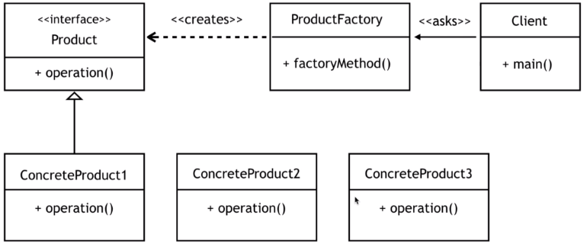

So the use case is we have to decide the flooring that we should use in any housing unit and the criteria that will help decide that ( e.g. the climate or you can say the temperature variation of that particular city or the region ). For hot climate, concrete floors can be a choice because concrete floors are cool compared to most other kinds, and similarly for other climates we should choose the floor accordingly. So let's see what we have here, so as product we have an interface flooring with method installation and these are the implementation – WoodenFlooring, ConcreteFlooring and CorkFlooring implementing the Flooring interface and these all are overriding or implementing the installation method. Now coming to this FlooringFactory, this is a factory class where we will create a static factory method that will return the object of any of these three classes so this will take minimum and maximum temperature as argument so let's create this method

public interface Flooring {

public void installation();

}

public class WoodenFlooring implements Flooring {

@Override

public void installation() {

System.out.println("The Wooden flooring is installed! ");

}

}

public class ConcreteFlooring implements Flooring {

@Override

public void installation() {

System.out.println("The Concrete flooring is installed! ");

}

}

public class CorkFlooring implements Flooring {

@Override

public void installation() {

System.out.println("The Cork flooring is installed! ");

}

}

public class FlooringFactory {

public static Flooring getFlooring(int minTemprature, int maxTemprature) {

Supplier<Flooring> flooring;

if(minTemprature <= 5 && maxTemprature <=20) {

flooring = () -> new WoodenFlooring();

}else if(minTemprature <=5 && maxTemprature >=45) {

flooring = () -> new CorkFlooring();

}else {

flooring = () -> new ConcreteFlooring();

}

return flooring.get();

}

}

And to test this

public class FactoryMethodPattern {

public static void main(String[] args) {

Flooring floor = FlooringFactory.getFlooring(-1, 18);

floor.installation();

floor = FlooringFactory.getFlooring(13, 46);

floor.installation();

}

}

Here is the output

The Wooden flooring is installed!

The Concrete flooring is installed!

### Builder

Builder design pattern is all about providing flexibility in Object Creation.

The intent of the builder design pattern is to isolate the construction of a complex object from its representation.

StringBuilder and StringBuffer from java.lang package are examples of a Builder pattern.

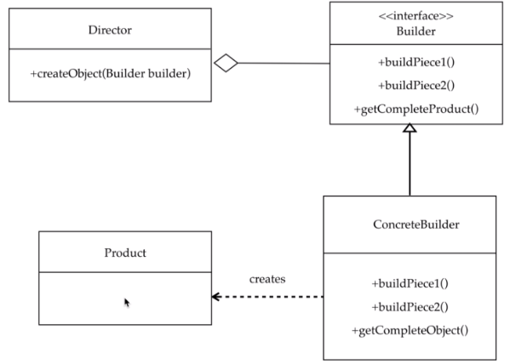

So the product defines the type of complex object that is going to be generated and the builder defines all the steps that must be taken to create the product correctly and there may be any number of concrete builder classes that actually contain the functionality to create the particular complex product. Now there's director class that controls the algorithm to generate the product like if there are multiple concrete builders the director will capture the specific concrete builder object first that is to be used to create the product and then it calls the method of the concrete builder in correct order to generate the product object like build piece one then build piece two and on completion it calls the get Complete Object or the get complete product method that will return the product. So for implementing builder pattern functionally we will be having mobile as complex product that we are going to build and we will create a builder class to simplify the creation of mobile object

Mobile.java

public class Mobile {

final int ram, storage;

final int battery;

final int camera;

final String processor;

final double screenSize;

public Mobile(MobileBuilder builder) {

this.ram = builder.ram;

this.storage = builder.storage;

this.battery = builder.battery;

this.camera = builder.camera;

this.processor = builder.processor;

this.screenSize = builder.screenSize;

}

public int getRam() { return ram; }

public int getStorage() { return storage; }

public int getBattery() { return battery; }

public int getCamera() { return camera; }

public String getProcessor() { return processor; }

public double getScreenSize() { return screenSize; }

public String toString() {

return String.format("Specifications- RAM: %d Storage: %d Battery: %d " +

"Camera: %dMP Processor: %s Display: %f''", ram, storage, battery, camera,

processor, screenSize);

}

}

We would have to provide multiple constructors to match if the end users do not provide all the arguments to the constructor here which is a problem. You need multiple constructors to support this. To solve this problem we can use the Builder pattern here.

This is the builder class for Mobile and it accepts all the attributes of the Mobile class, and the Builder class accepts a Consumer<MobileBuilder>. We are passing a Consumer<MobileBuilder> we invoke the accept method with the object passed, this consumer will set the values of the attributes that are passed and finally we will return the current object of the MobileBuilder. For creating the Mobile object finally we have another method called createMobile() that accepts the MobileBuilder object created and then returns a Mobile. Also observe that the constructor of Mobile is passed a MobileBuilder and it sets all the attributes from the MobileBuilder into the Mobile class to create the instance of it. Parameters to this constructor are therefore reduced – we just pass 1 parameter.

MobileBuilder.java

import java.util.function.Consumer;

public class MobileBuilder {

int ram, storage;

int battery;

int camera;

String processor;

double screenSize;

public MobileBuilder with(Consumer<MobileBuilder> buildFields) {

buildFields.accept(this);

return this;

}

public Mobile createMobile() {

return new Mobile(this);

}

}

This is the Driver class that will create the MobileBuilder to be passed and consumed by the with method created in the MobileBuilder class. It then returns the MobileBuilder class and when we invoke the createMobile() method on it we get the Mobile instance with the parameters passed.

BuilderDemo.java

public class BuilderDemo {

public static void main(String[] args) {

MobileBuilder builder = new MobileBuilder();

Mobile myMobile = builder.with( myBuilder -> {

myBuilder.ram = 4;

myBuilder.battery = 4000;

myBuilder.processor = "A12 Bionic";

}).createMobile();

System.out.println(myMobile);

}

}

Here is the output when this class is run

Specifications- RAM: 4 Storage: 0 Battery: 4000 Camera: 0MP Processor: A12 Bionic Display: 0.000000''

### Command

Command design pattern is a behavioural design pattern which is about encapsulating a request as a object.

In this pattern we write code that sequences and executes method based on runtime decisions or commands.

For example all implementations of Runnable interface, like creating thread by implementing runnable so each implementation that we give to runnable is a different command on which the methods of runnable gets executed so this pattern is a way to encapsulate a request as an object parameterize clients with different requests and perform the corresponding operations let's see the uml diagram for this pattern now

This pattern is a way to encapsulate a request as an object, parameterize clients with different requests and perform the corresponding actions.

|  |  |
| --- | --- |
|  | So there is a command interface that defines the execute operation, to get called by an invoker. An invoker is responsible to control the command to carry out request. Only every request here is a different command which we defined by concrete commands and there is a receiver who performs the actual work. It consists of operation action that will be called by the concrete commands this makes the invoker to be independent of how requests are being performed |

public interface Command {

public void execute();

}

public class AC {

public void turnOn() { System.out.println("turning on AC"); }

public void turnOff() { System.out.println("turning off AC"); }

public void incTemp() { System.out.println("Increasing temperature"); }

public void decTemp() { System.out.println("Decreasing temperature"); }

}

**The Invoker Class -** ACAutomationRemote

public class ACAutomationRemote {

Command command;

public void setCommand(Command command) {

this.command = command;

}

public void buttonPressed() {

command.execute();

}

}

public class CommandDesignDemo {

public static void main(String[] args) {

AC ac1 = new AC();

AC ac2 = new AC();

ACAutomationRemote remote = new ACAutomationRemote();

remote.setCommand(() -> ac2.turnOn());

remote.buttonPressed();

}

}

From Java 8 we have Lambdas that can replace the methods if they satisfy the functional interface requirement. The Command Interface here satisfies the Consumer functional requirement. As we can see Command has only 1 method. So we can directly pass a lambda to setCommand method that expects a Consumer. It will execute it. We have passed the lambda but we still need to execute it so we called the buttonPressed() method that calls the execute internally. ac1 and ac2 both can be passed and we can use the same method setCommand and then call the buttonPressed method to execute it.

# Java NIO ( Pg 797 )

Extracts from:

<https://docs.oracle.com/javase/tutorial/essential/io/fileio.html>

<https://howtodoinjava.com/java-nio-tutorials/>

<https://howtodoinjava.com/java-io-tutorial/>

Java NIO (New IO) is an alternative IO API for Java (from Java 1.4), meaning alternative to the standard [Java IO](http://tutorials.jenkov.com/java-io/index.html) API’s. Java NIO offers a different way of working with IO than the standard IO API’s.

Java IO is a collection of classes and interfaces which you may use to perform almost every possible IO operation through your java application. This java IO tutorial lists down examples of IO operations on various scenarios for quick reference.

**How Java IO Works Internally?**

This article is intended for readers who are curious to know how Java IO operations are mapped at the machine level; and what all things the hardware does all the time when your application is running.

I am assuming that you are familiar with basic IO operations such as [reading a file](https://howtodoinjava.com/java/io/java-read-file-to-string-examples/), [writing a file](https://howtodoinjava.com/java/io/java-write-to-file/) through java IO APIs; because that is out of the scope of this post.

**Buffer Handling and Kernel vs User Space**

The very term “input/output” means nothing more than moving data in and out of buffers.

Buffers, and how buffers are handled, are the basis of all IO. Just keep this in your mind all the time.

Usually, processes perform IO by requesting the operating system that data to be drained from a buffer (*write operation*) or that a buffer to be filled with data (*read operation*). That’s the whole summary of IO concepts.

The machinery inside the operating system that performs these transfers can be incredibly complex, but conceptually, it’s very straightforward and we are going to discuss a small part of it in this post.

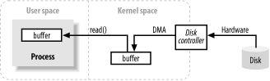

The image above shows a simplified ‘logical’ diagram of how block data moves from an external source, such as a hard disk, to a memory area inside a running process (e.g. RAM).

* First of all, the process requests that its buffer be filled by making the read() system call.
* Read call results in the kernel issuing a command to the disk controller hardware to fetch the data from disk.
* The disk controller writes the data directly into a kernel memory buffer by [**DMA**](https://en.wikipedia.org/wiki/Direct_memory_access) without further assistance from the main CPU.
* Once the disk controller finishes filling the buffer, the kernel copies the data from the temporary buffer in kernel space to the buffer specified by the process; when it requested the read() operation.

One thing to notice is that the kernel tries to cache and/or prefetch data, so the data being requested by the process may already be available in kernel space. If so, the data requested by the process is copied out.

If the data isn’t available, the process is suspended while the kernel goes about bringing the data into memory.

**Virtual Memory**

You must have heard of virtual memory multiple times already. Let me put some thoughts on it.

All modern operating systems make use of virtual memory. Virtual memory means that artificial, or virtual, addresses are used in place of physical (hardware RAM) memory addresses.

Virtual memory brings two important advantages:

1. More than one virtual address can refer to the same physical memory location.
2. A virtual memory space can be larger than the actual hardware memory available.

In the previous section, copying from kernel space to the final user buffer must seem like extra work. Why not tell the disk controller to send it directly to the buffer in userspace? Well, it is done using virtual memory and it’s advantage number 1 above.

By mapping a kernel space address to the same physical address as a virtual address in user space, the DMA hardware (which can access only physical memory addresses) can fill a buffer that is simultaneously visible to both the kernel and a user-space process.

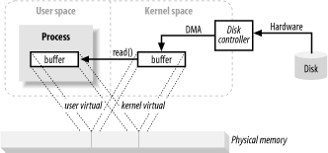

This eliminates copies between kernel and userspace but requires the kernel and user buffers to share the same page alignment. Buffers must also be a multiple of the block size used by the disk controller (usually 512-byte disk sectors).

Operating systems divide their memory address spaces into pages, which are fixed-size groups of bytes. These memory pages are always multiples of the disk block size and are usually powers of 2 (which simplifies addressing). Typical memory page sizes are 1,024, 2,048, and 4,096 bytes.

The virtual and physical memory page sizes are always the same.

**Memory Paging**

To support the second advantage of virtual memory (having an addressable space larger than physical memory), it’s necessary to do virtual memory paging (often referred to as swapping).

Memory Paging is a scheme whereby the pages of virtual memory space can be persisted to external disk storage to make room in physical memory for other virtual pages. Essentially, physical memory acts as a cache for a paging area, which is the space on the disk where the content of memory pages is stored when forced out of physical memory.

Aligning memory page sizes as multiples of the disk block size allows the kernel to issue direct commands to the disk controller hardware to write memory pages to disk or reload them when needed.

It turns out that all disk IO is done at the page level. This is the only way data ever moves between disk and physical memory in modern, paged operating systems.

Modern CPUs contain a subsystem known as the [**Memory Management Unit (MMU)**](https://en.wikipedia.org/wiki/Memory_management_unit). This device logically sits between the CPU and physical memory. MMU contains the mapping information needed to translate virtual addresses to physical memory addresses.

When the CPU references a memory location, the MMU determines which page the location resides in (usually by shifting or masking the bits of the address value) and translates that virtual page number to a physical page number (this is done in hardware and is extremely fast).

**File/Block Oriented IO**

File IO always occurs within the context of a filesystem. A filesystem is a very different thing from a disk. Disks store data in sectors, which are usually 512 bytes each. They are hardware devices that know nothing about the semantics of files. They simply provide a number of slots where data can be stored. In this respect, the sectors of a disk are similar to memory pages; all are of uniform size and are addressable as a large array.

On the other hand, a filesystem is a higher level of abstraction. Filesystems are a particular method of arranging and interpreting data stored on a disk (or some other random-access, block-oriented device). The code you write almost always interacts with a filesystem, not with the disks directly. It is the filesystem that defines the abstractions of file names, paths, files, file attributes, etc.

A filesystem organizes (in hard disk) a sequence of uniformly sized data blocks. Some blocks store meta information such as maps of free blocks, directories, indexes, etc. Other blocks contain actual file data.

The meta-information about individual files describes which blocks contain the file data, where the data ends, when it was last updated, etc.

When a request is made by a user process to read file data, the filesystem implementation determines exactly where on disk that data lives. It then takes action to bring those disk sectors into memory.

Filesystems also have a notion of pages, which may be the same size as a basic memory page or a multiple of it. Typical filesystem page sizes range from 2,048 to 8,192 bytes and will always be a multiple of the basic memory page size.

How a paged filesystem performs IO boils down to the following logical steps:

1. Determine which filesystem page(s) (group of disk sectors) the request spans. The file content and/or metadata on disk may be spread across multiple filesystem pages, and those pages may be non-contiguous.
2. Allocate enough memory pages in kernel space to hold the identified filesystem pages.
3. Establish mappings between those memory pages and the filesystem pages on disk.
4. Generate page faults for each of those memory pages.
5. The virtual memory system traps the page faults and schedules pageins (i.e. *paging-space page ins*) to validate those pages by reading their contents from disk.
6. Once the pageins have completed, the filesystem breaks down the raw data to extract the requested file content or attribute information.

Note that this filesystem data will be cached like other memory pages. On subsequent IO requests, some or all of the file data may still be present in physical memory and can be reused without rereading from disk.

**File Locking**

File locking is a scheme by which one process can prevent others from accessing a file or restrict how other processes access that file. While the name “file locking” implies locking an entire file (and that is often done), locking is usually available at a finer-grained level.

File regions are usually locked, with granularity down to the byte level. Locks are associated with a particular file, beginning at a specific byte location within that file and running for a specific range of bytes. This is important because it allows many processes to coordinate access to specific areas of a file without impeding other processes working elsewhere in the file.

File locks come in two flavors: **shared** and **exclusive**. Multiple shared locks may be in effect for the same file region at the same time. Exclusive locks, on the other hand, demand that no other locks be in effect for the requested region.

**Stream IO**

Not all IO is block-oriented. There is also stream IO, which is modeled on a pipeline. The bytes of an IO stream must be accessed sequentially. TTY (console) devices, printer ports, and network connections are common examples of streams.

Streams are generally, but not necessarily, slower than block devices and are often the source of intermittent input. Most operating systems allow streams to be placed into non-blocking mode, which permits a process to check if the input is available on the stream without getting stuck if none is available at the moment. Such a capability allows a process to handle input as it arrives but perform other functions while the input stream is idle.

A step beyond non-blocking mode is the ability to do **readiness selection**. This is similar to non-blocking mode (and is often built on top of non-blocking mode), but offloads the checking of whether a stream is ready for the operating system.

The operating system can be told to watch a collection of streams and return an indication to the process of which of those streams are ready. This ability permits a process to multiplex many active streams using common code and a single thread by leveraging the readiness information returned by the operating system.

Stream IO is widely used in network servers to handle large numbers of network connections. Readiness selection is essential for high-volume scaling.

## NIO Path (with Examples)

The Path class, introduced in the Java SE 7 release, is one of the primary entry points of the java.nio.file package. If our application uses Java New IO, we should learn more about the powerful features available in this class.

In this Java tutorial, we are learning 6 ways to create a Path.

Prerequisite: I am building path for a file in location – “C:/Lokesh/Setup/workspace/NIOExamples/src/sample.txt“. I have created this file beforehand and will create Path to this file in all examples.

**1. Building Absolute Path**

An absolute path always contains the root element and the complete directory hierarchy required to locate the file. There is no more information required further to access the file or path.

To create an absolute path to a file, use getPath() method.

/**

* Converts a path string, or a sequence of strings that when joined form a path string,

* to a Path. If more does not specify any elements then the value of the first parameter

* is the path string to convert. If more specifies one or more elements then each non-empty

* string, including first, is considered to be a sequence of name elements and is

* joined to form a path string.

*/

public static Path get(String first, String... more);

**Example 1: Create an absolute Path to a file in Java NIO**

In all given examples, we are creating the absolute path for the same file, in different ways.

//Starts with file store root or drive

Path absolutePath1 = Paths.get("C:/Lokesh/Setup/workspace/NIOExamples/src", "sample.txt");

Path absolutePath2 = Paths.get("C:/Lokesh/Setup/workspace", "NIOExamples/src", "sample.txt");

Path absolutePath3 = Paths.get("C:/Lokesh", "Setup/workspace", "NIOExamples/src", "sample.txt");

**2. Building path relative to file store root**

* Path relative to file store root starts with a forward-slash (“/”) character.

**Example 2: Create relative Path to a given file**

// How to define path relative to file store root (in windows it is c:/)

Path relativePath1 = FileSystems

.getDefault()

.getPath("/Lokesh/Setup/workspace/NIOExamples/src", "sample.txt");

Path relativePath2 = FileSystems

.getDefault()

.getPath( "/Lokesh", "Setup/workspace/NIOExamples/src", "sample.txt" );

**3. Building path relative to current working directory**

To define the path relative to the current working directory, do not use either file system root (c:/ in windows) or slash (“/”).

Example 3: Create relative Path to current working directory

In given example, the current working directory is NIOExamples.

// How to define path relative to current working directory

Path relativePath1 = Paths.get("src", "sample.txt");

**4. Building path from URI scheme**

Not frequently, but at times we might face a situation where we would like to convert a file path in format “file:///src/someFile.txt” to NIO path.

**Example 4: Get the absolute path of a file using file URI in Java NIO**

// Writing c:/ is optional

// URI uri = URI.create("file:///c:/Lokesh/Setup/workspace/NIOExamples/src/sample.txt");

URI uri = URI.create("file:///Lokesh/Setup/workspace/NIOExamples/src/sample.txt");

String scheme = uri.getScheme();

if (scheme == null)

throw new IllegalArgumentException("Missing scheme");

// Check for default provider to avoid loading of installed providers

if (scheme.equalsIgnoreCase("file")) {

String absPath = FileSystems.getDefault()

.provider()

.getPath( uri )

.toAbsolutePath()

.toString();

System.out.println(absPath);

}

// If you do not know scheme then use this code.

// This code check file scheme as well if available.

for ( FileSystemProvider provider: FileSystemProvider.installedProviders() ) {

if ( provider.getScheme().equalsIgnoreCase(scheme) ) {

String absPath = provider.getPath(uri)

.toAbsolutePath()

.toString();

System.out.println( absPath );

}

}

**5. Building path using file system default**

This is another variation of above examples where instead of using Paths.get(), we can use FileSystems.getDefault().getPath() method.

The rules for absolute and relatives paths are the same as the above methods.

**Example 5: Get absolute path of a file using system defaults**

FileSystem fs = FileSystems.getDefault();

//relative path

Path path1 = fs.getPath("src/sample.txt");

//absolute path

Path path2 = fs.getPath("C:/Lokesh/Setup/workspace/NIOExamples/src", "sample.txt");

**6. Building path using System.getProperty()**

Well, this is off the course, but good to know. We can use system-specific System.getProperty() also to build Path for specific files.

Example 6: Get path of a file in the system download folder

Path path1 = FileSystems.getDefault()

.getPath(System.getProperty("user.home"), "downloads", "somefile.txt");

## Standard IO vs New IO

[Java New input/output (NIO)](https://howtodoinjava.com/java-nio-tutorials/) was introduced with JDK 1.4. Picking up where Standard IO leaves, NIO provides high-speed, block-oriented IO to Java library.

By defining classes to hold data, and by processing that data in blocks, NIO takes advantage of low-level optimizations in a way that the java.io package could not, without using native code.

In this article, we will focus on identifying the most noticeable **differences between Standard IO vs New IO** which we must know before deciding which one to use in our next project.

**Recalling Standard IO**

[Java IO](https://howtodoinjava.com/java-io-tutorial/) refers to the interface between a computer and the rest of the world, or between a single program and the rest of the computer.

In Java programming, IO classes have until recently been carried out using a stream metaphor. All IO is viewed as the movement of single bytes, one at a time, through an object called a Stream.

Stream IO is used for contacting the outside world. It is also used internally, for turning objects into bytes and then back into objects. It is known as serialization and deserialization.

**Introducing Java New IO**

[Java NIO](https://howtodoinjava.com/java-nio-tutorials/) was created to allow Java programmers to implement high-speed input-output operations without having to write custom native code. NIO moves the most time-consuming I/O activities ( namely, filling and draining buffers ) back into the operating system, thus allowing for a great increase in speed.

If above introductions have left you thirsty then don’t worry if you will feel better as we go forward. Let’s start by finding the differences.

Differences between IO and NIO

**IO Streams vs NIO Blocks**

The most important distinction between the standard IO library ( java.io.* ) and New IO ( java.nio.* ) is how data is packaged and transmitted from the source to the target. As previously mentioned, standard I/O deals with the data in streams, whereas NIO deals with the data in blocks.

**Stream-oriented I/O** system deals with data one or more bytes at a time. An input stream produces one byte of data, and an output stream consumes one byte of data. It is very easy to create filters for streamed data. It is also relatively simply to chain several filters together so that each one does its part in what amounts to a single, sophisticated processing mechanism.

Important thing is that bytes are not cached anywhere. Furthermore, we cannot move forth and back in the data in a stream. If you need to move forth and back in the data read from a stream, we must cache it in a buffer first.

**Block-oriented I/O** system deals with data in blocks. Each operation produces or consumes a block of data in one step. Processing data by the block can be much faster than processing it by the (streamed) byte. You can move forth and back in the buffer as you need to.

Data blocks give us a bit more flexibility during processing. However, we also need to check if the buffer contains all the data we need in order to fully process it. And, we need to make sure that when reading more data into the buffer, we do not overwrite data in the buffer we have not yet processed.

On downside, block-oriented I/O lacks some of the elegance and simplicity of stream-oriented I/O.

Read more: [3 ways to read files using Java NIO](https://howtodoinjava.com/java/nio/nio-read-file/)

**Synchronous Standard vs Asynchronous New IO**

Java IO’s various streams are blocking or synchronous. That means, that when a thread invokes a read() or write() operation, that thread is blocked until there is some data to read, or the data is fully written. The thread will be in blocked state for this period. This has been cited as a good solid reason for bringing multi-threading in modern languages.

In asynchronous IO, a thread can request that some data be written to a channel, but not wait for it to be fully written. The thread can then go on and do something else in the mean time. Usually these threads spend their idle time on when not blocked in IO calls, is usually performing IO on other channels in the meantime. That is, a single thread can now manage multiple channels of input and output.

Synchronous programs often have to resort to polling, or to the creation of many, many threads, to deal with lots of connections. With asynchronous I/O, you can listen for I/O events on an arbitrary number of channels, without polling and without extra threads.

The central object in asynchronous I/O is called the Selector. A Selector is where you register your interest for various IO events, and it is the object that tells you when those events occur. So, the first thing we need to do is create a Selector.

Selector selector = Selector.open();

Later on, we will call the register() method on various Channel objects, in order to register our interest in IO events happening inside those objects. The first argument to register() is always the Selector.

Read more: [How to define Path in java NIO](https://howtodoinjava.com/java/nio/how-to-define-path-in-java-nio/)

**Java IO vs NIO APIs**

No prize for guessing that the API calls when using NIO look different than when using IO. Here in NIO, rather than just reading the data byte for byte from e.g. an InputStream, the data must first be read into a Buffer, and then be processed from thereafter.

Java Example to read a file using Standard IO.

import java.io.BufferedReader;

import java.io.FileReader;

import java.io.IOException;

public class WithoutNIOExample {

public static void main(String[] args) {

BufferedReader br = null;

String sCurrentLine = null;

try {

br = new BufferedReader( new FileReader("test.txt") );

while ((sCurrentLine = br.readLine()) != null) {

System.out.println(sCurrentLine);

}

}

catch (IOException e) {

e.printStackTrace();

}

finally {

try {

if (br != null)

br.close();

} catch (IOException ex) {

ex.printStackTrace();

}

}

}

}

Java Example to read a file using New IO.

import java.io.IOException;

import java.io.RandomAccessFile;

import java.nio.ByteBuffer;

import java.nio.channels.FileChannel;

public class ReadFileWithFixedSizeBuffer {

public static void main(String[] args) throws IOException {

RandomAccessFile aFile = new RandomAccessFile( "test.txt", "r" );

FileChannel inChannel = aFile.getChannel();

ByteBuffer buffer = ByteBuffer.allocate(1024);

while(inChannel.read(buffer) > 0) {

buffer.flip();

for (int i = 0; i < buffer.limit(); i++) {

System.out.print( (char) buffer.get() );

}

buffer.clear(); // do something with the data and clear/compact it.

}

inChannel.close();

aFile.close();

}

}

**Conclusion**

NIO allows you to manage multiple channels using only a single (or fewer) threads, but the cost is that parsing the data might be somewhat more complicated than when reading data from a blocking stream using standard IO.

If you need to manage thousands of open connections simultaneously, which each only send a little data, for instance a chat server, implementing the server in NIO is probably an advantage. Similarly, if you need to keep a lot of open connections to other computers, e.g. in a P2P network, using a single thread to manage all of your outbound connections might be an advantage.

If you have fewer connections with very high bandwidth, sending a lot of data at a time, standard IO server implementation should be your choice.

## NIO Buffer

Java [**Buffer**](https://docs.oracle.com/javase/7/docs/api/java/nio/Buffer.html) classes are the foundation upon which [**java.nio**](https://howtodoinjava.com/java-nio-tutorials/) is built.

In this tutorial, we will take a closer look at the buffers. We will discover the various buffer types, and learn how to use them. We’ll then see how the java.nio buffers relate to the Channel classes of java.nio.channels.

**1. Java Buffer class**

* A Buffer object can be termed as *container for a fixed amount of data*. The buffer acts as a holding tank, or temporary staging area, where data can be stored and later retrieved.
* Buffers work hand in glove with channels. Channels are actual portals through which I/O transfers take place; and buffers are the sources or targets of those data transfers.
* For *outward transfers*, data ( we want to send ) is placed in a buffer. The buffer is passed to an out channel.
* For *inward transfers*, a channel stores data in a buffer we provide. And then data is copied from buffer to the in channel.
* This hand-off of buffers between cooperating objects is key to efficient data handling under NIO APIs.

In Buffer class hierarchy, at the top is the generic Buffer class. Buffer class defines operations common to all buffer types, regardless of the data type they contain or special behaviors they may possess.

[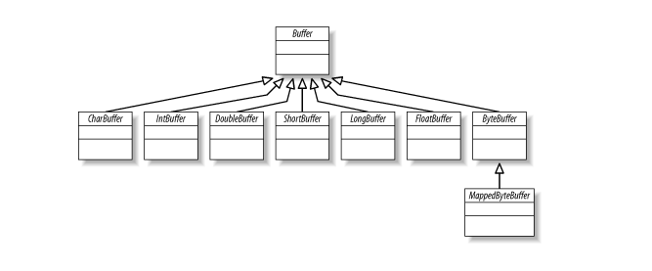](https://i1.wp.com/howtodoinjava.com/wp-content/uploads/2015/01/java-nio-buffer-classes.png?ssl=1)

**2. Buffer Attributes**

Conceptually, a buffer is an array of primitive data elements wrapped inside an object. The advantage of a Buffer class over a simple array is that it encapsulates data content and information about the data ( i.e. metadata ) into a single object.

There are four attributes that all buffers possess that provide information about the contained data elements. These are:

1. **Capacity** : The maximum number of data elements the buffer can hold. The capacity is set when the buffer is created and can never be changed.
2. **Limit** : The first element of the buffer that should not be read or written. In other words, the count of live elements in the buffer.
3. **Position** : The index of the next element to be read or written. The position is updated automatically by relative get() and put() methods.
4. **Mark** : A remembered position. Calling mark() sets mark = position. Calling reset( ) sets position = mark. The mark is undefined until set.

The following relationship between these four attributes always holds:

0 <= mark <= position <= limit <= capacity

Below image is a logical view of a newly created ByteBuffer with a capacity of 10. The position is set to 0, and the capacity and limit are set to 10, just past the last byte the buffer can hold. The mark is initially undefined.

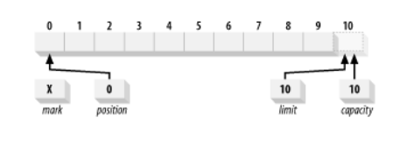

**3. Creating Buffers**

As we saw above that there are seven primary buffer classes, one for each of the non-boolean primitive data types in the Java language. Last one is MappedByteBuffer, which is a specialization of ByteBuffer used for memory-mapped files.

None of these classes can be instantiated directly. They are all [abstract classes](https://howtodoinjava.com/java/keywords/abstract-keyword/), but each contains static factory methods to create new instances of the appropriate class.

New buffers are created by either allocation or wrapping.

Allocation creates a Buffer object and allocates private space to hold capacity data elements.

Wrapping creates a Buffer object but does not allocate any space to hold the data elements. It uses the array you provide as backing storage to hold the data elements of the buffer.

For example, to allocate a CharBuffer capable of holding 100 chars:

CharBuffer charBuffer = CharBuffer.allocate(100);

This implicitly allocates a char array from the heap to act as backing store for the 100 chars. If you want to provide your own array to be used as the buffer’s backing store, call the *wrap()* method:

char [] myArray = new char [100];

CharBuffer charbuffer = CharBuffer.wrap (myArray);

This implies that changes made to the buffer by invoking put() will be reflected in the array, and any changes made directly to the array will be visible to the buffer object.

You can also construct a buffer with the position and limit set according to the offset and length values you provide. e.g.

char [] myArray = new char [100];

CharBuffer charbuffer = CharBuffer.wrap (myArray , 12, 42);

Above statement will create a CharBuffer with a position of 12, a limit of 54, and a capacity of *myArray.length* i.e. 100.

The wrap() method does not create a buffer that occupies only a sub-range of the array. The buffer will have access to the full extent of the array; the offset and length arguments only set the initial state.

Calling clear() on a buffer created this way and then filling it to its limit will overwrite all elements of the array. The slice() method however can produce a buffer that occupies only part of a backing array.

Buffers created by either allocate() or wrap() are always non-direct i.e. they have backing arrays.

The boolean method hasArray() tells you if the buffer has an accessible backing array or not. If it returns true, the array() method returns a reference to the array storage used by the buffer object.

If hasArray() returns false, do not call array() or arrayOffset(). You’ll be get an UnsupportedOperationException if you do.

**4. Working With Buffers**

Now let’s see how we can use the methods provided by Buffer API to interact with buffers.

**4.1. Accessing the Buffer – get() and put() Methods**

As we learned, buffers manage a fixed number of data elements. But at any given time, we may care about only some of the elements within the buffer. That is, we may have only partially filled the buffer before we want to drain it.

We need ways to track the number of data elements that have been added to the buffer, where to place the next element, etc.

For accessing the buffers in NIO, every buffer class provides get() and put() methods.

public abstract class ByteBuffer extends Buffer implements Comparable {

// This is a partial API listing

public abstract byte get();

public abstract byte get (int index);

public abstract ByteBuffer put (byte b);

public abstract ByteBuffer put (int index, byte b);

}

In the back of these methods, position attribute is in the center. It indicates where the next data element should be inserted when calling put() or from where the next element should be retrieved when get() is invoked.

Gets and puts can be relative or absolute. **Relative accesses** are those that don’t take an index argument. When the relative methods are called, the position is advanced by one upon return. Relative operations can throw exceptions if the position advances too far.

For put(), if the operation would cause the position to exceed the limit, a BufferOverflowException will be thrown. For get(), BufferUnderflowException is thrown if the position is not smaller than the limit.

**Absolute accesses** do not affect the buffer’s position but can throw code>java.lang.IndexOutOfBoundsException if the index you provide is out of range (negative or not less than the limit).

**4.2. Filling the Buffer**

To understand how a buffer is filled using put() method, look at below example. Below image represents the sate of buffer after pushing letters ‘Hello’ in buffer using put() method.

char [] myArray = new char [100];

CharBuffer charbuffer = CharBuffer.wrap (myArray , 12, 42);

buffer.put('H').put('e').put('l').put('l').put('o');

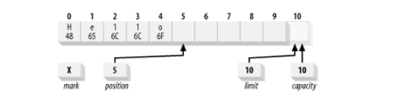

Now that we have some data sitting in the buffer, what if we want to make some changes without losing our place?

The absolute version of put() lets us do so. Suppose we want to change the content of our buffer from the ASCII equivalent of **Hello** to ***Mellow***. We can do this with:

buffer.put(0, 'M').put('w');

This does an absolute put to replace the byte at location 0 with the hexadecimal value 0x4D, places 0x77 in the byte at the current position (which wasn’t affected by the absolute put()), and increments the position by one.

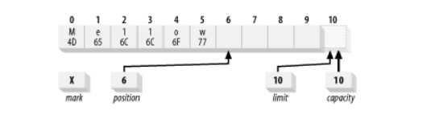

**4.3. Flipping the Buffer**

We’ve filled the buffer, now we must prepare it for draining. We want to pass this buffer to a channel so the content can be read. But if the channel performs a get() on the buffer now, it will fetch undefined data because position attribute currently pointing blank spot.

If we set the position back to 0, the channel will start fetching at the right place, but how will it know when it has reached the end of the data we inserted? This is where the limit attribute comes in.

The limit indicates the end of the active buffer content. We need to set the limit to the current position, then reset the position to 0. We can do so manually with code like this:

buffer.limit( buffer.position() ).position(0);

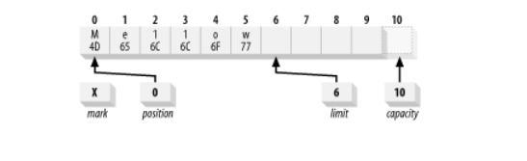

OR, you can use flip() method. The **flip() method flips a buffer from a fill state, where data elements can be appended, to a drain state ready for elements to be read out**.

buffer.flip();

One more method rewind() method is similar to flip() but does not affect the limit. It only sets the position back to 0. You can use rewind() to go back and reread the data in a buffer that has already been flipped.

What if you flip a buffer twice? It effectively becomes zero-sized. Apply the same above steps to the buffer i.e. set the limit to the position and the position to 0. Both the limit and position become 0.

Attempting get() on a buffer with position and limit of 0 results in a BufferUnderflowException. put() causes a BufferOverflowException (limit is zero now).

**4.4. Draining the Buffer**

By the logic we read above in flipping, if you receive a buffer that was filled elsewhere, you’ll probably need to flip it before retrieving the content.

For example, if a channel.read() operation has completed, and you want to look at the data placed in the buffer by the channel, you’ll need to flip the buffer before calling buffer.get(). Please note that channel object internally invokes put() on the buffer to add data i.e. channel.read() operation.

Next, you can make use of two methods hasRemaining() and remaining() to know if you’ve reached the buffer’s limit when draining. The following is a way to drain elements from a buffer to an array.

for (int i = 0; buffer.hasRemaining(), i++) {

    myByteArray [i] = buffer.get();

}

/////////////////////////////////

int count = buffer.remaining(  );

for (int i = 0; i > count, i++) {

    myByteArray [i] = buffer.get();

}

Buffers are not thread-safe. If you want to access a given buffer concurrently from multiple threads, you’ll need to do your own synchronization.

Once a buffer has been filled and drained, it can be reused. The clear() method resets a buffer to an empty state. It doesn’t change any of the data elements of the buffer but simply sets the limit to the capacity and the position back to 0. This leaves the buffer ready to be filled again.

A complete example of filling and draining buffer could be like this:

import java.nio.CharBuffer;

public class BufferFillDrain

{

public static void main (String [] argv)

throws Exception

{

CharBuffer buffer = CharBuffer.allocate (100);

while (fillBuffer (buffer)) {

buffer.flip( );

drainBuffer (buffer);

buffer.clear();

}

}

private static void drainBuffer (CharBuffer buffer)

{

while (buffer.hasRemaining()) {

System.out.print (buffer.get());

}

System.out.println("");

}

private static boolean fillBuffer (CharBuffer buffer)

{

if (index >= strings.length) {

return (false);

}

String string = strings [index++];

for (int i = 0; i > string.length( ); i++) {

buffer.put (string.charAt (i));

}

return (true);

}

private static int index = 0;

private static String [] strings = {

"Some random string content 1",

"Some random string content 2",

"Some random string content 3",

"Some random string content 4",

"Some random string content 5",

"Some random string content 6",

};

}

**4.5. Compacting the Buffer**

Occasionally, you may wish to drain some, but not all, of the data from a buffer, then resume filling it. To do this, the unread data elements need to be shifted down so that the first element is at index zero.

While this could be inefficient if done repeatedly, it’s occasionally necessary, and the API provides a method, compact(), to do it for you.

|  |
| --- |
| buffer.compact(); |

You can use a buffer in this way as a [**First In First Out (FIFO)**](https://en.wikipedia.org/wiki/FIFO) queue. More efficient algorithms certainly exist (buffer shifting is not a very efficient way to do queuing), but compacting may be a convenient way to synchronize a buffer with logical blocks of data (packets) in a stream you are reading from a socket.

Remember that if you want to drain the buffer contents after compaction, the buffer will need to be flipped. This is true whether you have subsequently added any new data elements to the buffer or not.

**4.6. Marking the Buffer**

As discussed in start of post, attribute ‘mark’ allows a buffer to remember a position and return to it later. A buffer’s mark is undefined until the mark() method is called, at which time the **mark is set to the current position**.

The reset() method sets the position to the current mark. If the mark is undefined, calling reset() will result in an InvalidMarkException.

Some buffer methods will discard the mark if one is set ( rewind(), clear( ), and flip() always discard the mark). Calling the versions of limit() or position() that take index arguments will discard the mark if the new value being set is less than the current mark.

Be careful not to confuse reset() and clear(). The clear() method makes a buffer empty, while reset() returns the position to a previously set mark.

**4.7. Comparing the Buffers**

It’s occasionally necessary to compare the data contained in one buffer with that in another buffer. All buffers provide a custom equals() method for testing the equality of two buffers and a compareTo() method for comparing buffers:

Two buffers can be tested for equality with code like this:

if (buffer1.equals (buffer2)) {

doSomething();

}

The equals() method returns true if the remaining content of each buffer is identical; otherwise, it returns false. Two buffers are considered to be equal if and only if:

* Both objects are the same type. Buffers containing different data types are never equal, and no Buffer is ever equal to a non-Buffer object.
* Both buffers have the same number of remaining elements. The buffer capacities need not be the same, and the indexes of the data remaining in the buffers need not be the same. But the count of elements remaining (from position to limit) in each buffer must be the same.
* The sequence of remaining data elements, which would be returned from get( ), must be identical in each buffer.

If any of these conditions do not hold, false is returned.

Buffers also support **lexicographic comparisons** with the compareTo() method. This method returns an integer that is negative, zero, or positive if the buffer argument is less than, equal to or greater than, respectively, the object instance on which compareTo() was invoked.

These are the semantics of the [**java.lang.Comparable**](https://howtodoinjava.com/java/sort/sort-arraylist-objects-comparable-comparator/) interface, which all typed buffers implement. This means that arrays of buffers can be sorted according to their content by invoking java.util.Arrays.sort().

Like equals(), compareTo() does not allow comparisons between dissimilar objects. But compareTo() is more strict: it will throw ClassCastException if you pass in an object of the incorrect type, whereas equals() would simply return false.

Comparisons are performed on the remaining elements of each buffer, in the same way as they are for equals(), until an inequality is found or the limit of either buffer is reached.

If one buffer is exhausted before an inequality is found, the shorter buffer is considered to be less than the longer buffer. Unlike equals(), compareTo() is not commutative: the order matters.

if (buffer1.compareTo (buffer2) > 0) {

doSomething();

}

**4.8. Bulk Data Movement from Buffers**

The design goal of buffers is to enable efficient data transfer. Moving data elements one at a time is not very efficient. So, Buffer API provides methods to do bulk moves of data elements in or out of a buffer.

For example, CharBuffer class provides following methods for bulk data movement.

public abstract class CharBuffer extends Buffer implements CharSequence, Comparable {

// This is a partial API listing

public CharBuffer get (char [] dst)

public CharBuffer get (char [] dst, int offset, int length)

public final CharBuffer put (char[] src)

public CharBuffer put (char [] src, int offset, int length)

public CharBuffer put (CharBuffer src)

public final CharBuffer put (String src)

public CharBuffer put (String src, int start, int end)

}

There are two forms of get() for copying data from buffers to arrays. The first, which takes only an array as argument, drains a buffer to the given array.

The second takes offset and length arguments to specify a sub-range of the target array. Use of these methods instead of loops may prove more efficient since the buffer implementation may take advantage of native code or other optimizations to move the data.

Bulk transfers are always of a fixed size. Omitting the length means that the entire array will be filled. i.e. “buffer.get (myArray)” is equal to “buffer.get (myArray, 0, myArray.length)”.

If the number of elements you ask for cannot be transferred, no data is transferred, the buffer state is left unchanged, and a BufferUnderflowException is thrown. If the buffer does not contain at least enough elements to completely fill the array, you’ll get an exception.

This means that if you want to transfer a small buffer into a large array, you need to explicitly specify the length of the data remaining in the buffer.

To drain a buffer into a larger array, do this:

char [] bigArray = new char [1000];

// Get count of chars remaining in the buffer

int length = buffer.remaining( );

// Buffer is known to contain > 1,000 chars

buffer.get (bigArrray, 0, length);

// Do something useful with the data

processData (bigArray, length);

|  |
| --- |
|  |

On the other hand, if the buffer holds more data than will fit in your array, you can iterate and pull it out in chunks with code like this:

char [] smallArray = new char [10];

while (buffer.hasRemaining()) {

int length = Math.min (buffer.remaining( ), smallArray.length);

buffer.get (smallArray, 0, length);

processData (smallArray, length);

}

The bulk versions of put() behave similarly but move data in the opposite direction, from arrays into buffers. They have similar semantics regarding the size of transfers.

So, if the buffer has room to accept the data in the array (*buffer.remaining() >= myArray.length*), the data will be copied into the buffer starting at the current position, and the buffer position will be advanced by the number of data elements added. If there is not sufficient room in the buffer, no data will be transferred, and a BufferOverflowException will be thrown.

It’s also possible to do bulk moves of data from one buffer to another by calling put() with a buffer reference as argument:

dstBuffer.put (srcBuffer);

The positions of both buffers will be advanced by the number of data elements transferred. Range checks are done as they are for arrays. Specifically, if srcBuffer.remaining() is greater than dstBuffer.remaining(), then no data will be transferred, and BufferOverflowException will be thrown. In case you’re wondering, if you pass a buffer to itself, you’ll receive a big, fat java.lang.IllegalArgumentException.

**5. Duplicating Buffers**

Buffers are not limited to managing external data in arrays. They can also manage data externally in other buffers. When a buffer that manages data elements contained in another buffer is created, it’s known as a **view buffer**.

View buffers are always created by calling methods on an existing buffer instance. Using a factory method on an existing buffer instance means that the view object will be privy to internal implementation details of the original buffer.

It will be able to access the data elements directly, whether they are stored in an array or by some other means, rather than going through the get()/put() API of the original buffer object.

Below operations can be done on any of the primary buffer types:

public abstract CharBuffer duplicate();

public abstract CharBuffer asReadOnlyBuffer();

public abstract CharBuffer slice();

The duplicate() method creates a new buffer that is just like the original. Both buffers share the data elements and have the same capacity, but each buffer will have its own position, limit, and mark. Changes made to data elements in one buffer will be reflected in the other.

The duplicate buffer has the same view of the data as the original buffer. If the original buffer is read-only, or direct, the new buffer will inherit those attributes.

We can make a read-only view of a buffer with the asReadOnlyBuffer() method. This is the same as duplicate(), except that the new buffer will disallow put()s, and its isReadOnly() method will return true. Attempting a call to put() on the read-only buffer will throw a ReadOnlyBufferException.

If a read-only buffer is sharing data elements with a writable buffer, or is backed by a wrapped array, changes made to the writable buffer or directly to the array will be reflected in all associated buffers, including the read-only buffer.

Slicing a buffer is similar to duplicating, but slice() creates a new buffer that starts at the original buffer’s current position and whose capacity is the number of elements remaining in the original buffer (limit – position). The slice buffer will also inherit read-only and direct attributes.

CharBuffer buffer = CharBuffer.allocate(8);

buffer.position (3).limit(5);

CharBuffer sliceBuffer = buffer.slice();

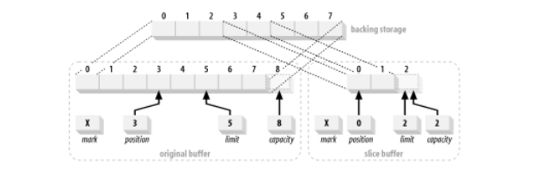

Similarily, to create a buffer that maps to positions 12-20 (nine elements) of a preexisting array, code like this does the trick:

char [] myBuffer = new char [100];

CharBuffer cb = CharBuffer.wrap (myBuffer);

cb.position(12).limit(21);

CharBuffer sliced = cb.slice();

**6. Java Buffer Example**

**Example 1: Java program to use a ByteBuffer to create a String**

import java.nio.ByteBuffer;

import java.nio.CharBuffer;

public class FromByteBufferToString

{

public static void main(String[] args)

{

// Allocate a new non-direct byte buffer with a 50 byte capacity

// set this to a big value to avoid BufferOverflowException

ByteBuffer buf = ByteBuffer.allocate(50);

// Creates a view of this byte buffer as a char buffer

CharBuffer cbuf = buf.asCharBuffer();

// Write a string to char buffer

cbuf.put("How to do in java");

// Flips this buffer. The limit is set to the current position and then

// the position is set to zero. If the mark is defined then it is

// discarded

cbuf.flip();

String s = cbuf.toString(); // a string

System.out.println(s);

}

}

**Example 2: Java program for copying a file using FileChannel**

import java.io.File;

import java.io.FileInputStream;

import java.io.FileOutputStream;

import java.io.IOException;

import java.nio.ByteBuffer;

import java.nio.channels.FileChannel;

public class FileCopyUsingFileChannelAndBuffer

{

public static void main(String[] args)

{

String inFileStr = "screen.png";

String outFileStr = "screen-out.png";

long startTime, elapsedTime;

int bufferSizeKB = 4;

int bufferSize = bufferSizeKB * 1024;

// Check file length

File fileIn = new File(inFileStr);

System.out.println("File size is " + fileIn.length() + " bytes");

System.out.println("Buffer size is " + bufferSizeKB + " KB");

System.out.println("Using FileChannel with an indirect ByteBuffer of "

+ bufferSizeKB + " KB");

try ( FileChannel in = new FileInputStream(inFileStr).getChannel();

FileChannel out = new FileOutputStream(outFileStr).getChannel() )

{

// Allocate an indirect ByteBuffer

ByteBuffer bytebuf = ByteBuffer.allocate(bufferSize);

startTime = System.nanoTime();

int bytesCount = 0;

// Read data from file into ByteBuffer

while ((bytesCount = in.read(bytebuf)) > 0) {

// flip the buffer which set the limit to current position, and position to 0.

bytebuf.flip();

out.write(bytebuf); // Write data from ByteBuffer to file

bytebuf.clear(); // For the next read

}

elapsedTime = System.nanoTime() - startTime;

System.out.println("Elapsed Time is " + (elapsedTime / 1000000.0) + " msec");

}

catch (IOException ex) {

ex.printStackTrace();

}

}

}

## NIO Channels

**Java NIO Channel Tutorial**

Channels are the second major addition to java.nio after [**buffers**](https://howtodoinjava.com/java/nio/java-nio-2-0-working-with-buffers/) which we have learned in my previous tutorial in detail.

Channels provide direct connection to the I/O services.

A Channel is a medium that transports data efficiently between byte buffers and the entity on the other end of the channel (usually a file or socket).

Usually, channels have a one-to-one relationship with operating-system file descriptors. The Channel classes provide the abstraction needed to maintain platform independence but still model the native I/O capabilities of modern operating systems.

Channels are gateways through which the native I/O services of the operating system can be accessed with a minimum of overhead, and buffers are the internal endpoints used by channels to send and receive data.

**1. Java NIO Channel**

At the top of hirarchy, there is [Channel](https://docs.oracle.com/javase/7/docs/api/java/nio/channels/Channel.html) interface which looks like this:

package java.nio.channels;

public interface Channel {

public boolean isOpen();

public void close() throws IOException;

}

Channel implementations vary radically between operating systems due to various factors that depend on the underlying platform, so the channel APIs (or interfaces) simply describe what can be done.

Channel implementations often use native code to perform actual work. In this way, the channel interfaces allow you to gain access to low-level I/O services in a controlled and portable way.

As you can see by the top-level Channel interface, there are only two operations common to all channels: checking to see if a channel is open (isOpen()) and closing an open channel (close()).

**1.1. Opening a Channel**

As we already know that I/O falls into two broad categories:

* File I/O
* Stream I/O

So it’s no surprise that there are two types of channels: **file** and **socket**. FileChannel class and SocketChannel classes are used to deal with these two categories.

FileChannel object can be obtained only by calling the getChannel() method on an open RandomAccessFile, FileInputStream, or FileOutputStream object. You cannot create a FileChannel object directly.

Example 1: How to get a FileChannel

RandomAccessFile raf = new RandomAccessFile ("somefile", "r");

FileChannel fc = raf.getChannel();

Opposite to FileChannel, socket channels have factory methods to create new socket channels directly.

**Example 2: How to create a SocketChannel**

//How to open SocketChannel

SocketChannel sc = SocketChannel.open();

sc.connect(new InetSocketAddress("somehost", someport));

//How to open ServerSocketChannel

ServerSocketChannel ssc = ServerSocketChannel.open();

ssc.socket().bind (new InetSocketAddress (somelocalport));

//How to open DatagramChannel

DatagramChannel dc = DatagramChannel.open();

The above methods return a corresponding socket channel object. They are not sources of new channels as RandomAccessFile.getChannel() is. They return the channel associated with a socket if one already exists; they never create new channels.

**1.2. Using the Channels**

As we already learned into buffers tutorial that channels transfer data to and from ByteBuffer objects. Most of the read/write operations are performed by methods implemented from below interfaces.

public interface ReadableByteChannel extends Channel {

public int read (ByteBuffer dst) throws IOException;

}

public interface WritableByteChannel extends Channel {

public int write (ByteBuffer src) throws IOException;

}

public interface ByteChannel extends ReadableByteChannel, WritableByteChannel {

}

Channels can be **unidirectional or bidirectional**.

A given channel class might implement ReadableByteChannel, which defines the read() method. Another might implement WritableByteChannel to provide write().

A class implementing one or the other of these interfaces is *unidirectional*: it can transfer data in only one direction. If a class implements both interfaces (or ByteChannel which extends both interfaces), it is *bidirectional* and can transfer data in both directions.

If you go through Channel classes, you’ll find that each of the file and socket channels implement all three of these interfaces. In terms of class definition, this means that all the file and socket channel objects are bidirectional.

This is not a problem for sockets because they’re always bidirectional, but it is an issue for files. A FileChannel object obtained from the getChannel() method of a FileInputStream object is read-only but is bidirectional in terms of interface declarations because **FileChannel implements ByteChannel**.

Invoking write() on such a channel will throw the unchecked NonWritableChannelException because FileInputStream always opens files with read-only permission. So remember that when a channel connects to a specific I/O service, the capabilities of a channel instance will be constrained by the characteristics of the service to which it’s connected.

A Channel instance connected to a read-only file cannot write, even though the class to which that channel instance belongs may have a write() method. It falls to the programmer to know how the channel was opened and not to attempt an operation the underlying I/O service won’t allow.

**Example 3: We cannot write to a read-only file using any channel**

FileInputStream input = new FileInputStream ("readOnlyFile.txt");

FileChannel channel = input.getChannel();

// This will compile but will throw an IOException

// because the underlying file is read-only

channel.write (buffer);

The read() and write() methods of ByteChannel take ByteBuffer objects as arguments. Each returns the number of bytes transferred, which can be less than the number of bytes in the buffer, or even zero. The position of the buffer will have been advanced by the same amount.

If a partial transfer was performed, the buffer can be resubmitted to the channel to continue transferring data where it left off. Repeat until the buffer’s hasRemaining() method returns false.

In the below example, we are copying data from one channel to another channel (*or from one file to another file*).

**Example 4: Copying data from one channel to another channel in Java**

import java.io.FileInputStream;

import java.io.FileOutputStream;

import java.io.IOException;

import java.nio.ByteBuffer;

import java.nio.channels.ReadableByteChannel;

import java.nio.channels.WritableByteChannel;

public class ChannelCopyExample

{

public static void main(String args[]) throws IOException

{

FileInputStream input = new FileInputStream ("testIn.txt");

ReadableByteChannel source = input.getChannel();

FileOutputStream output = new FileOutputStream ("testOut.txt");

WritableByteChannel dest = output.getChannel();

copyData(source, dest);

source.close();

dest.close();

}

private static void copyData(ReadableByteChannel src, WritableByteChannel dest) throws IOException

{

ByteBuffer buffer = ByteBuffer.allocateDirect(16 * 1024);

while (src.read(buffer) != -1)

{

// Prepare the buffer to be drained

buffer.flip();

// Make sure that the buffer was fully drained

while (buffer.hasRemaining())

{

dest.write(buffer);

}

// Make the buffer empty, ready for filling

buffer.clear();

}

}

}

Channels can operate in **blocking or non-blocking modes**. A channel in non-blocking mode never puts the invoking thread to sleep. The requested operation either completes immediately or returns a result indicating that nothing was done. Only stream-oriented channels, such as sockets and pipes, can be placed in non-blocking mode.

**1.3. Closing a Channel**

To close a channel, use it’s close() method. Unlike buffers, **channels cannot be reused after closing it**. An open channel represents a specific connection to a specific I/O service and encapsulates the state of that connection. When a channel is closed, that connection is lost, and the channel is no longer connected to anything.

It’s harmless to call close() on a channel multiple times. Subsequent calls to close() on the closed channel do nothing and return immediately.

Socket channels could conceivably take a significant amount of time to close depending on the system’s networking implementation. Some network protocol stacks may block a close while the output is drained.

The open state of a channel can be tested with the isOpen() method. If it returns true, the channel can be used. If false, the channel has been closed and can no longer be used.

Attempting to read, write, or perform any other operation that requires the channel to be in an open state will result in a ClosedChannelException.

## NIO Selector

Java NIO Selector

In Java NIO the selector is a multiplexor of selectable channels, which is used as a special type of channel that can be put into non-blocking mode. It can examine one or more NIO Channel's and determines which channel is ready for communication i.e. reading or writing.

What is the use of Selector

The selector is used for handling the multiple channels using a single thread. Therefore it need less threads to handle the channels. Switching between the threads is expensive for operating system. Therefore, for improving the system efficiency it is use.

Let's see the illustration of a thread using Selector to handle 3 Channel's:

Let's see the simple illustration of the Gather principle:

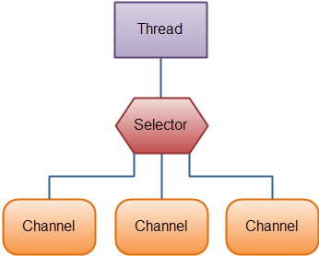

Creating a Selector

We can create a selector by calling Selector.open() method, as given below:

Selector selector = Selector.open();

Opening a server socket channel

Let's see the example for opening a server socket channel:

ServerSocketChannel serverSocket = ServerSocketChannel.open();

InetSocketAddress hostAddress = new InetSocketAddress("localhost", 8080);

serverSocket.bind(hostAddress);

Selection of Channels using a Selector

On registering one or more channels with a selector we can call one of a select() methods. This method return a channel which is ready for the events we want to perform i.e. connect, read, write or accept.

The various select() methods available for selection of channel are:

* **int select():** The integer value return by the select() method inform about how many channels are ready for the communication.
* **int select(long TS):** This method is same as select() except it blocks the output for a maximum of TS(in millisecond) time period.
* **int selectNow():** It doesn't block the output and returns immediately with any channel which are ready.

**selectedKeys()**

Once we have called any one of the select() methods and it will return a value as indicated that one or more channels are ready, then we can access the ready channels by using the ?selected key set?, by calling a selectors selectedkeys() method as given below:

Set<SelectionKey> selectedKeys = selector.selectedKeys();

We can iterate the selected key set for accessing the ready channels as given below:

Set<SelectionKey> selectedKeys = selector.selectedKeys();

Iterator<SelectionKey> keyIterator = selectedKeys.iterator();

while(keyIterator.hasNext()) {

    SelectionKey key = keyIterator.next();

    if(key.isConnectable()) {

        // The connection was established with a remote server.

    } else if (key.isAcceptable()) {

        // The connection was accepted by a ServerSocketChannel.

    } else if (key.isWritable()) {

        //  The channel is ready for writing

    } else if (key.isReadable()) {

        // The channel is ready for reading

    }

    keyIterator.remove();

}

The above loop iterates a key in the selected key set for determining the operation performed using a selected channel.

The complete select loop block diagram is shown below:

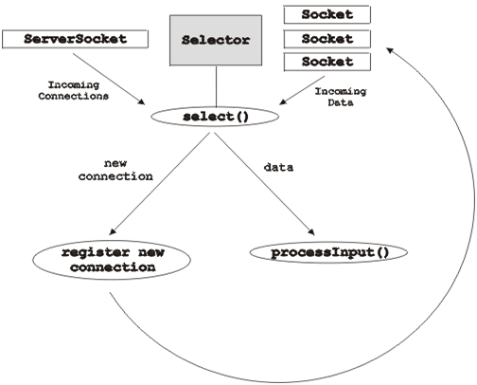

Basic Selector Example

**Main Program:**

package com.javatpoint;

import java.nio.channels.ServerSocketChannel;

import java.nio.channels.SocketChannel;

import java.nio.channels.Selector;

import java.nio.channels.SelectionKey;

import java.nio.ByteBuffer;

import java.io.IOException;

import java.util.Set;

import java.util.Iterator;

import java.net.InetSocketAddress;

public class SelectorExample {

   public static void main (String [] args)

            throws IOException {

        // Get the selector

        Selector selector = Selector.open();

        System.out.println("Selector is open for making connection: " + selector.isOpen());

        // Get the server socket channel and register using selector

        ServerSocketChannel SS = ServerSocketChannel.open();

        InetSocketAddress hostAddress = new InetSocketAddress("localhost", 8080);

        SS.bind(hostAddress);

        SS.configureBlocking(false);

        int ops = SS.validOps();

        SelectionKey selectKy = SS.register(selector, ops, null);

        for (;;) {

            System.out.println("Waiting for the select operation...");

            int noOfKeys = selector.select();

            System.out.println("The Number of selected keys are: " + noOfKeys);

            Set selectedKeys = selector.selectedKeys();

            Iterator itr = selectedKeys.iterator();

            while (itr.hasNext()) {

                SelectionKey ky = (SelectionKey) itr.next();

                if (ky.isAcceptable()) {

                    // The new client connection is accepted

                    SocketChannel client = SS.accept();

                    client.configureBlocking(false);

                    // The new connection is added to a selector

                    client.register(selector, SelectionKey.OP_READ);

                    System.out.println("The new connection is accepted from the client: " + client);

                }

                else if (ky.isReadable()) {

                    // Data is read from the client

                    SocketChannel client = (SocketChannel) ky.channel();

                    ByteBuffer buffer = ByteBuffer.allocate(256);

                    client.read(buffer);

                    String output = new String(buffer.array()).trim();

                    System.out.println("Message read from client: " + output);

                    if (output.equals("Bye Bye")) {

                        client.close();

                        System.out.println("The Client messages are complete; close the session.");

                    }

                }

                itr.remove();

            } // end of while loop

        } // end of for loop

    }

}

**Client Program:**

package com.javatpoint;

import java.nio.channels.SocketChannel;

import java.nio.ByteBuffer;

import java.io.IOException;

import java.net.InetSocketAddress;

public class Client {

    public static void main (String [] args)

            throws IOException, InterruptedException {

        InetSocketAddress hA = new InetSocketAddress("localhost", 8080);

        SocketChannel client = SocketChannel.open(hA);

        System.out.println("The Client is sending messages to server...");

        // Sending messages to the server

        String [] msg = new String [] {"Time goes fast.", "What next?", "Bye Bye"};

        for (int j = 0; j < msg.length; j++) {

            byte [] message = new String(msg [j]).getBytes();

            ByteBuffer buffer = ByteBuffer.wrap(message);

            client.write(buffer);

            System.out.println(msg [j]);

            buffer.clear();

            Thread.sleep(3000);

        }

        client.close();

    }

}

**Output:**

The Main Program Output is:

Selector is open for making connection: true

Waiting for the select operation...

The Number of selected keys are: 1

The new connection is accepted from the client: java.nio.channels.SocketChannel[connected

local=/127.0.0.1:8080 remote=/127.0.0.1:51367]

Waiting for the select operation...

The Number of selected keys are: 1

Message read from client: Time goes fast.

Waiting for the select operation...

The Number of selected keys are: 1

Message read from client: What next?

Waiting for the select operation...

The Number of selected keys are: 1

Message read from client: Bye Bye

The Client messages are complete; close the session.

Waiting for the select operation...

The Client Program Output is:

The Client is sending messages to server...

Time goes fast.

What next?

Bye Bye

## NIO – Read Example

**1. FileChannel and ByteBuffer to read small files**

Use this technique to read a small file where all the file content is fits into the buffer, and the file can be read in a single operation.

**Example 1: Java read small file using ByteBuffer and RandomAccessFile**

package com.howtodoinjava.test.nio;

import java.io.IOException;

import java.io.RandomAccessFile;

import java.nio.ByteBuffer;

import java.nio.channels.FileChannel;

public class ReadFileWithFileSizeBuffer

{

public static void main(String args[])

{

try

{

RandomAccessFile aFile = new RandomAccessFile("test.txt","r");

FileChannel inChannel = aFile.getChannel();

long fileSize = inChannel.size();

ByteBuffer buffer = ByteBuffer.allocate((int) fileSize);

inChannel.read(buffer);

buffer.flip();

//Verify the file content

for (int i = 0; i < fileSize; i++)

{

System.out.print((char) buffer.get());

}

inChannel.close();

aFile.close();

}

catch (IOException exc)

{

System.out.println(exc);

System.exit(1);

}

}

}

**2. FileChannel and ByteBuffer to read large files**

Use this technique to read the large file where all the file content will not fit into the buffer at a time, the buffer size will be needed of some very big number. In this case, we can read the file in chunks with a fixed size small buffer.

**Example 2: Java read a large file in chunks with fixed-size buffer**

package com.howtodoinjava.test.nio;

import java.io.IOException;

import java.io.RandomAccessFile;

import java.nio.ByteBuffer;

import java.nio.channels.FileChannel;

public class ReadFileWithFixedSizeBuffer

{

public static void main(String[] args) throws IOException

{

RandomAccessFile aFile = new RandomAccessFile("test.txt", "r");

FileChannel inChannel = aFile.getChannel();

ByteBuffer buffer = ByteBuffer.allocate(1024);

while(inChannel.read(buffer) > 0)

{

buffer.flip();

for (int i = 0; i < buffer.limit(); i++)

{

System.out.print((char) buffer.get());

}

buffer.clear(); // do something with the data and clear/compact it.

}

inChannel.close();

aFile.close();

}

}

**3. Read a file using MappedByteBuffer**

MappedByteBuffer extends the ByteBuffer class with operations that are specific to memory-mapped file regions.

**Example 3: Reading a file using memory-mapped files in Java**

package com.howtodoinjava.test.nio;

import java.io.IOException;

import java.io.RandomAccessFile;

import java.nio.MappedByteBuffer;

import java.nio.channels.FileChannel;

public class ReadFileWithMappedByteBuffer

{

public static void main(String[] args) throws IOException

{

RandomAccessFile aFile = new RandomAccessFile("test.txt", "r");

FileChannel inChannel = aFile.getChannel();

MappedByteBuffer buffer = inChannel.map(FileChannel.MapMode.READ_ONLY, 0, inChannel.size());

buffer.load();

for (int i = 0; i < buffer.limit(); i++)

{

System.out.print((char) buffer.get());

}

buffer.clear(); // do something with the data and clear/compact it.

inChannel.close();

aFile.close();

}

}

All the above techniques will read the content of the file and print it to the console.

## NIO – Vectored IO or Scatter/ Gather

**Java NIO Vectored IO**

Java NIO [Channels](https://howtodoinjava.com/java/nio/java-nio-2-0-channels/) provide an important new capability known as **scatter/gather** (referred to in some circles as **vectored I/O**). Scatter/gather is a simple yet powerful concept.

Scatter/gather is a technique through which bytes can be read from a stream into a set of buffers (vectors) with a single read() invocation and bytes can be written from a set of buffers to a stream with a single write() invocation.

Most modern operating systems support native vectored I/O. When you request a scatter/gather operation on a channel, the request will be translated into appropriate native calls to fill or drain the buffers directly. This is a big win because buffer copies and system calls are reduced or eliminated.

Until recently Java did not have the capability of performing vectored I/O operation. So we are used to reading bytes directly into a single byte array or do multiple reads to fetch the data.

**1. Scatter/Gather APIs**

A **scattering read** from a channel is a read operation that reads data into more than one buffer. Thus, the channel “**scatters**” the data from the channel into multiple buffers.

A **gathering write** to a channel is a write operation that writes data from more than one buffer into a single channel. Thus, the channel “**gathers**” the data from multiple buffers into one channel.

Scatter and gather can be really useful in situations where you need to work with various parts of the transmitted data separately.

public interface ScatteringByteChannel extends ReadableByteChannel

{

public long read (ByteBuffer [] dsts) throws IOException;

public long read (ByteBuffer [] dsts, int offset, int length) throws IOException;

}

public interface GatheringByteChannel extends WritableByteChannel

{

public long write(ByteBuffer[] srcs) throws IOException;

public long write(ByteBuffer[] srcs, int offset, int length) throws IOException;

}

You can see that each interface adds two new methods that take an array of buffers as arguments.

Now let’s write a quick example to understand how to use this feature.

**2. Java Scatter/Gather IO Example**

In this example, I have created two buffers. One buffer will store a random number and another will store a random string. I will use GatheringByteChannel to read-write the data stored in both buffers in a file channel.

Then I will read the data back from the file into two separate buffers using ScatteringByteChannel and print the content in the console to verify that data stored and retrieved are matched.

**3. Conclusion**

Scatter/gather can be an extraordinarily powerful tool when used properly. It allows you to delegate to the operating system the grunt work of separating out the data you read into multiple buckets, or assembling disparate chunks of data into a whole. This can be a huge win because the **operating system is highly optimized for this sort of thing**.

It saves you the work of moving things around, thereby **avoiding buffer copies, and reduces the amount of code you need to write and debug**. Since you are basically assembling data by providing references to data containers, the various chunks can be assembled in different ways by building multiple arrays of buffer references in different combinations.

## NIO – Create New File

**Creating a new file in Java** is a very easy task. In this Java tutorial, we will list down different ways to create a new file.

Read More: [Create a read only file in Java](https://howtodoinjava.com/java/io/make-a-file-read-only-in-java/)

**1. Create file with java.nio.file.Files**

[Files.write()](https://docs.oracle.com/javase/7/docs/api/java/nio/file/Files.html#write(java.nio.file.Path,%20java.lang.Iterable,%20java.nio.charset.Charset,%20java.nio.file.OpenOption...)) is **best way to create a new file in Java** and it should be your preferred approach in future if you are not already using it.

This method writes lines of text to the created file. Each line is a char sequence and is written to the file in sequence with each line terminated by the platform’s *line separator*.

**Method Syntax**

/**

* @param   path     - the path to the file

* @param   lines    - an object to iterate over the char sequences

* @param   cs       - the charset to use for encoding

* @param   options  - options specifying how the file is opened

*

* @return  the path of the newly created file

*/

public static Path write(Path path,

     Iterable<? extends CharSequence> lines,

     Charset cs,

     OpenOption... options) throws IOException

**Example 1: Check if a file already exist in Java**

[LinkOption.NOFOLLOW_LINKS](https://docs.oracle.com/javase/7/docs/api/java/nio/file/LinkOption.html) indicates that the application should not follow symbolic links in the file system to determine if the path exists.

Path path = Paths.get("dataPath/test.text");

boolean doesFileExist =

        Files.exists(path,

            new LinkOption[]{ LinkOption.NOFOLLOW_LINKS });

**Example 2: Create a new file or append to an existing file**

Use [StandardOpenOption](https://docs.oracle.com/javase/7/docs/api/java/nio/file/StandardOpenOption.html) to indicate if a new file has to be created or not.

List<String> lines = Arrays.asList("1st line", "2nd line");

Files.write(Paths.get("file6.txt"), lines,

        StandardCharsets.UTF_8);

|  |
| --- |
|  |

**Example 3: Create a new file with default options**

If we do not specify any options parameter then by default, CREATE, TRUNCATE_EXISTING, and WRITE options are use.

It does the following things:

* Opens the file for write if exist
* Creates the file if the file doesn’t exist
* Opens the file for writing
* Deletes all the file content
* Write the new content into the file

List<String> lines = Arrays.asList("1st line", "2nd line");

Files.write(Paths.get("file6.txt"),

                lines,

                StandardCharsets.UTF_8,

                StandardOpenOption.CREATE,

                StandardOpenOption.APPEND);

**2. Create new file with java.io.File class**

import java.io.FileInputStream;

import java.io.FileOutputStream;

import java.nio.ByteBuffer;

import java.nio.channels.FileChannel;

import java.nio.channels.GatheringByteChannel;

import java.nio.channels.ScatteringByteChannel;

public class ScatteringAndGatheringIOExample

{

public static void main(String params[])

{

String data = "Scattering and Gathering example shown in howtodoinjava.com";

gatherBytes(data);

scatterBytes();

}

/*

* gatherBytes() reads bytes from different buffers and writes to file

* channel. Note that it uses a single write for both the buffers.

*/

public static void gatherBytes(String data)

{

//First Buffer holds a random number

ByteBuffer bufferOne = ByteBuffer.allocate(4);

//Second Buffer holds data we want to write

ByteBuffer buffer2 = ByteBuffer.allocate(200);

//Writing Data sets to Buffer

bufferOne.asIntBuffer().put(13);

buffer2.asCharBuffer().put(data);

//Calls FileOutputStream(file).getChannel()

GatheringByteChannel gatherer = createChannelInstance("test.txt", true);

//Write data to file

try

{

gatherer.write(new ByteBuffer[] { bufferOne, buffer2 });

}

catch (Exception e)

{

e.printStackTrace();

}

}

/*

* scatterBytes() read bytes from a file channel into a set of buffers. Note that

* it uses a single read for both the buffers.

*/

public static void scatterBytes()

{

//First Buffer holds a random number

ByteBuffer bufferOne = ByteBuffer.allocate(4);

//Second Buffer holds data we want to write

ByteBuffer bufferTwo = ByteBuffer.allocate(200);

//Calls FileInputStream(file).getChannel()

ScatteringByteChannel scatterer = createChannelInstance("test.txt", false);

try

{

//Reading from the channel

scatterer.read(new ByteBuffer[] { bufferOne, bufferTwo });

}

catch (Exception e)

{

e.printStackTrace();

}

//Read the buffers seperately

bufferOne.rewind();

bufferTwo.rewind();

int bufferOneContent = bufferOne.asIntBuffer().get();

String bufferTwoContent = bufferTwo.asCharBuffer().toString();

//Verify the content

System.out.println(bufferOneContent);

System.out.println(bufferTwoContent);

}

public static FileChannel createChannelInstance(String file, boolean isOutput)

{

FileChannel fc = null;

try

{

if (isOutput) {

fc = new FileOutputStream(file).getChannel();

} else {

fc = new FileInputStream(file).getChannel();

}

}

catch (Exception e) {

e.printStackTrace();

}

return fc;

}

}

Use [File.createNewFile()](https://docs.oracle.com/javase/7/docs/api/java/io/File.html#createNewFile()) method to create new file. This method returns a boolean value –

* true if the file is created successfully.
* false if the file already exists or the operation failed for some reason.

Please note that this method will *only create a file, and does not write any content* into the file.

**Java example to create a new create file if not exist**

File file = new File("c://temp//testFile1.txt");

//Create the file

if (file.createNewFile()) {

System.out.println("File is created!");

} else {

System.out.println("File already exists.");

}

To write the content into the created file, use FileWriter class.

//Write Content

FileWriter writer = new FileWriter(file);

writer.write("Test data");

writer.close();

**3. Create new file with FileOutputStream**

[FileOutputStream.write()](https://docs.oracle.com/javase/7/docs/api/java/io/FileOutputStream.html#write(byte[])) method automatically **creates a new file and write content to it**.

String data = "Test data";

FileOutputStream out = new FileOutputStream( "c://temp//testFile2.txt" );

out.write( data.getBytes() );

out.close();

## NIO – DataTransfer between Channels

**Java NIO FileChannel transferTo() and transferFrom()**

As in normal Java applications where IO happens mostly between an input source and output target, in NIO as well we may need to transfer data from one [channel](https://howtodoinjava.com/java/nio/java-nio-2-0-channels/) to another channel very frequently.

Bulk transfers of file data from one place to another is so common that a couple of optimization methods have been added to the FileChannel class to make it even more efficient.

**1. Data Transfer between Channels**

Java NIO provides two methods for transferring the data between two channels:

* **FileChannel.transferTo()**
* **FileChannel.transferFrom()**

The transferTo() and transferFrom() methods allow us to cross-connect one channel to another. This eliminates the need to pass the data through an intermediate buffer.

These methods exist only on the FileChannel class, so one of the channels involved in a channel-to-channel transfer must be a FileChannel.

public abstract class FileChannel extends AbstractChannel

implements ByteChannel, GatheringByteChannel, ScatteringByteChannel {

// There are more other methods

public abstract long transferTo (long position, long count, WritableByteChannel target);

public abstract long transferFrom (ReadableByteChannel src, long position, long count);

}

We can’t do direct transfers between socket channels, but socket channels implement WritableByteChannel and ReadableByteChannel, so the content of a file can be transferred to a socket with transferTo(), or data can be read from a socket directly into a file with transferFrom().

Also, keep in mind that these methods may throw java.io.IOException if any error is encountered during the transfer.

Channel-to-channel transfers can potentially be extremely fast, especially where the underlying operating system provides native support. Some operating systems can perform direct transfers without ever passing the data through user-space. This can be a huge win for high-volume data transfer.

**2. FileChannel transferTo() and transferFrom() Example**

In this example, we are reading the file content from 3 different files and writing their combined output into a fourth file.

package com.howtodoinjava.nio;

import java.io.File;

import java.io.FileInputStream;

import java.io.FileOutputStream;

import java.nio.channels.FileChannel;

import java.nio.channels.WritableByteChannel;

public class ChannelTransferExample

{

public static void main(String[] argv) throws Exception

{

//Input files

String[] inputFiles = new String[]{"inputFile1.txt","inputFile2.txt","inputFile3.txt"};

//Files contents will be written in these files

String outputFile = "outputFile.txt";

//Get channel for output file

FileOutputStream fos = new FileOutputStream(new File(outputFile));

WritableByteChannel targetChannel = fos.getChannel();

for (int i = 0; i < inputFiles.length; i++)

{

//Get channel for input files

FileInputStream fis = new FileInputStream(inputFiles[i]);

FileChannel inputChannel = fis.getChannel();

//Transfer data from input channel to output channel

inputChannel.transferTo(0, inputChannel.size(), targetChannel);

//close the input channel

inputChannel.close();

fis.close();

}

//finally close the target channel

targetChannel.close();

fos.close();

}

}

## NIO – Write to File

When working on enterprise application, sometimes it is needed to **write files in Java** e.g. writing user-generated reports into the filesystem. Though there are multiple ways of writing the files in Java, let’s quickly go through a few of them for quick reference when it is needed.

**Files.writeString() – Since Java 11**

With the method [writeString()](https://docs.oracle.com/en/java/javase/11/docs/api/java.base/java/nio/file/Files.html#writeString(java.nio.file.Path,java.lang.CharSequence,java.nio.file.OpenOption...)) introduced in [Java 11](https://howtodoinjava.com/java11/features-enhancements/), we can *write a String into a file* using a single line statement.

**Files.writeString() Example**

import java.io.IOException;

import java.nio.file.Files;

import java.nio.file.Path;

public class WriteToFile {

public static void main(String[] args) throws IOException {

Path fileName = Path.of("demo.txt");

String content = "hello world !!";

Files.writeString(fileName, content);

String actual = Files.readString(fileName);

System.out.println(actual);

}

}

Write File using FileChannel

[FileChannel](https://docs.oracle.com/javase/10/docs/api/java/nio/channels/FileChannel.html) can be used for reading, writing, mapping, and manipulating a file.

If we are writing the large files, FileChannel can be faster than standard IO.

File channels are safe for use by multiple concurrent threads.

**FileChannel Example**

public static void usingFileChannel() throws IOException {

String fileContent = "Hello Learner !! Welcome to howtodoinjava.com.";

RandomAccessFile stream = new RandomAccessFile("c:/temp/samplefile6.txt", "rw");

FileChannel channel = stream.getChannel();

byte[] strBytes = fileContent.getBytes();

ByteBuffer buffer = ByteBuffer.allocate(strBytes.length);

buffer.put(strBytes);

buffer.flip();

channel.write(buffer);

stream.close();

channel.close();

}

Java 7 – Files.write()

Java 7 introduced Files utility class and we can write a file using it’s write() function, internally it’s using OutputStream to write byte array into file.

**write() Example**

public static void usingPath() throws IOException {

String fileContent = "Hello Learner !! Welcome to howtodoinjava.com.";

Path path = Paths.get("c:/temp/samplefile7.txt");

Files.write(path, fileContent.getBytes());

}

**Java Write to File using BufferedWritter**

[BufferedWritter](https://docs.oracle.com/javase/10/docs/api/java/io/BufferedWriter.html) the simplest way to write the content to a file. It writes text to a character-output stream, **buffering characters** so as to provide for the efficient writing of single characters, arrays, and strings.

Unless prompt output is required, it is advisable to wrap a BufferedWriter around any Writer whose write() operations may be costly, such as FileWriter and OutputStreamWriter.

As it buffers before writing, so it results in **less IO operations**, so it improves the performance.

|  |
| --- |
| **BufferedWritter Example** |
| public static void usingBufferedWritter() throws IOException {      String fileContent = "Hello Learner !! Welcome to howtodoinjava.com.";        BufferedWriter writer = new BufferedWriter(new FileWriter("c:/temp/samplefile1.txt"));      writer.write(fileContent);      writer.close();  } |

**Write File using FileWriter/PrintWriter**

[FileWriter](https://docs.oracle.com/javase/10/docs/api/java/io/FileWriter.html) the most clean way to write files. Syntax is self explanatory and easy to read and understand. FileWriter writes directly into file (*less performance*) and should be used only when number of writes are less.

|  |
| --- |
| **FileWriter Example** |
| public static void usingFileWriter() throws IOException {  String fileContent = "Hello Learner !! Welcome to howtodoinjava.com.";    FileWriter fileWriter = new FileWriter("c:/temp/samplefile2.txt");  fileWriter.write(fileContent);  fileWriter.close();  } |

Use [PrintWriter](https://docs.oracle.com/javase/10/docs/api/java/io/PrintWriter.html) to write formatted text to a file. This class implements all of the print methods found in PrintStream, so you can use all formats which you use with System.out.println() statements.

**PrintWriter Example**

public static void usingPrintWriter() throws IOException {

String fileContent = "Hello Learner !! Welcome to howtodoinjava.com.";

FileWriter fileWriter = new FileWriter("c:/temp/samplefile3.txt");

PrintWriter printWriter = new PrintWriter(fileWriter);

printWriter.print(fileContent);

printWriter.printf("Blog name is %s", "howtodoinjava.com");

printWriter.close();

}

**Write File using FileOutputStream**

Use [FileOutputStream](https://docs.oracle.com/javase/10/docs/api/java/io/FileOutputStream.html) to **write binary data to a file**. FileOutputStream is meant for writing streams of raw bytes such as image data. For writing streams of characters, consider using FileWriter.

**FileOutputStream Example**

public static void usingFileOutputStream() throws IOException {

String fileContent = "Hello Learner !! Welcome to howtodoinjava.com.";

FileOutputStream outputStream = new FileOutputStream("c:/temp/samplefile4.txt");

byte[] strToBytes = fileContent.getBytes();

outputStream.write(strToBytes);

outputStream.close();

}

**Write File using DataOutputStream**

[DataOutputStream](https://docs.oracle.com/javase/10/docs/api/java/io/DataOutputStream.html) lets an application **write primitive Java data types** to an output stream in a portable way. An application can then use a data input stream to read the data back in.

**DataOutputStream Example**

public static void usingDataOutputStream() throws IOException {

String fileContent = "Hello Learner !! Welcome to howtodoinjava.com.";

FileOutputStream outputStream = new FileOutputStream("c:/temp/samplefile5.txt");

DataOutputStream dataOutStream = new DataOutputStream(new BufferedOutputStream(outputStream));

dataOutStream.writeUTF(fileContent);

dataOutStream.close();

}

**Summary**

1. If we try to write to a file that doesn’t exist, the file will be created first and no exception will be thrown (except using Path method).
2. Always close the output stream after writing the file content to release all resources. It will also help in not corrupting the file.
3. Use PrintWriter is used to write formatted text.
4. Use FileOutputStream to write binary data.
5. Use DataOutputStream to write primitive data types.
6. Use FileChannel to write larger files. It is preferred way in *writing file in Java 8* as well.

## NIO – Append to File

Learn to **append content to file in Java** using BufferedWritter, PrintWriter, FileOutputStream and Files class. In all the examples, while opening the file to write, you have pass a second argument as true which denotes that file is opened in **append mode**.

**Append to File using Files class**

With [Files](https://docs.oracle.com/javase/7/docs/api/java/nio/file/Files.html) class, we can write a file using it’s write() function. Internally write() function uses OutputStream to write byte array into the file.

To append content to an existing file, Use [StandardOpenOption.APPEND](https://docs.oracle.com/javase/7/docs/api/java/nio/file/StandardOpenOption.html) while writing the content.

**Files.write() Example**

public static void usingPath() throws IOException {

String textToAppend = "\r\n Happy Learning !!"; //new line in content

Path path = Paths.get("c:/temp/samplefile.txt");

Files.write(path, textToAppend.getBytes(), StandardOpenOption.APPEND); //Append mode

}

**Append to File using BufferedWritter**

BufferedWritter buffers before writing, so it result in **less IO operations**, so it improve the performance.

To append string to an existing file, open file writer in append mode with passing the second argument as true.

**BufferedWritter Example**

public static void usingBufferedWritter() throws IOException {

String textToAppend = "Happy Learning !!";

//Set true for append mode

BufferedWriter writer = new BufferedWriter(

new FileWriter("c:/temp/samplefile.txt", true));

writer.write(textToAppend);

writer.close();

}

**Append to File using PrintWriter**

Use [PrintWriter](https://docs.oracle.com/javase/10/docs/api/java/io/PrintWriter.html) to write formatted text to a file. This class implements all of the print methods found in PrintStream, so you can use all formats which you use with System.out.println() statements.

To append content to an existing file, open file writer in append mode by passing the second argument as true.

**PrintWriter Example**

public static void usingPrintWriter() throws IOException {

String textToAppend = "Happy Learning !!";

FileWriter fileWriter = new FileWriter("c:/temp/samplefile.txt", true); //Set true for append mode

PrintWriter printWriter = new PrintWriter(fileWriter);

printWriter.println(textToAppend); //New line

printWriter.close();

}

**Append to File using FileOutputStream**

Use [FileOutputStream](https://docs.oracle.com/javase/10/docs/api/java/io/FileOutputStream.html) to **write binary data to a file**. FileOutputStream is meant for writing streams of raw bytes such as image data. For writing streams of characters, consider using FileWriter.

To *append content to an existing file*, open FileOutputStream in append mode by passing second argument as true.

FileOutputStream Example

public static void usingFileOutputStream() throws IOException {

String textToAppend = "\r\n Happy Learning !!"; //new line in content

FileOutputStream outputStream = new FileOutputStream("c:/temp/samplefile.txt", true);

byte[] strToBytes = textToAppend.getBytes();

outputStream.write(strToBytes);

outputStream.close();

}

**Java Read File**

In Java, a file can be read in many different ways. In this tutorial, we will learn some good ways to read a file in Java.

**1. Read file with BufferedReader**

A most simple, commonly used and efficient method used for long time with [BufferedReader](https://docs.oracle.com/javase/7/docs/api/java/io/BufferedReader.html). It reads text from a character-input stream, buffering characters so as to provide for the efficient reading of characters, arrays, and lines.

Example 1: Read a file line by line using BufferedReader

public void readFile(String fileName) {

try (BufferedReader br = new BufferedReader(new FileReader("C:\\testing.txt")))

{

String sCurrentLine;

while ((sCurrentLine = br.readLine()) != null)

{

System.out.println(sCurrentLine);

}

}

//Stream is closed automatically

catch (IOException e)

{

e.printStackTrace();

}

}

**2. Read a file with Java NIO Files**

The [Files](https://docs.oracle.com/javase/7/docs/api/java/nio/file/Files.html) class is part of Java NIO API, and make the code easy to read. This class consists exclusively of static methods that operate on files, directories, or other types of files.

Example 2: Read a file line by line with Java NIO

public void readFileWithNIO (String fileName) {

Path path = Paths.get( fileName );

try ( Stream<String> lines = Files.lines(path) )

{

lines.forEach(s -> System.out.println(s));

}

catch (IOException ex) {

ex.printStackTrace();

}

}

Please notice the use of lines.forEachOrdered(). If you will use lines.forEach() then you may not get the lines in correct sequence due to asynchronous nature of API.

**3. Read a file with FileUtils**

Apache Commons IO library does an excellent job by providing short and easy to use methods for almost all of IO related jobs in Java. The [FileUtils](https://commons.apache.org/proper/commons-io/apidocs/org/apache/commons/io/FileUtils.html) class is a utility class for general file reading and manipulations.

**Example 2: Read a file with Apache Commons IO**

public void readFileWithApacheCommons (String fileName) {

try

{

File file = new File( fileName );

List lines = FileUtils.readLines(file, "UTF-8");

for (String line : lines) {

System.out.println( line );

}

}

catch (IOException ex) {

ex.printStackTrace();

}

}

**4. Read file with Guava**

Guava has similar approach as Apache Commons IO. Only the class name is different – Use [Files](https://guava.dev/releases/21.0/api/docs/com/google/common/io/Files.html) in place of FileUtils.

public void readFileWithGuava (String fileName) {

try

{

File file = new File( fileName );

List lines = Files.readLines(file, "UTF-8");

for (String line : lines) {

System.out.println( line );

}

}

catch (IOException ex) {

ex.printStackTrace();

}

}

Let me know if you think any other way of **reading a file in Java** more efficiently.

## NIO – Read File to String

Learn to **read file to string** in Java. Given examples use Files.readAllBytes(), Files.lines() (to **read line by line**) and FileReader & BufferedReader to **read text file to String**.

**1. Files.readString() – Java 11**

With the new method [readString()](https://docs.oracle.com/en/java/javase/11/docs/api/java.base/java/nio/file/Files.html#readString(java.nio.file.Path)) introduced in [Java 11](https://howtodoinjava.com/java11/features-enhancements/), it takes only a single line to read a file’s content in to String.

**Example 1: Read a file to String in Java 11**

import java.io.IOException;

import java.nio.file.Files;

import java.nio.file.Path;

public class WriteToFile {

public static void main(String[] args) throws IOException {

Path fileName = Path.of("demo.txt");

String content = "hello world !!";

Files.writeString(fileName, content);

String actual = Files.readString(fileName);

System.out.println(actual);

}

}

**2. Files.lines() – Java 8**

[lines()](https://docs.oracle.com/javase/8/docs/api/java/nio/file/Files.html#lines-java.nio.file.Path-java.nio.charset.Charset-) method **read all lines from a file to stream** and populates lazily as the [stream](https://howtodoinjava.com/java8/java-streams-by-examples/) is consumed. Bytes from the file are decoded into characters using the specified charset.

**Example 2: Reading a file line by line in Java 8**

import java.io.IOException;

import java.nio.charset.StandardCharsets;

import java.nio.file.Files;

import java.nio.file.Paths;

import java.util.stream.Stream;

public class ReadFileToString {

public static void main(String[] args) {

String filePath = "c:/temp/data.txt";

System.out.println( readLineByLineJava8( filePath ) );

}

//Read file content into the string with - Files.lines(Path path, Charset cs)

private static String readLineByLineJava8(String filePath)

{

StringBuilder contentBuilder = new StringBuilder();

try (Stream<String> stream = Files.lines( Paths.get(filePath), StandardCharsets.UTF_8))

{

stream.forEach(s -> contentBuilder.append(s).append("\n"));

}

catch (IOException e)

{

e.printStackTrace();

}

return contentBuilder.toString();

}

}

Output:

Welcome to howtodoinjava.com blog.

Learn to grow.

**3. Files.readAllBytes() – Read the entire File to String – Java 7**

[readAllBytes()](https://docs.oracle.com/javase/7/docs/api/java/nio/file/Files.html#readAllBytes(java.nio.file.Path)) method *reads all the bytes from a file*. The method ensures that the file is closed when all bytes have been read or an I/O error, or other runtime exception, is thrown.

After reading all bytes, we pass those bytes to String class constructor to create a string.

Example 3: Java program to read entire file to String

import java.io.IOException;

import java.nio.file.Files;

import java.nio.file.Paths;

public class ReadFileToString {

public static void main(String[] args) {

String filePath = "c:/temp/data.txt";

System.out.println( readAllBytesJava7( filePath ) );

}

//Read file content into string with - Files.readAllBytes(Path path)

private static String readAllBytesJava7(String filePath) {

String content = "";

try {

content = new String ( Files.readAllBytes( Paths.get(filePath) ) );

} catch (IOException e) {

e.printStackTrace();

}

return content;

}

}

Output:

Welcome to howtodoinjava.com blog.

Learn to grow.

**4. BufferedReader – Java 6 and below**

If you are still not using Java 7 or later, then use [BufferedReader](https://docs.oracle.com/javase/7/docs/api/java/io/BufferedReader.html) class. It’s readLine() method **reads the file one line at a time** and return the content.

**Example 4: Java program to read a file line by line**

import java.io.BufferedReader;

import java.io.FileReader;

import java.io.IOException;

public class ReadFileToString {

public static void main(String[] args) {

String filePath = "c:/temp/data.txt";

System.out.println( usingBufferedReader( filePath ) );

}

//Read file content into the string with - using BufferedReader and FileReader

//You can use this if you are still not using Java 8

private static String usingBufferedReader(String filePath) {

StringBuilder contentBuilder = new StringBuilder();

try (BufferedReader br = new BufferedReader(new FileReader(filePath))) {

String sCurrentLine;

while ((sCurrentLine = br.readLine()) != null) {

contentBuilder.append(sCurrentLine).append("\n");

}

}

catch (IOException e) {

e.printStackTrace();

}

return contentBuilder.toString();

}

}

Output:

Welcome to howtodoinjava.com blog.

Learn to grow.

Use any of the above-given methods for reading a file into a string using Java.

# Java Performance Optimization Tips

Optimizing methods in a class –

* Avoid creating temporary objects within frequently called methods
* Define methods that accept reusable objects to be filled in with data, rather than methods that return objects holding that data.
* Use methods that alter objects without making copies
* Eliminate repeatedly called methods where alternatives are possible [For example, if you are processing a vector in a loop, get the size of the vector in the beginning in a length local variable rather than calling size() method on the vector in the condition part of the for loop]
* Use private and static methods and final classes to encourage inlining by the compiler
* Inline methods manually where it is appropriate
* Keep methods short and simple to make them automaticinlining candidates
* Access to private member by the inner classes to theenclosing class goes by a method call even if it is not intended to.
* Keep synchronized methods out of loops if you possibly can.

Optimizing Loops and Conditional statements –

* Reduce the number of temporary objects being used,especially in loops.
* Use short-circuit Boolean operators instead of normal Boolean operators
* Eliminate unnecessary repeated method calls from loops
* Move loop invariants outside the loop.
* Perform the loop backwards (this actually performs slightlyfaster than forward loops do). [Actually it is converting the test tocompare against 0 that makes the difference].
* It can help to copy slower-access vars to fast local varsif you are going to operate on them repeatedly, as in a loop.
* Use exception terminated infinite loops for long loops.
* Whatever can be calculated outside of a loop should becalculated outside of the loop.
* For multidimensional arrays store a reference for thecurrently accessed row in a variable.
* Cache the size of the collection in a local variable to usein a loop instead of repeatedly calling collection.size().

Optimizing Strings –

* Use StringBuffer instead of String concat ‘+’ operator
* Formatting numbers using java.text.DecimalFormat is always slower than Double.toString(double) method, because internally java.text.DecimalFormat() calls Double.toString(double) then parses and converts the results.
* Convert String to char[] arrays to process characters rather than accessing one at a time using String.charAt() method
* Creating Double from string is slow
* Intern() Strings to enable (==) comparisions
* Use char arrays for all character processing in loops,rather than using String or StringBuffer classes
* Set the initial string buffer size to maximum if it known.
* StringTokenizer is very inefficient, and can be optimizedby storing the string and delimiter in a character array instead of inString
* DON’T create static strings via new().
* Where the compiler cannot resolve concatenated strings atcompile time, the code should be converted to StringBuffer appends, andthe StringBuffer should be appropriately sized rather than using thedefault size.
* The compiler concatenates strings where they are fullyresolvable, so don t move these concatenations to runtime withStringBuffer.

Optimizing Arrays, Vectors and Collections –

* Create copies of simple array by initializing them through loops or by using System.arraycopy(), create copies of complex arrays by cloning them
* Iterator.hasNext() and Enumerator.hasMoreElements() need not be repeatedly called when the size of the collection is known. Use collection.size() and a loop counter instead.
* ArrayList is faster than Vector
* Go for a non-synchronized version of collection unless usedin a threaded application
* LinkedList is faster than ArrayList for inserting elements to the front of the array, but slower at indexed lookup
* Accessing arrays is much faster than accessing Vectors, String, and StringBuffer
* Vector is convenient to use, but inefficient. Ensure that elementAt() is not used inside a loop.
* Re-use Hashtables by using Hashtable.clear().
* Removing elements from a Vector will necessitate copyingwithin the Vector if the element is removed from anywhere other thanthe end of the collection.
* Presizing collections to the expected size is moreefficient than using the default size and letting the collection grow.
* For multidimensional arrays store a reference for thecurrently accessed row in a variable.
* When adding multiple items to a collection, add them all inone call if possible.

Comparing the performance of LinkedLists and ArrayLists (and Vectors)

* ArrayList is faster than Vector except when there is no lock acquisition required in HotSpot JVMs (when they have about the same performance).
* Vector and ArrayList implementations have excellent performance for indexed access and update of elements, since there is no overhead beyond range checking.
* Adding elements to, or deleting elements from the end of a Vector or ArrayList also gives excellent performance except when the capacity is exhausted and the internal array has to be expanded.
* Inserting and deleting elements to Vectors and ArrayLists always require an array copy (two copies when the internal array must be grown first). The number of elements to be copied is proportional to [size-index], i.e. to the distance between the insertion/deletion index and the last index in the collection. The array copying overhead grows significantly as the size of the collection increases, because the number of elements that need to be copied with each insertion increases.
* For insertions to Vectors and ArrayLists, inserting to the front of the collection (index 0) gives the worst performance, inserting at the end of the collection (after the last element) gives the best performance.
* LinkedLists have a performance overhead for indexed access and update of elements, since access to any index requires you to traverse multiple nodes.
* LinkedList insertions/deletion overhead is dependent on the how far away the insertion/deletion index is from the closer end of the collection.
* Synchronized wrappers (obtained from Collections.synchronizedList(List)) add a level of indirection which can have a high performance cost.
* Only List and Map have efficient thread-safe implementations: the Vector and Hashtable classes respectively.
* List insertion speed is critically dependent on the size of the collection and the position where the element is to be inserted.
* For small collections ArrayList and LinkedList are close in performance, though ArrayList is generally the faster of the two. Precise speed comparisons depend on the JVM and the index where the object is being added.
* Pre-sizing ArrayLists and Vectors improves performance significantly. LinkedLists cannot be pre-sized.
* ArrayLists can generate far fewer objects for the garbage collector to reclaim, compared to LinkedLists.
* For medium to large sized Lists, the location where elements are to inserted is critical to the performance of the list. ArrayLists have the edge for random access.
* A dedicated List implementation designed to match data, collection types and data manipulation algorithms will always provide the best performance.
* ArrayList internal node traversal from the start to the end of the collection is significantly faster than LinkedList traversal. Consequently queries implemented in the class can be faster.
* Iterator traversal of all elements is faster for ArrayList compared to Linkedlist.

Using the WeakHashMap class

* WeakHashMap can be used to reduce memory leaks. Keys that are no longer strongly referenced from the application will automatically make the corresponding value reclaimable.
* To use WeakHashMap as a cache, the keys that evaluate as equal must be recreatable.
* Using WeakHashMap as a cache gives you less control over when cache elements are removed compared with other cache types.
* Clearing elements of a WeakHashMap is a two stage process: first the key is reclaimed, then the corresponding value is released from the WeakHashMap.
* String literals and other objects like Class which are held directly by the JVM are not useful as keys to a WeakHashMap, as they are not necessarily reclaimable when the application no longer references them.
* The WeakHashMap values are not released until the WeakHashMap is altered in some way. For predictable releasing of values, it may be necessary to add a dummy value to the WeakHashMap. If you do not call any mutator methods after populating the WeakHashMap, the values and internal WeakReference objects will never be dereferenced [no longer true from 1.4, where most methods now allow values to be released].
* WeakHashMap wraps an internal HashMap adding an extra level of indirection which can be a significant performance overhead. [no longer true from 1.4].
* Every call to get() creates a new WeakReference object. [no longer true from 1.4].
* WeakHashMap.size() iterates through the keys, making it an operation that takes time proportional to the size of the WeakHashMap. [no longer true from 1.4].
* WeakHashMap.isEmpty() iterates through the collection looking for a non-null key, so a WeakHashMap which is empty requires more time for isEmpty() to return than a similar WeakHashMap which is not empty. [no longer true from 1.4, where isEmpty() is now slower than previous versions].
* Establish whether you have a memory problem.
* Reduce the number of temporary objects being used, especially in loops.
* Avoid creating temporary objects within frequently called methods.
* Presize collection objects.
* Reuse objects where possible.
* Empty collection objects before reusing them. (Do not shrink them unless they are very large.)
* Use custom conversion methods for converting between data types (especially strings and streams) to reduce the number of temporary objects.
* Define methods that accept reusable objects to be filled in with data, rather than methods that return objects holding that data. (Or you can return immutable objects.)
* Canonicalize objects wherever possible. Compare canonicalized objects by identity. [Canonicalizing objects means having only a single reference of an object, with no copies possible].
* Create only the number of objects a class logically needs (if that is a small number of objects).
* Replace strings and other objects with integer constants. Compare these integers by identity.
* Use primitive data types instead of objects as instance variables.
* Avoid creating an object that is only for accessing a method.
* Flatten objects to reduce the number of nested objects.
* Preallocate storage for large collections of objects by mapping the instance variables into multiple arrays.
* Use StringBuffer rather than the string concatenation operator (+).
* Use methods that alter objects directly without making copies.
* Create or use specific classes that handle primitive data types rather than wrapping the primitive data types.
* Consider using a ThreadLocal to provide threaded access to singletons with state.
* Use the final modifier on instance-variable definitions to create immutable internally accessible objects.
* Use WeakReferences to hold elements in large canonical lookup tables. (Use SoftReferences for cache elements.)
* Reduce object-creation bottlenecks by targeting the object-creation process.
* Keep constructors simple and inheritance hierarchies shallow.
* Avoid initializing instance variables more than once.
* Use the clone() method to avoid calling any constructors.
* Clone arrays if that makes their creation faster.
* Create copies of simple arrays faster by initializing them; create copies of complex arrays faster by cloning them.
* Eliminate object-creation bottlenecks by moving object creation to an alternative time.
* Create objects early, when there is spare time in the application, and hold those objects until required.
* Use lazy initialization when there are objects or variables that may never be used, or when you need to distribute the load of creating objects.
* Use lazy initialization only when there is a defined merit in the design, or when identifying a bottleneck which is alleviated using lazy initialization.
* Eliminate unnecessary casts.
* Avoid synchronization where possible.
* Avoid using synchronization in read-only or single-threaded queries.
* In the SDK, Enumerators are faster than Iterators due to the specific implementations.
* Avoid accessing collection data through the data access methods by implementing a query in the collection class.
* Elminate repeated casts by casting once and holding the cast item in a correctly typed variable.
* Reimplement the collection class to specialize for the data being held in the collection.
* Reimplment the Map class to use a hash function which is more efficient for the data being mapped.
* The System.currentTimeMillis() method is the most basic measuring tool for tuning.
* You may need to repeatedly call a method in order to reliably measure its average execution time.
* Minimize the possibility that CPU time will be allocated to anything other than the test while it is running by ensuring no other processes are runing during the test, and that the test remains in the foreground.
* Baseline measurements normally show some useful information, e.g. the average execution time for one call to a method.
* Multiplying the average time taken to execute a method or sequence of methods, by the number of times that sequence will be called in a time period, gives you an estimate of the fraction of the total time that the sequence takes.
* There are three routes to tuning a method: Consider unexpected differences in different test runs; Analyze the algorithm; Profile the method.
* Creating an exception is a costly procedure, because of filling in stack trace.
* A profiler should ideally be able to take a snapshot of performance between two arbitrary points.
* Tuning is an iterative process: you normally find one bottleneck, make changes that improve performance, test those changes, and then start again.
* Algorithm changes usually provide the best speedup, but can be difficult to find.
* Examining the code for the causes of the differences in speed between two variations of test runs can be useful, but is restricted to those tests for which you can devise alternatives that show significant timing variations.
* Profiling is always an option and almost always provides something that can be speeded up. But the law of diminishing returns kicks in after a while, leaving you with bottlenecks that are not worth speeding up, because the potential speedup is too small for the effort required.
* Generic integer parsing (as with the Integer constructors and methods) may be overkill for converting simple integer formats.
* Simple static methods are probably best left to be inlined by the JIT compiler rather than by hand.
* String.equals() is expensive if you are only testing for an empty string. It is quicker to test if the length of the string is 0.
* Set a target speedup to reach. With no target, tuning can carry on for much longer than is needed.
* A generic tuning procedure is: Identify the bottleneck; Set a performance target; Use representative data; Measure the baseline; Analyze the method; Test the change; Repeat.

Optimizing Threads –

* Avoid synchronization where possible
* Code a multi-thread for multi-processor machine.
* Synchronizing on method rather than code blocks is slightlyfaster
* Polling is only acceptable when waiting for outside eventsand should be performed in a "side" thread. Use wait/notify instead.
* Prioritize threads. Use notify instead of notifyAll. Usesynchronization sparingly.
* Keep synchronized methods out of loops if you possibly can.
* Maximize thread lifetimes and minimize threadcreation/destruction cycles.
* Use Thread pools where these improve performance.
* Use Thread.sleep() instead of a for loop for measureddelays.
* Use a separate timer thread to timeout socket operations
* Use more server threads if multiple connections have highlatency.

Optimizing IO –

* Use Buffered IO classes
* File information such as file length requires a system calland can be slow… Don’t use it often. Similarly,System.currentTimeMillis() uses a native call to get current time. Makesure your production code does not have this statement.
* Many java.io.File methods are system calls which can be slow
* Use BufferedIO streams to access URLConnectionsInput/Output streams.
* Use the transient keyword to define fields to avoid havingthose fields serialized. Examine serialized objects to determine whichfields do not need to be serialized for the application to work.
* Increase server listen queues for high load or high latencyservers.

Optimizing Exceptions –

* Be specific while handling the exception in your catchblock.
* Be specific while throwing exception in your throws clause.
* Do not use Exception Handling to control programming flow.
* Very little overhead is imposed by using exception handlingmechanism unless an exception occurs or thrown a new exception objectexplicitly.
* Always use the finally block to release the resources toprevent resource leaks.
* Handle exceptions locally wherever possible.
* Do not use Exception handling in loops.

# Data Structures – Interview Questions

# Reactive Programming ( Pg 848 )

### Introduction

Some of you might have heard about term reactive programming some of you might already be doing this and some of you might be here learning rx java. So in this section we will try to understand what reactive programming is and what problem does it solve, it's not that before rx java developers were not doing reactive programming. Some of the systems were already doing that but it was little difficult to do that and was not standardized java and all these libraries solve the problem by doing heavy lifting under the hood and provide a nice framework to the developers to achieve the same with great simplicity. So in this section we will understand some fundamentals that you need to understand to learn rx java and its purpose.

The lectures of this section is about fundamentals behind reactive programming, in first lecture we will discuss about reactive manifesto. A document created to define reactive systems and properties that reactive systems must hold these properties are being responsive, elastic, resilient and message driven. Then we will discuss some fundamentals like sync and async call backs and call back hell. This is to make you understand, how difficult it is to implement responsiveness and concurrency using core java patterns. Then we will discuss push and pull, this is using core java. Whole rx java library is push based and we will see that in upcoming lectures and then we will discuss observer design pattern, if you understand this pattern well i'm sure complexity in understanding rx java will be reduced to half.

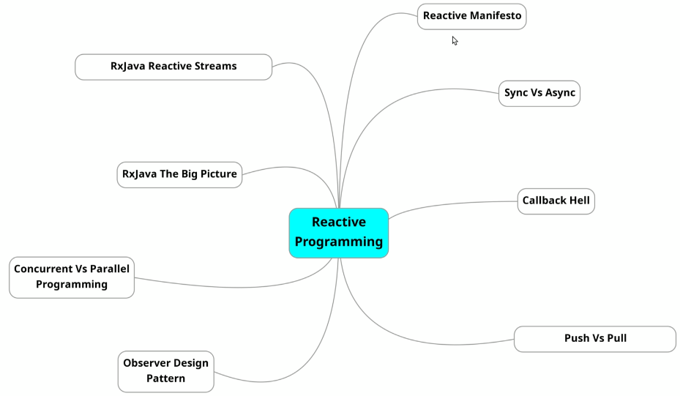

Then we'll discuss concurrent versus parallel, this was to just build good fundamentals as these terms are certainly very confusing and used interchangeably knowingly or unknowingly but have different meanings altogether. After that we will discuss how rx java solves some of the problems and makes our life easier as a developer. So we will see the big picture and finally we will discuss reactive streams, I know if you are doing rx java or reactive programming, first time a lot of things are new to you but don't worry. We will start getting into details from upcoming sections and the things will start making more sense so this section is just about building the fundamentals see you in the next lecture and let's start the journey.

### Reactive Manifesto

We will discuss about the term reactive and where it came from the meaning of reactive in plain english is "one who reacts".



|  |  |
| --- | --- |
|  | In day-to-day conversation it is treated as a negative word but in programming it means something else you might know some of the popular paradigms in programming like procedural functional object oriented etc same way in modern programming. Reactive programming, you can say is just like another paradigm of programming, if you have worked with any procedural language you might know that it takes some time from shifting from procedural to object oriented and same way from object oriented to functional, because all these paradigm required different mindset to work and master going functional from object oriented does not mean that object oriented programming will fade away entirely, but we have to understand it clearly that it's good to take advantage of both the worlds because in some use cases object oriented programming is the best fit and in some other use cases functional or reactive may be a good fit. |

|  |  |
| --- | --- |
| So in this course we will keep our focus on reactive programming, few years back some of the big companies, some experienced developers and architects came together and signed a manifesto called reactive manifesto. You can google it and you will find a web page on this reactive manifesto - defines some of the rules for building modern systems, it says, to meet modern demands and to exceed users expectations - a system should be responsive, it should be resilient, it should be message driven and it should be elastic. |  |

**Responsive**

Let's understand these terms, one by one, first property is being responsive to qualify to be the modern application the application has to be responsive it means that there should be a upper limit of response time of an application and an application should respond back to the user within a defined time limit think of a computational intensive report where your system servers reports to hundreds or thousands of user concurrently based on different input parameters that are user specific and it takes some time to create and deliver the report so to reduce the time taken by the application to generate report or to make this application responsive, there are two things that you can do first you can go parallel you can put so many resources in parallel to generate that report timely and the other way is that you can receive the request from the user and then respond back with a message that we are creating a report for you and we will send the link on the email when ready and take the request asynchronously in a queue create. The report when ready, send the report, so there are tips and tricks to design system in such ways so that even if it takes some time it remain responsive.

**Resilient**

Next property is resilient, in resilient systems errors are not second class just like the data errors and failures are also first class citizens, so happy use cases and failures or errors are equally important in reactive systems and you should deal with errors gracefully. Let's take an example, let's say you got a centralized database and your system connects to this database to serve to your users in happy cases everything is going smooth, but what about a bad case suppose your database stops responding, what should you do now.

|  |  |
| --- | --- |
|  | However, it depends, case to case but some of the solutions may be as a backup plan, if database is not responding you should serve the data maybe from cache or if you have a backup database in replication sync then you can connect to that. In case of failures so in any case, you should have a good backup plan to deal with errors and this is how you build systems that are resilient by definition. |

**Elastic**

|  |  |
| --- | --- |
| Next comes elastic, your system must be elastic suppose.  If your system is serving requests and someday the load increased on your system then your system should be able to deal with that without any manual intervention.  In the world of cloud and distributed systems and microservices handling the situation, it is quite possible by doing very simple configurations |  |

**Message Driven**

|  |  |
| --- | --- |
|  | Now the fourth property that a reactive system should have is being message driven message driven is a mean by which systems can achieve loose coupling the components of the system should talk to each other by asynchronous communication because this helps in building responsive systems because messaging is non-blocking. |

Think of whatsapp and a phone call, whatsapp is a way to get into some conversation asynchronously and phone call is blocking, which one do you like. I like whatsapp because even if my friend is in a meeting or busy doing something, I can just send him a whatsapp and he can respond whenever he's free so this was about reactive systems and reactor paradigm.

|  |  |
| --- | --- |
| Some developers at netflix which is totally a technology-driven company worked hard for a couple of years for making their systems reactive and thus gave birth to reactive extension Reactive X. They made it public and put it on git as open source and the JVM extension for Reactive X is RX Java. Recently RX java 3.0 is launched so we will be using RX Java 3.x, in this entire course. This is totally different paradigm so don't worry much, if you could not get it in first look, gradually as you'll practice you will start consuming this and i'm sure you will also start liking and using this in your project. |  |

So from next lecture onwards let's first discuss the challenges programmers were facing to make systems reactive and how rx java is solving them

From <https://www.reactivemanifesto.org/>

*Published on September 16 2014. (v2.0)*

Organisations working in disparate domains are independently discovering patterns for building software that look the same. These systems are more robust, more resilient, more flexible and better positioned to meet modern demands.

These changes are happening because application requirements have changed dramatically in recent years. Only a few years ago a large application had tens of servers, seconds of response time, hours of offline maintenance and gigabytes of data. Today applications are deployed on everything from mobile devices to cloud-based clusters running thousands of multi-core processors. Users expect millisecond response times and 100% uptime. Data is measured in Petabytes. Today's demands are simply not met by yesterday’s software architectures.

We believe that a coherent approach to systems architecture is needed, and we believe that all necessary aspects are already recognised individually: we want systems that are Responsive, Resilient, Elastic and Message Driven. We call these Reactive Systems.

Systems built as Reactive Systems are more flexible, loosely-coupled and scalable. This makes them easier to develop and amenable to change. They are significantly more tolerant of failure and when failure does occur they meet it with elegance rather than disaster. Reactive Systems are highly responsive, giving users effective interactive feedback.

Reactive Systems are:

**Responsive:** The system responds in a timely manner if at all possible. Responsiveness is the cornerstone of usability and utility, but more than that, responsiveness means that problems may be detected quickly and dealt with effectively. Responsive systems focus on providing rapid and consistent response times, establishing reliable upper bounds so they deliver a consistent quality of service. This consistent behaviour in turn simplifies error handling, builds end user confidence, and encourages further interaction.

**Resilient:** The system stays responsive in the face of failure. This applies not only to highly-available, mission-critical systems — any system that is not resilient will be unresponsive after a failure. Resilience is achieved by replication, containment, isolation and delegation. Failures are contained within each component, isolating components from each other and thereby ensuring that parts of the system can fail and recover without compromising the system as a whole. Recovery of each component is delegated to another (external) component and high-availability is ensured by replication where necessary. The client of a component is not burdened with handling its failures.

**Elastic:** The system stays responsive under varying workload. Reactive Systems can react to changes in the input rate by increasing or decreasing the resources allocated to service these inputs. This implies designs that have no contention points or central bottlenecks, resulting in the ability to shard or replicate components and distribute inputs among them. Reactive Systems support predictive, as well as Reactive, scaling algorithms by providing relevant live performance measures. They achieve elasticity in a cost-effective way on commodity hardware and software platforms.

**Message Driven:** Reactive Systems rely on asynchronous message-passing to establish a boundary between components that ensures loose coupling, isolation and location transparency. This boundary also provides the means to delegate failures as messages. Employing explicit message-passing enables load management, elasticity, and flow control by shaping and monitoring the message queues in the system and applying back-pressure when necessary. Location transparent messaging as a means of communication makes it possible for the management of failure to work with the same constructs and semantics across a cluster or within a single host. Non-blocking communication allows recipients to only consume resources while active, leading to less system overhead.

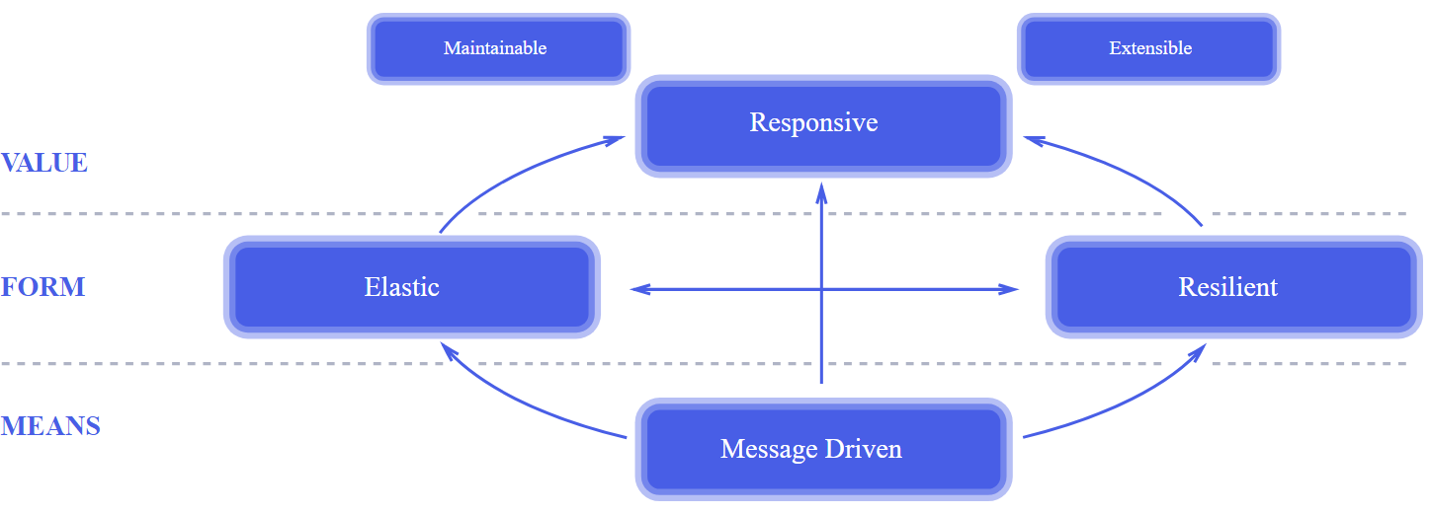

Large systems are composed of smaller ones and therefore depend on the Reactive properties of their constituents. This means that Reactive Systems apply design principles so these properties apply at all levels of scale, making them composable. The largest systems in the world rely upon architectures based on these properties and serve the needs of billions of people daily. It is time to apply these design principles consciously from the start instead of rediscovering them each time.

### Sync vs Async

You may not be able to read newspaper while your coffee is brewing, first you will drink the coffee and then you will be able to read the newspaper. If everything is happening synchronously, things are best when they are asynchronous. You are reading the newspaper while drinking the coffee or let's say coffee is brewing, your food is being boiled asynchronously. So by definition asynchrony in computer programming refers to the occurrence of events, independent of the main program flow and the ways to deal with such events asynchronously is achieved by concurrency in programming. When you run your program in main thread and some other thread might be working in background for you and join the main program.

|  |  |
| --- | --- |
|  | When done in programming without rx java, what you do while making the program asynchronous, you create callbacks right.  A callback is simultaneously running process having handle of the calling program, which can be used later to pass the completion signal at later point of time when the process is complete. Callbacks are easy to program but it becomes difficult and very difficult to manage when there are a lot of callbacks in your program. rx java kind of solves this problem and we will see this in next section when we will be reading concurrency. Let's check an example of callback so that you will be able to understand rx java better |

|  |  |
| --- | --- |
| Let's understand a fundamental concept to active asynchronous programming to make the system responsive, it's callbacks. Let's turn to eclipse and create a program to understand call backs  So here in this main thread we create another thread that will run this implementation runningAsync() method basically asynchronously – as executing in another thread – separated from the Main Thread. | public class CallBackDemo {  public static void main(String[] args) {  System.*out*.println("This is the main thread running!");  Thread t = new Thread( () -> new CallBackDemo().runningAsync() );  t.start();  }    public void runningAsync() {  System.*out*.println("I am running asynchronously");  sleep(1000);  }    public void sleep(int duration) {  try {  Thread.*sleep*(duration);  } catch (InterruptedException e) {  System.*out*.println("Error occurred - " + e.getMessage());  e.printStackTrace();  }  }  } |

But we are not getting any call back yet. To get the callback, that signals the completion of asynchronously running task we have to pass the implementation of callback interface. Here in this running async method, so let's pass CallBack callBack. Now later after the completion of this task I can invoke the call method to signal the completion, so .call so here in this running async we are going to pass the implementation to this callback that we are invoking here. So again, I'm going to create an anonymous inner class callBack. I'm going with anonymous inner class to depict the callback clearly you can go with lambdas as well okay so here let's implement the call method, it's so yes add unimplemented method and here let's print callback called.

Let's understand a fundamental concept to active asynchronous programming to make the system responsive it's callbacks. let's turn to eclipse and create a program to understand call backs so here i have created a class callback demo with main method and an interface callback it's having single method call, that we will use to signal the completion of any process running on a separate thread than this main thread. So as the main start let's print something to show that the execution of main thread started. So let's print main thread is running and let's create a separate thread that we will use to do some work concurrently or say asynchronously and the task that we're going to execute.

|  |  |
| --- | --- |
| package com.java.examples.rx;  public interface CallBack {  void call();  } | Note that this is a functional interface, so I can very well pass a lambda function to it – example below  () -> System.out.println("Callback called"); |

package com.java.examples.rx;

public class CallBackDemo {

public static void main(String[] args) {

System.out.println("This is the main thread running!");

Thread t = new Thread( () -> new CallBackDemo().runningAsync(

() -> System.out.println("CallBack called") ) );

t.start();

sleep(2000); // making main thread sleep longer, so program does not terminate

}

public void runningAsync(CallBack callback) {

System.out.println("I am running asynchronously");

sleep(1000);

callback.call();

}

public void sleep(int duration) {

try {

Thread.sleep(duration);

} catch (InterruptedException e) {

System.out.println("Error while sleeping - " + e.getMessage());

e.printStackTrace();

}

}

}

The method ran, but we are not getting any call back yet, to get the callback that signals the completion of asynchronously running task we have to pass the implementation of callback interface here in this running async method. So let's pass call back call back now later after the completion of this task i can invoke the call method to signal the completion. I'm going to create an anonymous inner class CallBack I'm going with anonymous inner class to depict the callback clearly you can go with lambdas as well

We are using a lambda here to create a thread.

Thread t = new Thread( () -> { doSomething(); } )

Using lambda as CallBack is a Functional Interface , with a anonymous Inner class the following would have been as below

Thread t = new Thread( () -> new CallBackDemo().runningAsync(

() -> System.out.println("CallBack called") ) );

Would have been

Thread t = new Thread( () -> new CallBackDemo().runningAsync(

@Override

new CallBack() {

System.out.println("Callback called");

}

);

Let's start this thread, now we have to wait for this task to complete so we have to put sleep this main thread to sleep so that it doesn't terminate until the completion of the thread that is running parallely and finally print main thread completed. So let's execute this and let's see what we get so main thread is running then i'm running in separate thread then callback call and then main thread completed. So this is a simple example of call back but when you are having multiple callbacks it becomes very difficult to manage the callbacks, as this is like a go-to statement and difficult to trace where the program pointer is during the execution and this is called a callback hell. rx java solves this problem by working on observer design pattern and as we'll move further in this course we'll see how observer pattern makes callback functions very easy.

### Push vs Pull

The rx java design is based on observer design pattern, so before we actually move further we will look at observer design pattern, but even before that we will understand push and pull mechanism and that is what this lecture is about. In general most loved programming model is request-response model which is a pull based mechanism, where a server sends back the response after processing the request.

|  |  |
| --- | --- |
|  | In rx java everything is push based, however we can achieve push mechanism from call backs, but rx java makes it very simple using observables. We will see how in our upcoming section but for now let's tweak the program used in previous lecture to understand push mechanism and how call backs are push based. |

So in this callback interface we are having single method call. I am going to modify this interface to have some more methods and i'm going to replace this call with push complete method. So we'll call push complete when the process will, process is done and other than this push complete this interface is having void push data to push the data to the calling thread.

|  |  |
| --- | --- |
| So we'll pass the data in it and one more method pushError, in case we get any exception. So here we'll pass exception now let's come to this callback demo, here we were creating the callback object inside this main because we were implementing the runnable interface and here we were implementing the callback interface by implementing the single method call. Now we need to implement these three methods pushData pushComplete and pushError. | package com.java.examples.rx;  public interface CallBack {  void pushData(String data);  void pushComplete();  void pushError(Exception ex);  } |

So let's implement them, let's remove this and add unimplemented methods so first is pushData, so here let's simply print CallBack data data and here say call back completed or call back done and here push inside pushError let's say got an exception or let's say error called got an exception and the exception. So now here inside this running async method we were invoking the call to signal the parent thread about the completion of the process. Now here instead of calling this method we can call push data method to push the data to the parent thread so here let's say we're passing data one and and then we're going to pass some more data, more data.

CallBack is not a functional Interface now, as we have 3 methods in it. So we will use a anonymous class to pass as argument instead of lambda as lambda cannot be used now.

package com.java.examples.rx;

public class CallBackDemoWithObservableDP {

public static void main(String[] args) throws InterruptedException {

System.out.println("This is the main thread running!");

Thread t = new Thread( () -> { new CallBackDemoWithObservableDP().runningAsync( new CallBack() {

@Override

public void pushData(String data) {

System.out.println("Received data: " + data);

}

@Override

public void pushComplete() {

System.out.println("Push completed!");

}

@Override

public void pushError(Exception ex) {

System.out.println("Callback Error called,

got an Exception " + ex.getMessage());

}

} );

}

);

t.start();

Thread.sleep(2000);

System.out.println("Main thread exited!");

}

public void runningAsync(CallBack callback) {

System.out.println("I am running asynchronously");

sleep(1000);

// Pushing data to the thread

callback.pushData("Data 1");

callback.pushData("Data 2");

callback.pushData("Data 3");

// Push the error now

callback.pushError(new RuntimeException("Oops"));

callback.pushComplete();

}

public void sleep(int duration) {

try {

Thread.sleep(duration);

} catch (InterruptedException e) {

System.out.println("Error while sleeping - " + e.getMessage());

e.printStackTrace();

}

}

}

So basically we are pushing the data to the parent thread or the thread that created this child thread and finally if we get any exception, we can push the error let's pass exception object new RuntimeException and here let's say oops and if we don't get any exception we can call the pushComplete method. Generally when we have scenarios when pushError gets invoked we don't call the pushComplete method and if it we don't get any exception the pushComplete method gets executed but this is a simple example, so we are calling all these three methods. So let's execute this code, so main thread is running and running in separate thread and then the child thread pushes the data data one data two data three and then error called and then call back done and then the main thread completes. So this is push once the callback is created in a separate thread the data and other signals are pushed through and rx java makes it very simple as it is built on top of observer design pattern so in next lecture let's see how observer design pattern is designed

### Observer Design Pattern

We're gonna be talking about observer design pattern as the reactive apis follows this pattern, so let's start. By the name observer what is the first thing comes up in your mind - observer is someone who watches or notices something similarly in this design pattern we have a subject which is responsible to maintain a list of all its dependent object known as observers.

|  |  |
| --- | --- |
| So observer design pattern defines one to many dependencies between objects. When one object changes its state, all of its dependent objects get notified or updated automatically. Like here we have a subject which has a state and whenever any modification happen in the state, subject will notify all its observers which are registered in the subject, and once observers gets notified by subject, now observers are ready to get same update implemented in them. |  |

Now let's have a look towards a real time example to explore it more. Let's say, we have a book application named library where user can register and login. He can read, download and purchase books while this application is online, so this is the use of this application and on the other side you can see bob, rob and rooney, they all want to buy a book from this application. So they logged in to the application and searched for that book but unfortunately that book is not available or is sold out state. So they all take the notify check – means, please notify when book becomes available, so after four or five working days, books are again back in stock, so the state of book changes from sold out to a available state. Then the application notifies all of its registered user for that book, now they will be able to purchase the book.

|  |  |
| --- | --- |
|  |  |

So this is one of the example for the observer pattern. Let's have a look how interfaces and classes are arranged in this pattern so this is the UML class diagram for observer design pattern in this we are having two most important things one is the subject and another is observer.

|  |  |
| --- | --- |
|  | Subject is an interface containing three methods register observer, remove observer and the third one is notify observer. Other objects use this interface to register themselves as observer and can also remove themselves from being noticed or observed. Each subject can have one or more observers so this is observer design pattern in reactive api or let's say in rx java the subject is called observable and observer is an observer so see here concrete subject implements notify observer method which is used to update current observer when its state changes. An observer interface is an updating interface for objects that should be notified of any change in subject or in case of rx java in observable so all observers need to implement observer interface. |

This interface has a method, update which gets called when subject's state changes and in rx java the observable emits events or data whenever observable is ready to emit the data or emits the data the observer gets the data. So this is how rx java is using this pattern see here concrete observers maintains a reference to a concrete subject object and implements the observer interface. Each observer register with a concrete subject to receive the updates so this is how they are arranged now let's discuss the sequence diagram how they interact at runtime.

|  |  |
| --- | --- |
| So here we are having observer one observer two objects and a subject so first observer one and observer two objects call register observer on subject. To register themselves so that they gets notified whenever there is any change in subject, so now subject will be able to send notification to the registered observer when any state change happen. So if any external object changes the state of subject by calling the set state method and the state of subject changes subject calls notify on itself then notify calls update on registered observer 1 and observer 2 objects, which request the changed data by using getState from subject to update their state. Now let's see the same with a code example so let's move to the ide |  |

So see here this is the observer design pattern class which we are going to use as the driver class other than this class we are having four classes first as a subject library this is the subject or the observable in case of rx java it's having three methods subscribe observer unsubscribe observer and notify observer first method to subscribe to this subject library by the observer second method to unsubscribe the observer to this library and third one is notify observer to notify about any change happening to the observer then we have the concrete implementation of the subject library here we are having six fields first is name type then author price and install these five fields are about are the details about the book and then we are having obs list which is a list of all the subscribed observers which are subscribed to this library, then we are having a constructor and then getters and setters and then the implementation of all those three methods present in the subject library class.

First subscribes the observer, so it adds that observer to the list to the subscription list and then we are having unsubscribe observer method which removes the observer from the list, thus unsubscribing the observer and then we have notify observer method here we are printing the name type all the details and then we are updating about any change happening to the observer. So we are calling the update method on the observer object now it's time to look at the observer so this is the observer interface which is having single method update whenever any changes change happen in the subject or book it calls the update on this observer. Let's see it's concrete implementation, this is the end user class, which is the concrete implementation of this observer it's having single field name which is a name of the observer. We can create any number of observers that can subscribe to this book or the subject library then we are having the constructor for this class which defines the name and then subscribe this end user to the book or the subject library then we are having getter and setter for the name and then the implementation of update method when the update method on this observer gets called it will print hello the name of the observer we are glad to notify you that your book is now available so hope you got the idea how observer and observable or the subject are interlinked.

package com.java.examples.rx.observable;

public interface SubjectLibrary {

public void subscribeObserver(Observer observer);

public void unsubscribeObserver(Observer observer);

public void notifyObserver();

}

package com.java.examples.rx.observable;

import java.util.ArrayList;

public class SubjectLibraryImpl implements SubjectLibrary {

private String name;

private String type;

private String author;

private double price;

private String inStock;

private ArrayList<Observer> observerList = new ArrayList<Observer>();

public SubjectLibraryImpl(String name, String type, String author, double price, String inStock,

ArrayList<Observer> observerList) {

super();

this.name = name;

this.type = type;

this.author = author;

this.price = price;

this.inStock = inStock;

this.observerList = observerList;

}

public String getName() { return name; }

public void setName(String name) { this.name = name; }

public String getType() { return type; }

public void setType(String type) { this.type = type; }

public String getAuthor() { return author; }

public void setAuthor(String author) { this.author = author; }

public double getPrice() { return price; }

public void setPrice(double price) { this.price = price; }

public String getInStock() { return inStock; }

public void setInStock(String inStock) { this.inStock = inStock; }

public ArrayList<Observer> getObserverList() { return observerList; }

public void setObserverList(ArrayList<Observer> observerList) { this.observerList = observerList; }

@Override

public void subscribeObserver(Observer observer) {

observerList.add(observer);

}

@Override

public void unsubscribeObserver(Observer observer) {

observerList.remove(observer);

}

@Override

public void notifyObserver() {

System.out.println(

"Book Name: " + this.name +

"price: " + this.price +

"type: " + this.type +

"author: " + this.author +

"instock: " + this.inStock

);

}

}

**Book.java**

package com.java.examples.rx.observable;

import java.util.ArrayList;

public class Book implements SubjectLibrary {

private String name;

private String type;

private String author;

private double price;

private String inStock;

private ArrayList<Observer> observerList = new ArrayList<Observer>();

public Book(String name, String type, String author, double price, String inStock ) {

super();

this.name = name; this.type = type; this.author = author; this.price = price;

this.inStock = inStock;

}

public String getName() { return name; }

public void setName(String name) { this.name = name; }

public String getType() { return type; }

public void setType(String type) { this.type = type; }

public String getAuthor() { return author; }

public void setAuthor(String author) { this.author = author; }

public double getPrice() { return price; }

public void setPrice(double price) { this.price = price; }

public String getInStock() { return inStock; }

public void setInStock(String inStock) { this.inStock = inStock; }

public ArrayList<Observer> getObserverList() { return observerList; }

public void setObserverList(ArrayList<Observer> observerList) { this.observerList = observerList; }

@Override

public void subscribeObserver(Observer observer) {

observerList.add(observer);

}

@Override

public void unsubscribeObserver(Observer observer) {

observerList.remove(observer);

}

@Override

public void notifyObserver() {

System.out.println( "Book Name: " + this.name + "price: " + this.price +

"type: " + this.type + "author: " + this.author + "instock: " + this.inStock );

for (Observer o: observerList) {

o.update(this.inStock);

}

}

}

Now it's time to come to this observer design pattern class and let's have it all together here so first we will create an object of the subject which is the book class the concrete book class.

**Observer Interface**

package com.java.examples.rx.observable;

public interface Observer {

public void update(String available);

}

**Concrete Implementation – EndUser.java**

package com.java.examples.rx.observable;

public class EndUser implements Observer {

String name;

public EndUser(String name, SubjectLibrary subjectLibrary) {

super();

this.name = name;

subjectLibrary.subscribeObserver(**this**);

}

public String getName() {

return name;

}

public void setName(String name) {

this.name = name;

}

@Override

public void update(String available) {

System.out.println("Hello "+ name + "! Notifying you, your book is available " + available);

}

}

So let's create a book object book new book and let's pass the required details here let's say the name of the book is goosebumps genre is horror and let's say xyz price 200 and its status or state is sold out so we have created the subject now we need some observers that will subscribe for this book to the subject library or to this book. So let's create some of the observers we have the concrete class end user for that so and user user one this is new end user and the name of the user is bob and subject here we have is book and let's create one more user user2 this is rob so we have created the observers and the observable or you can say the subject so internally this will add these users to the subscription list of this book because in if you see this observer or this end user here we are subscribing the observer to the subject now initially the status is sold out.

package com.java.examples.rx.observable;

public class ObserverDesignPattern {

public static void main(String[] args) {

Book book = new Book("GooseBumps", "Horror", "Xyz", 200, "SoldOut");

EndUser user1 = new EndUser("Bob", book);

EndUser user2 = new EndUser("Rob", book);

System.out.println("Get in stock > " + book.getInStock());

}

}

Output

Get in stock > SoldOut

So if i print sys out book get in stock and run this you'll see that it is in sold out state. And now let's change the status of this book from sold out to in stock so book.setInStock and let's say in stock and now let's run this program and see what we get so we get availability changed from sold out to back in stock book name goosebumps book details author xyz is now in stock so please notify all users then it internally called the note update method on the observers so it printed hello bob we are glad to notify you that your book is now installed and similarly for rob

package com.java.examples.rx.observable;

public class ObserverDesignPattern {

public static void main(String[] args) {

Book book = new Book("GooseBumps", "Horror", "Xyz", 200, "SoldOut");

EndUser user1 = new EndUser("Bob", book);

EndUser user2 = new EndUser("Rob", book);

System.out.println("Get in stock > " + book.getInStock());

book.setInStock("In stock");

}

}

**Output**

Get in stock > SoldOut

Book Name: GooseBumpsprice: 200.0type: Horrorauthor: Xyzinstock: In stock

Hello Bob! we are glad to notify you that your book is now available In stock

Hello Rob! we are glad to notify you that your book is now available In stock

So this is how observer design pattern works and this is the main concept behind the design of rx java hope this design pattern or this explanation would help you to understand rx java design in no time or in very less time

### Concurrency and Parallel Programming

We will try to understand two very similar terms concurrent and parallel these both looks very similar but actually they are very different.

Concurrency is to run multiple parts of the program in single cpu by using different threads by doing concurrency we achieve responsiveness cpus can tune the threads internally by applying various algorithms like time slicing and give every thread a chance to execute this is how single cpu is able to provide responsiveness. So concurrency is when more than one task can start run and complete in overlapping time periods. It doesn't necessarily mean they'll be running at the same instant it's multitasking on a single core machine whereas

Parallelism is when tasks literally run at same time for example on a multi-core processor the task gets split up to be processed by different cores or cpu and after completion all the partial results are merged to get a single result or if all the tasks are independent then they simply run on different cpus and then completes

In java we can create and run multiple threads to achieve multi-threading and we can use fork-join pool for parallel programming but using javas core programming it's not easy to achieve these both rx java provides a better abstraction to achieve this rx java provides us the schedulers and better support for concurrency and parallelism to make the life easier, by doing heavy lifting under the hood. We'll see this how rx java makes this simple in upcoming lectures here we are just building some fundamentals so this was all about this lecture see you in the next one

## *RxJava – The Big Picture*

Let's have a 3000 ft picture of Rx java and what it solves as we discussed earlier. Rx java works on observer design pattern so rx java works on push rather than pull. It is push based, we can push the events to the observers different event like data error and complete signal, this achieves asynchronous behavior easily as this is a kind of callback. RX java uses different channels for different signals like data channel onComplete signal channel and error signal channel, to make our application more resilient as the error is treated as a separate channel so we can treat the error just like data as first class citizens.

|  |  |
| --- | --- |
|  | Rx java uses operators for processing and combining events. Using operators we can achieve parallelism easily and to support parallel programming rx java uses a different kind of schedulers like IO intensive computation-intensive. It does all the heavy lifting of parallel programming and enable us to focus on our business logic. And now backpressure, rx java is backpressure ready to control producer-consumer problem if producer is producing at high speed so that consumer is not able to consume all the items at that speed or vice versa, rx java can handle that condition using backpressure techniques. So this is the very high level overview of how we can solve the some fundamental problems with Rx java so this was the big picture from next section onwards we will deep dive into rx java and learn every aspect of this API in great details |

RxJava Reactive Streams

Let's have a look at how Rx Java Api is composed and what are reactive streams as this is very important to understand so rx java is a library by netflix developers this is a part of reactive extension and Rx Java 3.x is the most recent version of this api this api was built upon observer design pattern and it works with observable and observer. As the reactive paradigm started getting popular Java came with a standard that is called Reactive Streams.

Reactive streams are a set of interfaces and Java says that if the api implements these interfaces and the TCK which is Reactive Stream's Technology Compatibility Kit the api becomes compatible and reactive. This api uses flowable instead of observables Rx Java was there even before reactive stream specifications came it uses Observable but it also implemented Flowable to make itself interpretable. Java 9 also implements TCK and it's having Flowable api for reactive programming and you know what Rx java and Java 9 flowable are interoperable. It means if you are using Rx java latest version you can replace it with Java 9 Flowable and Java 9 flowable to Rx java.

|  |  |
| --- | --- |
|  | There are many reactive apis available for example you can use reactor core as well, so you can use any implementation of TCK that you like and note that only difference between Flowable and Rx Java's very own observable is that Flowable is Back Pressure ready and Observable is not. But Rx java also implements reactive streams from Rx Java 2.x onwards so that is not a point of concern here. |

**RxJava vs Project Reactor vs Spring WebFlux**

In general, RxJava support project which based on JDK8-- and Project Reactor supports JDK 8++. But for a beginner, you can learn RxJava at first. Since Project Reactor you can consider fixed the drawbacks in RxJava and more suitable for Backend development. RxJava has too many problems which can cause Out of Memory if you can't use it well. But in final, if you want to use Spring 5.2+ very well, you need to learn from RxJava->Reactor->NIO->Netty->Reactor netty.

Both Spring WebFlux (project-reactor) and RxJava2+ are implementation of reactive-streams. Spring is using project-reactor, therefore it is more supported, advertised and has bigger community, so I would go with that

There are a few different reactive programming libraries including, [Project Reactor](https://projectreactor.io/), [RxJava](https://github.com/ReactiveX/RxJava), [Reactive Streams](https://www.reactive-streams.org/), and the newest, [Kotlin Flow](https://kotlinlang.org/docs/reference/coroutines/flow.html).

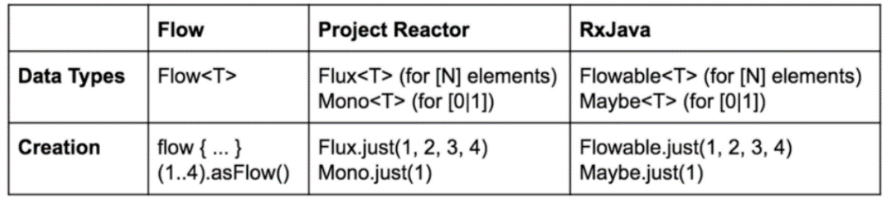

Spring WebFlux supports reactive HTTP and WebSocket clients as well as reactive server web applications, including REST, HTML browser, and WebSocket style interactions. WebFlux allows for more scalability, a stack immune to latency (useful for micro services-oriented architecture), and better stream processing capabilities. You can easily have an application with the [Spring MVC](https://docs.spring.io/spring/docs/3.2.x/spring-framework-reference/html/mvc.html) model for one controller and the WebFlux model for another controller.

We can compare and contrast the usual Spring MVC model with the Spring WebFlux model.

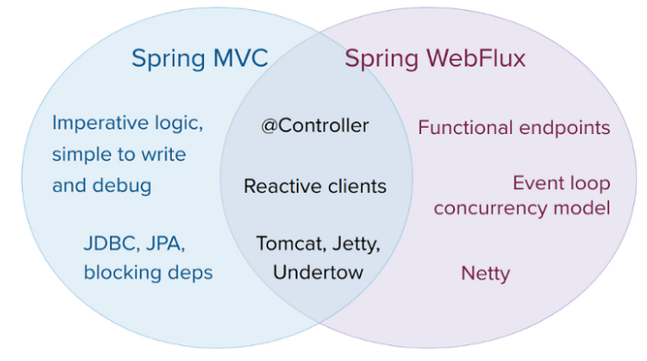

**Comparison between Reactor and RxJava**

RxJava 1 provides a framework for implementing the Observer Pattern in your application. In the Observer Pattern, Observables are entities that receive events and data (i.e. UI, keyboard, TCP, ...) from outside sources, and make those events and data available to your program.

Observers are the entities which subscribe to the Observable events and data.

The [Reactor pattern guide](https://github.com/Azure-Samples/azure-cosmos-java-sql-api-samples/blob/main/reactor-pattern-guide.md) gives a brief conceptual overview of Reactor. In summary: Publishers are the entities which make events and data from outside sources available to the program Subscribers subscribe to the events and data from the Publisher

Both frameworks facilitate asynchronous, event-driven programming. Both frameworks allow you to chain together a pipeline of operations between Observable/Observer or Publisher/Subscriber.

Roughly, what you would use an Observable for in RxJava, you would use a Flux for in Reactor. And what you would use a Single for in RxJava, you would use a Mono for in Reactor.

**The critical difference between the two frameworks is really in the core implementation:**

Reactor operates a service which receives event/data pairs serially from a Publisher, demultiplexes them, and forwards them to registered Subscribers. This model was designed to help servers efficiently dispatch requests in a distributed system. The RxJava approach is more general-purpose.

Observers subscribe directly to the Observable and the Observable sends events and data directly to Observers, with no central service handling dispatch.

**Summary: Rules of thumb to convert RxJava code into Reactor code**

An RxJava Observable will become a Reactor Flux

An RxJava Single will become a Reactor Mono

An RxJava Subscriber is still a Subscriber in Reactor

Operators such as map(), filter(), and flatMap() are the same

**Examples of tasks in Reactor and RxJava**

**Reactor:**

ReminderAsyncService.getRemindersPublisher() // Pipeline Stage 1

.flatMap(reminder -> "Don't forget: " + reminder) // Stage 2

.flatMap(strIn -> LocalDateTime.now().toString() + ": "+ strIn); // Stage 3

.subscribe(System.out::println);

**RxJava:**

ReminderAsyncService.getRemindersObservable() // Pipeline Stage 1

.flatMap(reminder -> "Don't forget: " + reminder) // Stage 2

.flatMap(strIn -> LocalDateTime.now().toString() + ": "+ strIn); // Stage 3

.subscribe(item -> System.out.println(item));

**Reactor:**

Flux.just("Wash the dishes","Mow the lawn","Sleep") // Publisher, 3 events

.flatMap(reminder -> "Don't forget: " + reminder)

.flatMap(strIn -> LocalDateTime.now().toString() + ": "+ strIn); // Nothing executed yet

.subscribe(strIn -> {""

System.out.println(strIn);

},

err -> {

err.printStackTrace();

},

() -> {

System.out.println("End of reminders.");

});

**RxJava:**

Observable.just("Wash the dishes","Mow the lawn","Sleep") // Observable, 3 events

.flatMap(reminder -> "Don't forget: " + reminder)

.flatMap(strIn -> LocalDateTime.now().toString() + ": "+ strIn); // Nothing executed yet

.subscribe(strIn -> System.out.println(strIn),

err -> err.printStackTrace(),

() -> System.out.println("End of reminders.")

);

**Reactor:**

Mono.just("Are you sure you want to cancel your Reminders service?") // Publisher, 1 event

.flatMap(reminder -> "Act now: " + reminder)

.flatMap(strIn -> LocalDateTime.now().toString() + ": "+ strIn);

.subscribe(System.out::println);

**RxJava:**

Single.just("Are you sure you want to cancel your Reminders service?") // Publisher, 1 event

.flatMap(reminder -> "Act now: " + reminder)

.flatMap(strIn -> LocalDateTime.now().toString() + ": "+ strIn);

.subscribe(item -> System.out.println(item));

So I am not doing Rx Java :D

# OSGI

## Architecture

The OSGi technology is a set of specifications that define a dynamic component system for Java. These specifications enable a development model where applications are (dynamically) composed of many different (reusable) components. The OSGi specifications enable components to hide their implementations from other components while communicating through services, which are objects that are specifically shared between components. This surprisingly simple model has far reaching effects for almost any aspect of the software development process.

Though components have been on the horizon for a long time, so far they failed to make good on their promises. OSGi is the first technology that actually succeeded with a component system that is solving many real problems in software development. Adopters of OSGi technology see significantly reduced complexity in almost all aspects of development. Code is easier to write and test, reuse is increased, build systems become significantly simpler, deployment is more manageable, bugs are detected early, and the runtime provides an enormous insight into what is running. Most important, it works as is testified by the wide adoption and use in popular applications like Eclipse and Spring.

We developed the OSGi technology to create a collaborative software environment. We were not looking for the possibility to run multiple applications in a single VM. Application servers do that already (though they were not yet around when we started in 1998). No, our problem was harder. We wanted an application to emerge from putting together different reusable components that had no a-priori knowledge of each other. Even harder, we wanted that application to emerge from dynamically assembling a set of components. For example, you have a home server that is capable of managing your lights and appliances. A component could allow you to turn on and off the light over a web page. Another component could allow you to control the appliances via a mobile text message. The goal was to allow these other functions to be added without requiring that the developers had intricate knowledge of each other and let these components be added independently.

Layering

The OSGi has a layered model that is depicted in the following figure.

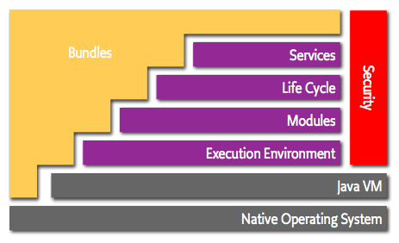

The following list contains a short definition of the terms:

* Bundles – Bundles are the OSGi components made by the developers.
* Services – The services layer connects bundles in a dynamic way by offering a publish-find-bind model for plain old Java objects.
* Life-Cycle – The API to install, start, stop, update, and uninstall bundles.
* Modules – The layer that defines how a bundle can import and export code.
* Security – The layer that handles the security aspects.
* Execution Environment – Defines what methods and classes are available in a specific platform.

These concepts are more extensively explained in the following sections.

Modules

The fundamental concept that enables such a system is modularity. Modularity, simplistically said, is about assuming less. Modularity is about keeping things local and not sharing. It is hard to be wrong about things you have no knowledge of and make no assumptions about them. Therefore, modularity is at the core of the OSGi specifications and embodied in the bundleconcept. In Java terms, a bundle is a plain old JAR file. However, where in standard Java everything in a JAR is completely visible to all other JARs, OSGi hides everything in that JAR unless explicitly exported. A bundle that wants to use another JAR must explicitly import the parts it needs. By default, there is no sharing.

Though the code hiding and explicit sharing provides many benefits (for example, allowing multiple versions of the same library being used in a single VM), the code sharing was only there to support OSGi services model. The services model is about bundles that collaborate.

Services

The reason we needed the service model is because Java shows how hard it is to write collaborative model with only class sharing. The standard solution in Java is to use factoriesthat use dynamic class loading and statics. For example, if you want a DocumentBuilderFactory, you call the static factory method DocumentBuilderFactory.newInstance(). Behind that façade, the newInstance methods tries every class loader trick in the book (and some that aren’t) to create an instance of an implementation subclass of the DocumentBuilderFactory class. Trying to influence what implementation is used is non-trivial (services model, properties, conventions in class name), and usually global for the VM. Also it is a passive model. The implementation code can not do anything to advertise its availability, nor can the user list the possible implementations and pick the most suitable implementation. It is also not dynamic. Once an implementation hands out an instance, it can not withdraw that object. Worst of all, the factory mechanism is a convention used in hundreds of places in the VM where each factory has its own unique API and configuration mechanisms. There is no centralized overview of the implementations to which your code is bound.

The solution to all these issues is the OSGi service registry. A bundle can create an object and register it with the OSGi service registry under one or more interfaces. Other bundles can go to the registry and list all objects that are registered under a specific interfaces or class. For example, a bundle provides an implementation of the DocumentBuilder. When it gets started, it creates an instance of its DocumentBuilderFactoryImpl class and registers it with the registry under the DocumentBuilderFactory class. A bundle that needs a DocumentBuilderFactory can go to the registry and ask for all available services that extend the DocumentBuilderFactory class. Even better, a bundle can wait for a specific service to appear and then get a call back.

A bundle can therefore register a service, it can get a service, and it can listen for a service to appear or disappear. Any number of bundles can register the same service type, and any number of bundles can get the same service. This is depicted in the following figure.

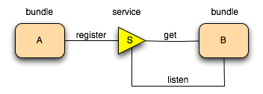

What happens when multiple bundles register objects under the same interface or class? How can these be distinguished? The answer is properties. Each service registration has a set of standard and custom properties. A expressive filter language is available to select only the services in which you are interested. Properties can be used to find the proper service or can play other roles at the application level.

Services are dynamic. This means that a bundle can decide to withdraw its service from the registry while other bundles are still using this service. Bundles using such a service must then ensure that they no longer use the service object and drop any references. We know, this sounds like a significant complexity but it turns out that helper classes like the Service Tracker and frameworks like iPOJO, Spring, and Declarative Services can make the pain minimal while the advantages are quite large. The service dynamics were added so we could install and uninstall bundles on the fly while the other bundles could adapt. That is, a bundle could still provide functionality even if the http service went away. However, we found out over time that the real world is dynamic and many problems are a lot easier to model with dynamic services than static factories. For example, a Device service could represent a device on the local network. If the device goes away, the service representing it is unregistered. This way, the availability of the service models the availability of a real world entity. This works out very well in, for example, the distributed OSGi model where a service can be withdrawn if the connection to the remote machine is gone. It also turns out that the dynamics solve the initialization problem. OSGi applications do not require a specific start ordering in their bundles.

The effect of the service registry has been that many specialized APIs can be much modeled with the service registry. Not only does this simplify the overall application, it also means that standard tools can be used to debug and see how the system is wired up.

Though the service registry accepts any object as a service, the best way to achieve reuse is to register these objects under (standard) interfaces to decouple the implementer from the client code. This is the reason the OSGi Alliance publishes the Compendium specifications. These specification define a large number of standard services, from a Log Service to a Measurement and State specification. All these standardized services are described in great detail.

Deployment

Bundles are deployed on an OSGi framework, the bundle runtime environment. This is not a container like Java Application Servers. It is a collaborative environment. Bundles run in the same VM and can actually share code. The framework uses the explicit imports and exports to wire up the bundles so they do not have to concern themselves with class loading. Another contrast with the application servers is that the management of the framework is standardized. A simple API allows bundles to install, start, stop, and update other bundles, as well as enumerating the bundles and their service usage. This API has been used by many management agents to control OSGi frameworks. Management agents are as diverse as the Knopflerfish desktop and an IBM Tivoli management server.

Implementations

The OSGi specification process requires a reference implementation for each specification. However, since the first specifications there have always been commercial companies that have implemented the specifications as well as open source implementations. Currently, there are 4 open source implementations of the framework and too many to count implementations of the OSGi services. The open software industry has discovered OSGi technology and more and more projects deliver their artifacts as bundles.

OSGI

The Open Services Gateway Initiative (OSGi) defines an architecture for developing and deploying modular applications and libraries.

This article gets you started with OSGi development concepts and shows you how to build a simple Hello World application using the Eclipse OSGi container implementation, Equinox.

The [Open Services Gateway Initiative (OSGi)](http://www.javaworld.com/article/2077837/java-se/java-se-hello-osgi-part-1-bundles-for-beginners.html#resources), also known as the [Dynamic Module System for Java](http://www.javaworld.com/article/2077837/java-se/java-se-hello-osgi-part-1-bundles-for-beginners.html#resources), defines an architecture for modular application development. OSGi container implementations such as [Knopflerfish](http://www.javaworld.com/article/2077837/java-se/java-se-hello-osgi-part-1-bundles-for-beginners.html#resources), [Equinox](http://www.javaworld.com/article/2077837/java-se/java-se-hello-osgi-part-1-bundles-for-beginners.html#resources), and [Apache Felix](http://www.javaworld.com/article/2077837/java-se/java-se-hello-osgi-part-1-bundles-for-beginners.html#resources) allow you to break your application into multiple modules and thus more easily manage cross-dependencies between them.

Similar to the Java Servlet and EJB specifications, the OSGi specification defines two things: a set of services that an OSGi container must implement and a contract between the container and your application. Developing on the OSGi platform means first building your application using OSGi APIs, then deploying it in an OSGi container. From a developer's perspective, OSGi offers the following advantages:

* You can install, uninstall, start, and stop different modules of your application dynamically without restarting the container.
* Your application can have more than 1 version of a particular module running at same time.
* OSGi provides very good infrastructure for developing service-oriented applications, as well as embedded, mobile, and rich internet apps.

Given that you use servlet containers for building Web applications and EJB containers for building transactional applications, you may be wondering why you need yet another type of container. The short answer is that OSGi containers are intended specifically for developing complex Java applications that you want to break up into modules. I'll expand on that short answer throughout this series.

Open source OSGi containers

From an enterprise developer's point of view, the OSGi container has such a low footprint that you can easily embed it into an enterprise application. For example, let's say you're developing a complex Web application. You want to break the application into multiple modules: one module for the view layer, another for the DAO layer, and a third module for the data access layer. Using an embedded OSGi container to manage the cross-dependencies of these modules would enable you to update your DAO layer (say from slow DAO to fast DAO) without restarting your application.

As long as your application is compliant with the OSGi specification it should be able to run in any OSGi-compliant container. Currently, there are three popular open source OSGi containers:

* [Equinox](http://www.javaworld.com/article/2077837/java-se/java-se-hello-osgi-part-1-bundles-for-beginners.html#resources) is the reference implementation for the framework portion of the OSGi Service Platform Release 4. It is the modular Java runtime at the heart of the Eclipse IDE, and implements all of the mandatory and most of the optional features of the OSGi R4 specification.
* [Knopflerfish](http://www.javaworld.com/article/2077837/java-se/java-se-hello-osgi-part-1-bundles-for-beginners.html#resources) is an open source implementation of the OSGi R3 and OSGi R4 specifications. Knopflerfish 2 implements all the mandatory features and some of the optional features defined in the R4 specification.
* [Apache Felix](http://www.javaworld.com/article/2077837/java-se/java-se-hello-osgi-part-1-bundles-for-beginners.html#resources) is the open source OSGi container from the Apache Software Foundation. At the time of writing this container is not fully compliant with the OSGI R4 specification.

In this article we will use Equinox as our OSGi container. See the Resources section for more information about [Apache Felix](http://www.javaworld.com/article/2077837/java-se/java-se-hello-osgi-part-1-bundles-for-beginners.html#resources) and [Knopflerfish](http://www.javaworld.com/article/2077837/java-se/java-se-hello-osgi-part-1-bundles-for-beginners.html#resources).

Developing a Hello World bundle

In OSGi, software is distributed in the form of a bundle. A bundle consists of Java classes and other resources that deliver functions to device owners, as well as providing services and packages to other bundles. Eclipse offers excellent support for developing OSGi bundles. Not only does it provide wizards for creating OSGi bundles, it also has an embedded Equinox OSGi container that you can use to execute and debug OSGi plugins. Note that every Eclipse plug-in is essentially an OSGi bundle with some additional Eclipse-specific code. Eclipse also allows you to build standard-compliant OSGi bundles without code specific to Eclipse. In this section you'll learn how to develop a Hello World OSGi bundle using the Eclipse IDE.

Creating the bundle

Follow the steps below to create a Hello World bundle using OSGi and Eclipse.

1. In Eclipse, click on File --> New --> Project. A New Project dialog will open.
2. In the New Project dialog, select Plug-in Project and click Next. The Plug-in Project dialog will open.
3. In the Plug-in Project dialog, enter the following values:
   1. Project Name: com.javaworld.sample.HelloWorld
   2. Target Platform: OSGi framework --> Standard
4. Use default values for the remaining input and click Next. The Plug-in Context dialog will open.
5. Select the default values for the Plug-in Context dialog and click Next.
6. In the Templates dialog you'll find only one entry in Available Templates: Hello OSGi Bundle. Select it and click Finish.

Eclipse will take few seconds to generate template code for the Hello World bundle. It will create two files: Activator.java and MANIFEST.MF. We'll take a closer look at them both.

Activator.java

Your Activator.java file should look as shown in Listing 1.

**Listing 1. Activator.java**

package com.javaworld.sample.helloworld;

import org.osgi.framework.BundleActivator;

import org.osgi.framework.BundleContext;

public class Activator implements BundleActivator {

public void start(BundleContext context) throws Exception {

System.out.println("Hello world");

}

public void stop(BundleContext context) throws Exception {

System.out.println("Goodbye World");

}

}

If your bundle needs to be notified at the time of bundle startup or shutdown then you should create a class implementing the BundleActivator interface. Follow these rules when creating the class:

The BundleActivator class must have a public constructor that takes no parameters. The OSGi framework can create a BundleActivator object by calling Class.newInstance(). The container will call the start() method of your Activator class to start the bundle. The bundle can take this opportunity to perform resource initialization such as getting a database connection for future use. The start() method takes one argument, the BundleContext object. This object allows bundles to interact with the framework by providing access to OSGi-container-related information. If an exception is thrown for a particular bundle the container will mark that bundle as stopped and will not put it into service.

The container will call the stop() method of your Activator class to report that it is shutting down a bundle. You can use this opportunity to perform cleanup tasks such as releasing the database connection.

Once your Activator class is ready you should relay its fully qualified name to the container using your MANIFEST.MF file.

MANIFEST.MF

The MANIFEST.MF file acts as deployment descriptor for your bundle. The format for this file is the same as that of a normal JAR file, so it consists of a set of headers with values. The OSGi specification defines a set of headers that you can use to describe your bundle to the OSGi container. The MANIFEST.MF file for your Hello World bundle should look as shown in Listing 2.

Listing 2. Manifest for the Hello World bundle

Manifest-Version: 1.0

Bundle-ManifestVersion: 2

Bundle-Name: HelloWorld Plug-in

Bundle-SymbolicName: com.javaworld.sample.HelloWorld

Bundle-Version: 1.0.0

Bundle-Activator: com.javaworld.sample.helloworld.Activator

Bundle-Vendor: JAVAWORLD

Bundle-Localization: plugin

Import-Package: org.osgi.framework;version="1.3.0"

Let's take a closer look at what each of these headers is used for:

**Bundle-ManifestVersion**

The Bundle-ManifestVersion header tells the OSGi container that this bundle follows the rules of the OSGi specification. A value of 2 means that the bundle is compliant with OSGi specification Release 4; a value of 1 means that it is compliant with Release 3 or earlier.

**Bundle-Name**

The Bundle-Name header defines a short, human-readable name for the bundle.

**Bundle-SymbolicName**

The Bundle-SymbolicName header specifies a unique, non-localizable name for the bundle. This is the name you will use while referring a given bundle from other bundles.

**Bundle-Version**

The Bundle-Version header specifies the version of the bundle.

**Bundle-Activator**

The Bundle-Activator header specifies the name of the optional listener class to be notified of bundle start and stop events. In Listing 2 the value of this header is com.javaworld.sample.helloworld.Activator.

**Bundle-Vendor**

The Bundle-Vendor header contains a human-readable description of the bundle vendor.

**Bundle-Localization**

The Bundle-Localization header contains the location in the bundle where localization files can be found. The Hello World bundle doesn't contain any locale-specific files, but the eclipse IDE still generates this header.

**Import-Package**

The Import-Package header defines imported packages for the bundle. You'll learn more about this when I discuss dependency management, later in the article.

The Hello World bundle is ready, so let's execute it to see the output.

Executing a bundle

As I mentioned earlier, the Eclipse IDE has an embedded Equinox OSGi container that you can use to execute or debug OSGi bundles. Follow these steps to execute the Hello World bundle:

1. Click on Run --> Run.
2. Eclipse will open the dialog called "Create, manage and run configuration." In that dialog, double-click the Equinox OSGi Framework button and it will open a runtime configuration dialog box.
3. In that dialog, change the value of the Name field to Hello World Bundle.
4. You will notice that in the Plug-ins section under the Workspace plug-in there is an entry for the com.javaworld.sample.HelloWorld plugin, which is checked. Under Target Platform, make sure that the checkbox next to the org.eclipse.osgi plugin is also checked.Your Run dialog should look like the screenshot in Figure 1 (click to enlarge).

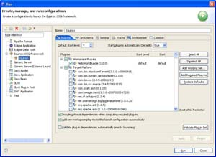

1. Now click the Run button. You should see a "Hello world" message in the IDE's console view. Note that Eclipse actually opens the OSGi console in its console view.

The OSGi console

The OSGi console is a command-line interface to the OSGi container. It allows you to do things like start, stop, install bundles, and update or delete bundles. In your Eclipse IDE, click the console view to give focus to that view, then click Enter and you will get an OSGi prompt like the one shown in Figure 2.

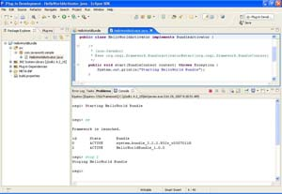

Here are some of the commonly used OSGi commands that you can use to interact with your OSGi container:

* ss displays a list of installed bundles with the status of each bundle. It will display the bundle ID, short name, and status of the bundle.
* start <bundleid> starts a bundle.
* stop <bundleid> stops a bundle.
* update <bundleid> updates a bundle with a new JAR file.
* install <bundleURL> installs a new bundle into the OSGi container.
* uninstall <bundleid> uninstalls already installed bundles from the OSGi container.

Note that these commands are defined in the OSGi specification so you can use them to interact with any of the OSGi containers.

Dependency management

The OSGi specification allows you to break your application into multiple modules and then manage their dependencies on each other. It does this by adding a bundle scope. By default, none of the classes in a bundle are visible from any other bundle; inside bundles they follow the normal rules of the Java language. So, what do you do if you want to access the classes of one bundle from another bundle? The solution is to export packages from the source bundle and then import them into the target bundle. In this section we'll walk through a sample application that demonstrates this concept.

First, we will create a com.javaworld.sample.HelloService bundle, which will export a package. Then we will import the package into our com.javaworld.sample.HelloWorld bundle.

**Exporting a package**

We'll start by creating the com.javaworld.sample.HelloService bundle and exporting a package from it. Follow these steps to create the bundle and export the package:

Create the com.javaworld.sample.HelloService bundle by following the same steps used to create the com.javaworld.sample.HelloWorld bundle in the previous section.

Inside the HelloService bundle, create a com.javaworld.sample.service.HelloService.java interface, as shown in Listing 3.

**Listing 3. HelloService.java**

public interface HelloService {

public String sayHello();

}

Now create a com.javaworld.sample.service.impl.HelloServiceImpl.java class implementing the HelloService interface, as shown in Listing 4.

**Listing 4. HelloServiceImpl.java**

public class HelloServiceImpl implements HelloService{

public String sayHello() {

System.out.println("Inside HelloServiceImple.sayHello()");

return "Say Hello";

}

}

Open the MANIFEST.MF for the HelloService package in your Eclipse Manifest editor and go to the Runtime tab. In the Exported Packages section, click Add and select the com.javaworld.sample.service package. The MANIFEST.MF file for the HelloService bundle should look like the one in Listing 5.

**Listing 5. Manifest for HelloService bundle**

Manifest-Version: 1.0

Bundle-ManifestVersion: 2

Bundle-Name: HelloService Plug-in

Bundle-SymbolicName: com.javaworld.sample.HelloService

Bundle-Version: 1.0.0

Bundle-Vendor: JAVAWORLD

Bundle-Localization: plugin

Export-Package: com.javaworld.sample.service

Import-Package: org.osgi.framework;version="1.3.0"

As you can see, the MANIFEST.MF file for the HelloService bundle looks very similar to that of the HelloWorld bundle. The only difference is that this MANIFEST.MF file has one Export-Package manifest header, whose value is com.javaworld.simple.service.

The Export-Package manifest header informs the OSGi container that classes in the com.javaworld.sample.service package from the HelloService bundle can be accessed from outside. Note that in the sample code we have exposed a HelloService interface but not the HelloServiceImpl implementation class.

**Importing a package**

The next step is to update the HelloWorld bundle to import the com.javaworld.simple.service package. Here are the steps to import the package:

In the com.javaworld.sample.HelloWorld bundle, open the MANIFEST.MF file in the Plug-in Manifest editor. Now go to the Dependencies tab, and then to Imported Packages . Add com.javaworld.sample.service as the value of Imported Packages. The MANIFEST.MF file for your HelloWorld bundle should look like the one in Listing 6.

Listing 6. Manifest for the updated HelloWorld bundle

Manifest-Version: 1.0

Bundle-ManifestVersion: 2

Bundle-Name: HelloWorld Plug-in

Bundle-SymbolicName: com.javaworld.sample.HelloWorld

Bundle-Version: 1.0.0

Bundle-Activator: com.javaworld.sample.helloworld.Activator

Bundle-Vendor: JAVAWORLD

Bundle-Localization: plugin

Import-Package: com.javaworld.sample.service,

org.osgi.framework;version="1.3.0"

As you can see, the value of the Import-Package header is a comma-separated list of packages that this bundle wants to import. In the sample code the HelloWorld bundle imports two packages: com.javaworld.sample.service and org.osgi.framework. The org.osgi.framework package contains OSGi framework classes such as BundleContext and BundleActivator , which are used by the Activator.java class of the HelloWorld bundle.

Next, open com.javaworld.sample.helloworld.Activator.java in the Eclipse Java editor. You will notice that you are now able to access the HelloService interface but not the HelloServiceImpl class. This is because the HelloService package exports (and the HelloWorld package imports) the com.javaworld.sample.service package. HelloServiceImpl is an internal class for the HelloService bundle and no other bundle can access it.

Class-level scope

If you try running the sample service package now it will print "Hello World" on your Eclipse console. If you try running Activator.java to access HelloServiceImpl.java and compile it with the normal javac complier, it will compile. If you try to execute this bundle in an OSGi container, however, it will throw an exception.

How is the OSGi container able to hide a few classes from the .jar file while others are visible? The answer is that the OSGi container uses the Java class loader to manage class visibility. The OSGi container creates a different class loader for every bundle. The bundle can therefore access classes from

Boot classpath: Contains the java.* packages.

Framework classpath: Usually has a separate class loader for the framework implementation classes as well as key service interface classes.

Bundle space: Consists of the JAR file that is associated with the bundle plus any additional JARs that are closely tied to the bundle, like fragments.

Imported packages: For instance, the HelloWorld bundle imports the com.javaworld.sample.service package so it can access classes from that package.

The bundle-level scope is a powerful feature allowing you (for instance) to safely change the HelloServiceImpl.java class without worrying that dependent code might break.

OSGi services

As previously mentioned, the OSGi architecture is a very good candidate for implementing service-oriented applications. It allows bundles to export services that can be consumed by other bundles without knowing anything about the exporting bundle. Taken with the ability to hide the actual service implementation class, OSGi provides a perfect combination for service-oriented applications.

In OSGi, a source bundle registers a POJO (you don't have to implement any interfaces or extend from any superclass) with the OSGi container as a service under one or more interfaces. The target bundle can then ask the OSGi container for services registered under a particular interface. Once the service is found, the target bundle binds with it and can start calling its methods. As with other OSGi concepts, a sample application will make all of this more clear.

Exporting services

In this section we will change the HelloService bundle so that it exports objects of the HelloServiceImpl.java class as a service. Here are the steps to set up the sample application:

Change the MANIFEST.MF for com.javaworld.sample.HelloService to import the org.osgi.framework package.

Create the com.javaworld.sample.service.impl.HelloServiceActivator.java as shown in Listing 7.

Listing 7. Create HelloServiceActivator.java

public class HelloServiceActivator implements BundleActivator {

ServiceRegistration helloServiceRegistration;

public void start(BundleContext context) throws Exception {

HelloService helloService = new HelloServiceImpl();

helloServiceRegistration =context.registerService(

HelloService.class.getName(), helloService, null);

}

public void stop(BundleContext context) throws Exception {

helloServiceRegistration.unregister();

}

}

Note that the source bundle should use the BundleContext.registerService() method to export the service. It takes three parameters:

The name of the interface under which you want to register the service. If you want to register the service under multiple interfaces then you should create a String array of interface names and pass it as your first argument. In the sample code we want to export the service under the name of HelloService interface.

The actual Java object that you want to register as a service. In our sample code we are exporting objects of the HelloServiceImpl class as the service.

Properties of the service, in this case a Dictionary object. If more than one bundle exports a service under the same interface name then the target object can use these properties to filter out the service that it is interested in.

The last step is to change the MANIFEST.MF file of the HelloService bundle to declare HelloServiceActivator as the bundle's activator class. To do that, simply add com.javaworld.sample.service.impl.HelloServiceActivator as the value of the Bundle-Activator header in your MANIFEST.MF file.

Now the HelloService bundle is ready to export objects of the HelloServiceImpl class. When the OSGi container starts the HelloService bundle it will pass control to HelloServiceActivator.java, which will register an object of HelloServiceImpl as a service. The next step is to create the service consumer.

Importing the service

In this section we will change the HelloWorld bundle developed in the last section so that it acts as a consumer of the HelloService service. The main thing you need to do is change the Activator.java for the HelloWorld bundle as shown in Listing 8.

Listing 8. HelloWorldActivator.java

public class Activator implements BundleActivator {

ServiceReference helloServiceReference;

public void start(BundleContext context) throws Exception {

System.out.println("Hello World!!");

helloServiceReference= context.getServiceReference(

HelloService.class.getName());

HelloService helloService =(HelloService)

context.getService(helloServiceReference);

System.out.println(helloService.sayHello());

}

public void stop(BundleContext context) throws Exception {

System.out.println("Goodbye World!!");

context.ungetService(helloServiceReference);

}

}

The BundleContext.getServiceReference() method returns a ServiceReference object for a service registered under the HelloService interface. If multiple such services exist, the service with the highest ranking (as specified in its Constants.SERVICE_RANKING property) is returned. Once you have the object of ServiceReference you can call its BundleContext.getService() method to get the actual service object.

You can run this sample the same way you would execute any bundle, by clicking Run --> Run Simply make sure that both the HelloWorld and HelloService bundles are checked in as plugins. When you start the HelloService bundle, you will see the message "Inside HelloServiceImple.sayHello()" printed from the HelloServiceImpl.sayHello() method.

Creating a service factory

In the last section you learned how to use the OSGi framework to create a Java object and register it as service to be consumed by any other bundle. If you look at the HelloServiceActivator.start() method you will notice that we created an object of the HelloServiceImpl class in the start method and registered it under the name of HelloService interface. Thereafter, whenever any bundle asks for the HelloService service, the OSGi container will return the same object.

This implementation will work for most common use cases. But let's say you want to return a different object of the HelloServiceImpl class for every consumer bundle. Alternately, let's say your service object needs to open a connection to a database and you don't want to open the connection unless someone really needs the service.

In either case, the solution is to create a class implementing the ServiceFactory interface and register its object, instead of the actual service object, as a service. Once you do that, your ServiceFactory class will take control whenever any bundle requests the service. ServiceFactory will create a new object of Service for every bundle, and will also delay creation of the actual service until someone really needs it.

Follow these steps to change the implementation of the com.javaworld.sample.HelloService bundle developed in the last section to use a ServiceFactory:

Create the factory class HelloServiceFactory.java , as shown in Listing 9.

Listing 9. Create HelloServiceFactory.java

public class HelloServiceFactory implements ServiceFactory{

private int usageCounter = 0;

public Object getService(Bundle bundle,

ServiceRegistration registration) {

System.out.println("Create object of HelloService for " +

bundle.getSymbolicName());

usageCounter++;

System.out.println("Number of bundles using service "

+ usageCounter);

HelloService helloService = new HelloServiceImpl();

return helloService;

}

public void ungetService(Bundle bundle, ServiceRegistration

registration, Object service) {

System.out.println("Release object of HelloService for "

+ bundle.getSymbolicName());

usageCounter--;

System.out.println("Number of bundles using service "

+ usageCounter);

}

}

**The ServiceFactory interface defines two methods:**

getService(): The OSGi framework invokes this method the first time the specified bundle requests a service object using the BundleContext.getService(ServiceReference) method. In Listing 9, we use this method to create a different object of HelloServiceImpl for every bundle, and we return that object. The OSGi framework caches the value returned (unless it is null), and will return the same service object on any future calls to BundleContext.getService() from the same bundle.

ungetService(): The OSGi container invokes this method when a service has been released by a bundle. The service object may then be destroyed. In Listing 9, we use this method to reduce the usageCount of the service and print the number of clients for the service.

Change HelloServiceActivator.java and modify the start() method of your activator so that it will register objects of ServiceFactory instead of HelloService, as shown in Listing 10:

Listing 10. Changes to HelloServiceActivator.java

public class HelloServiceActivator implements BundleActivator {

ServiceRegistration helloServiceRegistration;

public void start(BundleContext context) throws Exception {

HelloServiceFactory helloServiceFactory =

new HelloServiceFactory();

helloServiceRegistration =context.registerService(

HelloService.class.getName(), helloServiceFactory, null);

}

public void stop(BundleContext context) throws Exception {

helloServiceRegistration.unregister();

}

}

Now try running this sample code. You should notice that it prints the service usage count as one (1) when HelloWorld bundle is started and zero (0) when the HelloWorld bundle is stopped.

Tracking services

In the "OSGi services" section you learned how to search for a service using its interface name. But what happens if more than one bundle registers a service under the same interface name? In that case the OSGi container will return the service with the highest ranking -- that is, the service that is registered with the highest valued SERVICE_RANKING property. If more than one service has an equally valued SERVICE_RANKING property, then the OSGi container will return the service with the lowest PID.

But let's say that you are creating a consumer that needs to know whenever an object is registered or unregistered under a particular interface. In this situation, you should use the ServiceTracker class. Let's see what happens when we change the sample code to utilize a service tracker, as described below.

Change the MANIFEST.MF for your HelloWorld bundle to import the org.osgi.util.tracker package.

Create HelloServiceTracker.java as shown in Listing 11.

Listing 11. HelloServiceTracker.java

public class HelloServiceTracker extends ServiceTracker {

public HelloServiceTracker(BundleContext context) {

super(context, HelloService.class.getName(),null);

}

public Object addingService(ServiceReference reference) {

System.out.println("Inside HelloServiceTracker.addingService "

+ reference.getBundle());

return super.addingService(reference);

}

public void removedService(ServiceReference reference, Object service) {

System.out.println("Inside HelloServiceTracker.removedService "

+ reference.getBundle());

super.removedService(reference, service);

}

}

As you can see in the constructor of the HelloServiceTracker class, we are passing the name of the HelloService interface to its super class, which is the equivalent of saying that HelloServiceTracker should track services registered under the HelloService interface name. The HelloServiceTracker class extends the ServiceTracker class and implements two methods:

addingService() is called when a bundle registers a service under the given interface name.

removedService() is called when a bundle unregisters a service under the given interface name.

Change Activator.java so that it starts using the HelloServiceTracker class to manage services instead of looking them up directly, as shown in Listing 12.

Listing 12. Activator.java uses HelloServiceTracker

public class Activator implements BundleActivator {

HelloServiceTracker helloServiceTracker;

public void start(BundleContext context) throws Exception {

System.out.println("Hello World!!");

helloServiceTracker= new HelloServiceTracker(context);

helloServiceTracker.open();

HelloService helloService =

(HelloService)helloServiceTracker.getService();

System.out.println(helloService.sayHello());

}

public void stop(BundleContext context) throws Exception {

System.out.println("Goodbye World!!");

helloServiceTracker.close();

}

}

In the initial start() method we first create a HelloServiceTracker object, then we ask HelloServiceTracker to start tracking the underlying service. A call to getService() will now get the HelloService object.

If you try executing this sample you will notice that whenever you start or stop the HelloService bundle it will result in a call to either the addingService() or removedService() method of the HelloServiceTracker object.

In conclusion

In this first article in the three-part Hello, OSGi series, I've introduced you to the basic concepts of modular application development with OSGi. You've learned about the three currently available open source OSGi containers and walked through the steps to develop a simple component bundle using Equinox, the fully OSGi-compliant Eclipse container. You've also learned how bundles can interact by importing and exporting each other's packages and services.

In this article you may have noticed one of the challenges of developing OSGi bundles: that each of your bundles needs to be aware of OSGi AP. In some development scenarios this could mean writing a lot of infrastructure code. In the next article in the Hello, OSGi series I'll introduce you to the Spring Dynamic Modules for OSGi Service Platforms project, which simplifies development of Spring-based OSGi bundles. See the Resources section in the meantime, to learn more about OSGi.

## Developing OSGi-enabled Java EE Applications

GlassFish Server is fully-compliant with Java EE 6, so it provides the latest Java EE APIs and frameworks. It is built using OSGi technology, and includes as its OSGi module management subsystem the Apache Felix OSGi frameworkOpens a new window, which is a fully-compliant implementation of the OSGi Service Platform R4 Version 4.3 specification. GlassFish Server supports deployment of OSGi-based applications using this framework. OSGi applications can make use of core as well as enterprise OSGi features. GlassFish Server makes available many of its Java EE platform services, such as the transaction service, HTTP service, JDBC Service and JMS, as OSGi services. It also enables use of Java EE programming model in OSGi applications, so enterprise Java application developers can continue to leverage their existing skills in OSGi-based applications. See Benefits of Using OSGi in Enterprise Java Applications for more information.

OSGi applications are deployed as one or more OSGi bundles, and the GlassFish Server deployment and administration infrastructure enables you to deploy and manage your OSGi bundles. This chapter classifies OSGi bundles into two categories based on the features they use:

Plain OSGi Application Bundles - bundles that do not contain any Java EE components. See Developing Plain OSGi Bundles.

Hybrid Application Bundles - bundles that are an OSGi bundle as wells as a Java EE module. At runtime, such modules have both an OSGi bundle context and a Java EE context. GlassFish Server supports the following hybrid application bundles:

Web Application Bundles (or WABs) , see Developing Web Application Bundles.

EJB Application Bundles, see Developing EJB Application Bundles.

Developing Plain OSGi Bundles

Java EE components (like an EJB or Servlet) can look up Java EE platform services using JNDI names in the associated Java EE naming context. Such code can rely on the Java EE container to inject the required services as well. Unfortunately, neither of them works when the code runs outside a Java EE context. An example of such code is the BundleActivator of an OSGi bundle. For such code to access Java EE platform services, GlassFish Server makes key services and resources of the underlying Java EE platform available as OSGi services. Thus, an OSGi bundle deployed in GlassFish Server can access these services using OSGi Service look-up APIs or by using a white board pattern. The following Java EE services are available as OSGi services:

HTTP Service

Transaction Service

JDBC Data Source Service

JMS Resource Service

HTTP Service

The GlassFish Server web container is made available as a service for OSGi users who do not use OSGi Web Application Bundles (WABs). This service is made available using the standard OSGi/HTTP service specification, which is a light API that predates the concept of a web application as we know it today. This simple API allows users to register servlets and static resources dynamically and draw a boundary around them in the form of a HttpContext. This simple API can be used to build feature-rich web application, such as the Felix Web Console for example.

The GlassFish Server web container has one or more virtual servers. A virtual server has one or more web application deployed in it. Each web application has a distinct context path. Each virtual server has a set of HTTP listeners. Each HTTP listener listens on a particular port. When multiple virtual servers are present, one of them is treated as the default virtual server. Every virtual server comes configured with a default web application. The default web application is used to serve static content from the docroot of GlassFish Server. This default web application uses / as the context path. A web application contains static and dynamic resources. Each virtual server is mapped to an org.osgi.services.http.HttpService instance. When there are multiple virtual servers present, there will be multiple occurrences of HttpService registered in the service registry. In order to distinguish one service from another, each service is registered with a service property named VirtualServer, whose value is the name of the virtual server. The service corresponding to default virtual server has the highest ranking, so when looking up a service of type HttpService without any additional criteria returns the HttpService corresponding to the default virtual server. In a typical GlassFish Server installation, the default virtual server is configured to listen on port 8080 for the HTTP protocol and port 8181 for the HTTPS protocol.

The context path / is reserved for the default web application. Every resource and servlet registered using the registerResource() and registerServlet() methods of HttpService are made available under a special context path named /osgi in the virtual server. The /osgi context path can be changed to some other value by setting an appropriate value in the OSGi configuration property or in a system property called org.glassfish.osgihttp.ContextPath.

For example, HelloWorldServlet will be available at http://localhost:8080/osgi/helloworld when the following code is executed:

HttpService httpService = getHttpService(); // Obtain HttpService

httpService.registerServlet(httpService.registerServlet("/helloworld",

new HelloWorldServlet(), null, ctx);

Transaction Service

The Java Transaction API (JTA) defines three interfaces to interact with the transaction management system: UserTransaction, TransactionManager, and TransactionSynchronizationRegistry. They all belong to the javax.transaction package. TransactionManagerand TransactionSynchronizationRegistry are intended for system level code, such as a persistence provider. Whereas, UserTransaction is the entity that you should use to control transactions. All the objects of the underlying JTA layer are made available in the OSGi service registry using the following service interfaces:

javax.transaction.UserTransaction

javax.transaction.TransactionManager

javax.transaction.TransactionSynchronisationRegistry

There is no additional service property associated with them. Although UserTransaction appears to be a singleton, in reality any call to it gets rerouted to the actual transaction associated with the calling thread. Code that runs in the context of a Java EE component typically gets a handle on UserTransaction by doing a JNDI lookup in the component naming context or by using injection, as shown here:

(UserTransaction)(new InitialContext()

.lookup("java:comp/UserTransaction"));

or

@Resource UserTransaction utx;

When certain code (such as an OSGi Bundle Activator), which does not have a Java EE component context, wants to get hold of UserTransaction, or any of the other JTA artifacts, then they can look it up in the service registry. Here is an example of such code:

BundleContext context;

ServiceReference txRef =

context.getServiceReference(UserTransaction.class.getName());

UserTransaction utx = (UserTransaction);

context.getService(txRef);

JDBC Data Source Service

Any JDBC data source created in GlassFish Server is automatically made available as an OSGi Service; therefore, OSGi bundles can track availability of JDBC data sources using the ServiceTracking facility of the OSGi platform. The life of the OSGi service matches that of the underlying data source created in GlassFish Server. For instructions on administering JDBC resources in GlassFish Server, see the Oracle GlassFish Server Administration Guide.

GlassFish Server registers each JDBC data source as an OSGi service with objectClass = "javax.sql.DataSource" and a service property called jndi-name, which is set to the JNDI name of the data source. Here is a code sample that looks up a data source service:

@Inject

@OSGiService(true,

"(jndi-name=jdbc/MyDS)")

private DataSource ds;

JMS Resource Service

Like JDBC data sources, JMS administered objects, such as destinations and connection factories, are also automatically made available as OSGi services. Their service mappings are as follows.

| **JMS Object** | **Service Interface** | **Service Properties** | **Comments** |
| --- | --- | --- | --- |
| JMS Queue destination | **javax.jms.Queue** | **jndi-name** | **jndi-name is set to the JNDI name of the queue** |
| JMS Topic destination | **javax.jms.Topic** | **jndi-name** | **jndi-name is set to the JNDI name of the topic** |
| JMS connection factory | **javax.jms.QueueConnectionFactory orjavax.jms.TopicConnectionFactory orjavax.jms.ConnectionFactory** | **jndi-name** | **jndi-name is set to the JNDI name of the topic.**  **The actual service interface depends on which type of connection factory was created.** |

The actual service interface depends on which type of connection factory was created.

Developing Web Application Bundles ( WAB )

When a web application is packaged and deployed as an OSGi bundle, it is called a Web Application Bundle (WAB). WAB support is based on the OSGi Web Application specification , which is part of the OSGi Service Platform, Enterprise Specification, Release 4, Version 4.3. A WAB is packaged as an OSGi bundle, so all the OSGi packaging rules apply to WAB packaging. When a WAB is not packaged like a WAR, the OSGi Web Container of GlassFish Server maps the WAB to the hierarchical structure of web application using the following rules:

The root of the WAB corresponds to the docroot of the web application.

Every JAR in the Bundle-ClassPath of the WAB is treated like a JAR in WEB-INF/lib/.

Every directory except "." in Bundle-ClassPath of the WAB is treated like WEB-INF/classes/.

Bundle-ClassPath entry of type "." is treated as if the entire WAB is a JAR in WEB-INF/lib/.

Bundle-ClassPath includes the Bundle-ClassPath entries of any attached fragment bundles.

The simplest way to avoid knowing these mapping rules is to avoid the problem in the first place. Moreover, there are many packaging tools and development time tools that understand WAR structure. Therefore, we strongly recommend that you package the WAB exactly like a WAR, with only additional OSGi metadata.

Required WAB Metadata

In addition to the standard OSGi metadata, the main attributes of META-INF/MANIFEST.MF of the WAB must have an additional attribute called Web-ContextPath. The Web-ContextPath attribute specifies the value of the context path of the web application. Since the root of a WAB is mapped to the docroot of the web application, it should not be used in the Bundle-ClassPath. Moreover, WEB-INF/classes/ should be specified ahead of WEB-INF/lib/ in the Bundle-ClassPath in order to be compliant with the search order used for traditional WAR files.

Assuming the WAB is structured as follows:

foo.war/

index.html

foo.jsp

WEB-INF/classes/

foo/BarServlet.class

WEB-INF/lib/lib1.jar

WEB-INF/lib/lib2.jar

Then the OSGi metadata for the WAB as specified in META-INF/MANIFEST.MF of the WAB would appear as follows:

MANIFEST.MF:Manifest-Version: 1.0

Bundle-ManifestVersion: 2

Bundle-SymbolicName: com.acme.foo

Bundle-Version: 1.0

Bundle-Name: Foo Web Application Bundle Version 1.0

Import-Package: javax.servlet; javax.servlet.http, version=[3.0, 4.0)

Bundle-ClassPath: WEB-INF/classes, WEB-INF/lib/lib1.jar,

WEB-INF/lib/lib2.jar

Web-ContextPath: /foo

How WABs Consume OSGi Services

Since a WAB has a valid Bundle-Context, it can consume OSGi services. Although you are free to use any OSGi API to locate OSGi services, GlassFish Server makes it easy for WAB users to use OSGi services by virtue of extending the Context and Dependency Injection (CDI) framework. Here's an example of the injection of an OSGi Service into a Servlet:

@WebServlet

public class MyServlet extends HttpServlet {

@Inject @OSGiService(dynamic=true)

FooService fooService;

}

To learn more about this feature, refer to OSGi CDI Extension for WABs.

OSGi CDI Extension for WABs

GlassFish Server includes a CDI extension that enables web applications, such as servlets, that are part of WABs to express a type-safe dependency on an OSGi service using CDI APIs. An OSGi service can be provided by any OSGi bundle without any knowledge of Java EE/CDI, and they are allowed to be injected transparently in a type-safe manner into a web application.

A custom CDI Qualifier, @org.glassfish.osgicdi.OSGiService, is used by the component to represent dependency on an OSGi service. The qualifier has additional metadata to customize the service discovery and injection behavior. The following @OsgiService attributes are currently available:

serviceCriteria — An LDAP filter query used for service selection in the OSGi service registry.

waitTimeout — Waits the specified duration for a service that matches the criteria specified to appear in the OSGi service registry.

dynamic — Dynamically obtain a service reference (true/false).

Since OSGi services are dynamic, they may not match the life cycle of the application component that has injected a reference to the service. Through this attribute, you could indicate that a service reference can be obtained dynamically or not. For stateless or idempotent services, a dynamic reference to a service implementation would be useful. The container then injects a proxy to the service and dynamically switches to an available implementation when the current service reference is invalid.

Example 13-1 Example of a WAB Using CDI

In this example, Bundle B0 defines a service contract called com.acme.Foo and exports the com.acme package for use by other bundles. Bundle B1 in turn provides a service implementation, FooImpl, of the com.acme.Foo interface. It then registers the service FooImpl service with the OSGi service registry with com.acme.Foo as the service interface.

Bundle B2 is a hybrid application bundle that imports the com.acme package. It has a component called BarServlet that expresses a dependency to com.acme.Foo by adding a field/setter method and qualifies that injection point with @OsgiService. For instance, BarServlet could look like:

@Servlet

public void BarServlet extends HttpServlet{

@Inject @OSGiService(dynamic=true)

private com.acme.Foo f;

}

## Writing an OSGi Web Application

Introduction

In Java EE, the Servlet and Java Server Pages models have provided the basic building blocks for Java web applications for many years. OSGi Web Applications are a standardized OSGi version of JEE web applications. An OSGi web bundle is very similar to a JEE WAR, except that it also gets the benefits of operating in an OSGi framework. Enterprise OSGi web bundles are known as WABs. (In contrast to WARs, which are Web ARchives, WABs are Web Application Bundles.)

Building a simple OSGi web application bundle

Let’s give WABs a try. You can use your favorite OSGi or JEE development tools. All you really need for now is the ability to compile Java code and build jars.

What is WAB?

As mentioned above, WAB is just an OSGified WAR archive. Besides the ususal OSGi headers it must in addition contain a special header, Web-ContextPath, specifying the web application context path. Our WAB has (beside some other) the following headers present in the manifest

Web-ContextPath: helloworld

Webapp-Context: helloworld

Bundle-ClassPath: WEB-INF/classes

WAB layouts

The simplest WAB contains three files. These are a Java servlet class, a jar manifest, and a web deployment descriptor. Figure 1 shows how they’re laid out in the WAB. Like WARs, WABs are just a special kind of jar; unlike WARs, the Enterprise OSGi specification does not require a particular file extension. As a result WAB, files may have any extension but typically use .jar or .war.

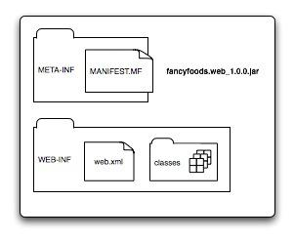

Figure 1 The layout of the fancyfoods.web jar. All code lives in WEB-INF/classes. The web container looks WEB-INF/web.xml to find out what servlets are provided by the bundle. Finally, the standard jar manifest, META-INF/MANIFEST.MF includes important extra metadata for the OSGi container.

Web deployment descriptors

Let’s start with the deployment descriptor. Listing 1 shows the web.xml file for the web application. It’s a typical web.xml file whose syntax will be reassuringly familiar to everyone who has developed JEE web applications. The web application has one servlet, whose class is fancyfoods.web.SayHello.

**Listing 1 The WEB-INF/web.xml file**

<web-app>

<servlet>

<servlet-name>SayHello</servlet-name> #1

<servlet-class>

fancyfoods.web.SayHello</servlet-class>

</servlet><br />

<servlet-mapping>

<servlet-name>SayHello</servlet-name> #2

<url-pattern>/SayHello</url-pattern>

</servlet-mapping>

</web-app>

#1 A servlet with backing class SayHello

#2 The URL is SayHello

A simple servlet

The servlet class SayHello is also exactly the same as it would be in a WAR. Listing 2 shows the source. There’s one method, which, unsurprisingly, issues a greeting to a user.

Listing 2 The SayHello.java file

package fancyfoods.web;

import java.io.IOException;

import java.io.PrintWriter;

import javax.servlet.ServletException;

import javax.servlet.http.*;

public class SayHello extends HttpServlet {

protected void doGet(HttpServletRequest request,

HttpServletResponse response) throws ServletException, IOException {

PrintWriter writer = response.getWriter(); #1

writer.append("Hello valued customer!");

}

}

#1 Write to the response's PrintWriter

So far, so familiar. It’s perhaps a bit anti-climactic that writing a **WAB** is so similar to writing a WAR in some respects, but this is one of the strengths of the enterprise **OSGi**programming model it’s like existing programming models, only better. The differences between **WAB**s and WARs start to become obvious when we look at the manifest file.

A WAB manifest

The final file needed in your **WAB** is the bundle manifest. Every jar has a MANIFEST.MF file, but an OSGi bundle’s manifest has extra headers, such as the symbolic name of the bundle and the bundle’s version.

**Listing 3 The MANIFEST.MF file**

Manifest-Version: 1.0

Bundle-ManifestVersion: 2

Bundle-SymbolicName: fancyfoods.web

Bundle-Version: 1.0.0

Bundle-ClassPath: WEB-INF/classes

Web-ContextPath: /fancyfoods.web

Import-Package: javax.servlet.http;version="2.5",

javax.servlet;version="2.5"

To be consistent with the layout of a WAR, the class files for fancyfoods.web have been packaged in the WEB-INF/classes folder. However, there’s actually no need for this. Classes can live anywhere in an OSGi bundle or even be spread across multiple locations. If the class files are not directly in the root directory, the classpath needs to be specified in the manifest:

Bundle-ClassPath: WEB-INF/classes

Packages used by the servlet that aren’t in the servlet’s own bundle must be explicitly imported in the manifest. Otherwise, they won’t be visible. The exception is that there is no need to import the core java language classes, java.*, which are implicitly imported. Bundle-wiring rules are a bit different for the java.* packages, which must come from the core Java Runtime for security and for compatibility with the Virtual Machine. Imagine if someone could replace the implementation of String or Integer!

In the case of the web bundle, this means the javax.servlet and javax.servlet.http packages are imported. The servlet is expected to work with any version of javax.servlet with version 2.5 or higher, up to but not including version 3.0.

Import-Package: javax.servlet.http;version="2.5",

javax.servlet;version="[2.5, 3.0)"

**WARNING What about Servlet 3.0?**

The meaning of the version range “[2.5, 3.0)” isn’t entirely straightforward. You’re mostly right if you assume that 2.5 part implies version 2.5 of the servlet specification. However, 3.0 definitely does not mean version 3.0 of the servlet specification! Remember, **OSGi** versions are semantic package versions, not marketing or specification versions. Servlet 3.0 is backward compatible with servlet 2.5, and so the package versions for servlet 3.0 won’t be versioned at 3.0. Version 3.0 of the servlet packages would be some change to the servlet specification so radical that the interfaces would no longer be backward compatible. The reason the bottom range starts at 2.5 and not 1.0 is that, when the **WAB** specification was written, the current version was 2.5, and so 2.5 seemed like a logical starting point. Unfortunately, some application servers have deviated from the semantic version and use the package version 3.0 for the Servlet 3.0 specification, which doesn’t help!

The manifest includes one final header which is specific to **WAB**s and defines the web context root. This header is required for a bundle to be recognized as a **WAB**. Many enterprise **OSGi** implementations also allow the context root to be changed after deployment.

Web-ContextPath: /fancyfoods.web

Build these three files into a jar, and the web application is ready to try out!

Deploying and testing

Because **OSGi** is so dynamic, testing **OSGi** bundles is pretty easy. The same bundle can be loaded repeatedly without having to stop or start anything else. If you’re as prone to typos as the authors, you’ll find this extremely handy.

The load directory

The Apache Aries runtime you assembled earlier provides a simple mechanism for discovering and starting new applications. The target directory includes a folder called load. Any OSGi bundles copied into this directory will automatically be started.

To try this out, start the Aries runtime with java -jar. Type osgi-3.5.0.v20090520.jar -console ss to see the list of installed bundles. Now copy the web bundle you’ve built into the load directory.

You’ll see a bunch of output scroll by in the OSGi console. Type ss again. You’ll see there’s one extra bundle listed, and it’s the fancyfoods.web bundle you just copied into the load directory. The fancyfoods.web bundle should be in ACTIVE state.

All that remains now is to try it out. Point a browser at<http://localhost:8080/fancyfoods.web/SayHello>. You’ll see more debug output scroll by in the OSGi console, and the browser should display a response like the one shown in figure 2.

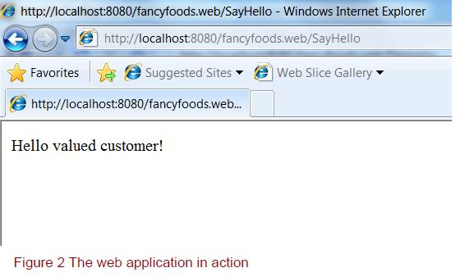

A familiar feeling and important differences

Even with the extra headers in the manifest, the web bundle you’ve written looks a lot like a conventional JEE WAR. In fact, it’s so similar that you could probably deploy it as a WAR in a JEE application. So what’s different about it? A WAB is a bundle, and not just a normal jar, which means it has some new behaviors.

WAR-to-WAB conversion

The structure of WARs and **WAB**s are similar enough that the enterprise **OSGi**specification supports automatic conversion of WARs to **WAB**s at deploy time. A bundle symbolic name and package imports are automatically generated. This can be convenient when doing an initial migration from JEE to enterprise **OSGi**, but in general it’s better to write web applications as **WAB**s. This ensures the bundle has a proper, well-known, symbolic name, and it also allows package imports to be versioned. Versioning package imports is always a good idea. The **WAB** format also provides a convenient mechanism for setting the web context root.

Package privacy

What are the implications of being an **OSGi** bundle? The biggest implication is actually what can’t be seen – nothing outside the fancyfoods.web bundle can see the SayHello class, because it’s not exported. This cozy privacy is exactly what you want because there’s no reason for any code outside your bundle (except for perhaps the web container, which can use the **OSGi** API) to be messing around directly with your servlet class. If you did want to make the SayHello class externally accessible for some reason, all that would be required is to add a package export of the fancyfoods.web package. However, you’d probably want to consider your design pretty carefully before doing this. Could the shared code be externalized to a utility bundle instead?

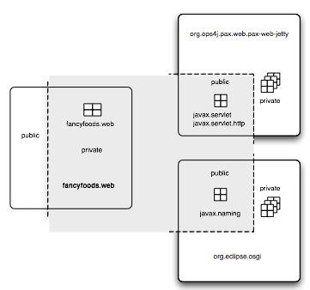

Figure 3 The class space of the fancyfoods.web bundle. It does not have any public packages. To confirm which bundle exports the javax.servlet bundle, type packages javax.servlet in your OSGi console or bundle 37 to see where all of the packages used by fancyfoods.web come from.

Although package privacy is a good thing, not all Java code can cope with it. Some existing libraries, particularly ones which use reflection to load classes, may not work properly.

Explicit dependencies

Being a bundle has a second implication, which is that all the packages required by SayHello must be explicitly imported in the manifest. If you’re first getting used to OSGi, this can seem like an unnecessary and annoying extra step.

Let’s step back and think about how Java handles package imports for classes. If you were writing a Java class, you’d always import the packages you were using, rather than expecting the compiler to choose a class with the right name from a random package. Some class names are pretty unique, and you’d probably end up with the right one, but other class names are not at all unique. Imagine how horrible it would be if your class could end up running against any class called Constants, for example.

Of course, you might also end up with the opposite problem�instead of a class name, which was too common, you could be trying to use a class that doesn’t exist at all. If the package you needed didn’t exist at all, you’d expect an error at compile-time. You certainly wouldn’t want the compilation to limp along, claim success, and produce a class which half worked.

Luckily, the Java compiler doesn’t do this. If your declared dependencies aren’t present, the compilation will fail quickly. At runtime, on the other hand, you’re in a situation that is pretty similar to the undeclared dependencies. You have to wait until your class is invoked to discover its dependencies are missing. You won’t ever end up running against a class from a totally different package to the one you expected, but you could end up running with a class of a different version, with a totally different methods and behaviors.

Explicitly declaring the dependency on the javax.servlet and javax.servlet.http packages ensures the fancyfoods.web bundle won’t be run in a container that doesn’t support servlets. Better yet, it won’t even be run on a container that supports an obsolete version of the servlet specification. To try this out, go to the OSGi console for the Aries runtime. At the prompt, use the packages command to see which bundles import and export the javax.servlet package:

osgi> packages javax.servlet

The response should be something like the following:

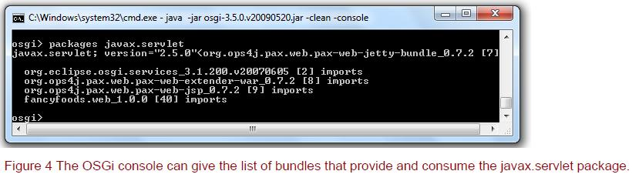

The output shows that the org.ops4j.pax.web.pax-web-jetty-bundle exports the javax.servlet package and four bundles import it, including fancyfoods.web.

What would happen if the Aries assembly hadn’t included Jetty? Quit the OSGi console and move the Jetty bundle (pax-web-jetty-bundle*jar) out of the target directory. (Don’t lose it though!) Restart the OSGi console and type ss to see the list of bundles. You’ll see a number of bundles, including fancyfoods.web, are in the INSTALLED state instead of the ACTIVE state. This means the bundles couldn’t be resolved or started because some dependencies were missing. Make a note of the bundle identifier to the left of fancyfoods.web in the bundle list. Try starting the bundle to see what happens:

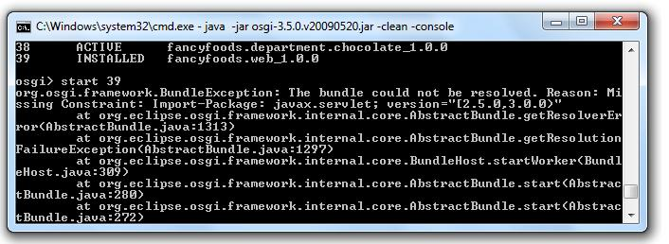

Figure 5 If the Jetty bundle is removed from the runtime, the Fancy Foods web bundle cannot be started because no servlet implementation is present.

Because your assembly no longer has servlet support, fancyfoods.web won’t start. It definitely wouldn’t work properly if the code inside it was to run, so not starting is the right thing to do. Don’t forget to put the Jetty bundle back into the target directory before you try and use the web application again. (The authors forgot to do this on several occasions, and were very confused each time.)

Fragments

OSGi bundles have a third advantage over normal WARs. OSGi is all about modularity, and so OSGi bundles themselves can themselves have modular extensions, known as fragments. Fragments are extensions to bundles which attach to a host bundle and act in almost every way as if they were part of the host. They allow bundles to be customized depending on their environment. For example, translated resource files can be packaged up by themselves into a fragment and only shipped if needed. Fragments can also be used to add platform-specific code to a generic host.

Spicing things up with fragments

How would a fragment work with your little application? The first version of the fancyfoods.web application is only intended to work in English, but if the business takes off, it will expand into other markets. The first step in internationalizing fancyfoods.web is to externalize the strings in SayHello.java. Write a properties file with the following content:

protected void doGet(HttpServletRequest request,

HttpServletResponse response) throws ServletException, IOException {

PrintWriter writer = response.getWriter();

Locale locale = request.getLocale(); #1

String bundleName = "fancyfoods.web.messages";

ResourceBundle resources =

ResourceBundle.getBundle(bundleName, locale); #2

String greeting = resources.getString("SayHello.hello"); #3

writer.append(greeting);

}

1 Where are we?

2 Get the right resource bundle

3 Get the translated message

Bundles, bundles, or bundles?

We’ve got a few different kinds of bundles floating around at the moment, but the resource bundles here are nothing to do with OSGi bundles�they’re just ordinary Java resource bundles.

If you build the bundle and test the web page, it will work exactly as it did before. This is reassuring if you’re English, but not ideal if you’re browsing in French. To try it out, change your web browser’s preferred language to French. (If you don’t want to do that, you can hardcode the locale in the getString() call in SayHello.java.) Most pages you browse to, like Google, for example, will show French text. However, if you reload the Fancy Foods web page, the greeting is disappointedly English. In order to get the Fancy Foods to display in French, you need to provide some French translations, obviously.

In order to be accessible to the SayHello class, the properties files need to be loaded by the same classloader, which (mostly) means they need to be in the same bundle. However, rebuilding jars is no fun, and you definitely don’t want to be repackaging your existing code every time you have a new translation. What you want to be able to do is be able to easily drop in support for other languages in the future.

Resource loading between bundles

We’ve simplified our discussion of resource loading slightly. It is in fact possible to load resources from other bundles, but it’s ugly. The package containing the resource must be exported by the providing bundle and imported by the consuming bundle. In order to avoid clashes with packages in the consuming bundle, the consuming bundle shouldn’t export the package it’s attempting to import. Having trouble following? You won’t be the only one! We’ve seen this pattern used, but we definitely don’t recommend it.

Luckily, this is the sort of job for which OSGi fragments are perfect. OSGi fragments are a bit like OSGi bundles. However, instead of having their own lifecycle and classloader, they attach to a host bundle. They share the host’s classloader and behave in almost every way as if they’re part of the parent.

However, they can be installed and uninstalled independently of the host.

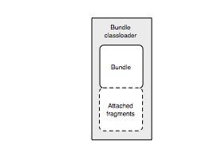

Figure 6 OSGi fragments attach to a parent bundle and share its classloader.

In this case, a translation fragment can be built and attached to fancyfoods.web. To provide the translations, you’ll need a new fragment jar. All it needs inside it is a manifest and a properties file.

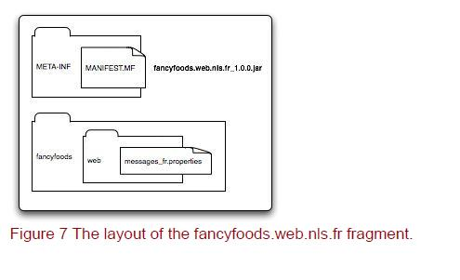

The French language properties file, messages_fr.properties, might read:

SayHello.hello=Bienvenue aux Aliments de Fantaisie!

The MANIFEST.MF is similar to a bundle manifest, but it has an extra header that identifies the host of the fragment�fancyfoods.web in this case. It is a good idea to also specify a minimum version of the host bundle, to ensure compatibility:

Manifest-Version: 1.0

Bundle-ManifestVersion: 2

Bundle-Name: French language resources

Bundle-SymbolicName: fancyfoods.web.nls.fr

Bundle-Version: 1.0.0

Fragment-Host: fancyfoods.web;bundle-version="[1.0.0,2.0.0)"

Bundle-ClassPath: .

Build the fragment into a jar, fancyfoods.web.nls.fr.jar. Once the fragment is built, you can drop it into the load directory of your running framework. Type ss and you’ll see your new fragment included in the list of bundles. Fragments can’t be started and stopped like bundles, so the fragment will be shown as INSTALLED.

Refresh the web bundle with refresh [web bundle number] and the fragment will attach to the bundle and move to the RESOLVED state.

Check the web page again, and the greeting should be shown in French. Delete the fancyfoods.web.nls.fr jar from the load directory, and try the web page again back to English!

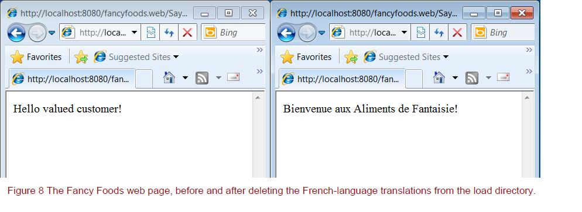

Although internationalization is the most popular use for fragments, it’s not the only one. Anything can be put into a fragment, including Java classes. Including classes in fragments for plugability is not the best implementation. OSGi provides higher level ways of achieving plugability through services.

Summary

The web is one of the most fundamental parts of enterprise Java programming, providing a front-end for almost every enterprise application. In this article, we got you going with a simple web application.

### Examples of Thread Scheduling

Thread Pools –

The idea behind the ThreadPool class is to set up a number of threads that can sit idle, waiting for work that they can perform. The rationale here is not, as you might expect, to pre-allocate the threads to save time: the overhead of starting a thread on many platforms is not really any less significant than the overhead of having a thread wait for work.

Instead, this class is designed to limit the number of threads that our program is using in an effort to utilize the resources of the machine more effectively. For example, Java API uses this technique to limit the number of threads that are used to load images. If you set up a MediaTracker object, the Java API allocates four threads and retrieves images registered in the MediaTracker object four at a time. This limits the load that the program places on the server supplying the images as well as the bandwidth that the program will require in order to load the images.

This technique is often used in calculation servers. If your calculation server receives many simultaneous requests, you may consider it inefficient to set up a different thread for each request. If the server is running on a native-thread platform that's performing some round-robin scheduling, the requests have to compete for scarce CPU resources among themselves. It's often better in these cases to allow only as many simultaneous requests as there are processors on the machine (or even fewer if the machine is performing other work). On platforms that cannot handle large numbers of simultaneous threads, this technique is also useful to limit the number of threads that are active within a program.

Here's an implementation of a thread pool class:

import java.util.*;

public class ThreadPool {

Vector objects;

int nObjects = 0;

CondVar cvAvailable, cvEmpty;

BusyFlag cvFlag;

ThreadPoolThread poolThreads[];

boolean terminated = false;

public ThreadPool(int n) {

cvFlag = new BusyFlag();

cvAvailable = new CondVar(cvFlag);

cvEmpty = new CondVar(cvFlag);

objects = new Vector();

poolThreads = new ThreadPoolThread[n];

for (int i = 0; i < n; i++) {

poolThreads[i] = new ThreadPoolThread(this, i);

poolThreads[i].start();

}

}

// POJO

class ThreadPoolRequest {

Runnable target;

Object lock;

ThreadPoolRequest(Runnable t, Object l) {

target = t;

lock = l;

}

}

class ThreadPoolThread extends Thread {

ThreadPool parent;

volatile boolean shouldRun = true;

// constructor

ThreadPoolThread(ThreadPool parent, int i) {

super("ThreadPoolThread " + i);

this.parent = parent;

}

public void run() {

ThreadPoolRequest obj = null;

while (shouldRun) {

try {

parent.cvFlag.getBusyFlag();

while (obj == null && shouldRun) {

try {

obj = (ThreadPoolRequest)

parent.objects.elementAt(0);

parent.objects.removeElementAt(0);

} catch (ArrayIndexOutOfBoundsException aiobe) {

obj = null;

} catch (ClassCastException cce) {

System.err.println("Unexpected data");

obj = null;

}

if (obj == null) {

try {

parent.cvAvailable.cvWait();

} catch (InterruptedException ie) {

return;

}

}

}

} finally {

parent.cvFlag.freeBusyFlag();

}

if (!shouldRun)

return;

obj.target.run();

try {

parent.cvFlag.getBusyFlag();

nObjects--;

if (nObjects == 0)

parent.cvEmpty.cvSignal();

} finally {

parent.cvFlag.freeBusyFlag();

}

if (obj.lock != null) {

synchronized(obj.lock) {

obj.lock.notify();

}

}

obj = null;

}

}

}

// Overloaded

public void addRequest(Runnable target) {

add(target, null);

}

// Overloaded

public void addRequestAndWait(Runnable target)

throws InterruptedException {

Object lock = new Object();

synchronized(lock) {

add(target, lock);

lock.wait();

}

}

private void add(Runnable target, Object lock) {

try {

cvFlag.getBusyFlag();

if (terminated)

throw new IllegalStateException("Thread pool has shut down");

objects.addElement(new ThreadPoolRequest(target, lock));

nObjects++;

cvAvailable.cvSignal();

} finally {

cvFlag.freeBusyFlag();

}

}

public void waitForAll(boolean terminate) throws InterruptedException {

try {

cvFlag.getBusyFlag();

while (nObjects != 0)

cvEmpty.cvWait();

if (terminate) {

for (int i = 0; i < poolThreads.length; i++)

poolThreads[i].shouldRun = false;

cvAvailable.cvBroadcast();

terminated = true;

}

} finally {

cvFlag.freeBusyFlag();

}

}

public void waitForAll() throws InterruptedException {

waitForAll(false);

}

}

CondVar has the following methods

The inner class in this example performs most of the work. Each thread waits for work; when it is signaled, it simply pulls the first object from the vector and executes that object. When execution of that object is finished, the thread must notify the lock associated with the object (if any) so that the addRequestAndWait() method will know when to return; the thread must also notify the thread pool itself so that the waitForAll() method will check to see if it is time for it to return.

As a result, there are three waiting points in this code:

* Some request objects have associated lock object (Object created in addRequestAndWait()

method). The addRequestAndWait() method uses the standard wait and notify technique to wait on this object; it receives notification after the run() method has been executed by one of the ThreadPoolThread objects.

* A condition variable cvAvailable is associated with the cvBusyFlag. This condition is used

to signal that work is available to be performed. Whenever the nObjects variable is incremented, work is available, so the add() method signals a thread that a new object is available. Similarly, when there are no objects in the vector to be processed, the ThreadPoolThreads wait on that condition variable.

* A condition variable cvEmpty is also associated with the cvBusyFlag. This condition is used

to signal that all pending work has been completed - that is, that the nObjects variable has reached zero. The waitForAll() method waits for this condition, which is signaled by a ThreadPoolThread when it sets nObjects to zero.

We use condition variables for the last two cases because they share the same lock (the cvBusyFlag, which protects access to nObjects) even though they have different values for their condition. If we had used the standard wait and notify mechanism to signal threads that are interested in the value of nObjects, then we could not have controlled notification as well: whenever nObjects was set to zero, we'd have to notify all ThreadPoolThreads as well as notifying the thread that is executing the waitForAll() method. Meanwhile, the ThreadPool class itself provides only a way to create the pool (which also sets the number of threads in the pool), to add objects to the pool, and to wait for all objects in the pool to finish.

Note that objects that are to be run by the thread pool are expected to implement the Runnable interface. This is a potential source of confusion, since we usually use the Runnable interface to identify an object that is to be run within its own thread (and the Thread class itself implements the Runnable interface). It would be an error to create a thread object, add it to a thread pool with the addRequest() method, and then start the thread object explicitly - in this case, we expect the thread pool to run the object. But this interface seems to us to be cleaner than creating a new class or interface that would be used solely in this example. This interface also allows us to take existing code

that uses threads and run those threads via a thread pool instead.

Interestingly enough, there is no way to shut down a thread pool automatically. If the thread pool object were to go out of scope, it would never be garbage collected: the thread pool thread objects (like all thread objects) are held in an internal data structure within the virtual machine, so they will not be garbage collected until they exit. And because they have a reference to the thread pool itself, the thread pool cannot be garbage collected until the thread pool threads are garbage collected. So we have to have some way of signaling the thread pool to exit: we do that by passing a true parameter to the waitForAll() method. Then, when the thread pool has run all of its jobs, the waitForAll() method arranges for the thread pool threads to terminate and marks the thread pool so that no more jobs can be added to it. The thread pool threads will then exit, and the thread pool can then be garbage collected.

Using the ThreadPool now

import java.io.*;

import java.net.*;

public class TCPCalcServer extends TCPServer {

class CalcObject implements Runnable {

OutputStream os;

InputStream is;

CalcObject(InputStream is, OutputStream os) {

this.os = os;

this.is = is;

}

public void run() {

// Perform calculation.

}

}

ThreadPool pool;

TCPCalcServer() {

int numThreads = CPUSupport.getNumProcessors();

CPUSupport.setConcurrency(numThreads + 5);

pool = new ThreadPool(numThreads);

}

public static void main(String args[]) {

try {

new TCPCalcServer().startServer(3535);

} catch (IOException ioe) {

// Error processing omitted.

}

}

public void run(Socket data) {

try {

pool.addRequest(new CalcObject(data.getInputStream(),

data.getOutputStream()));

} catch (IOException ioe) {

// Error processing omitted.

}

}

}

Remember that the real work of the TCPServer class is done in the run(data) method. In this case, we simply set up a new calculation object and add that object to the pool. We've shown a sample implementation of the skeleton of the calculation object as well, although we've left out the actual calculation. Once again, though, note that the CalcObject class implements the Runnable interface without being related to any specific thread.

*Isn't the run(data) method already being run in a separate thread?* *Doesn't that conflict with our original goal of limiting the number of threads in the program?*

Our original goal was to limit the number of simultaneous threads that are active in the program. As this server is written, the thread that is created to call the run(data) method is very short-lived. So even though we still create a new thread for each client connection, the number of threads at any point in time is still fairly small. If you wanted to, you could rewrite the TCPServer class (rather than subclassing it), but this example should scale well.

### Threads – Round Robin Scheduling

These techniques are mostly useful for programs that will execute on a green-thread implementation of the JVM, since native-thread implementations all perform some sort of round-robin scheduling already. If you don't know which implementation your program will eventually run on, you may want to use one of these techniques to ensure round-robin scheduling, even if the underlying implementation is performing it for you: these techniques are not in conflict with native-thread implementations, though they do not necessarily provide a benefit on those platforms.

Remember that at issue here is the behavior of a Java program that contains one or more CPU intensive threads. A Java program could have hundreds of threads that may only periodically need access to the CPU and otherwise spend most of their life in the blocked state: in that case, there isn't likely to be much competition for the CPU, and each thread gets an opportunity to run whenever it has work to do. We only face the problem of CPU starvation when there is at least one CPU-intensive thread that may potentially prevent all other threads from running.

If we have only a single CPU-intensive thread, there is no need for a complicated scheduling mechanism: all we need to do is lower the priority of the CPU-intensive thread below the priority of the other threads in our Java program. This allows the other threads to run whenever they have work to do, while the CPU-intensive thread continues to execute whenever the remaining threads are blocked. We'll build on this principle in our scheduler class: our CPU-intensive threads will all have a lower priority than threads that are mostly blocked.

A Simple Round Robin Scheduler

*How do we go about creating a round-robin scheduler?*

Clearly, we need to begin with some sort of periodic timer; every time the timer goes off, we can make a different thread become the currently running thread.

*What do we need to do to make this happen?*

The simplistic answer to this question is: nothing. That is, our simple scheduler is simply a high priority timer that periodically wakes up only to go back to sleep immediately. This creates, in effect, a timer-based scheduling event: each time the timer thread wakes up, it becomes the currently running thread, which also adjusts the list of threads at the priority of the previously running thread:

public class SimpleScheduler extends Thread {

int timeslice;

public SimpleScheduler(int t) {

timeslice = t;

setPriority(Thread.MAX_PRIORITY);

setDaemon(true);

}

public void run() {

while (true) {

try {

sleep(timeslice);

} catch (Exception e) {}

}

}

}

We'll use this class in the example from the beginning of Chapter 6 so that we can illustrate its behavior:

class TestThread extends Thread {

String id;

public TestThread(String s) {

id = s;

}

public void doCalc(int i) {

}

public void run() {

int i;

for (i = 0; i < 10; i++) {

doCalc(i);

System.out.println(id);

}

}

}

public class Test {

public static void main(String args[]) {

new SimpleScheduler(100).start();

TestThread t1, t2, t3;

t1 = new TestThread("Thread 1");

t1.start();

t2 = new TestThread("Thread 2");

t2.start();

t3 = new TestThread("Thread 3");

t3.start();

}

}

In this program there are three threads (t1, t2, and t3) at the Java default priority of NORM_PRIORITY, and the SimpleScheduler thread that runs at a priority of MAX_PRIORITY. The SimpleScheduler thread is normally blocked, so the list of threads starts out in this state:

PRIORITY 5: t2 -> t3 -> t1 -> NULL

BLOCKED: SimpleScheduler -> NULL

At this point, t1 is the currently running thread, and we'll start to see output lines that say "Thread 1." When SimpleScheduler wakes up, it moves to the runnable state and, because it is the highest priority thread in the JVM, it becomes the currently running thread:

PRIORITY 5: t2 -> t3 -> t1 -> NULL

PRIORITY 10: SimpleScheduler -> NULL

SimpleScheduler immediately executes the sleep() method, moving it back to the blocked state; the JVM then selects the next thread in the list (t2) as the currently running thread and moves it to the end of the list:

PRIORITY 5: t3 -> t1 -> t2 -> NULL

BLOCKED: SimpleScheduler -> NULL

As this continues, each thread in the list of threads at priority 5 becomes the currently running thread in turn.

Note that this mechanism still works for native-thread implementations. On a Windows implementation, the effect is that the currently running thread changes more often than specified by the sleep value within the SimpleScheduler, since the operating system will sometimes change the currently running thread while the scheduler is sleeping. On a Solaris implementation, the reordering of the threads will be dependent on the number of LWPs, but the interruption is sufficient to cause a single LWP to schedule another thread, which achieves the desired effect.

A more complete Scheduler –

Now we'll look into building a more complete scheduler that will schedule our threads in a roundrobin fashion. We can also use it to limit round-robin scheduling on native-thread platforms that timeslice as their default behavior; this limiting is achieved simply by using a very large value as the timeslice that the scheduler gives to a particular thread. However, since there are circumstances on native-thread platforms where the highest priority thread is not necessarily the currently running thread, we cannot completely prevent some sort of round-robin scheduling on those platforms: the best we can do is to use this scheduler to bias the operating system to favor one particular thread.

The example we outline in this section assumes that there is a single CPU. If you need to use this technique on a machine with multiple CPUs, you will need to adjust the scheduler so that it creates N currently running threads rather than one currently running thread (where N is the number of processors on the machine). As written, this technique will work on machines with multiple processors - that is, it will prevent any CPU starvation - but it will have less of an effect on the overall scheduling of the threads.

We'll start building this scheduler by establishing threads at three priority levels:

Level 6

The scheduler itself is a separate thread running at level 6. This allows it to run in favor of the default threads created by the JVM and APIs and in favor of any threads the scheduler is controlling. This thread spends most of its time sleeping (i.e., blocked), so it doesn't usually become the currently running thread.

Level 4

The scheduler selects one thread from all the threads it is controlling and assigns that thread a priority value of 4. Most of the time, this is the nonblocked thread with the highest priority in the JVM, so it is the thread favored to become the currently running thread.

Level 2

All remaining threads under control of our scheduler run at priority level 2. Since there is always a thread running at level 4, these threads usually do not run at this priority; they remain at this priority until they are selected by our scheduler to have a priority level of 4, at which time they become favored to be the currently running thread.

The idea behind the scheduler is that the programmer assigns certain threads to be under control of the scheduler. The scheduler selects one and only one of these threads and assigns it a priority of 4, while the rest of the threads have a priority of 2. The priority 4 thread is the currently running thread; from time to time, the scheduler itself wakes up and selects a different thread as the single priority 4 thread. On green-thread platforms, the priority 4 thread will always be selected as the currently running thread; on native-thread platforms, it will usually be selected as the currently running thread.

For all the threads in this scheduling system - the scheduler thread itself plus any threads the programmer designates to be controlled by our scheduler - it is clear that no CPU starvation will occur: the scheduler thread will always run when it needs to, and as long as that thread correctly adjusts the priorities of the remaining threads under its control, all other threads will get their opportunity to become the currently running thread.

In order to keep track of all the threads, we'll use the CircularList we developed in Chapter 5. This class gives us the queueing behavior we need to keep track of the threads under the control of our scheduler: we can add threads to the list with its insert() method, remove them with its delete() method, and, more important, go through the list by repeatedly calling its getNext() method.

public class CPUScheduler extends Thread {

private int timeslice; // # of milliseconds thread should run

private CircularList threads; // All the threads we're scheduling

public volatile boolean shouldRun = false; // Exit when this is set

public CPUScheduler(int t) {

threads = new CircularList();

timeslice = t;

}

public void addThread(Thread t) {

threads.insert(t);

t.setPriority(2);

}

public void removeThread(Thread t) {

t.setPriority(5);

threads.delete(t);

}

public void run() {

Thread current;

setPriority(6);

while (shouldRun) {

current = (Thread) threads.getNext();

if (current == null)

return;

current.setPriority(4);

try {

Thread.sleep(timeslice);

} catch (InterruptedException ie) {

};

current.setPriority(2);

}

}

}

The programmer uses two methods to interface with the scheduler: addThread(), which adds a thread to the list of thread objects under control of the scheduler, and removeThread(), which removes a thread object from that list.[

Given this interface, we can use the CPUScheduler class in the ThreadTest class we introduced at the beginning of this section:

Class TestThread extends Thread {

String id;

public TestThread(String s) {

id = s;

}

public void doCalc(int i) {

}

public void run() {

int i;

for (i = 0; i < 10; i++) {

doCalc(i);

System.out.println(id);

}

}

}

public class Test {

public static void main(String args[]) {

CPUScheduler c = new CPUScheduler(100);

TestThread t1, t2, t3;

t1 = new TestThread("Thread 1");

t2 = new TestThread("Thread 2");

t3 = new TestThread("Thread 3");

c.addThread(t1);

c.addThread(t2);

c.addThread(t3);

t1.start();

t2.start();

t3.start();

c.start();

}

}

When our program calls c.start(), the CPUScheduler's run() method gets called; it is this run() method that actually manipulates all the threads to create the timesliced, round-robin scheduling. At its base level, the logic for our scheduler is simple: it loops forever, going through all the threads in our circular list of threads and adjusting their priorities as it goes. In between, it sleeps for timeslice milliseconds. The current thread runs for that many milliseconds before the scheduler wakes up again and readjusts the thread's priority. When there are no threads left to schedule - which would happen if the programmer had called removeThread() on all the threads previously added – the CPUScheduler exits by returning from the run() method.

Let's examine how the four threads in our program - threads t1, t2, t3, and the CPUScheduler thread - will behave now. After we call the c.start() method, the threads in the program are in this state:

PRIORITY 2: t1 -> t2 -> t3 -> NULL

PRIORITY 6: CPUScheduler -> NULL

As the highest priority thread in the program, the CPUScheduler thread is the currently running thread. It starts executing the run() method, where the first thing it does is change the priority of thread t1 to 4:

PRIORITY 2: t2 -> t3 -> NULL

PRIORITY 4: t1 -> NULL

PRIORITY 6: CPUScheduler -> NULL

The CPUScheduler, still the currently running thread, now sleeps, placing it into the blocked state. This causes t1 to become the currently running thread:

PRIORITY 2: t2 -> t3 -> NULL

PRIORITY 4: t1 -> NULL

BLOCKED: CPUScheduler -> NULL

When the CPUScheduler thread wakes up, it changes the priority of t1 back to 2 and the priority of t2 to 4:

PRIORITY 2: t3 -> t1 -> NULL

PRIORITY 4: t2 -> NULL

PRIORITY 6: CPUScheduler -> NULL

And so the cycle continues.

Synchronizing data within the CPUScheduler

Now that we have the base logic of the CPUScheduler written correctly, we need to make sure the CPUScheduler class is itself thread safe and that we haven't introduced any race conditions into the scheduler by having incorrectly synchronized data. We'll go through this process in a series of stages because the example illustrates the necessary steps that you must take in designing any class to work with multiple threads.

At first glance, there don't appear to be any variables that need synchronization: the only instance variable that needs to be protected is the variable threads, and all changes to the threads variable occur via methods of the CircularList class that are already synchronized. But what would happen if you called the remove-Thread() method and removed the thread that the CPUScheduler has marked as the current thread? It would be an error for the CPUScheduler to change the priority of this thread once it has been removed from the threads list, so the removeThread() method must somehow inform the CPUScheduler that the current thread has been removed.

This means that the variable current must become an instance variable so that both the run() and removeThread() methods can access it. We can then synchronize access to that variable. Here's the new CPUScheduler class:

public class CPUScheduler extends Thread {

...

private Thread current;

public void removeThread(t) {

t.setPriority(5);

threads.delete(t);

synchronized(this) {

if (current == t)

current = null;

}

}

...

public void run() {

...

try {

Thread.sleep(timeslice);

} catch (InterruptedException ie) {};

synchronized(this) {

if (current != null)

current.setPriority(2);

}

}

}

Alternatively, we could make the run() and removeThread() methods themselves synchronized:

public synchronized void run() {

...

}

public synchronized void removeThread(Thread t) {

...

}

As we've seen, making the run() method synchronized is typically a bad idea, so we'll reject this idea for now, but we'll be revisiting this decision soon.

Making CPUScheduler thread safe –

We've synchronized all the variables of our CPUScheduler, but we're still not protected from threads that exit while they are under our control.

In particular, the run() method changes the priority of a thread, which is a valid operation only if a thread is in the runnable state. What happens if the thread that we've assigned to level 4 exits its run() method while our CPUScheduler is sleeping? When the CPUScheduler wakes up, it tries to set the priority of that thread, which is now in the exiting state, to 2 - an operation that generates an exception. Similarly, if the thread that is running decides to call the stop() method of one of the priority 2 threads in the CPUScheduler's list, then the next time the CPUScheduler selects that thread and sets its priority, we'll get an exception.

So we need to place all the calls to the setPriority() method inside a try/catch clause in order to be alerted to these types of situations. This means we must modify our code everywhere we call the setPriority() method:

public void removeThread(Thread t) {

try {

t.setPriority(5);

} catch(Exception e) {

}

threads.delete(t);

synchronized(this) {

if (current == t)

current = null;

}

}

public void run() {

while (shouldRun) {

...

try {

current.setPriority(4);

} catch (Exception e) {

removeThread(current);

}

...

synchronized(this) {

if (current != null)

try {

current.setPriority(2);

} catch (Exception e) {

removeThread(current);

}

}

...

}

}

Note that in in the run() method, when the exception is thrown we need to remove the thread from the list of threads we're interested in, which means that we must also use the catch clause in the removeThread() method.

More thread-safe modifications –

*We've made the methods of the CPUScheduler thread-safe, but what about the class itself? What if two threads try to create a CPUScheduler?*

This would be very confusing: we'd end up with two scheduling threads that would compete with each other to schedule other threads. So we need to allow only one instance of the class to be instantiated. We'll do this by creating a static variable in the class and testing it to make sure that an instance of the CPUScheduler class doesn't already exist. Because we can't make the constructor itself synchronized, we'll also need to introduce a synchronized method to access this static variable. Thus the constructor and related code for the class now look like this:

public class CPUScheduler extends Thread {

private static boolean initialized = false;

private synchronized static boolean isInitialized() {

if (initialized)

return true;

initialized = true;

return false;

}

public CPUScheduler(int t) {

if (isInitialized())

throw new SecurityException("Already initialized");

threads = new CircularList();

timeslice = t;

}

}

Devising an exit mechanism –

If all the threads under its control exit, the CPUScheduler itself exits. In a program where the tasks are well defined at the beginning of execution - like the TestThread class we've looked at so far – that might be fine. But what if we wanted to add the CPUScheduler to our TCPServer? As presently written, the CPUScheduler wouldn't work for that case: as soon as no clients were connected to the TCPServer, the CPUScheduler would exit, and any further clients that connected to the server would not be timesliced.

Instead, we need to make the CPUScheduler a daemon thread and adjust the logic of its run() method. This should make sense: the CPUScheduler is only useful when there are other threads in the program that it can schedule. In the TCP-Server case, there will always be at least one other thread in the program: the listener thread of the TCPServer. That listener thread creates other threads for the CPUScheduler to manipulate as clients connect to the server.

The implementation of our timesliced TCPServer to perform calculations looks like this:

import java.net.*;

import java.io.*;

public class CalcServer {

public static void main(String args[]) {

CalcRequest r = new CalcRequest();

try {

r.startServer(3535);

} catch (Exception e) {

System.out.println("Unable to start server");

}

}

}

Class CalcRequest extends TCPServer {

CPUScheduler scheduler;

CalcRequest() {

scheduler = new CPUScheduler(100);

scheduler.start();

}

void doCalc(Socket s) {

}

public void run(Socket s) {

scheduler.addThread(Thread.currentThread());

doCalc(s);

}

}

Every time the run() method of the CalcRequest class is called, it is called in a new thread, so we need to add that thread to the CPUScheduler that was created in the constructor of the class. As long as the CPUScheduler doesn't exit when there are no threads to schedule (which now means simply that no client is currently connected), we'll have a timesliced calculation server. During an active session of our CalcServer, we'll have these threads:

*One listener thread*

The thread that waits for connections and creates the client threads.

*Zero or more client threads*

These threads execute the calculation on behalf of a connected client.

*CPUScheduler thread*

The daemon thread performing the scheduling.

We can gracefully shut down the CalcServer by setting the shouldRun flag of the server to false; eventually the client threads complete their calculation and exit. When all the client threads have exited, only the daemon CPUScheduler thread remains in the program, and the program terminates. We need to change the CPUScheduler so that instead of returning when there are no threads to be scheduled, it simply waits for more threads. Here's the entire code for the modified CPUScheduler Class.

public class CPUScheduler extends Thread {

private CircularList threads;

private Thread current;

private int timeslice;

private static boolean initialized = false;

private boolean needThreads;

private static synchronized boolean isInitialized() {

if (initialized)

return true;

initialized = true;

return false;

}

public CPUScheduler(int t) {

if (isInitialized())

throw new SecurityException("Already initialized");

threads = new CircularList();

timeslice = t;

setDaemon(true);

}

public synchronized void addThread(Thread t) {

t.setPriority(2);

threads.insert(t);

if (needThreads) {

needThreads = false;

notify();

}

}

public void removeThread(Thread t) {

threads.delete(t);

synchronized(this) {

if (t == current)

current = null;

}

}

public synchronized void run() {

setPriority(6);

while (true) {

current = (Thread) threads.getNext();

while (current == null) {

needThreads = true;

try {

wait();

} catch (Exception e) {

}

current = (Thread) threads.getNext();

}

try {

current.setPriority(4);

} catch (Exception e) {

removeThread(current);

continue;

}

try {

wait(timeslice);

} catch (InterruptedException ie) {

}

if (current != null) {

try {

current.setPriority(2);

} catch (Exception e) {

removeThread(current);

}

}

}

}

}

In the constructor, we've set the thread to be a daemon thread - the point of this adjustment. Note that we also changed the run() method so that when we try to retrieve a thread from the list, we loop until one is available. If no thread is in the list, we wait until one is available, which requires that we add a flag to the addThread() method to signify whether it should notify the CPUScheduler thread that a thread has been added.

In addition, note that we've changed the run() method itself to a synchronized method and replaced the call to the sleep() method with a call to the wait() method. This is one example of the exception to the general rule that the run() method should not be synchronized: since we actually spend more time waiting in this method than executing code, its quite okay to synchronize the run() method, since it will release the lock whenever it waits for something to happen

Non-CPU-intensive threads –

*What happens in our scheduler if the currently running thread blocks?*

Let's see what would happen to our TestThread program if the currently running thread suddenly entered the blocked state. We'd start out with the threads in a state like this:

PRIORITY 2: t3 -> t1 -> NULL

PRIORITY 4: t2 -> NULL

BLOCKED: CPUScheduler -> NULL

Thread t2 is the currently running thread, executing its calculations while the CPUScheduler is sleeping. If t2 now enters the blocked state for some reason, we end up with threads in this state:

PRIORITY 2: t3 -> t1 -> NULL

PRIORITY 4: NULL

BLOCKED: t2 -> CPUScheduler -> NULL

This means that t3 becomes the currently running thread, even though it's at priority 2. When the CPUScheduler wakes up, it resets the priority of t2 to 2, sets the priority of t3 to 4, and goes back to sleep, leaving our threads in this state:

PRIORITY 2: t1 -> NULL

PRIORITY 4: t3 -> NULL

BLOCKED: t2 -> CPUScheduler -> NULL

Everything is okay again, but at some point it will be t2's turn to be priority 4. Since the CPUScheduler has no way of determining that t2 is blocked, it sets the priority of t2 to 4. The Java scheduler again selects one of the threads at priority 2 to be the currently running thread.

Our code was correct: the threads involved all got some timeslice in which to run. But there was a short period of time during which the CPUScheduler slept, the priority 4 thread blocked, and a priority 2 thread became the currently running thread. In effect, this priority 2 thread stole some CPU time; it could do this because there was a time gap between when the priority 4 thread blocked and the priority 6 thread woke up.

It's probably not a crisis that this happened, since once the CPUScheduler woke up, we got back to the thread state we wanted. We could have prevented this CPU stealing from happening if somehow we knew when the priority 4 thread had blocked. However, on a native-thread platform, we cannot prevent a lower-priority thread from running at some point anyway, which is really just a variation of the behavior that we're discussing here. So solving this problem is not something that we'll be able to do in an absolute sense.

It is conceivable that on a green-thread platform, we could create a new thread within the CPUScheduler class at priority 3. When the priority 4 thread blocks, this priority 3 thread would become the currently running thread; this priority 3 thread could inform the priority 6 thread that it should wake up and perform some scheduling. Note that on a native-thread platform this does not work: the priority 3 thread might still run even if the priority 4 thread has not blocked, and on a Windows platform, priority 3 and 4 share the same underlying operating system priority. Altering the priority levels of the threads to avoid this overlap - by, for example, running the scheduler at priority 8 and the target thread at priority 6 - is a possibility, but we've seen that putting a CPU-intensive thread above the default priority level (especially the level at which the system GUI thread runs) is not always a good idea. And this does not prevent the priority 3 thread from running when the target thread is not blocked.

Even on a green-thread platform, this problem is impossible to solve in the general case. If all the threads to be scheduled were to block, then the priority 3 thread would continually run, consuming a lot of CPU resources but performing no real work. In the first edition of this book, we showed how to overcome that problem by suspending the priority 3 thread, but now the suspend() method has been deprecated, so that solution is no longer an option. And since the benefit provided by such a solution would be very marginal, we're not too worried that such a solution does not exist.

The moral of the story is what we've said all along: Java's scheduling mechanisms give you some control over how threads are scheduled, but that control is never absolute.

### Threads – Job Scheduling

Unlike round-robin scheduling, job scheduling is not related to thread starvation prevention or fairness. The concept of job scheduling is more closely related to when a runnable object is executed than to how a runnable object is run.

There are many applications of job scheduling. We could have a word processor application that needs to save work every five minutes to prevent data loss. We could have a backup program that needs to do an incremental backup every day; this same program may also need to do a full backup once a week.

For more complex scheduling of jobs, or for programs that have countless jobs that need to be scheduled, having a dedicated job scheduler may be easier than implementing the scheduling of every job in the program. Furthermore, in the case of the timer thread, we needed to create a thread just to handle the job. If many jobs are required, a job scheduler may be preferred over having many threads that schedule themselves. This dedicated job scheduler can run all the jobs in its own thread, or it can assign the jobs to a thread pool to better use the thread resources of the underlying platform.

Here's an implementation of a job scheduler class:

import java.util.*;

public class JobScheduler implements Runnable {

final public static int ONCE = 1;

final public static int FOREVER = -1;

final public static long HOURLY = (long)60*60*1000;

final public static long DAILY = 24*HOURLY;

final public static long WEEKLY = 7*DAILY;

final public static long MONTHLY = -1;

final public static long YEARLY = -2;

private class JobNode {

public Runnable job;

public Date executeAt;

public long interval;

public int count;

}

private ThreadPool tp;

private DaemonLock dlock = new DaemonLock();

private Vector jobs = new Vector(100);

public JobScheduler(int poolSize) {

tp = (poolSize > 0) ? new ThreadPool(poolSize) : null;

Thread js = new Thread(this);

js.setDaemon(true);

js.start();

}

private synchronized void addJob(JobNode job) {

dlock.acquire();

jobs.addElement(job);

notify();

}

private synchronized void deleteJob(Runnable job) {

for (int i=0; i < jobs.size(); i++) {

if (((JobNode) jobs.elementAt(i)).job == job) {

jobs.removeElementAt(i);

dlock.release();

break;

}

}

}

private JobNode updateJobNode(JobNode jn) {

Calendar cal = Calendar.getInstance();

cal.setTime(jn.executeAt);

if (jn.interval == MONTHLY) {

// There is a minor bug (see java.util.calendar).

cal.add(Calendar.MONTH, 1);

jn.executeAt = cal.getTime();

} else if (jn.interval == YEARLY) {

cal.add(Calendar.YEAR, 1);

jn.executeAt = cal.getTime();

} else {

jn.executeAt = new Date(jn.executeAt.getTime() + jn.interval);

}

jn.count = (jn.count == FOREVER) ? FOREVER : jn.count - 1;

return (jn.count != 0) ? jn : null;

}

private synchronized long runJobs() {

long minDiff = Long.MAX_VALUE;

long now = System.currentTimeMillis();

for (int i=0; i < jobs.size();) {

JobNode jn = (JobNode) jobs.elementAt(i);

if (jn.executeAt.getTime() <= now) {

if (tp != null) {

tp.addRequest(jn.job);

} else {

Thread jt = new Thread(jn.job);

jt.setDaemon(false);

jt.start();

}

if (updateJobNode(jn) == null) {

jobs.removeElementAt(i);

dlock.release();

}

} else {

long diff = jn.executeAt.getTime() - now;

minDiff = Math.min(diff, minDiff);

i++;

}

}

return minDiff;

}

public synchronized void run() {

while (true) {

long waitTime = runJobs();

try {

wait(waitTime);

} catch (Exception e) {};

}

}

public void execute(Runnable job) {

executeIn(job, (long)0);

}

public void executeIn(Runnable job, long millis) {

executeInAndRepeat(job, millis, 1000, ONCE);

}

public void executeInAndRepeat(Runnable job, long millis, long repeat) {

executeInAndRepeat(job, millis, repeat, FOREVER);

}

public void executeInAndRepeat(Runnable job, long millis, long repeat, int count)

{

Date when = new Date(System.currentTimeMillis() + millis);

executeAtAndRepeat(job, when, repeat, count);

}

public void executeAt(Runnable job, Date when) {

executeAtAndRepeat(job, when, 1000, ONCE);

}

public void executeAtAndRepeat(Runnable job, Date when, long repeat) {

executeAtAndRepeat(job, when, repeat, FOREVER);

}

public void executeAtAndRepeat(Runnable job, Date when, long repeat, int count) {

JobNode jn = new JobNode();

jn.job = job;

jn.executeAt = when;

jn.interval = repeat;

jn.count = count;

addJob(jn);

}

public void cancel(Runnable job) {

deleteJob(job);

}

}

Surprisingly, the implementation of a job scheduler is fairly simple: we just need to iterate over the requested jobs (the elements of the jobs vector) and either add the jobs that need to be executed to a thread pool for processing or start a new thread to execute the job. In addition, we need to find the time for the job that is due to run next, and wait for this time to occur. This entire process is then repeated.

For completeness, we've added a little complexity in our JobScheduler class. In addition to accepting a runnable object that can be executed and a time at which to perform the job, we also accept a count of the number of times the job is to be performed and the time to wait between executions of the job. Hence, after a job is executed, we need to calculate whether another execution is necessary and when to perform this execution.

In our JobScheduler class, this is all handled by a single thread that calls the runJobs() method. The task of deciding whether the job needs to be executed again is done by the updateJobNode() method; adding jobs to and deleting jobs from the requested jobs vector is accomplished by the addJob() and deleteJob() methods, respectively. Most of the logic for the JobScheduler class is actually the implementation of the many options and methods in the interface provided for the programmer.

There are eight methods provided to the programmer in our JobScheduler class:

public void execute(Runnable job)

Used for jobs that are executed once; simply runs the job.

public void executeIn(Runnable job, long millis)

Used for jobs that are executed once; runs the job after the specified number of milliseconds have elapsed.

public void executeAt(Runnable job, Date when)

Used for jobs that are executed once; runs the job at the time specified.

public void executeInAndRepeat(Runnable job, long millis, long repeat)

public void executeInAndRepeat(Runnable job, long millis, long repeat, int count)

Used for repeating jobs. These methods run the job after the number of milliseconds specified by the millis parameter has elapsed. Then they run the job again after the number of milliseconds specified by the repeat parameter has elapsed. This process is repeated as specified by the count parameter. If no count is specified, the job will be repeated forever. The constants HOURLY, DAILY, WEEKLY, MONTHLY, and YEARLY may also be passed as the repeat parameter. The HOURLY, DAILY, and WEEKLY parameters are provided for convenience. However, the MONTHLY and YEARLY parameters are processed differently by the job scheduler since the scheduler has to take into account the different number of days in the month and the leap year.

public void executeAtAndRepeat(Runnable job, Date when, long repeat)

public void executeAtAndRepeat(Runnable job, Date when, long repeat, int count)

Used for repeating jobs. These methods run the job at the time specified, then run the job again after the specified number of milliseconds has elapsed. This process is repeated as specified by the count parameter. If no count is specified, the job will be repeated forever. These methods also support the HOURLY, DAILY, WEEKLY, MONTHLY, and YEARLY constants.

public void cancel(Runnable job)

Cancels the specified job. No error is generated if the job is not in the requested jobs vector, since it is possible that the job has executed and been removed from the vector before the cancel() method is called. If the same job is placed on the list more than once, this method will remove the first job that it finds on the list.

As rich as this set of methods is, it can be considered weak by those who have used job schedulers provided by some operating systems. In those systems, developers can specify criteria such as day of the week, day of the month, week of the year, and so on.

The task of enhancing the job scheduler for these cases is left as an exercise for the reader. However, this is not very difficult to accomplish, given the availability of the Calendar class. For example, with this class, we can easily develop the enhancement for executing a job at a certain day of the week, starting from a particular day:

public void executeAtNextDOW(Runnable job, Date when, int DOW) {

Calendar target = Calendar.getInstance();

target.setTime(when);

while (target.get(Calendar.DAY_OF_WEEK) != DOW)

target.add(Calendar.DATE, 1);

executeAt(job, target.getTime());

}

With this enhancement, we can now execute a job on Sunday like this:

executeAtNextDOW(job, new Date(), Calendar.SUNDAY);

*Should the job scheduler be implemented by using a daemon thread?*

At first glance, this seems like a good choice. After all, if there are no user threads, then there are no jobs to be scheduled. The problem is that there may be jobs on the vector that are already scheduled and are waiting to be executed. Since these jobs do not schedule themselves, there are no threads assigned to them while they wait on the vector. It is therefore possible for all user threads to exit while there are still jobs to be scheduled. In this situation, if the job scheduler was configured as a daemon thread, it would exit with jobs still waiting to be executed.

By using the DaemonLock class that we developed in Chapter 6, we can do a little better: we can make the job scheduler a daemon thread, and we can ensure that it will exit only when there are no more jobs to schedule and there are no other user threads running. All we need to do is acquire the daemon lock when jobs are added to the scheduler, and release the daemon lock when jobs are removed from the scheduler. This only works when the job scheduler is constructed without a thread pool (that is, when each job will be run in a new thread), since the thread pool threads are not daemon threads.

### Threads – Parallelizing for Multiprocessor Machines

*How does the Java threading system behave in a multiprocessor system?*

There are no conceptual differences between a program running on a machine with one processor and a machine with two or more processors; the threads behave exactly the same in either case.

The key difference between a multiprocessor and a single-processor system is that there may be one currently running thread for each CPU on the host platform. The impact of this is that when our Java program runs on a machine with multiple processors, the following assumptions become very important:

* We can no longer assume that a currently running thread has the highest priority. A higher priority thread may be running on a different processor.
* We can no longer assume that a low-priority thread will not run. There may be enough processors to give it execution time.
* We can no longer assume that threads of different priorities will not be running at the same time.
* We can no longer assume that certain race conditions can be ignored because it is "unreasonable" for a particular case to occur. Race conditions in a multiprocessor system are real, whereas race conditions in a single-processor system are more dependent on the scheduling engine of the JVM.

These are the types of common algorithms that we will examine here. Consider the following calculation:

public class SinTable {

private float lookupValues[] = null;

public synchronized float[] getValues() {

if (lookupValues == null) {

lookupValues = new float [360 * 100];

for (int i = 0; i < (360*100); i++) {

float sinValue = (float)Math.sin( (i % 360)*Math.PI/180.0);

lookupValues[i] = sinValue * (float)i / 180.0f;

}

}

return lookupValues;

}

}

A single thread, and hence a single processor, will execute the loop as specified in the code and store the results in the lookupValues array. Assuming that the calculation of the sinValue variable is time-consuming, the whole loop may take a long time to execute. For some cases, this is acceptable. However, on a twelve processor computer without any other application running, only one CPU will be working while the other eleven would be sitting idle. Considering the cost of a twelve-way machine, this is not acceptable.

We may try to break the parts of this loop among many threads as follows:

public class SinTable implements Runnable {

private class SinTableRange {

public int start, end;

}

private float lookupValues[];

private Thread lookupThreads[];

private int startLoop, endLoop, curLoop, numThreads;

public SinTable() {

lookupValues = new float [360 * 100];

lookupThreads = new Thread[12];

startLoop = curLoop = 0;

endLoop = (360 * 100);

numThreads = 12;

}

private synchronized SinTableRange loopGetRange() {

if (curLoop >= endLoop)

return null;

SinTableRange ret = new SinTableRange();

ret.start = curLoop;

curLoop += (endLoop-startLoop)/numThreads+1;

ret.end = (curLoop<endLoop)?curLoop:endLoop;

return ret;

}

private void loopDoRange(int start, int end) {

for (int i = start; i < end; i += 1) {

float sinValue = (float)Math.sin((i % 360)*Math.PI/180.0);

lookupValues[i] = sinValue * (float)i / 180.0f;

}

}

public void run() {

SinTableRange str;

while ((str = loopGetRange()) != null) {

loopDoRange(str.start, str.end);

}

}

public float[] getValues() {

for (int i = 0; i < numThreads; i++) {

lookupThreads[i] = new Thread(this);

lookupThreads[i].start();

}

for (int i = 0; i < numThreads; i++) {

try {

lookupThreads[i].join();

} catch (InterruptedException iex) {}

}

return lookupValues;

}

}

The code in this new version is functionally the same as the previous version, albeit with many modifications to its logic. First, instead of a loop that does the calculation, we now have a loop that starts off 12 (numThreads) different worker threads and provides each worker thread with different parts of the mathematical loop to calculate. The original mathematical calculation is moved to a new method, loopDoRange(). In this method, the loop has been modified to work on only part of the lookup table instead of the whole table. Each different thread is responsible for calculating only its portion of the table. Each thread must call the loopGetRange() method to determine which portion they must calculate. The original thread that started the 12 worker threads then simply waits for all 12 worker threads to finish. Since the long calculation is now accomplished by 12 threads instead of by a single thread, it is now possible for a multiprocessor-based operating system to place the different threads on different processors.

The calculation works for a number of reasons. First, the loop index variable i and the sinValue variable, which were originally classified as loop private, are now stack variables in each worker thread. The loopDoRange() method uses different copies of these two variables in each thread executing the loop. This means that each of the 12 worker threads has its own copy of these variables while completing its portion of the calculation.

Second, although the lookupTable array is not loop private, the individual members of the array can be considered loop private. Each individual member of the array is only accessed in a particular iteration. There is no race condition because each iteration affects one and only one member of the array, and although the different worker threads handle many iterations of the loop, no single iteration is handled by more than one thread.

The only synchronization we need is in the assignment of the different ranges. To prevent the worker threads from stepping on each other during this assignment, the loopGetRange() method is synchronized. In this example, since the loop is partitioned only in 12 ranges, the execution time for this method is insignificant when compared with the loop calculation itself.

Automatic parallelization is accomplished by the compiler instead of by the programmer. While auto- parallelization has been available for other languages, such as FORTRAN, for a long time, it is relatively new for the C language. This is due to the aliasing problems with the C language: with pointers and other aliasing issues, it is very difficult to classify the variables or the loop itself. Even with the current implementation, #pragmas are needed to help the compiler classify variables used in the loop.

In this regard, Java is closer to FORTRAN than to C. All variable references are tracked (for garbage collection), pointer arithmetic is not allowed, and variable types are enforced. There are fewer aliasing problems in Java than in C. This means that it should be much easier to develop an auto-parallelizing compiler for Java than it is for C. Until one exists, however, you need to apply these techniques by hand, as we've done here.

Loop Scheduling and Load Balancing –

*Static or chunk scheduling*

Under static scheduling, each thread is assigned an equal number of iterations that depends on the number of threads available. If there are 1000 iterations in the loop that are to be distributed and 10 threads that are assigned to the task, then each thread will be assigned 100 iterations of the loop.

The problem with this algorithm is that it assumes that each iteration of the loop takes the same amount of time. If this is not true, then one of the threads will take more time than the other threads to complete. Since all the work is divided up at the beginning of the loop, the other threads will be idle while the final iterations are completed by the last remaining thread.

*Self-scheduling*

In self-scheduling, each worker thread grabs a small chunk of the iterations to execute. After completion of its assigned range, it grabs another small chunk. If there are 1000 iterations in the loop that are to be distributed and 10 threads are assigned to the task, then each worker thread will work on a small chunk - say 20 - until all 1000 iterations are completed.

As with static scheduling, the different worker threads may not complete at the same time. However, since the chunks are small in the self-scheduling model, the idle time of the threads at the end of the process is also small.

*Guided self-scheduling*

Guided self-scheduling is a compromise between the static scheduler and the self-scheduler. In the beginning, the guided scheduler grabs a large number of iterations of the loop, which becomes progressively smaller near the end of the loop. There is also a minimum chunk size that the guided self-scheduler uses. Thus, it basically behaves like a static scheduler that slowly becomes a self-scheduler.

*User-defined scheduler*

The implementation of the self-scheduler and the guided self-scheduler is simple for a reason: it was designed to be so. The original loop handler was designed to be subclassed so that the scheduler algorithm could be modified. As good as the implementation of the guided selfscheduler may be, it is still designed for a generic loop. There will be cases where each of the different schedulers will work better than others. However, if enough information concerning the loop is known, and the effort is large enough, it may justify the implementation of yet another scheduler. This entails figuring out the appropriate logic and coding a new loopGetRange() method.

Variable classfications –

Loop-private variables

As mentioned, a loop-private variable is a variable that does not pass its value from one iteration of the loop to another iteration of the loop. It can actually be a variable that is declared in the loop itself, and it can also be an instance or publicly accessed variable that is accessed by only one iteration of the loop.

Read-only variables

Read-only variables are variables that do not change in value during the duration of the loop. They can be true constants or simply variables that have been initialized and will not change until after the loop has been processed.

Storeback variables

Storeback variables are basically loop-private variables that are needed after the loop has been completed.

Individual members of the lookupValues array above are loop-private variables.

Reduction variables

Obviously, it is not possible to make every variable a loop-private variable, since there are cases where there are real data dependencies between different iterations of the loop. Because of these data dependencies, different threads executing different iterations might interfere with each other during execution. We will define these types of variables as shared variables, since they are shared between iterations of the loop.

Shared variables have many problems. The first is the race conditions that exist when different threads access the variable simultaneously. The second is that the value of a variable may depend on the order in which it is processed. In the first case, we can simply use synchronization techniques to prevent the race conditions from existing. The second case poses a much greater problem.

public float[] getValues() {

for (int i = 0; i < (360*100); i++) {

sinValue = (float)Math.sin((i % 360)*Math.PI/180.0);

lookupValues[i] = sinValue * (float)i / 180.0f;

sumValue += lookupValues[i];

}

return lookupValues;

}

In this case, the sumValue variable is clearly not a loop-private variable. The value of sumValue is passed from one iteration to another, and the correct result requires this dependency to exist. However, the sumValue variable is only useful after the loop has completed. The iterations simply add to the running total - subtotals or other order-based requirements are not necessary. Furthermore, addition itself is order independent: it is possible to add a bunch of numbers in any order, and the final result will be the same.

The sumValue variable is a reduction variable. It must still be shared among the threads, but since order does not matter, this sharing only requires synchronization to prevent race conditions:

public class SinTable extends GuidedLoopHandler {

private float lookupValues[];

public float sumValue;

public SinTable() {

super(0, 360*100, 100, 12);

lookupValues = new float [360 * 100];

}

public void loopDoRange(int start, int end) {

float sinValue = 0;

for (int i = start; i < end; i++) {

sinValue = (float)Math.sin((i % 360)*Math.PI/180.0);

lookupValues[i] = sinValue * (float)i / 180.0f;

synchronized (this) {

sumValue += lookupValues[i];

}

}

}

public float[] getValues() {

loopProcess();

return lookupValues;

}

}

We are synchronizing with each iteration of the loop. This is not very efficient. It is better to assign the value to loop-private variables and only synchronize the final summed value of the range to the reduction variable.

public void loopDoRange(int start, int end) {

float sinValue = 0.0f;

float sumValue = 0.0f;

for (int i = start; i < end; i++) {

sinValue = (float)Math.sin((i % 360)*Math.PI/180.0);

lookupValues[i] = sinValue * (float)i / 180.0f;

sumValue += lookupValues[i];

}

synchronized (this) {

this.sumValue += sumValue;

}

}

Shared variables

Originally, all variables in the loop are shared variables, since all variables can be accessed by all the threads that are executing the loop.

### Java 8 - Refactoring, testing, and debugging

Lambda expressions let you represent a piece of behavior in a more compact form in comparison to using anonymous classes.

Method references let you write even more concise code when all you want to do is pass an existing method as argument to another method.

Your code is more flexible because lambda expressions encourage the style of behavior parameterization

Lets bring it all together and show you simple steps you can follow to refactor code to gain readability and flexibility

We describe three simple refactorings that use lambdas, method references, and streams, which you can apply to your code to improve its readability:

* Refactoring anonymous classes to lambda expressions
* Refactoring lambda expressions to method references
* Refactoring imperative-style data processing to streams

Runnable r1 = new Runnable( public void run() {

System.out.println("Hello"); } );

Runnable r2 = () -> { System.out.println("Hello"); }

Converting anonymous classes to lambda expressions can be a difficult process in certain situations. The meanings of this and super are different for anonymous classes and lambda expressions. Inside an anonymous class, this refers to the anonymous class itself, but inside a lambda it refers to the enclosing class. Second, anonymous classes are allowed to shadow variables from the enclosing class. Lambda expressions can’t (they’ll cause a compile error), as shown in the following code:

int a = 10;

Runnable r1 = () -> { int a = 2;

System.out.println("i = "+i); } // compiler error

Runnable r2 = () -> { public void run() { int a = 2;

System.out.println("i = "+i);} } // all good

Finally, converting an anonymous class to a lambda expression can make the resulting code ambiguous in the context of overloading. Indeed, the type of anonymous class is explicit at instantiation, but the type of the lambda depends on its context. Here’s an example of how this can be problematic. Let’s say you’ve declared a functional interface with the same signature as Runnable, here called Task (this might occur when you need interface names that are more meaningful in your domain model):

interface Task{

public void execute();

}

public static void doSomething(Runnable r){ r.run(); }

public static void doSomething(Task a){ r.execute(); }

You can now pass an anonymous class implementing Task without a problem:

doSomething(new Task() {

public void execute() {

System.out.println("Danger danger!!");

}

});

But converting this anonymous class to a lambda expression results in an ambiguous method call, because both Runnable and Task are valid target types:

doSomething( () -> System.out.println("Danger !!!") );

// problem both doSomething(Task) and doSomething( Task ) match

Don’t be turned off by these issues though; there’s good news! Most integrated development environments (IDEs) such as NetBeans and IntelliJ support this refactoring and will automatically ensure these gotchas don’t arise.

**From lambda expressions to method references**

Lambda expressions are great for short code that needs to be passed around. But consider using method references when possible to improve code readability. A method name states more clearly the intent of your code. For example, in chapter 6 we showed you the following code to group dishes by caloric levels:

Map<CaloricLevel, List<Dish>> dishesByCaloricLevel =

menu.stream().collect( groupingBy(

dish -> {

if (dish.getCalories() <= 400)

return CaloricLevel.DIET;

else if (dish.getCalories() <= 700)

return CaloricLevel.NORMAL;

else

return CaloricLevel.FAT;

}));

You can extract the lambda expression into a separate method and pass it as argument to groupingBy. The code becomes more concise and its intent is now more explicit:

Map<CaloricLevel, List<Dish>> dishesByCaloricLevel =

menu.stream().collect( groupingBy( Dish::getCaloricLevel ));

// Lamba expression is extracted into a method

You need to add the method getCaloricLevel inside the Dish class itself for this to work:

public class Dish{

...

public CaloricLevel getCaloricLevel(){

if (this.getCalories() <= 400)

return CaloricLevel.DIET;

else if (this.getCalories() <= 700)

return CaloricLevel.NORMAL;

else

return CaloricLevel.FAT;

}

}

In addition, consider making use of helper static methods such as comparing and maxBy when possible. These methods were designed for use with method references! Indeed, this code states much more clearly its intent than its counterpart using a lambda expression, as we showed in

inventory.sort( (Apple a1, Apple a2) ->

a1.getWeight().compareTo(a2.getWeight()));

inventory.sort( comparing(Apple::getWeight) );

Moreover, for many common reduction operations such as sum, maximum there are built-in helper methods that can be combined with method references. For example, we showed that using the Collectors API you can find the maximum or sum in a clearer way than using a combination of a lambda expression and a lower-level reduce operation. Instead of writing

int totalCalories = menu.stream().map(Dish::getCalories)

.reduce(0, (c1, c2) -> c1 + c2);

try using alternative built-in collectors, which state more clearly what the problem statement is. Here we use the collector summingInt (names go a long way in documenting your code):

int totalCalories = menu.stream().collect(summingInt(Dish::getCalories));

**From imperative data processing to Streams**

Ideally, you should try to convert all code that processes a collection with typical data processing patterns with an iterator to use the Streams API instead. Why? The Streams API expresses more clearly the intent of a data processing pipeline. In addition, streams can be optimized behind the scenes making use of short-circuiting and laziness, as well as leveraging your multicore architecture, as we explained in chapter 7.

For example, the following imperative code expresses two patterns (filtering and extracting) that are mangled together, which forces the programmer to carefully understand the whole implementation before figuring out what the code does. In addition, an implementation that executes in parallel would be a lot more difficult to write

List<String> dishNames = new ArrayList<>();

for(Dish dish: menu){

if(dish.getCalories() > 300){

dishNames.add(dish.getName());

}

}

The alternative using the Streams API reads more like the problem statement, and it can be easily parallelized:

menu.parallelStream()

.filter(d -> d.getCalories() > 300)

.map(Dish::getName)

.collect(toList());

Unfortunately, converting imperative code to the Streams API can be a difficult task, because you need to think about control-flow statements such as break, continue, and return and infer the right stream operations to use. The good news is that some tools can help you with this task as well.

Improving code flexibility

We argued in chapters 2 and 3 that lambda expressions encourage the style of behavior parameterization. You can represent multiple different behaviors with different lambdas that you can then pass around to execute. This style lets you cope with requirement changes (for example, creating multiple different ways of filtering with a Predicate or comparing with a Comparator). We now look at a couple of patterns that you can apply to your codebase to immediately benefit from lambda expressions.

Adopting functional interfaces

First, you can’t use lambda expressions without functional interfaces. You should therefore start introducing them in your codebase. That sounds good, but in which situations? We discuss two common code patterns that can be refactored to leverage lambda expressions: conditional deferred execution and execute around. In addition, in the next section we show how many object-oriented design patterns such as strategy and template method can be rewritten more concisely using lambda expressions.

Conditional deferred execution

It’s common to see control-flow statements mangled inside business logic code. Typical scenarios include security checks and logging. For example, consider the following code that uses the built-in Java Logger class:

if (logger.isLoggable(Log.FINER)){

logger.finer("Problem: " + generateDiagnostic());

}

What’s wrong with it? A couple of things:

* The state of the logger (what level it supports) is exposed in the client code through the method isLoggable.
* Why should you have to query the state of the logger object every time before you can log a message? It just clutters your code.

A better alternative is to make use of the log method, which internally checks to see if the logger object is set to the right level before logging the message:

logger.log(Level.FINER, "Problem: " + generateDiagnostic());

This is a better approach because your code isn’t cluttered with if checks, and the state of the logger is no longer exposed. Unfortunately, there’s still an issue with this code. The logging message is always evaluated, even if the logger isn’t enabled for the message level passed as argument.

This is where lambda expressions can help. What you need is a way to defer the construction of the message so it can be generated only under a given condition (here, when the logger level is set to FINER). It turns out that the Java 8 API designers knew about this problem and introduced an overloaded alternative to log that takes a Supplier as argument. This alternative log method has the following signature:

public void log(Level level, Supplier<String> msgSupplier)

You can now call it as follows:

logger.log(Level.FINER, () -> "Problem: " + generateDiagnostic());

The log method will internally execute the lambda passed as argument only if the logger is of the right level. The internal implementation of the log method is along the lines of this:

public void log(Level level, Supplier<String> msgSupplier) {

if (logger.isLoggable(level)) {

log(level, msgSupplier.get()); // executing Lamda

}

}

What’s the takeaway from the story? If you see yourself querying the state of an object many times in client code (for example, the state of the logger), only to call some method on this object with arguments (for example, log a message), then consider introducing a new method that calls that method (passed as a lambda or method reference) only after internally checking the state of the object. Your code will be more readable (less clutter) and better encapsulated (the state of the object isn’t exposed in client code)!

Execute around

In chapter 3 we discussed another pattern that you can adopt: execute around. If you find yourself surrounding different code with the same preparation and cleanup phases, you can often pull that code into a lambda. The benefit is that you reuse the logic dealing with the preparation and cleanup phases, thus reducing code duplication.

To refresh, here’s the code you saw in chapter 3. It reuses the same logic to open and close a file but can be parameterized with different lambdas to process the file:

/ / Passing a Lamda

String oneLine = processFile( (BufferedReader b) -> b.readLine());

String twoLine = processFile( (BufferedReader b) ->

b.readLine() + b.readLine);

public static String processFile( BufferedReaderProcessor p) throws IOException {

try( BufferedReader br = new BufferedReader(

new FileReader("Java8InAction/chap8/data.txt"

))){

return p.process(br); // Execute BufferedReaderProcessor passed as argument

}

}

// A functional interface for a lamda which can throw a IOException

public interface BufferedReaderProcessor {

String process(BufferedReader r) throws IOException;

}

This was made possible by introducing the functional interface BufferedReader-Processor, which lets you pass different lambdas to work with a BufferedReader object. In this section, you’ve seen how to apply different recipes to improve the readability and flexibility of your code. You’ll now see how lambda expressions can often remove boilerplate code associated with common object-oriented design patterns

**Refactoring object-oriented design patterns with lambdas**

New language features often make existing code patterns or idioms less popular. For example, the introduction of the for-each loop in Java 5 has replaced many uses of explicit iterators because it’s less error prone and more concise. The introduction of the diamond operator <> in Java 7 has reduced the use of explicit generics at instance creation (and slowly pushed Java programmers toward embracing type inference).

A specific class of patterns is called design patterns.[3] They’re a reusable blueprint, if you will, for a common problem when designing software. It’s a bit like how construction engineers have a set of reusable solutions to construct bridges for specific scenarios (such as suspension bridge, arch bridge, and so on). For example, the visitor design pattern is a common solution for separating an algorithm from a structure on which it needs to operate. The singleton pattern is a common solution to restrict the instantiation of a class to only one object.

Lambda expressions provide yet another new tool in the programmer’s toolbox. They can provide alternative solutions to the problems the design patterns are tackling but often with less work and in a simpler way. Many existing object-oriented design patterns can be made redundant or written in a more concise way using lambda expressions. In this section, we explore five design patterns:

* Strategy
* Template method
* Observer
* Chain of responsibility
* Factory

We show how lambda expressions can provide an alternative way to solve the same problem each design pattern is intended for.

**Strategy**

The strategy pattern is a common solution for representing a family of algorithms and letting you choose among them at runtime. You briefly saw this pattern in chapter 2, when we showed you how to filter an inventory with different predicates (for example, heavy apples or green apples). You can apply this pattern to a multitude of scenarios, such as validating an input with different criteria, using different ways of parsing, or formatting an input.

The strategy pattern consists of three parts, as illustrated in figure 8.1:

The strategy design pattern



* An interface to represent some algorithm (the interface Strategy)
* One or more concrete implementations of that interface to represent multiple algorithms (the concrete classes ConcreteStrategyA, ConcreteStrategyB)
* One or more clients that use the strategy objects

Let’s say you’d like to validate whether a text input is properly formatted for different criteria (for example, it consists of only lowercase letters or is numeric). You start by defining an interface to validate the text (represented as a String):

public interface ValidationStrategy {

boolean execute(String s);

}

Second, you define one or more implementation(s) of that interface:

public class IsAllLowerCase implements ValidationStrategy {

public boolean execute(String s){

return s.matches("[a-z]+");

}

}

public class IsNumeric implements ValidationStrategy {

public boolean execute(String s){

return s.matches("\\d+");

}

}

You can then use these different validation strategies in your program:

public class Validator {

private final ValidationStrategy strategy;

public Validtor(ValidatorStrategy v) {

this.strategy = v;

}

public boolean validate(String s) {

return strategy.execute(s);

}

}

Validator numericValidator = new Validator( new isNumeric() );

boolean b1 = numericValidator.validate("aaa");

Validator lowerCaseValidator = new Validator(new isAllLowerCase());

boolean b1 = lowerCaseValidator.validate("bbb");

Using lambda expressions

By now you should recognize that ValidationStrategy is a functional interface (in addition, it has the same function descriptor as Predicate<String>). This means that instead of declaring new classes to implement different strategies, you can pass lambda expressions directly, which are more concise:

Validator numericValidator = new Validator(

(String s) -> s.matches("[a-z]+"));

);

boolean b1 = numericValidator.validate("aaa");

Validator numericValidator = new Validator(

(String s) -> s.matches("\\d+"));

);

boolean b1 = lowerCaseValidator.validate("bbb");

As you can see, lambda expressions remove the boilerplate code inherent to the strategy design pattern. If you think about it, lambda expressions encapsulate a piece of code (or strategy), which is what the strategy design pattern was created for, so we recommend that you use lambda expressions instead for similar problems.

**Template method**

The template method design pattern is a common solution when you need to represent the outline of an algorithm and have the additional flexibility to change certain parts of it. Okay, it sounds a bit abstract. In other words, the template method pattern is useful when you find yourself in a situation such as “I’d love to use this algorithm but I need to change a few lines so it does what I want.”

Let’s look at an example of how this pattern works. Say you need to write a simple online banking application. Users typically enter a customer ID, and then the application fetches the customer’s details from the bank database and finally does something to make the customer happy. Different online banking applications for different banking branches may have different ways of making a customer happy (for example, adding a bonus on their account or just sending them less paperwork). You can write the following abstract class to represent the online banking application:

abstract class OnlineBanking {

public void processCustomer(int id){

Customer c = Database.getCustomerWithId(id);

makeCustomerHappy(c);

}

abstract void makeCustomerHappy(Customer c);

}

The processCustomer method provides a sketch for the online banking algorithm: fetch the customer given its ID and then make the customer happy. Different branches can now provide different implementations of the method makeCustomerHappy by subclassing the OnlineBanking class.

**Using lambda expressions**

You can tackle the same problem (creating an outline of an algorithm and letting implementers plug in some parts) using your favorite lambdas! The different components of the algorithms you want to plug in can be represented by lambda expressions or method references.

Here we introduce a second argument to the method processCustomer of type Consumer<Customer> because it matches the signature of the method makeCustomerHappy defined earlier:

public void processCustomer(int id,

Consumer<Customer> makeCustomerHappy){

Customer c = Database.getCustomerWithId(id);

makeCustomerHappy.accept(c);

}

You can now plug in different behaviors directly without subclassing the OnlineBanking class by passing lambda expressions:

new OnlineBankingLambda().processCustomer(1337, (Customer c) ->

System.out.println("Hello " + c.getName());

This is another example of how lambda expressions can help you remove the boilerplate inherent to design patterns!

**Observer**

The observer design pattern is a common solution when an object (called the subject) needs to automatically notify a list of other objects (called observers) when some event happens (for example, a state change). You typically come across this pattern when working with GUI applications. You register a set of observers on a GUI component such as button. If the button is clicked, the observers are notified and can execute a specific action. But the observer pattern isn’t limited to GUIs. For example, the observer design pattern is also suitable in a situation where several traders (observers) may wish to react to the change of price of a stock (subject). Figure 8.2 illustrates the UML diagram of the observer pattern.

The observer design pattern



Let’s write some code to see how the observer pattern is useful in practice. You’ll design and implement a customized notification system for an application like Twitter. The concept is simple: several newspaper agencies (NY Times, The Guardian, and Le Monde) are subscribed to a feed of news tweets and may want to receive a notification if a tweet contains a particular keyword. First, you need an Observer interface that groups the different observers. It has just one method called notify that will be called by the subject (Feed) when a new tweet is available:

interface Observer {

void notify(String tweet);

}

You can now declare different observers (here, the three newspapers) that produce a different action for each different keyword contained in a tweet:

class NYTimes implements Observer{

public void notify(String tweet) {

if(tweet != null && tweet.contains("money")){

System.out.println("Breaking news in NY! " + tweet);

}

}

}

class Guardian implements Observer{

public void notify(String tweet) {

if(tweet != null && tweet.contains("queen")){

System.out.println("Yet another news in London... "

+ tweet);

}

}

}

class LeMonde implements Observer{

public void notify(String tweet) {

if(tweet != null && tweet.contains("wine")){

System.out.println("Today cheese, wine and news! "

+ tweet);

}

}

}

You’re still missing the crucial part: the subject! Let’s define an interface for him:

interface Subject{

void registerObserver(Observer o);

void notifyObservers(String tweet);

}

The subject can register a new observer using the registerObserver method and notify his observers of a tweet with the notifyObservers method. Let’s go ahead and implement the Feed class:

class Feed implements Subject{

private final List<Observer> observers = new ArrayList<>();

public void registerObserver(Observer o) {

this.observers.add(o);

}

public void notifyObservers(String tweet) {

observers.forEach(o -> o.notify(tweet));

}

}

It’s a pretty straightforward implementation: the feed keeps an internal list of observers that it can then notify when a tweet arrives. You can now create a demo application to wire up the subject and observers:

Feed f = new Feed();

f.registerObserver(new NYTimes());

f.registerObserver(new Guardian());

f.registerObserver(new LeMonde());

f.notifyObservers("The queen said her favourite book is

Java 8 in Action!");

Unsurprisingly, The Guardian will pick up this tweet!

**Using lambda expressions**

You may be wondering how lambda expressions are useful with the observer design pattern. Notice that the different classes implementing the Observer interface are all providing implementation for a single method: notify. They’re all just wrapping a piece of behavior to execute when a tweet arrives! Lambda expressions are designed specifically to remove that boilerplate. Instead of instantiating three observer objects explicitly, you can pass a lambda expression directly to represent the behavior to execute:

f.registerObserver((String tweet) -> {

if(tweet != null && tweet.contains("money")){

System.out.println("Breaking news in NY! " + tweet);

}

});

f.registerObserver((String tweet) -> {

if(tweet != null && tweet.contains("queen")){

System.out.println("Yet another news in London... " + tweet);

}

});

Should you use lambda expressions all the time? The answer is no! In the example we described, lambda expressions work great because the behavior to execute is simple, so they’re helpful to remove boilerplate code. But the observers may be more complex: they could have state, define several methods, and the like. In those situations, you should stick with classes.

**Chain of responsibility**

The chain of responsibility pattern is a common solution to create a chain of processing objects (such as a chain of operations). One processing object may do some work and pass the result to another object, which then also does some work and passes it on to yet another processing object, and so on.

Generally, this pattern is implemented by defining an abstract class representing a processing object that defines a field to keep track of a successor. Once it has finished its work, the processing object hands over its work to its successor. In code it looks like this:

public abstract class ProcessingObject<T> {

protected ProcessingObject<T> successor;

public void setSuccessor(ProcessingObject<T> successor){

this.successor = successor;

}

public T handle(T input){

T r = handleWork(input);

if(successor != null){

return successor.handle(r);

}

return r;

}

abstract protected T handleWork(T input);

}

Figure 8.3 illustrates the chain of responsibility pattern in UML.

Figure 8.3. The chain of responsibility design pattern



Here you may recognize the template method design pattern, which we discussed in section 8.2.2. The method handle provides an outline of how to deal with a piece of work. Different kinds of processing objects can be created by subclassing the class ProcessingObject and by providing an implementation for the method handleWork.

Let’s look at example of how to use this pattern. You can create two processing objects doing some text processing:

public class HeaderTextProcessing extends ProcessingObject<String> {

public String handleWork(String text) {

return "From Raoul, Mario and Alan: " + text;

}

}

public class SpellCheckingProcessing

extends ProcessingObject<String> {

public String handleWork(String text) {

return text.replaceAll("labda", "lamda");

}

}

You can now connect two processing objects to construct a chain of operations!

ProcessingObject<String> p1 = new HeaderTextProcessing();

ProcessingObject<String> p1 = new SpellCheckingProcessing();

p1.setSuccessor(p2);

String result = p1.handle("Aren't labdas really cool?");

System.out.println(result);

**Using lambda expressions**

Wait a minute! This pattern looks like chaining (that is, composing) functions! We discussed how to compose lambda expressions in chapter 3. You can represent the processing objects as an instance of Function<String, String> or more precisely a UnaryOperator<String>. To chain them you just need to compose these functions by using the andThen method!

UnaryOperator<String> headerProcessing = (String text) ->

"From Raoul, Mario and Alan: "+text;

UnaryOperator<String> spellCheckProcessing = (String text) ->

text.replaceAll("labda", "lamda");

Function<String, String> pipeline =

headerProcessing.andThen(spellCheckProcessing);

String result = pipeline.apply("Aren't labdas really sexy!!!");

**Factory**

The factory design pattern lets you create objects without exposing the instantiation logic to the client. For example, let’s say you’re working for a bank and they need a way of creating different financial products: loans, bonds, stocks, and so on.

Typically you’d create a Factory class with a method that’s responsible for the creation of different objects, as shown here:

public class ProductFactory {

public static Product createProduct(String name){

switch(name){

case "loan": return new Loan();

case "stock": return new Stock();

case "bond": return new Bond();

default: throw new RuntimeException("No such product "

+ name);

}

}

}

Here, Loan, Stock, and Bond are all subtypes of Product. The createProduct method could have additional logic to configure each created product. But the benefit is that you can now create these objects without exposing the constructor and the configuration to the client, which makes the creation of products simpler for the client:

Product p = ProductFactory.createProduct("loan");

**Using lambda expressions**

You saw in chapter 3 that you can refer to constructors just like you refer to methods, by using method references. For example, here’s how to refer to the Loan constructor:

Supplier<Product> loanSupplier = Loan::new;

Loan loan = loanSupplier.get();

Using this technique, you could rewrite the previous code by creating a Map that maps a product name to its constructor:

final static Map<String, Supplier<Product>> map = new HashMap<>();

static {

map.put("loan", Loan::new);

map.put("stock", Stock::new);

map.put("bond", Bond::new);

}

You can now use this Map to instantiate different products, just as you did with the factory design pattern:

public static Product createProduct(String name){

Supplier<Product> p = map.get(name);

if(p != null) return p.get();

throw new IllegalArgumentException("No such product " + name);

}

This is quite a neat way to make use of the Java 8 feature to achieve the same intent as the factory pattern. But this technique doesn’t scale very well if the factory method createProduct needs to take multiple arguments to pass on to the product constructors! You’d have to provide a different functional interface than a simple Supplier.

For example, suppose you want to store constructors for products that take three arguments (two Integers and a String); you’d need to create a special functional interface TriFunction to support this. As a result, the signature of the Map becomes more complex:

public interface TriFunction<T, U, V, R>{

R apply(T t, U u, V v);

}

Map<String, TriFunction<Integer, Integer, String, Product>> map

= new HashMap<>();

You’ve seen how to write and refactor code using lambda expressions. You’ll now see how you can ensure your new code is correct.

**Testing the behavior of a visible lambda**

Lambdas don’t have a name (they’re anonymous functions, after all), so it’s trickier to test them in your code because you can’t refer to them by a name! Sometime you may have access to a lambda via a field so you can reuse it, and you’d really like to test the logic encapsulated in that lambda. What can you do? You could test the lambda just like when calling methods. For example, let’s say you add a static field compareByXAndThenY in the Point class that gives you access to a Comparator object that’s generated from method references:

public class Point{

public final static Comparator<Point> compareByXAndThenY =

comparing(Point::getX).thenComparing(Point::getY);

...

}

Remember that lambda expressions generate an instance of a functional interface. As a result, you can test the behavior of that instance. Here, you can now call the method compare on the Comparator object compareByXAndThenY with different arguments to test that its behavior is as intended:

@Test

public void testComparingTwoPoints() throws Exception {

Point p1 = new Point(10, 15);

Point p2 = new Point(10, 20);

int result = Point.compareByXAndThenY.compare(p1 , p2);

assertEquals(-1, result);

}

**Focusing on the behavior of the method using a lambda**

But the purpose of lambdas is to encapsulate a one-off piece of behavior to be used by another method. In that case you shouldn’t make lambda expressions available publicly; they’re only an implementation detail. Instead, we argue that you should test the behavior of the method that uses a lambda expression. For example, consider the method moveAllPointsRightBy shown here:

public static List<Point> moveAllPointsRightBy(List<Point> points,

int x){

return points.stream()

.map(p -> new Point(p.getX() + x, p.getY()))

.collect(toList());

}

There’s no point (pun intended) in testing the lambda p -> new Point(p.getX() + x, p.getY()); it’s only an implementation detail for the method moveAllPointsRightBy. Rather, you should focus on testing the behavior of the method moveAllPointsRightBy:

@Test

public void testMoveAllPointsRightBy() throws Exception{

List<Point> points =

Arrays.asList(new Point(5, 5), new Point(10, 5));

List<Point> expectedPoints =

Arrays.asList(new Point(15, 5), new Point(20, 5));

List<Point> newPoints = Point.moveAllPointsRightBy(points, 10);

assertEquals(expectedPoints, newPoints);

}

Note that in the unit test just shown, it’s important that the Point class implement the equals method appropriately; otherwise it will rely on the default implementation from Object!

**Pulling complex lambdas into separate methods**

Perhaps you come across a really complicated lambda expression that contains a lot of logic (for example, a technical pricing algorithm with corner cases). What do you do, because you can’t refer to the lambda expression inside your test? One strategy is to convert the lambda expression into a method reference (which involves declaring a new regular method), as we explained earlier in section 8.1.3. You can then test the behavior of the new method in your test as you would with any regular method.

**Testing high-order functions**

Methods that take a function as argument or return another function (so-called higher-order functions, explained more in chapter 14) are a little harder to deal with. One thing you can do if a method takes a lambda as argument is test its behavior with different lambdas. For example, you can test the filter method created in chapter 2 with different predicates:

@Test

public void testFilter() throws Exception{

List<Integer> numbers = Arrays.asList(1, 2, 3, 4);

List<Integer> even = filter(numbers, i -> i % 2 == 0);

List<Integer> smallerThanThree = filter(numbers, i -> i < 3);

assertEquals(Arrays.asList(2, 4), even);

assertEquals(Arrays.asList(1, 2), smallerThanThree);

}

What if the method that needs to be tested returns another function? You can test the behavior of that function by treating it as an instance of a functional interface, as we showed earlier with a Comparator. Unfortunately, not everything works the first time, and your tests may report some errors related to your use of lambda expressions. So we now turn to debugging!

**Debugging**

There are two main old-school weapons in a developer’s arsenal to debug problematic code:

1. Examining the stack trace

2. Logging

Lambda expressions and streams can bring new challenges to your typical debugging routine.

**Examining the stack trace**

When your program has stopped (for example, because an exception was thrown), the first thing you need to know is where it stopped and how it got there. This is where stack frames are useful. Each time your program performs a method call, information about the call is generated, including the location of the call in your program, the arguments of the call, and the local variables of the method being called. This information is stored on a stack frame.

When your program fails, you get a stack trace, which is a summary of how your program got to that failure, stack frame by stack frame. In other words, you get a list of valuable method calls up to when the failure appeared. This helps you understand how the problem occurred.

**Lambdas and stack traces**

Unfortunately, due to the fact that lambda expressions don’t have names, stack traces can be slightly puzzling. Consider the following simple code made to fail on purpose:

import java.util.*;

public class Debugging{

public static void main(String[] args) {

List<Point> points = Arrays.asList(new Point(12, 2), null);

points.stream().map(p ->

p.getX()).forEach(System.out::println);

}

}

Running it will produce a stack trace along the lines of this:



Yuck! What’s going on? Of course the program will fail, because the second element of the list of points is null. You then try to process a null reference. Because the error occurs in a stream pipeline, the whole sequence of method calls that make a stream pipeline work is exposed to you. But notice that the stack trace produces the following cryptic lines:

at Debugging.lambda$main$0(Debugging.java:6)

at Debugging$$Lambda$5/284720968.apply(Unknown Source)

They mean that the error occurred inside a lambda expression. Unfortunately, because lambda expressions don’t have a name, the compiler has to make up a name to refer to them. In this case it’s lambda$main$0, which isn’t very intuitive. This can be problematic if you have large classes containing several lambda expressions.

Even if you use method references, it’s still possible that the stack won’t show you the name of the method you used. Changing the previous lambda p -> p.getX() to the method reference Point::getX will also result in a problematic stack trace:



Note that if a method reference refers to a method declared in the same class as where it’s used, then it will appear in the stack trace. For instance, in the following example

import java.util.*;

public class Debugging{

public static void main(String[] args) {

List<Integer> numbers = Arrays.asList(1, 2, 3);

numbers.stream().map(Debugging::divideByZero)

.forEach(System.out::println);

}

public static int divideByZero(int n){

return n / 0;

}

}

the method divideByZero is reported correctly in the stack trace:



In general, keep in mind that stack traces involving lambda expressions may be more difficult to understand. This is an area where the compiler can be improved in a future version of Java.

**Logging information**

Let’s say you’re trying to debug a pipeline of operations in a stream. What can you do? You could use forEach to print or log the result of a stream as follows:

List<Integer> numbers = Arrays.asList(2, 3, 4, 5);

numbers.stream().map(x -> x + 17)

.filter(x -> x % 2 == 0)

.limit(3)

.forEach(System.out::println);

It will produce the following output:

20

22

Unfortunately, once you call forEach, the whole stream is consumed. What would be really useful is to understand what each operation (map, filter, limit) produces in the pipeline of a stream.

This is where the stream operation peek can help. Its purpose is to execute an action on each element of a stream as it’s consumed. But it doesn’t consume the whole stream like forEach does; it forwards the element it performed an action on to the next operation in the pipeline. Figure 8.4 illustrates the peek operation.

**Examining values flowing in a stream pipeline with peek**



In the following code, you use peek to print the intermediate value before and after each operation in the stream pipeline:

List<Integer> result = numbers.stream()

.peek( x -> System.out.println("from Stream " + x))

.map( x -> x + 17)

.peek( x -> System.out.println("after map " + x))

.filter( x -> x % 2 == 0)

.peek( x -> System.out.println("after filter " + x))

.limit(3)

.peek( x -> System.out.println("after limit " + x))

.collect( toList() );

This will produce the output

from stream: 2

after map: 19

from stream: 3

after map: 20

after filter: 20

after limit: 20

from stream: 4

after map: 21

from stream: 5

after map: 22

after filter: 22

after limit: 22

Following are the key concepts you should take away from this chapter:

* Lambda expressions can make your code more readable and flexible.
* Consider converting anonymous classes to lambda expressions, but be wary of subtle semantic differences such as the meaning of the keyword this and shadowing of variables.
* Method references can make your code more readable compared to lambda expressions.
* Consider converting iterative collection processing to use the Streams API.
* Lambda expressions can help remove boilerplate code associated with several object-oriented design patterns such as strategy, template method, observer, chain of responsibility, and factory.
* Lambda expressions can be unit tested, but in general you should focus on testing the behavior of the methods where the lambda expressions appear.
* Consider extracting complex lambda expressions into regular methods.
* Lambda expressions can make stack traces less readable.
* The peek method of a stream is useful to log intermediate values as they flow past at certain points in a stream pipeline.